# 

User Manual

# 

iBOS Limited, an AKIJ Company

October, 2023

|  |  |  |  |  |  |
| --- | --- | --- | --- | --- | --- |
| Version History | | | | | |
| **Version** | **Date** | **Title** | **Reviewed By** | **Approved By** | **Author** |
| 1-3 | 22 September, 2022 | User Manual of Managerium: Cloud ERP | MD. Abuhanifa Ronny |  | Raisa Zarin |
| 4 | 15 October, 2023 | User Manual of Managerium: Cloud ERP |  |  | Farha Jabin Oyshee |

Address: 6/2 Kazi Nazrul Islam Rd, Lalmatia, Mohammadpur, Dhaka-1207

E-mail: info@ibos.io

Contact: 01321157152, 01703596292

**Disclaimers**

Copyright © 2023 iBOS Limited

All rights reserved, Printed in Bangladesh

The information in this document is subject to change without any prior notice. The statements, configurations, technical data, and recommendations in this document are believed to be accurate and reliable but are presented without express or implied warranty. Users must take full responsibility for the applications of any products specified in this document.

All rights reserved. Permission to use, copy, modify, and distribute this software and its documentation for any purpose and without fee is hereby granted, provided that the above copyright notice and this permission notice appear in supporting documentation.

iBOS Limited disclaims all warranties with regard to this software, including all implied warranties of merchantability and fitness. iBOS Limited will not be liable for any special, indirect, or consequential damages or any damages whatsoever resulting from loss of use, data, or profits, whether in an action of contract, negligence, or other tortuous action, arising out of or in connection with the use or performance of this software.

The information in this document is proprietary to iBOS Limited.

**Statement of Conditions**

In the interest of improving internal design, operational function, and /or reliability, iBOS Limited reserves the right to make changes to the products described in this document without notice. iBOS Limited does not assume any liability that may occur due to the use or application of the product(s) or network configurations described herein.

The Programs (which include both the software and documentation) contain proprietary information of iBOS Limited; they are provided under a license agreement containing restrictions on use and disclosure and are also protected by copyright, patent and other intellectual property law. Reverse engineering of the Programs is prohibited. No part of this document may be reproduced or transmitted in any form or by any means, electronic or mechanical, for any purpose, without the express written permission of iBOS Limited. The information contained in this document is subject to change without notice. If users find any problems in the documentation, please report them to us in writing. iBOS Limited does not warrant that this document is error-free.

**Table of Contents**

1. Purchase Module 12

1.1 Request For Dashboard 13

1.2 Purchase Requisition 15

1.3 Request For Quotation 16

1.2.1 Creating a New RFQ: 18

1.3 Quotation Entry 19

1.3.1 Creating a New RFQ: 20

Filling Out Quotation Details: 20

1.4 Comparative Statement 21

Menu Path: Purchase (Module) > Comparative Statement 21

1.4.1 View and Add to PO: 22

1.5 Purchase Order 23

1.5.1 Local Purchase 24

1.5.2 Creating a Local Purchase Order: 26

1.5.3 Foreign Purchase Order: 28

1.5.4 Creating a Foreign Purchase Order: 29

Create from Options: 29

Date Details: 30

Supplier Details: 30

Shipping Details: 30

Currency Details: 30

Item Details: 30

Order Summary Table: 30

Order Total: 30

Additional Features: 30

● Saving the Purchase Order: 32

1.5.4.1 Create New Shipment for a Foreign PO: 33

User Interface [Create New Shipment for a Foreign PO] : 33

● Verify PO Approval 33

● Accessing the PO Details 33

● Initiate Shipment Creation 33

Inputting Charges 34

Reviewing Total Charges 34

Saving the Charge Conditions 34

1.5.5 Intending Purchase 35

1.5.6 Creating an Intending Purchase Order: 36

User Interface [+Create Intending PO] : 36

Create from Options: 36

Date Details: 36

Supplier Details: 36

Shipping Details: 36

Currency Details: 37

Item Details: 37

Order Summary Table: 37

Order Total: 37

Additional Features: 37

● Saving the Purchase Order: 37

1.5.7 Purchase Method : 38

Landing Page details: 38

1.6 Purchase Receive 39

1.6.1 Creating a Direct Receive: 41

1.6.2 Creating a Receive Order [PO Wise]: 43

1.6.3 View the received PO: 47

1.7 Purchase Return 48

1.7.1 Creating a Return [PO Wise]: 50

1.7.2 Return Full or Partial [PO/Direct Wise]: 51

1.7.3 View the RETURN LIST: 54

1.8 Purchase Payment 55

Sales Module 62

2.1 Sales Dashboard 63

64

2.2 Sales Quotation 64

2.2.1 Sales Quotation Landing 64

2.2.2 Creating a New Sales Quotation: 66

2.2.3 Sales Quotation- Terms & Conditions: 68

2.3 Sales Order 70

2.3.1 New Sales Order Landing: 70

2.3.2 Creating a New Sales Order: 72

Create Date: Set the current date or the date when the order is being placed. 72

Office: Select usersr office location from the drop-down menu. 72

Sales Force: Assign the sales representative responsible for the order, if applicable. 72

Customer Details: 72

● Customer: Choose a customer from the list or add a new one using the '+ ADD NEW' option. 72

● Contact Information: Enter or confirm the customer's contact details and delivery address. 72

Order Specifics: 73

● Delivery Date: Specify when the customer expects to receive the goods. 73

● Terms & Conditions: Review or input terms related to the sale, such as payment terms, warranty, and delivery instructions.[Same As Before] 73

Item Selection: 73

● Category & Sub Category: Define the category and sub-category of the items to be ordered. 73

● Items: Add products by selecting from a searchable drop-down list or by adding new items. 73

Quantity and Pricing: 73

● Input the quantity and confirm the unit price for each item. 73

● Apply any discounts, VAT, AIT, and add warranty details if needed.[Calculation Same As Before] 73

Reviewing the Order: 73

● Total Summary: Check the overall total, including any discounts, taxes, and additional charges like delivery or other fees. 73

● Advance Amount: Enter any advance payment made or to be made for the order. 73

Saving the Sales Order: 73

● Finalize: Review all the details for accuracy. 73

● Save: Once verified, click the 'SAVE' button to record the sales order. 73

2.3.3 Rental Order Landing: 73

2.3.4 Creating Rental Order : 74

2.3.5 Delivery Schedule Landing : 75

2.4 Sales Delivery: 76

2.4.1 Approved PO Landing : 76

User Interface [APPROVED SO-Landing Page]: 76

2.4.2 Delivery For SO from table: 77

User Interface [Delivery For SO]: 77

User Interface [Transportation Details]: 78

2.4.3 Direct Delivery: 79

User Interface [Direct Delivery]: 79

2.4.4 Delivery List: 80

User Interface [Delivery List]: 80

2.5 Sales Return: 81

User Interface [ DELIVERY LIST landing]: 82

2.5.1 Creating a Return [SO Wise]: 83

2.5.2 Return Full or Partial [SO/Direct Wise]: 84

2.5.3 View the RETURN LIST: 86

2.6 Sales Collection: 87

2.7 Sales Target: 91

2.8 Field Collection: 94

Accounting Module 98

3.1 Accounting Dashboard 98

3.2 Bank Account 100

3.4 Cost Center 105

3.5 Accounting Journal 107

3.6 Budget 113

3.7 Expense/Advance 115

3.8 Project Accounting 120

3.9 Fund Transfer 122

3.10 Cheque Setup 124

3.11 LC Margin 125

4. Inventory Module 128

4.1 Inventory Dashboard 128

4.2 Item Request 130

4.2.1 Creating an Inventory Request: 132

Steps to Create an Item Request: 132

4.3 Transfer 133

4.3.1 Creating an Direct Transfer: 134

● 4.4 Item Conversion 135

4.4.1 Item Conversion-Landing: 135

Steps 135

Item Conversion: 135

Steps for Creating an Item Conversion: 136

● 4.5 Item Requisition 137

4.5.1 Item Requisition-Landing: 137

Features: Steps 138

Creating an Item Requisition: 138

4.6 Item Issue 138

4.6.1 Item Issue-Landing: 138

Steps for Issuing Items: 139

After Issuing the Items: 140

4.6.2 Create Item Issue: 140

Steps 141

Creating an Item Issue: 141

4.7 Stock Adjustment 142

4.7.1 Stock Update-Landing: 142

Steps 142

Updating Stock: 142

Stock Adjustment 143

Steps for Making a Stock Adjustment: 143

Dispose 143

Steps for Disposing of Items: 143

● 4.8 Audit Setup 144

● 4.9 Audit 144

5. HR Module 144

5.1.2 Types of Users 144

5.1.3 Home Page 145

5.1.4 Holiday 146

5.1.5 Calendar 147

5.1.6 Roster 151

5.1.6 Salary 152

5.1.7 Overtime 154

5.1.8 Notice Board 156

5.1.8 Others: 158

5.2.1 Dashboard 159

5.2.1.1 Types of View 160

5.3.1 Attendance 161

5.4.1 Leave and Movement 163

5.4.1.1 Leave 164

5.4.1.2 Movement 164

5.5 Payroll 165

5.5.1 Regenerate [ ] 166

5.5.2 View [ ] 167

5.5.3 Salary Sheet Generate [ ] 168

5.8 Salary Disbursement 169

6. Asset 171

6.1 Asset Dashboard 171

Key Features: 172

6.2 Registration 172

6.2.1 Asset Registration-Landing: 173

6.2.2 Asset Registration-Landing: 174

6.2.3 Asset List-Landing: 175

6.3 Assign 176

6.3.1 Asset Assign-Landing: 176

Landing Details: 176

6.3.2 Asset Assign: 176

Using Asset Assign: 177

6.4 Maintenance 177

6.4.1 Maintenance-Landing: 177

6.4.1 Send Asset to Maintenance: 177

6.5 Depreciation 178

6.5.1 Asset Depreciation-Landing: 179

Functionality: 179

Asset Depreciation Landing Details: 179

6.6 Asset Disposal 180

6.6.1 Disposal-Landing: 180

6.6.2 Recording a Disposal 180

Sales Disposal 180

Destroy Disposal 180

6.6.3 +Create Disposal [ Sales & Destroy]: 181

Accessing Create Sales 181

Header Information: 181

Asset Lists/ Table Section: 181

6.6.3 Create Destroy (Disposal) 182

Accessing Create Destroy 182

Recording an Asset Destruction 182

Asset Lists Section 182

7. Production 183

7.1 Production Dashboard 183

Dashboard Metrics 183

Production Volume (Unit) 183

Productivity (Unit per hour) 183

Produced Item 184

Machine Utilization 184

7.2 Bill Of Material 184

7.2.1 Bill of Material Details: 185

FG Item and BOM Information 185

Material Item List 185

Reviewing and Editing Material Details 185

Material Total 185

7.2.2 +Create Bill of Material: 186

● BOM Name: Enter a name for the new Bill of Material for easy identification. 186

● Lot Size: Specify the number of finished goods that this BOM will produce. 186

Step 2: Add Materials 186

● Quantity: Enter the quantity of the material required. 187

● Wastage (%): If applicable, enter the percentage of material that may be wasted during production. 187

Step 3: Reviewing Materials List 187

● The materials list will display all added materials with their unit of measure (UoM), quantity, wastage percentage, rate, and total cost. 187

● SL: The serial number of the material in the BOM. 187

● Item Name: The name of the material. 187

● UoM: The unit of measurement for the material. 187

● Quantity: The amount needed for production. 187

● Wastage (%): Expected wastage during production. 187

● Rate: Cost per unit of the material. 187

● Total: Total cost for the quantity needed. 187

Step 4: Save the BOM 187

● Confirm the ‘Grand Total’, which is the sum of the cost of all materials. 187

● Review the entire BOM to ensure all materials and quantities are correct. 187

● Once verified, click the ‘Save’ button to finalize the BOM. 187

Editing and Deleting Materials 187

● To edit a material entry, click on the input field to type. 187

● To remove a material from the BOM, click the trash bin icon in the ‘Actions’ column. 187

7.3 Production Order 187

7.3.1 Production Order-Landing 188

Table Details: Viewing Orders 188

Editing Orders 188

Monitoring Order Progress 188

Filtering and Searching 188

7.3.2 Creating Production Order 189

Tables Order Details: 189

Reviewing the Order 189

7.3.2 Production Order Approval 190

Step-by-Step Approval Process 190

Step 1: Production Order Approval 190

Step 2: Inventory Requisition Approval 190

Step 3: Item Issue 190

7.4 Production Entry 191

**8. CRM 193**

8.1 Employee 193

8.2 Employee 193

**9. Configuration 193**

9.1 Employee 193

9.2 Item Profile 194

9.3 Account 194

9.4 Branch 194

9.5 Customer Profile 194

9.6 Office 194

9.7 Supplier Profile 194

9.8 Other Partner Profile 194

9.9 Warehouse 194

9.10 Company Profile 194

9.11 Offer Setup 194

9.12 Customer Price Setup 194

9.13 Standard Price Setup 194

9.14 Wallet Setup 194

9.15 Barcode 194

9.16 Sales Setup 194

9.17 MGT 194

9.18 Favorite Menu Setup 194

9.19 Approval Setup 194

9.20 Expose API Config 194

9.21 Expose API Config 194

9.22 User Group 194

9.23 Package 194

9.24 Banner Upload 194

9.25 Outlet Setup 194

9.26 Tour Plan Setup 194

9.27 Responsibility Transfer 194

# **Purchase Module**

Purchase means the process of obtaining certain property, assets or goods by completing pre- agreed monetary transactions.

To purchase a certain good, a requisition needs to be submitted to the procurement team. Based on the requisition and RFQ (Request for Quotation)/ Request for Proposal is created and sent to the suppliers or vendors. In response to the RFQ suppliers/vendors will send a Quotation.

After careful review, a Purchase Order is created by the procurement team in response to the winning Quotation.

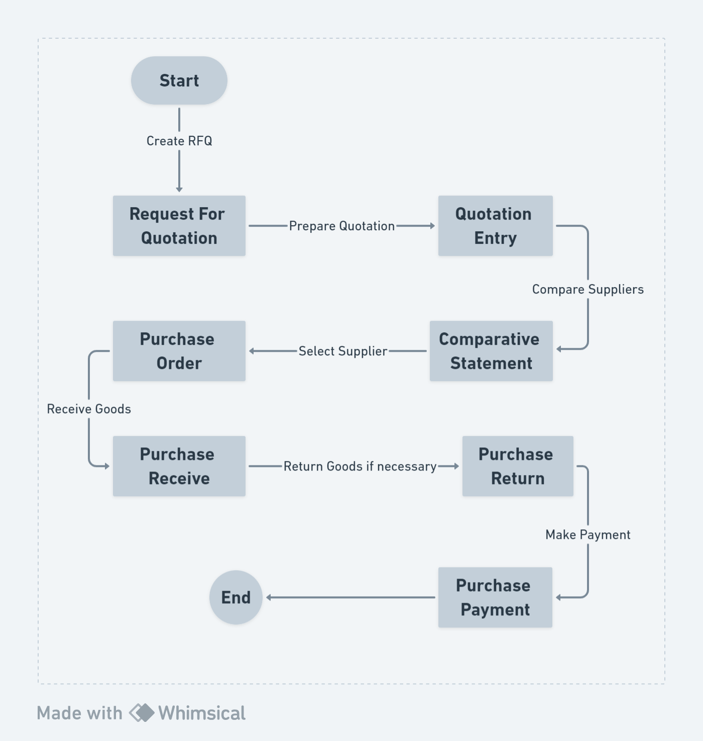

**Features Of Purchase Module:**

## 1.1 Request For Dashboard

It appears to be a dashboard interface focusing on purchasing analytics. users have various visual data representations like pie charts, bar graphs, and line charts showing metrics related to purchasing activities.

**Menu Path: Purchase (Module) > Purchase Dashboard**

The user will see a landing page after clicking the "Purchase Dashboard" feature.

**User Interface [Landing]**

## 

## 

User can view the following information:

* **Type Wise Purchase:** A pie chart representing the distribution of different types of purchases.
* **Warehouse Wise Purchase:** Displays the distribution of purchases across different warehouses.
* **On-Time Payment (Rate):** A metric highlighting the percentage of payments made on time versus late payments.
* **Avg. Procurement Cycle Time (In Days):** A progress bar showcasing the average time taken at different stages of the procurement process.
* **Purchase Expenditure:** A line chart illustrating the expenditure trend over a specified time frame.
* **Avg. Procurement Cycle (Supplier Classification):** The bar chart shows the procurement cycle duration categorized by supplier type.
* **Top 10 Suppliers:** Lists the top suppliers based on purchase frequency or value.
* **Top 10 Items:** Displays the most frequently purchased items or those with the highest value.

## 1.2 Purchase Requisition

Purchase Requisition is an internal document utilized by an employee within an organization to formally request the acquisition of goods or services for the company's benefit. These acquisitions can range widely in purpose, including but not limited to, the procurement of business operational necessities, inventory restocking, or acquiring manufacturing inputs critical for production processes.

**Menu Path:** Purchase (Module) > Purchase Requisition

**User Interface [Create Requisition] :**

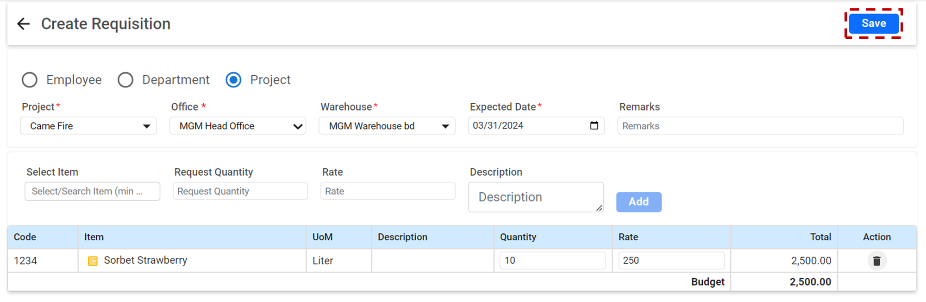

**Requisition Type**

* **Employee:** Select this option if the requisition is made by an individual employee.
* **Department:** Choose this if the requisition is for a specific department.
* **Project:** Select this option for project-related requisitions.

**Project Information**

* **Project:** Click on the dropdown and select the project for which the requisition is being made.
* **Office:** Select the office that is initiating the requisition.
* **Warehouse:** Choose the warehouse from which the items will be dispatched.
* **Expected Date:** Click on the calendar icon and select the date by which you need the requisition fulfilled.

**Item Details**

* **Select Item**: Click into the field to search for an item. Must type at least 3 characters to see suggestions.
* **Request Quantity:** Input the number of items you require.
* **Rate:** Enter the cost per unit for the item.
* **Description (optional):** Provide any additional details or specifications about the item.

**Reviewing and Adding Items**

* Once users have filled in the details for an item, click **'Add**' to include it in the requisition.
* Review the added items in the table below, where you can see the Code, Item, UoM (Unit of Measure), Description, Quantity, Rate, and Total.
* If you need to edit or remove an item, use the **'Action'** column's options accordingly.

**Budget and Remarks**

* **Budget:** The system will calculate the total cost of the requisition based on the items added. Review this to ensure it aligns with your budgetary constraints.
* **Remarks:** If there are any additional notes or instructions regarding the requisition, enter them in the Remarks box.

## 

## 1.3 Request For Quotation

The Request For Quotation (RFQ) allows users to manage and create new quotations for purchasing requirements efficiently. This guide provides an overview of navigating and utilizing the RFQ module effectively.  
 **Menu Path:** Purchase (Module) > Request For Quotation

The user will see a landing page after clicking the "Request For Quotation" feature.

**User Interface [Landing] :**

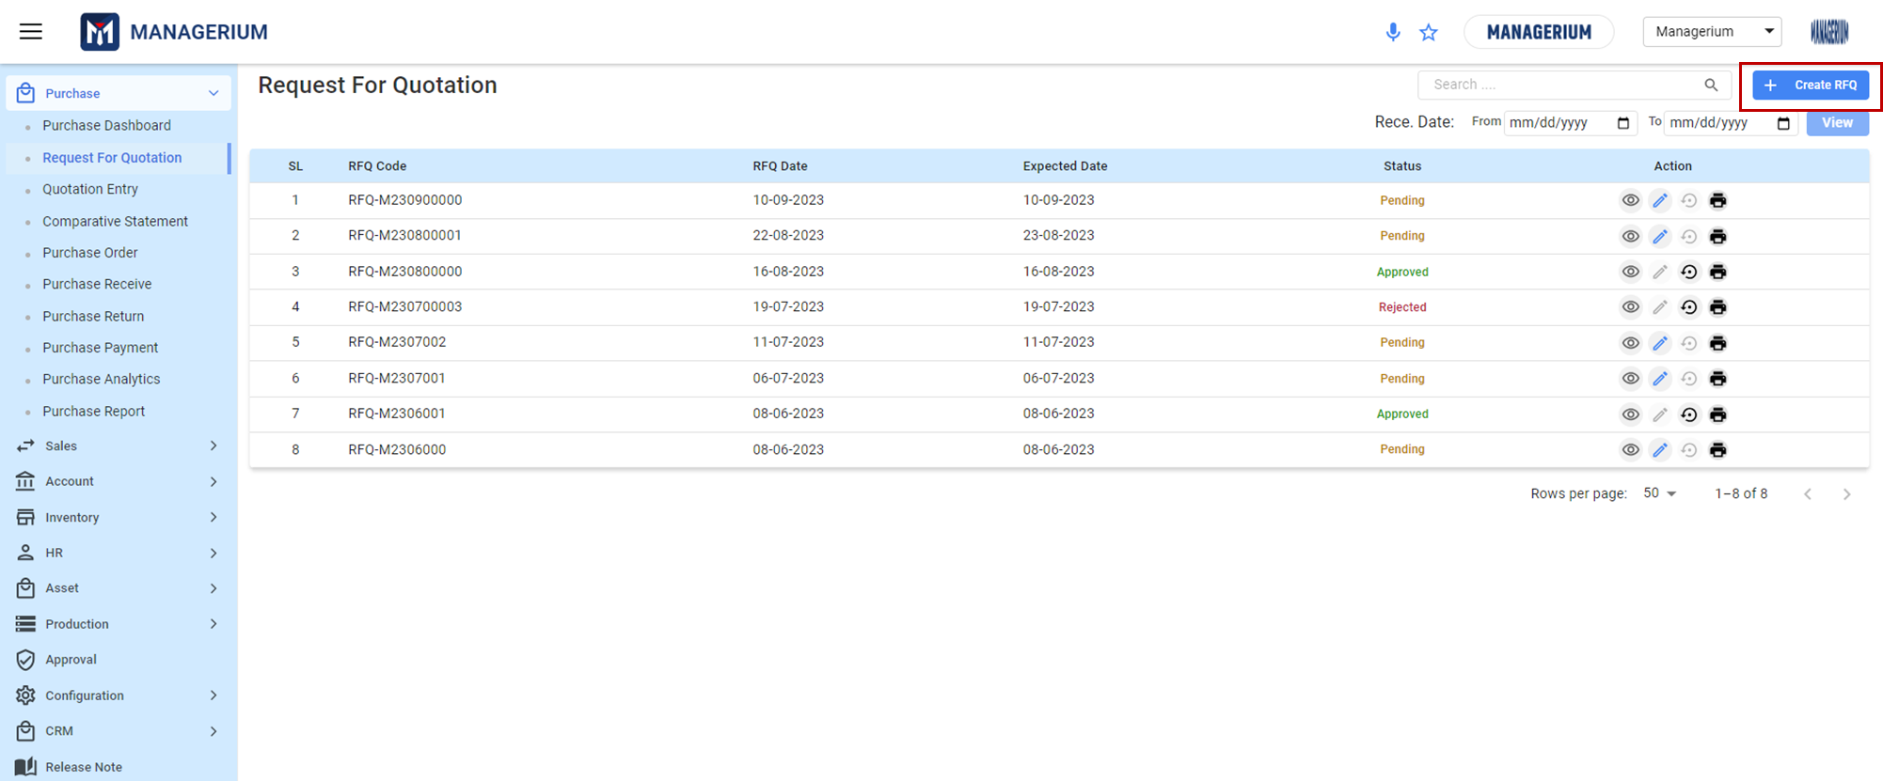

**Features:**

* **Search Bar:** At the top, there's a search bar. Input keywords to search for specific RFQs.
* **Create RFQ Button:** Located on the top right. Clicking this will direct users to the RFQ creation page.
* **Date Filter:** Filter RFQs based on their receipt date range.
* **View Toggle:** Adjust the displayed RFQs per page.
* **Table View:** Lists all RFQs with relevant details:
  + ***SL:*** Serial number.
  + ***RFQ Code:*** Unique code for each RFQ.
  + ***RFQ Date:*** Date when the RFQ was created.
  + ***Expected Date:***Date by which the quotation is expected.
  + ***Status:*** Shows the current status (e.g., Pending, Approved, Rejected).
  + ***Action:*** Icons to view, edit, print or reverse the RFQ.

Click the **"Create RFQ"** Button on the top right of the RFQ Listings page.

### 

### 

### ***1.2.1 Creating a New RFQ:***

**User Interface [Create RFQ]:**

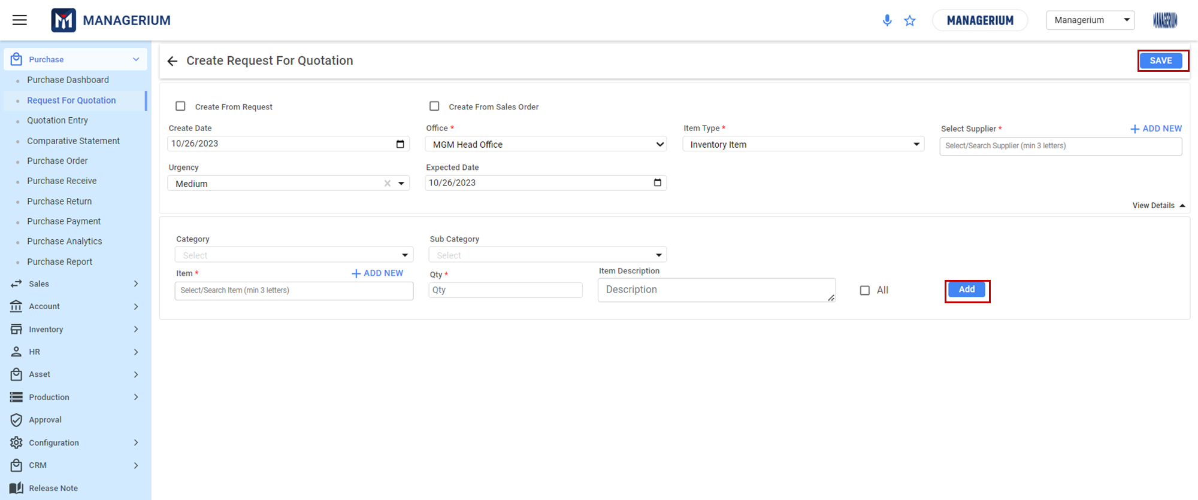

***Steps:***

* **Option Selection:**
* **Create From Request:** Select if the RFQ is based on a prior request.
* **Create From Sales Order:** Choose this if the RFQ originates from a sales order.
* **RFQ Details:**
* **Office:** Select the relevant office from the dropdown.
* **Urgency:** Specify the urgency level (e.g., Medium).
* **Create Date:** Automatically captures the current date but can be adjusted.
* **Expected Date:** Choose the expected response date from the calendar picker.
* **Item Details:**
* **Item Type:** Specify the type (e.g., Inventory Item).
* **Select Supplier:** Choose the supplier from the dropdown or add a new one.
* **Category & Sub Category:** Classify the item by selecting appropriate categories.
* **Item:** Start typing to search for the item. Must input a minimum of 3 letters for suggestions.
* **Qty:** Input the quantity required.
* **Item Description:** Describe the item in detail, if necessary.
* **Add Multiple Items:** By clicking on **"+ ADD NEW,"** users can input details for multiple items in one RFQ.

Once all details are filled in, click on the **"SAVE"** button at the top right corner to create the RFQ.

**\*\*\* After saving, the status of the quotation will automatically show as "Pending." The quotation remains in the "Pending" state until it's either "Approved" or "Rejected."**

## 

## 1.3 Quotation Entry

This feature is a dedicated section designed to help users record and manage the quotations received from various suppliers. The quotations can be related to products or services required by the organization.  
  
**Menu Path:**  Purchase (Module) > Quotation Entry

The user will see a landing page after clicking the **"Quotation Entry"** feature.

**User Interface [Landing] :**

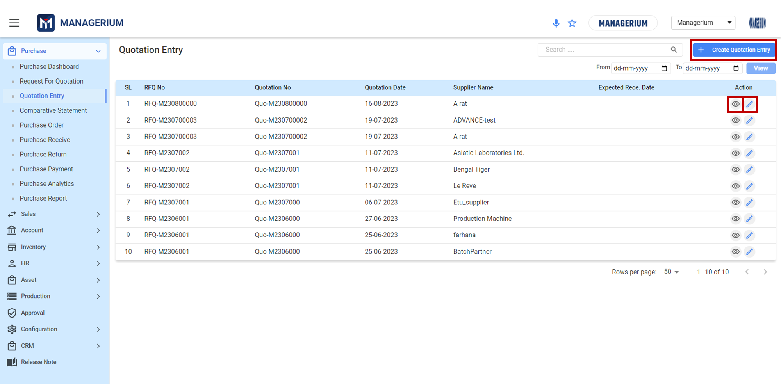

**Features:**

* **Viewing Saved Quotations:**
  + The main screen of Quotation Entry displays a list of all saved quotations.
  + Each entry shows the RFQ No., Quotation No., Quotation Date, Supplier Name, and Expected Receive Date.
  + Actions for each quotation are located on the rightmost column, represented by icons to edit, and view.
* **Searching for Quotations:**
  + Use the search bar at the top to input specific terms or details.
  + users can filter users search by date by selecting a range using the From and To date pickers. Click View after setting the range.
* **Creating a New Quotation:**
  + Click on the +**Create Quotation Entry** button located at the top right corner.

**User Interface [**+**Create Quotation Entry] :**

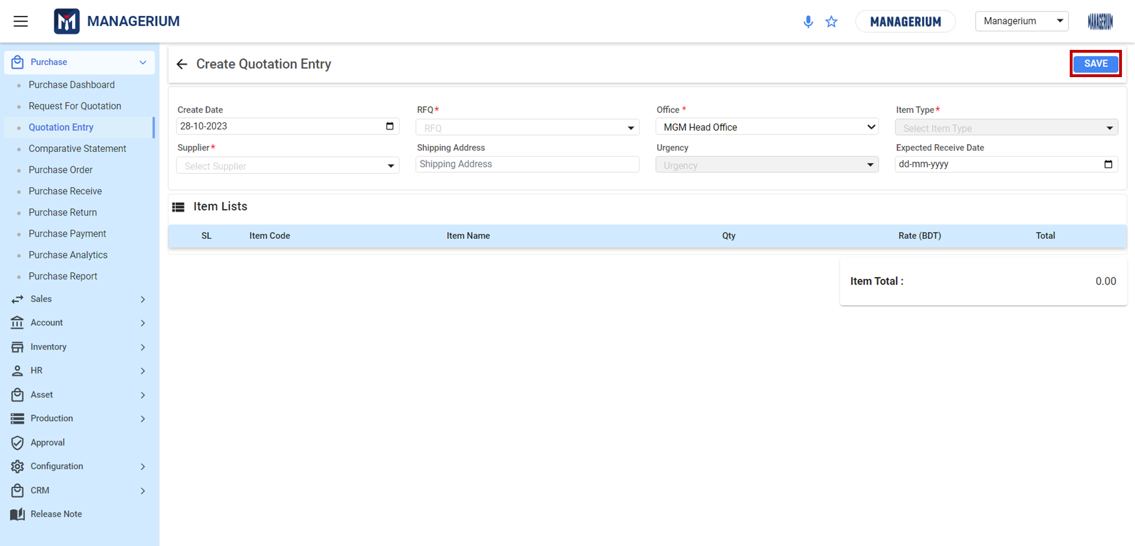

### 

### ***1.3.1 Creating a New RFQ:***

***Steps:***

### **Filling Out Quotation Details:**

* **Create Date:** This field will automatically display the current date. Ensure it represents the date the quotation is being created.
* **Supplier:** Click on the dropdown arrow and select the appropriate supplier from the list. This is a mandatory field (indicated by *).
* **RFQ:** If the quotation corresponds to an approved Request for Quotation, check the box and select the RFQ number.
* **Office:** Click on the dropdown arrow next to the 'Office' field. Select the office location for which the quotation is being made. This is a mandatory field (indicated by *).
* **Item Type:** Select the type of item being quoted from the dropdown menu. This is a mandatory field (indicated by *).
* **Shipping Address:** Enter the address to which the items should be shipped once the order is confirmed.
* **Urgency:** Indicate the priority or urgency level for this quotation by selecting from the dropdown list.
* **Expected Received Date:** Choose the date users expect to receive the quoted items. Use the date picker (calendar icon) to assist in selecting the date.

Once all details are filled in, click on the **"SAVE"** button at the top right corner to create the RFQ.

## 

## 1.4 Comparative Statement

Comparative Statement displays various RFQs (Request For Quotation) and their associated details, including responses from suppliers. By combining RFQs and supplier responses, users can quickly compare, evaluate, and track quotations they receive, ensuring informed decisions.

## Menu Path: Purchase (Module) > Comparative Statement

The user will see a landing page after clicking the **"Comparative Statement"** feature.

**User Interface [Landing] :**

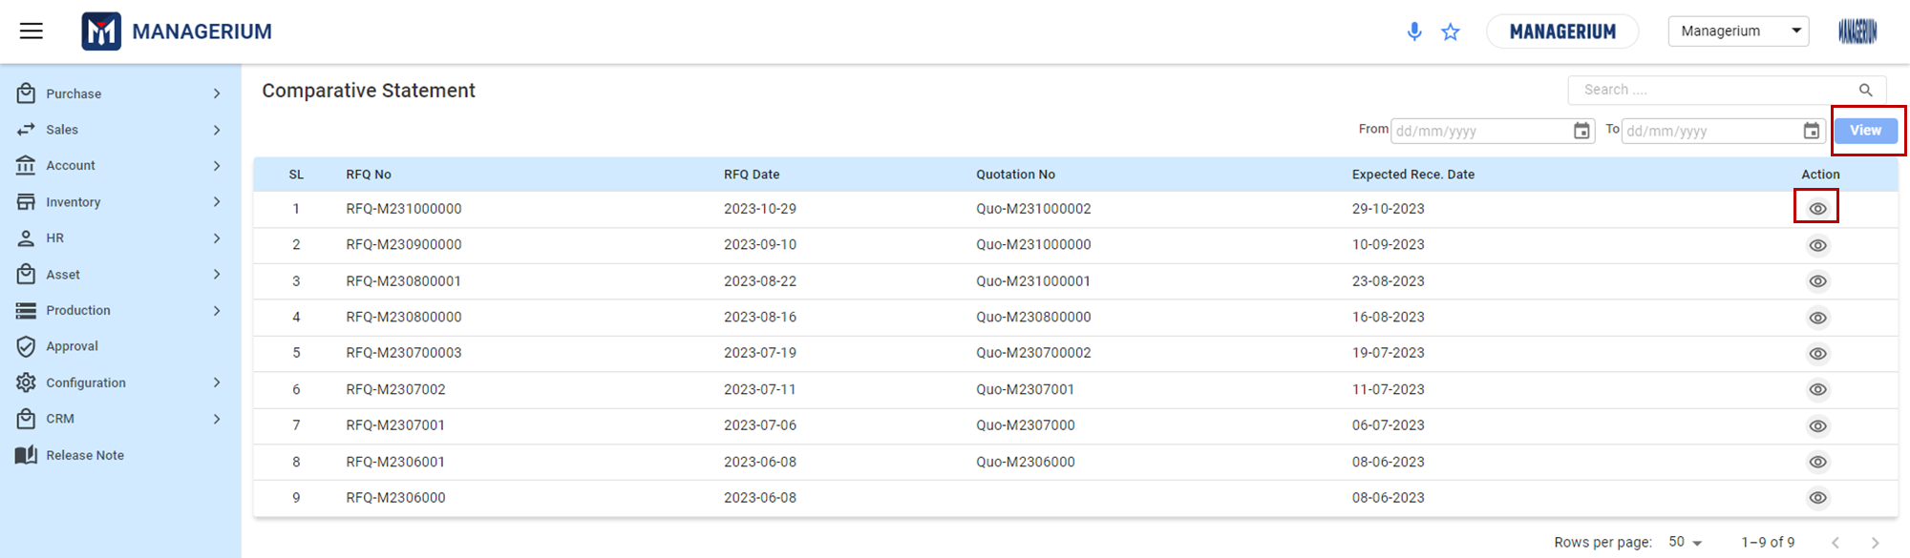

**Features:**

**RFQ Table:**

* This table showcases a list of RFQs with the following columns:
  + **SL:** Serial number for referencing.
  + **RFQ No:** The unique number assigned to each RFQ.
  + **RFQ Date:** The date when the RFQ was generated or received.
  + **Quotation No:** The unique number assigned to the quotation linked with the RFQ.
  + **Expected Rece. Date:** The date on which the quotation or item is expected to be received.
  + **Action:** That allows users to view more details related to the RFQ.

**Filtering and Viewing Options:**

* Use the search bar at the top right to quickly find specific RFQs.
* Adjust the "From" and "To" date fields to filter RFQs based on a specific date range, then click on "View" to apply the filter.
* At the bottom right of the table, set the "Rows per page" option to display a preferred number of RFQs per page.
* Use the navigation arrows at the bottom right to move between pages.

**Actions on RFQs:**

* Clicking on the action icons/buttons beside each RFQ will allow users to:
  + View detailed information about the RFQ.
  + Regularly review the comparative statement to keep track of all usersr quotations and their statuses.
  + Use the search and filter functions effectively to quickly find and manage RFQs.
  + Ensure accurate data entry to maintain the reliability of the comparative statement.

**User Interface [View Comparative Statement]:**

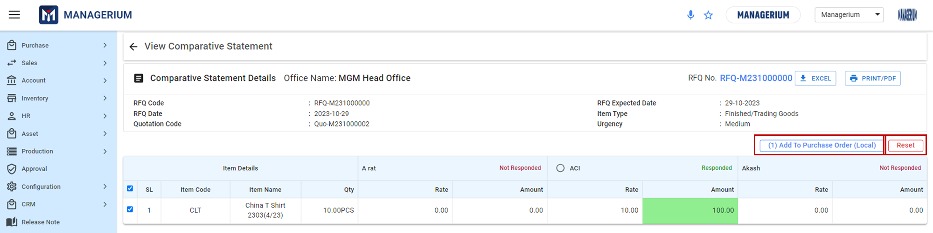

### ***1.4.1 View and Add to PO:***

***Steps:***

**RFQ Details:** This section provides primary details about the selected RFQ:

* + **RFQ Code:** Unique identification number for the RFQ.
  + **RFQ Date:** Date when the RFQ was created.
  + **Quotation Code:** Unique identification for the quotation associated with the RFQ.
  + **RFQ Expected Date:** The expected date by which the RFQ needs a response.
  + **Item Type:** The category of the item, e.g., Finished/Trading Goods.
  + **Urgency:** Priority level of the RFQ, e.g., Medium.
  + **Office Name:** Specifies from which office the RFQ has originated.
  + **Export and Print Options:** At the top right corner, users have options to export the RFQ data into an Excel sheet or print/PDF it.

**Item Details Section:**

* **Item Code:** A unique identification number or code for the item in question.
* **Item Name:** Description or name of the productQty: Specifies the quantity of the product requested in the RFQ.
* **Rate & Amount Columns:** These columns show the rates quoted by different suppliers and the total amount for the given quantity. If two suppliers have provided their rates,their column will display **'Responded'**. If a supplier hasn't responded, their column will display **'Not Responded'.**

**Actions:**

* **Add To Purchase Order (Local):** Once users have reviewed and decided on a supplier's quote, users can directly add it to a local purchase order by clicking this button.That will take the user to the **Purchase Order** Menu.
* **Reset:** This button allows the user to clear any selections or inputted data on the page to its default state.

***\*\*\* Users Can Directly Create Purchase Order from Purchase Module Without RFQ.***

## 1.5 Purchase Order

Purchase Order is a commercial source document that includes types, quantity and price of the goods that needs to be purchased. User can create two types of Purchase Order –

* Local
* Foreign and Intending

**Features:**

**Tabs:**

* + **LOCAL PO:** Displays the list of purchase orders created for local suppliers.
  + **FOREIGN PO & INDENTING PO:** Other tabs for different types of purchase orders, not detailed in this section.
* **Office Dropdown:** Allows filtering of purchase orders based on the originating office.
* **Date Range Filter:** Users can filter purchase orders based on a specific date range using the 'From' and 'To' date pickers.
* **Search Bar:** Enables users to search for specific purchase orders using keywords or PO numbers.
* **Create Local/ Foreign /Intending Order Button:** Located at the top right, this button allows users to initiate and create a new purchase order.

**Purchase Order Table:**

This table displays a list of all the local purchase orders with the following columns:

* **SL:** Serial number for easy referencing.
* **PO Date:** Date when the purchase order was created.
* **Rece. Date:** Expected or scheduled receipt date for the ordered items.
* **PO No:** Unique identification number assigned to each purchase order.
* **Supplier:** Name of the supplier from whom the items are being purchased.
* **Amount (BDT):** Total amount for the order in Bangladeshi Taka.
* **Status:** Current status of the purchase order, e.g., Pending, Approved.
* **Action:** This column provides various action buttons:
  + ***Edit (Pencil Icon):*** Allows modification of the purchase order details.
  + ***Delete (Trash Icon):*** Permanently removes the purchase order from the system.
  + ***View (Eye Icon):*** Enables users to view in-depth details of the purchase order.
  + ***Other Icons:*** Depending on the software's features, there might be additional action icons for tasks like printing, and reversing the order.

### ***1.5.1 Local Purchase***

The 'Purchase Order' page provides a consolidated view of all the **Local PO** created within the system. This enables users to efficiently track, manage, and act on each order based on its status and details.

**Menu Path:**  Purchase (Module)> Purchase Order> Local PO> Create Local PO

**User Interface [Local PO Landing] :**

## 

***Steps:***

**Tabs:**

* + **LOCAL PO:** Displays the list of purchase orders created for local suppliers.
  + **FOREIGN PO & INDENTING PO:** Other tabs for different types of purchase orders,are not detailed in this section.
* **Office Dropdown:** Allows filtering of purchase orders based on the originating office.
* **Date Range Filter:** Users can filter purchase orders based on a specific date range using the 'From' and 'To' date pickers.
* **Search Bar:** Enables users to search for specific purchase orders using keywords or PO numbers.
* **Create Local Order Button:** Located at the top right, this button allows users to initiate and create a new local purchase order.

**Purchase Order Table (Local):**

This table displays a list of all the local purchase orders with the following columns:

* **SL:** Serial number for easy referencing.
* **PO Date:** Date when the purchase order was created.
* **Rece. Date:** Expected or scheduled receive date for the ordered items.
* **PO No:** Unique identification number assigned to each purchase order.
* **Supplier:** Name of the supplier from whom the items are being purchased.
* **Amount (BDT):** Total amount for the order in Bangladeshi Taka.
* **Status:** Current status of the purchase orders.
* **Action:** This column provides various action buttons:
  + ***Edit (Pencil Icon):*** Allows modification of the purchase order details.
  + ***View (Eye Icon):*** Enables users to view in-depth details of the purchase order.
  + ***Print (Icon):*** Allows user to print the PO details
  + ***Reverse (Icon):***  Allows users to reverse the PO and send for approval again.

**Filtering and Viewing Options:**

* Use the 'Search' bar at the top right to quickly find specific POs by their attributes.
* Filter the POs by date using the 'From' and 'To' date picker fields.
* Select an 'Office' from the dropdown to view POs specific to that location.

### ***1.5.2 Creating a Local Purchase Order:***

**User Interface [**+**Create Local PO] :**

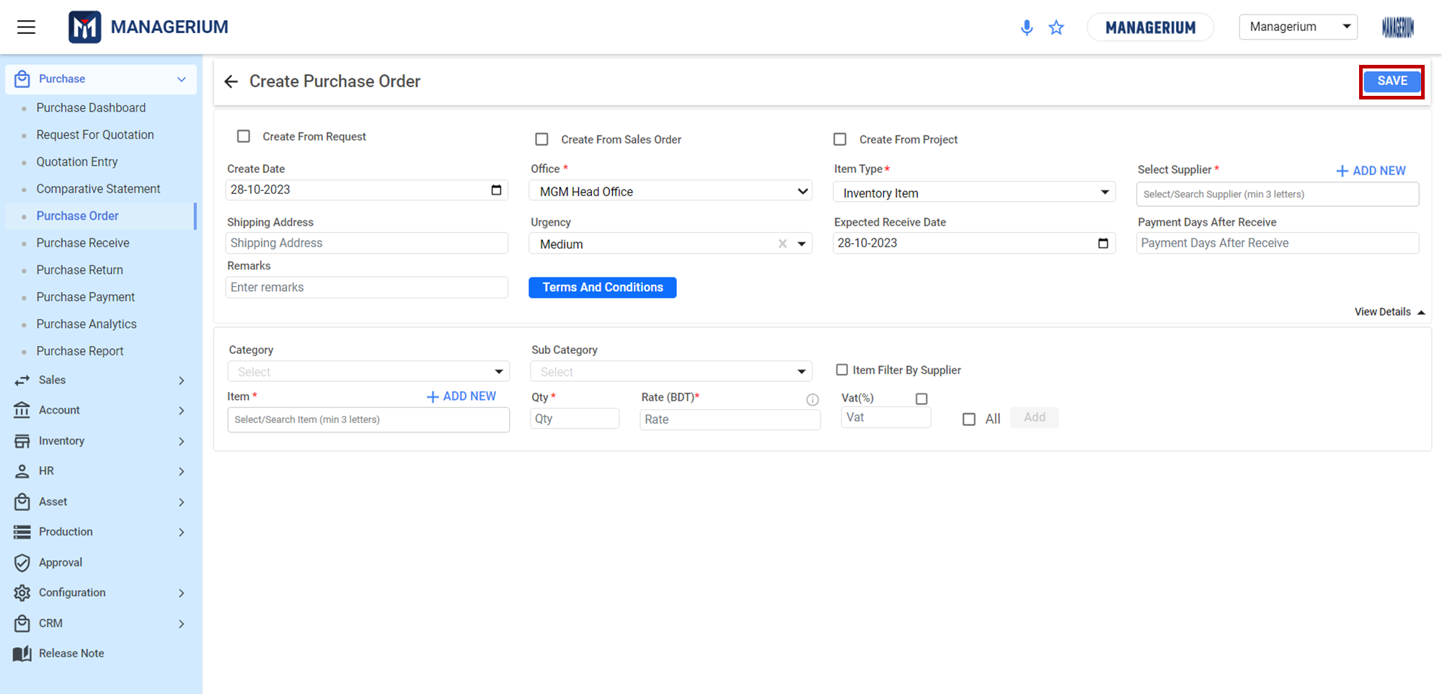

**Setting Up Order Details:**

* **Create from Options:** Choose how users would like to initiate the purchase order. Options available:
  + Create From Request [Inventory > Item Request]
  + Create From Sales Order [Sales > Sales Order]
  + Create From Project [Accounting > Project Accounting]
* **Date Details:**
  + **Create Date:** The date on which the purchase order is being created.
  + **Expected Received Date:** Select the date users anticipate to receive the order.
* **Supplier Details:**
  + **Select Supplier:** Search and select the supplier users wish to place the order with. If the supplier doesn't exist, click on '+ ADD NEW' to add a new supplier.
* **Shipping Details:**
  + **Shipping Address:** Input the desired shipping address for the order delivery.
  + **Office:** Choose the office location users are ordering from.
  + **Urgency:** Select the urgency of the delivery; options might include Low, Medium, High, etc.
* **Item Details:**
  + **Category:** Choose the category of the item, e.g., 'Clothes'.
  + **Sub Category:** Define the sub-category, e.g., 'Menswear'.
  + **Item:** Search and select the item users wish to order.
  + **Qty:** Input the quantity of the item being ordered.
  + **Rate (BDT):** Specify the rate at which users are purchasing the item.
  + **VAT (%):** Input the VAT percentage for the item.We can insert VAT amount by TK.
* **Order Summary Table:**
  + This table will dynamically display the items added to the purchase order, showing details like item code, name, quantity, rate, VAT, and the total price. users can add multiple items and view the cumulative total.
* **Order Total:**
  + At the bottom right of the screen, users will see the breakdown of users order's total cost, including the item total, discount, and post-discount total.
  + Choose users method of advance payment, if any: Cash or Bank.

* **Additional Features:**
* **Remarks:** Add any additional comments or specifications for users order.
* **Terms and Conditions:** Click this button to view or specify the terms and conditions related to this purchase order.
* **Item Filter By Supplier:** An optional feature to filter items available from a specific supplier.
* **View Details:** Click on this for a comprehensive view or to make changes to the order details.
* **Saving the Purchase Order:**
* Once all details are filled out and users have verified the information, click on the **'SAVE'** button located at the top right corner of the screen.

**\*\*\* Once the Purchase order received the impact on Approved PO [ Local PO] status changes as the Purchase Received fully/partially done to ‘Completed’.**

### ***1.5.3 Foreign Purchase Order:***

The 'Purchase Order' page provides a consolidated view of all the **Foreign PO** created within the system. This enables users to efficiently track, manage, and act on each order based on its status and details.

**Menu Path:**  Purchase (Module)> Purchase Order> Foreign PO> Create Foreign PO

**User Interface [Foreign PO Landing]:**

## 

**Purchase Order Table (Foreign):**

This table displays a list of all the local purchase orders with the following columns:

* **SL:** Serial number for easy referencing.
* **PO Date:** Date when the purchase order was created.
* **Rece. Date:** Expected or scheduled receipt date for the ordered items.
* **PO No:** Unique identification number assigned to each purchase order.
* **Supplier:** Name of the supplier from whom the items are being purchased.
* **Amount (BDT):** Total amount for the order in Bangladeshi Taka including separator ‘**|**’ in exchange amount.
* **Status:** Current status of the purchase orders.
* **Action:** This column provides various action buttons:
  + ***Edit (Pencil Icon):*** Allows modification of the purchase order details.
  + ***View (Eye Icon):*** Enables users to view in-depth details of the purchase order.
  + ***Print (Icon):*** Allows user to print the PO details
  + ***Reverse (Icon):***  Allows users to reverse the PO and send for approval again.

**Filtering and Viewing Options:**

* Use the 'Search' bar at the top right to quickly find specific POs by their attributes.
* Filter the POs by date using the 'From' and 'To' date picker fields.
* Select an 'Office' from the dropdown to view POs specific to that location.

### ***1.5.4 Creating a Foreign Purchase Order:***

**User Interface [**+**Create Foreign PO]:**

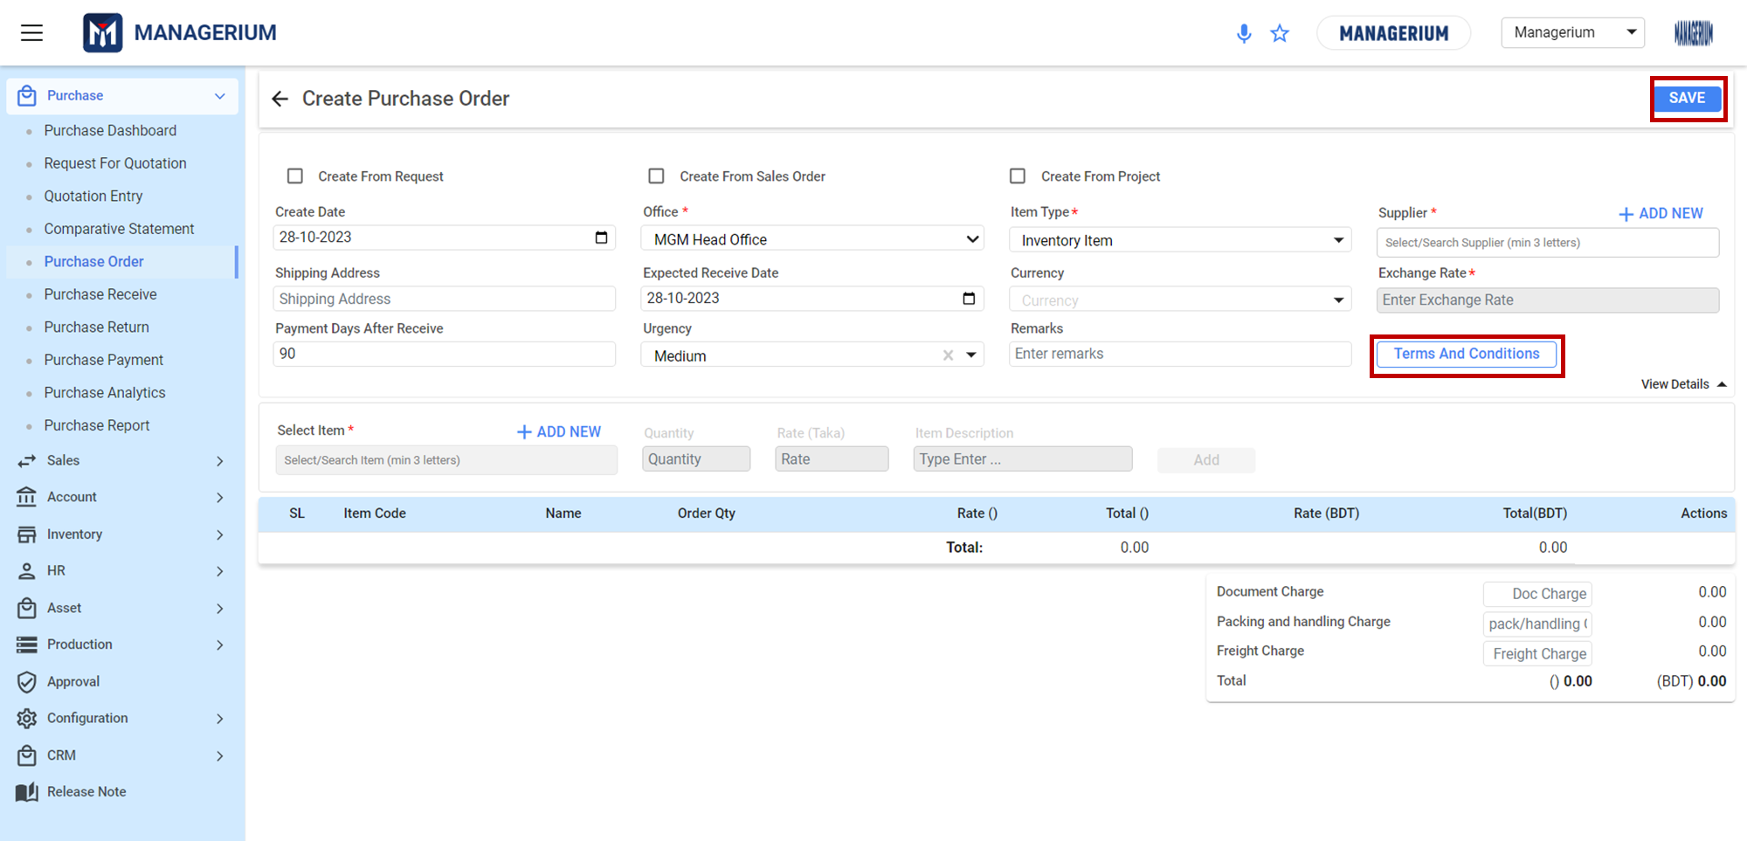

#### Create from Options:

Choose how users will like to initiate the purchase order. Options available:

* Create From Request [Inventory > Item Request]
* Create From Sales Order [Sales > Sales Order]
* Create From Project [Accounting > Project Accounting]

#### Date Details:

* **Create Date:** The date on which the purchase order is being created.
* **Expected Receive Date:** Select the date users anticipate to receive the order.

#### Supplier Details:

* **Select Supplier:** Search and select the supplier users wish to place the order with. If the supplier doesn't exist, click on **'+ ADD NEW**' to add a new supplier.

#### Shipping Details:

* **Shipping Address:** Input the desired shipping address for the order delivery.
* **Office:** Choose the office location users are ordering from.
* **Urgency:** Select the urgency of the delivery; options might include Low, Medium, High, etc.

#### Currency Details:

* **Currency:** Choose the foreign currency for the order, e.g., 'TRY (Turkish Lira)'.
* **Exchange Rate:** Specify the current exchange rate for the selected currency.

#### Item Details:

* **Item:** Search and select the item users wish to order.
* **Qty:** Input the quantity of the item being ordered.
* **Rate (CURRENCY):** Specify the rate in foreign currency at which users are purchasing the item.
* **Rate (BDT):** The system will automatically calculate the rate in local currency based on the specified exchange rate.

#### Order Summary Table:

This table will dynamically display the items added to the purchase order, showing details like item code, name, quantity, rate (in both CURRENCY and BDT), and the total price. users can add multiple items and view the cumulative total.

#### Order Total:

At the bottom right of the screen, users will see the breakdown of usersr order's total cost, including the item total, any additional charges like document, packing, and freight charges, and the total in both currencies.

### **Additional Features:**

* ***Remarks:*** Add any additional comments or specifications for users order.
* ***Terms and Conditions:*** Click this button to view or specify the terms and conditions related to this purchase order.

**[Terms and Conditions]:**

Before entering shipment details, be aware of the overarching terms and conditions that govern the Foreign PO. These define the foundational agreements between the buyer and the seller.

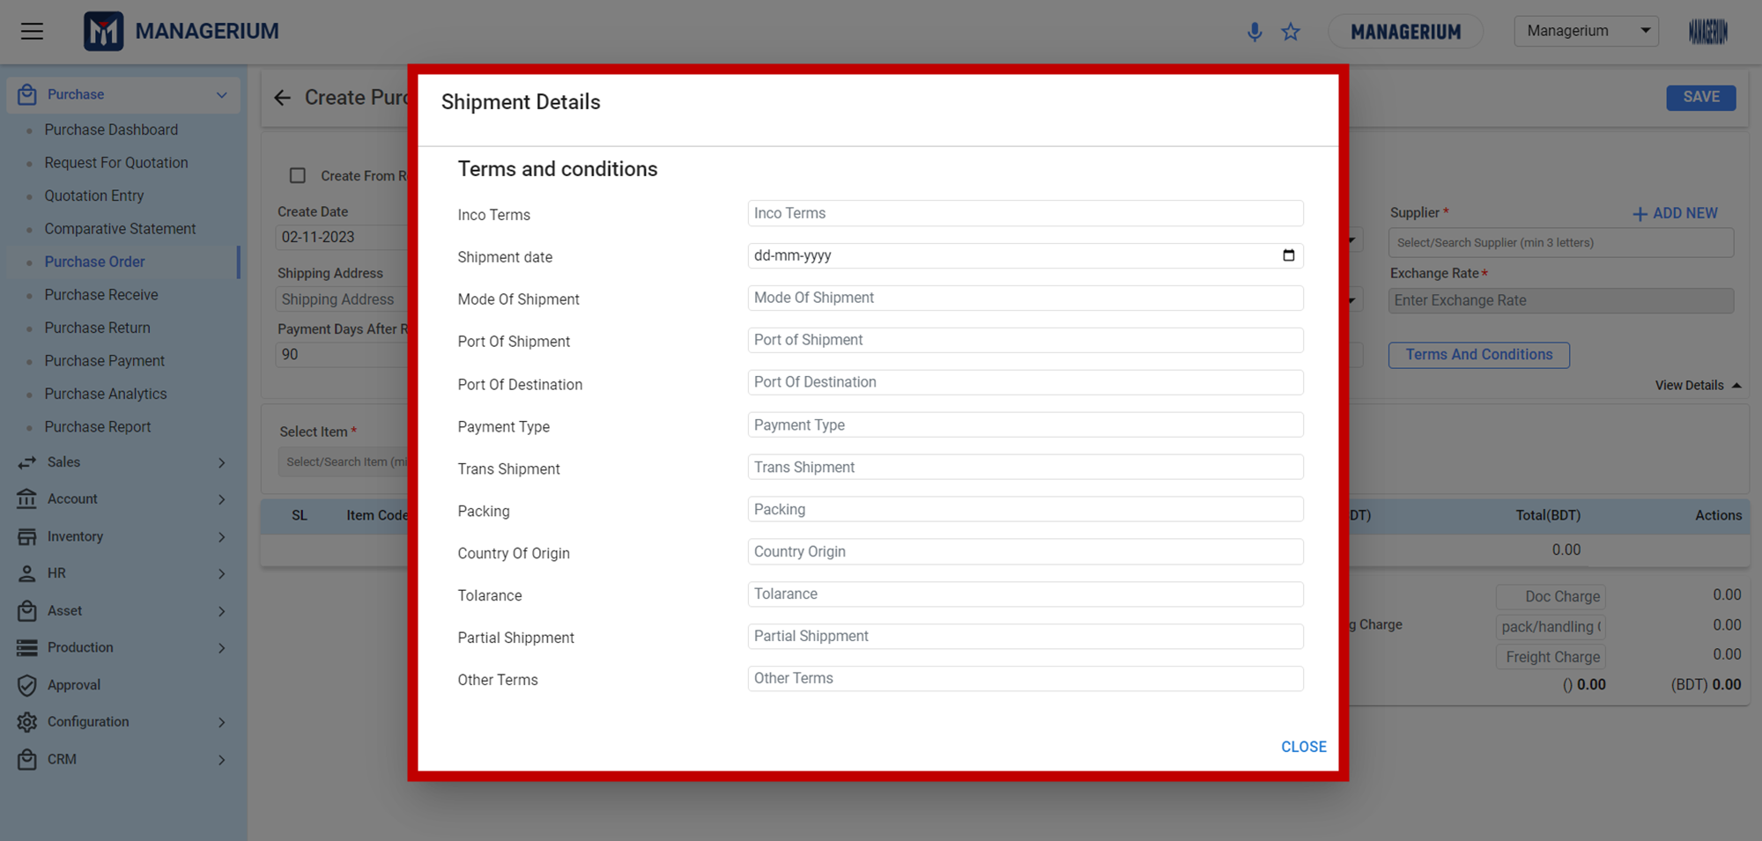

* ***Inco Terms:***
  + Definition: International Commercial Terms that specify who is responsible for the payment of the freight, and insurance and specifies when the risk of the goods transfer from the seller to the buyer.
  + Input: Select from a dropdown list of standard Inco Terms (e.g., EXW, FOB, CIF).
* ***Shipment Date:***
  + Definition: The anticipated date the shipment will depart from the origin.
  + Input: Enter the date in the format dd-mm-yyyy.
* ***Mode Of Shipment:***
  + Definition:: The method by which the goods will be transported.
  + Input: Select from options like Air, Sea, Rail, or Road.
* ***Port Of Shipment:***
  + Definition:: The port from where the goods will be shipped.
  + Input: Type in or select the specific port name.
* ***Port Of Destination:***
  + Definition: The port where the goods will be received.
  + Input: Type in or select the destination port name.
* ***Payment Type:***
  + Definition: Method agreed upon for payment of the shipment.
  + Input: Choose from options such as Letter of Credit, Bank Transfer, etc.
* ***Trans Shipment:***
  + Definition: Whether goods will be transferred from one vessel or vehicle to another during transit.
  + Input: Choose 'Yes' if trans shipment is allowed, 'No' if not.
* ***Packing:***
  + Definition: Details about how goods are packed for shipment.
  + Input: Provide information about the type of packing, e.g., crates, boxes, or containers.
* ***Country Of Origin:***
  + Definition: The country where the goods were produced or manufactured.
  + Input: Select the relevant country from a dropdown list.
* ***Tolerance:***
  + Definition: The allowable deviation, usually in percentage, from the ordered quantity that is still acceptable to the buyer.
  + Input: Specify the tolerance percentage or amount.
* ***Partial Shipment:***
  + Definition: Whether shipment of only part of the goods is allowed before the full order is complete.
  + Input: Choose 'Yes' if partial shipment is acceptable, 'No' if not.
* ***Other Terms:***
  + Definition: Any additional terms or conditions agreed upon between the buyer and seller that don't fit in the other categories.
  + Input: Type in any other specific terms or agreements.
* **View Details:** Click on this for a comprehensive view or to make changes to the order details.

### **Saving the Purchase Order:**

Once all details are filled out and users have verified the information, click on the **'SAVE'** button located at the top right corner of the screen.

**\*\*\* Once the Foreign PO gets approved, the user can +Create Shipment,update the PI/PO details from the view icon.**

#### 1.5.4.1 Create New Shipment for a Foreign PO:

It provides instructions to initiate the shipment process and update Proforma Invoice (PI) or Purchase Order (PO) details.

##### User Interface [Create New Shipment for a Foreign PO] :

**STEP: 1 Create New Shipment**

#### 

#### Verify PO Approval

Before proceeding with the shipment creation, confirm that the Foreign PO status is marked as **"Approved”** and **“Shipment Not Created"** .

#### Accessing the PO Details

Locate the approved Foreign PO in the system. Use the "View" icon (represented by an eye symbol) to open the detailed view of the order.

#### Initiate Shipment Creation

Once the detailed PO view is open, look for the **"Create New Shipment"** button. This is typically located towards the bottom-right section of the screen within the PO details page. Once inside the PO details, navigate to the section labeled "Foreign Other Charge Conditions."

**STEP: 2 Other Foreign Charge Conditions**

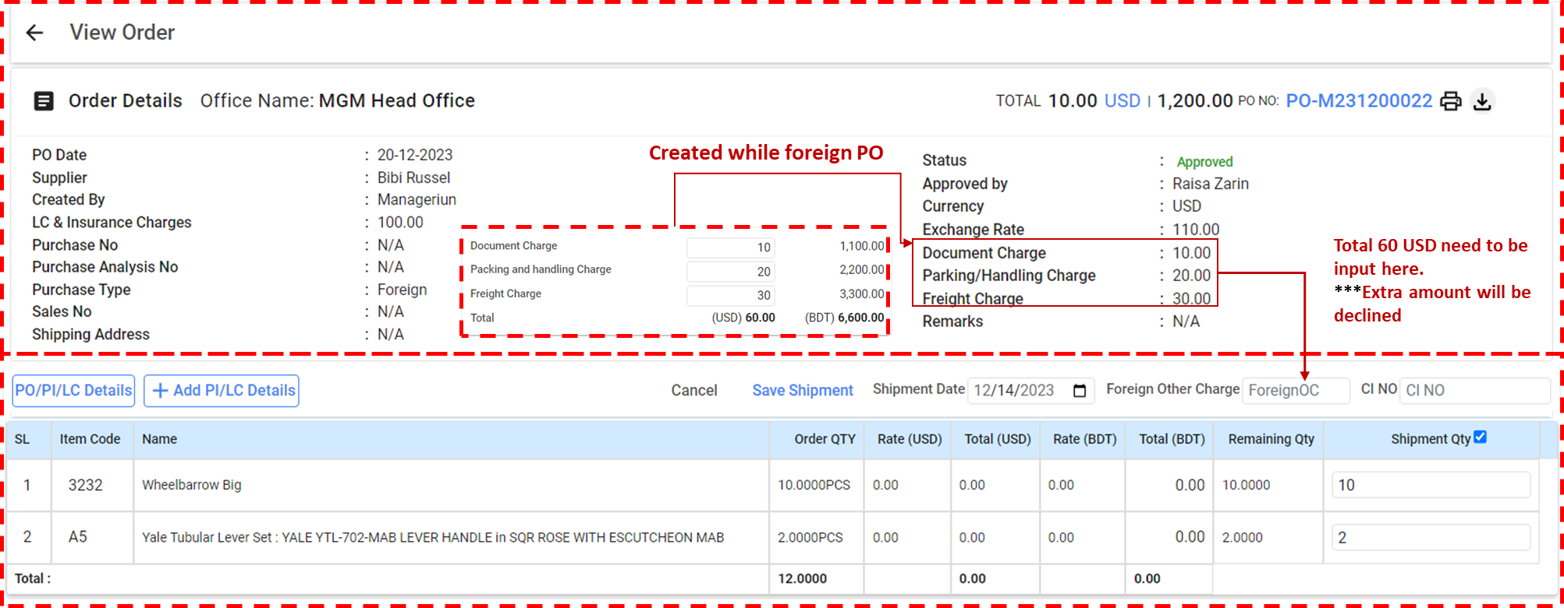

#### Inputting Charges

* In the Document Charge field, enter the applicable amount for processing the documents related to the purchase. This is typically a fixed fee.
* For Packing and Handling Charge, input the cost associated with packing and handling of the order for shipment.
* Enter the cost incurred for transporting the goods in the Freight Charge field.

#### Reviewing Total Charges

* The system will automatically calculate the total foreign charge in USD and the equivalent in the local currency (BDT in this example), based on the individual charges entered.
* Verify the Total (USD) and Total (BDT) fields to ensure the cumulative charge is correct.  
  **\*\*\* Note:** The system will only accept the total amount of (Document Charge + Parking/Handling Charge + Freight Charge) for these charges. Any amount entered beyond this will be declined.

#### Saving the Charge Conditions

* Review all entered details for accuracy.
* Once you have confirmed that all charge amounts are correct and the total charge matches the approved amount,(as example 60 USD), click on the **"Save Shipment"** button to record these charges with the PO.
* Ensure that you have also entered or confirmed the Shipment Date as necessary.

**STEP: 2 Other Foreign Charge Conditions**

### 1.5.5 Intending Purchase

The 'Purchase Order' page provides a consolidated view of all the **Intending PO** created within the system. This enables users to efficiently track, manage, and act on each order based on its status and details.

**Menu Path:**  Purchase (Module)> Purchase Order> Intending PO> Create Intending PO

**User Interface**  **Intending PO Landing] :**

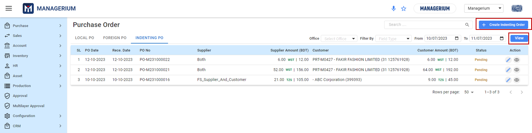

**Purchase Order Table (Intending):**This table displays a list of all the intending purchase orders with the following columns:

* **SL:** Serial number of the purchase orders listed.
* **PO Date:** The date when the purchase order was issued.
* **Rece. Date:** The expected receiving date of the goods or services.
* **PO No:** Unique Purchase Order number.
* **Supplier:** The name of the supplier from whom the goods or services are being purchased.
* **Supplier Amount (BDT):** The total amount to be paid to the supplier, listed in Bangladeshi Taka (BDT) including separator ‘**|**’ in exchange amount.
* .
* **Customer:** The name of the customer for whom the purchase order is intended.
* **Customer Amount (BDT):** The total amount billed to the customer, in Bangladeshi Taka (BDT).
* **Status:** Current status of the PO, such as 'Pending'.
* **Action:** Icons allowing users to perform actions like edit, view, or delete the PO.

**Filtering and Viewing Options:**

* Use the 'Search' bar at the top right to quickly find specific POs by their attributes.
* Filter the POs by date using the 'From' and 'To' date picker fields.
* Select an 'Office' from the dropdown to view POs specific to that location.

### ***1.5.6 Creating an Intending Purchase Order:***

##### User Interface [+Create Intending PO] :

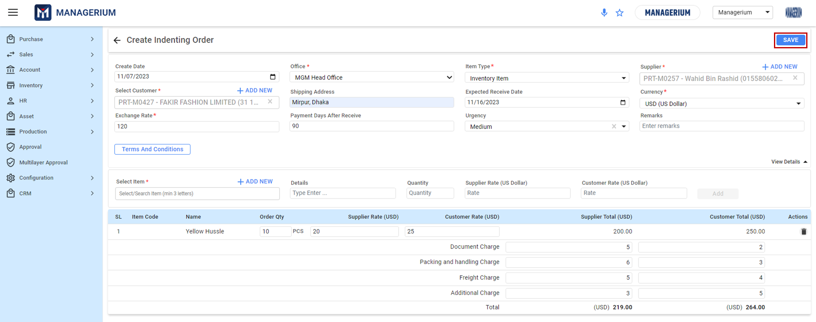

#### Create from Options:

Choose how users would like to initiate the purchase order. Options available:

* Create From Request [Inventory > Item Request]
* Create From Sales Order [Sales > Sales Order]
* Create From Project [Accounting > Project Accounting]

#### Date Details:

* **Create Date:** The date on which the purchase order is being created.
* **Expected Receive Date:** Select the date users anticipate to receive the order.

#### Supplier Details:

* **Select Supplier:** Search and select the supplier users wish to place the order with. If the supplier doesn't exist, click on **'+ ADD NEW**' to add a new supplier.

#### Shipping Details:

* **Shipping Address:** Input the desired shipping address for the order delivery.
* **Office:** Choose the office location users're ordering from.
* **Urgency:** Select the urgency of the delivery; options might include Low, Medium, High, etc.

#### Currency Details:

* **Currency:** Choose the foreign currency for the order, e.g., 'TRY (Turkish Lira)'.
* **Exchange Rate:** Specify the current exchange rate for the selected currency.

#### Item Details:

* **Item:** Search and select the item users wish to order.
* **Qty:** Input the quantity of the item being ordered.
* **Rate (CURRENCY):** Specify the rate in foreign currency at which users are purchasing the item.
* **Rate (BDT):** The system will automatically calculate the rate in local currency based on the specified exchange rate.

#### Order Summary Table:

This table will dynamically display the items added to the purchase order, showing details like item code, name, quantity, rate (in both CURRENCY and BDT), and the total price. users can add multiple items and view the cumulative total.

#### Order Total:

At the bottom right of the screen, users will see the breakdown of the user's total cost, including the item total, any additional charges like document, packing, and freight charges, and the grand total in both currencies.

### **Additional Features:**

* ***Remarks:*** Add any additional comments or specifications for users order.
* ***Terms and Conditions:*** Click this button to view or specify the terms and conditions related to this purchase order.

**[Terms and Conditions]: The same as before.**

### **Saving the Purchase Order:**

Once all details are filled out and users have verified the information, click on the **'SAVE'** button located at the top right corner of the screen.

### 1.5.7 Purchase Method :

[Farha Jabin Oyshee](mailto:oyshee@ibos.io)

**User Interface of Purchase Method**

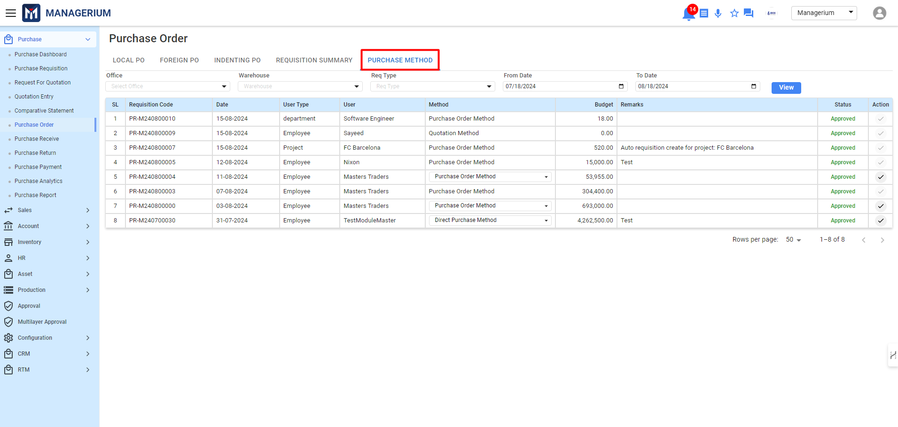

* **Office:** Choose the office location user has requested from.
* **Warehouse:** Choose the warehouse in which order will be received.
* **Req Type:** Consisting of Three types:

1. **Employee**
2. **Department**
3. **Project**

* **From Date & To Date:** Date Range for the mentioned order method

#### Landing Page details:

* **SL:** Serial Number of Purchase Requisition.
* **Requisition Code:** Code that is generated from purchase requisition tab.
* **User Type:** Mentioned Used for which the requisition is being created.
* **User:** User who has requested for the requisition.
* **Method:** Here are four types of Purchase method:

1. **Purchase Order Method**
2. **Quotation Method**
3. **Direct Purchase Method**
4. **Direct Issue**

[Method Can be changed until it is directed for further use. Once the further

task is taken, it will not be reversable.]

* **Budget:** The estimated cost for the requisition items.
* **Remaks**: Any notable mentioned words will be displayed here.
* **Status**: Requisition Approval status
* **Action**: The mentioned method will be updated in the Action tab.

## 1.6 Purchase Receive

Purchase Receive confirms that the items on a purchase order have been delivered. This is an essential step for keeping track of stock, managing finances, and preparing to pay for the goods .This process is essential for inventory control, accounting, and payment processing.

**Menu Path:**  **Purchase (Module)> Purchase Receive> Approved PO/Received PO**

**Features:**

**Tabs:**

* + **Approved PO:** Displays the list of approved purchase orders created for local and foreign suppliers.
  + **Received PO:** Other tabs display the list of received purchase orders created for local and foreign suppliers.

**User Interface [Approved PO Landing]:**

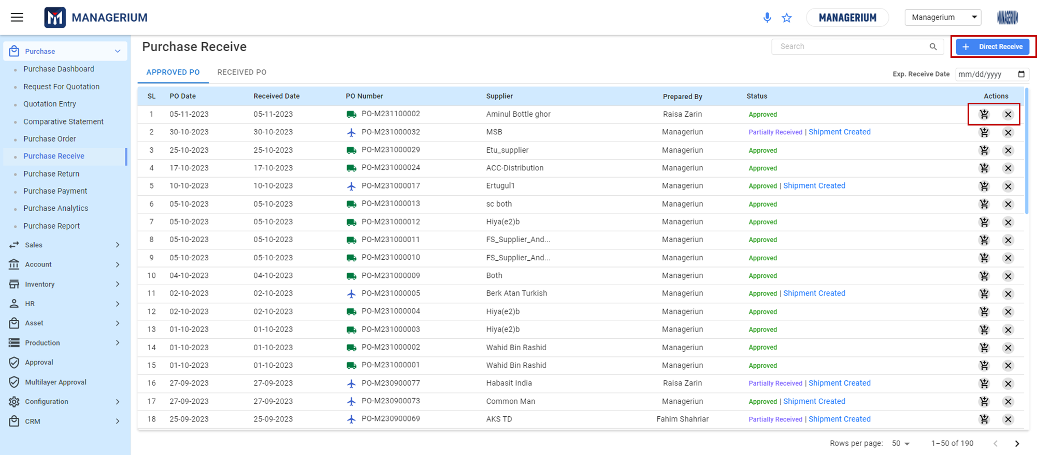

**Table Information Details:**

* + **PO Number:** Choose the PO number that corresponds with the received goods.
  + **Received Date:** The system may autofill today’s date, but ensure this reflects the actual date users received the goods.
  + **Supplier:** Select the supplier from whom the items were received or add a new supplier if not already listed.
  + **Items Received:** Add the items that have been received, ensuring the quantities and descriptions match the physical goods received.
  + **Prepared By:** It provides an at-a-glance view of who is responsible for the order, which can be useful for queries or follow-up.
  + **Status:** The "Status" column shows the current state of the purchase order .Common statuses might include **"Approved,"** **"Partially Received," "Shipment Created,"** etc.
    - **"Approved"** indicates that the PO has been reviewed and sanctioned for processing.
    - **"Partially Received"** means that only some items in the PO have been received, and others are still pending.
    - **"Shipment Created"** suggests that a shipment has been prepared for the items in the purchase order, which may involve a logistics provider for delivery.
    - **Action:** This column provides various action buttons:
      * ***Receive (Cart Icon):*** Allows receive the order after the PO is updated, by adding Quantity that has been received.
      * ***Close (Cross Icon):*** Enables users to cancel the approved PO.

**Filtering and Viewing Options:**

* Use the 'Search' bar at the top right to quickly find specific POs by their attributes.

### ***1.6.1 Creating a Direct Receive:***

**User Interface [**+**Create Direct Receive] :**

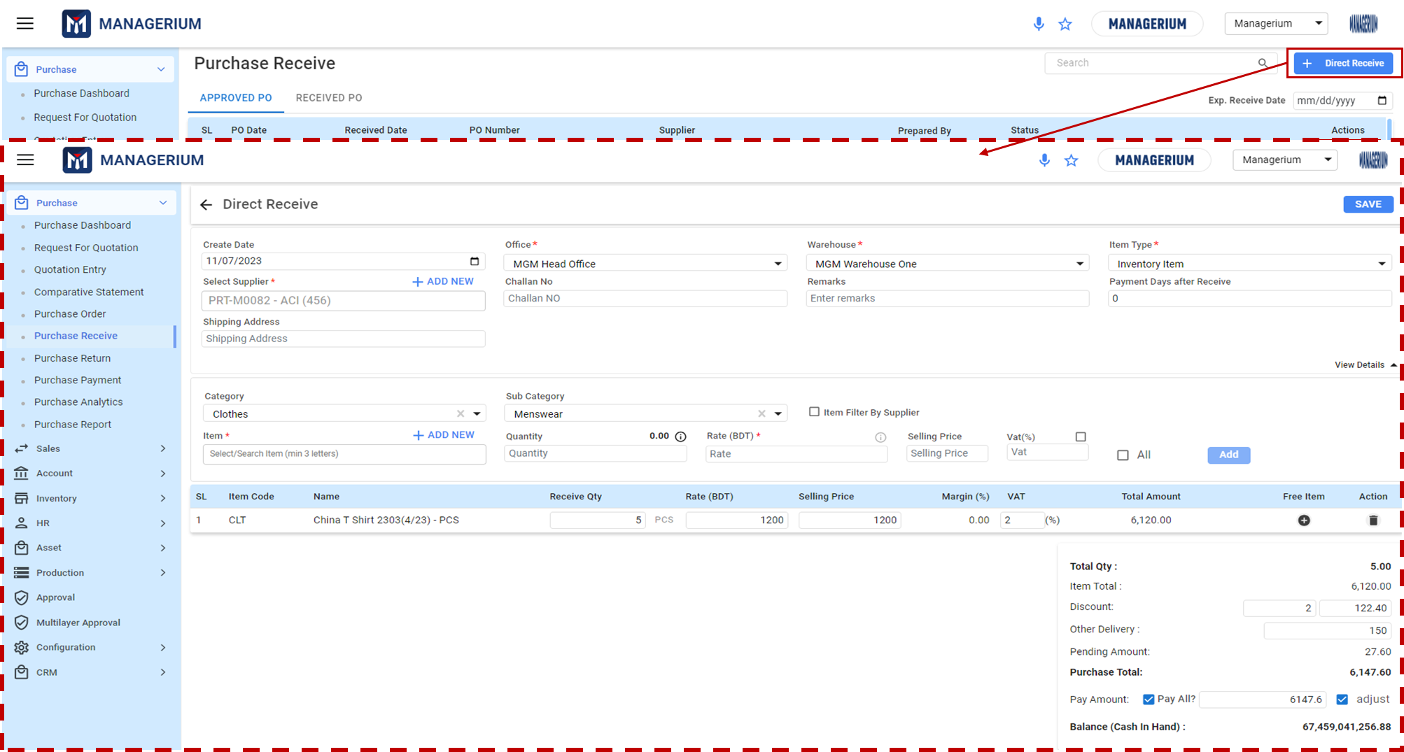

**Direct Receive Information:**

**Receive Details:**

* **Create Date:** Input the date when the items are being directly received.
* **Select Supplier:** Search and select the supplier from whom users are receiving the items. If the supplier is not listed, use the '+ ADD NEW' option to add them to the system.
* **Challan No:** Enter the challan or delivery note number that accompanies the goods.
* **Warehouse:** Choose the warehouse location where the items will be received and stored.
* **Office:** Select the office that is processing the direct receive.

**Item Details:**

* **Category:** Choose the broad category of the received items, e.g., 'Clothes'.
* **Sub Category:** Further specify the classification, for instance, 'Menswear'.
* **Item:** Search for and select the specific item being received.

**Quantity and Pricing:**

* **Receive Qty:** Input the number of units received.
* **Rate (BDT):** Specify the purchase rate per unit in Bangladeshi Taka (BDT).
* **Selling Price:** If applicable, input the selling price per unit.
* **Margin (%):** Optionally, indicate the profit margin percentage on the selling price.
* **VAT (%):** Enter the applicable VAT percentage for the received items.

**Financial Summary:**

* **Total Amount:** This field will auto-calculate the total amount based on the received quantity and rate.
* **Free Item:** If users have received any item for free, it can be indicated here.

**Actions:**

* This section allows users to perform only delete.

**Transaction Details:**

* **Total Qty:** Automatically sums up the quantity of all items received.
* **Item Total:** Provides the total cost before any deductions.
* **Discount:** If a discount is applicable, it is entered here.
* **Other Delivery**: Any additional delivery charges can be entered here.
* **Pending Amount:** If there is any amount that remains to be paid or received, it's noted here.
* **Purchase Total:** Displays the final total for the direct receive after all adjustments.

**Payment Section:**

* **Pay Amount:** Decide if users are going to pay for the total purchase immediately or adjust the payment.
* **Balance (Cash In Hand):** This reflects the current cash position of the transaction.

**Saving the Purchase Direct Purchase Receive:**

Once all details are filled out and users have verified the information, click on the **'SAVE'** button located at the top right corner of the screen.

### 

### 

### ***1.6.2 Creating a Receive Order [PO Wise]:***

**User Interface [Receive Order]-For Local PO :**

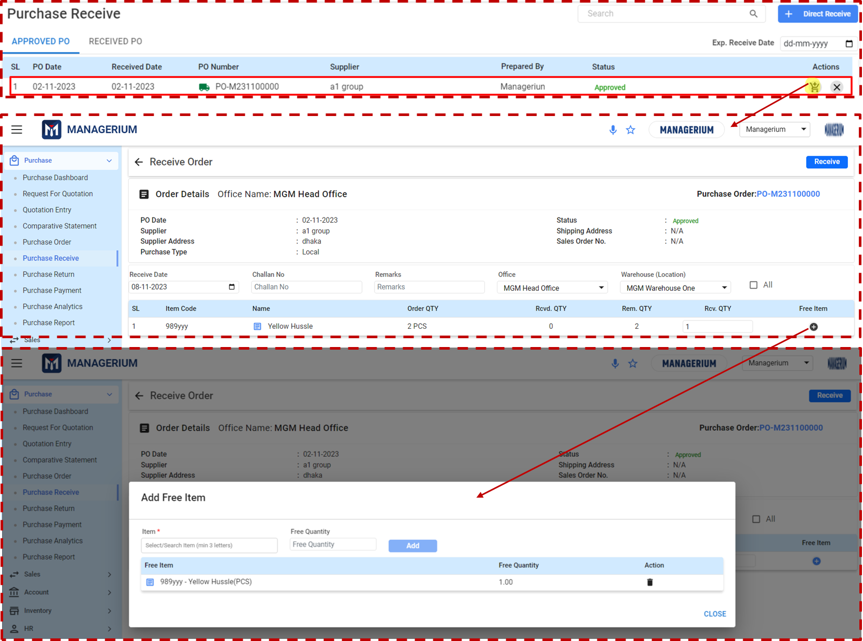

**Receive Order Information-For Local PO:**

**Receive Details:**

**Order Details**

* **Office Name**: The office name is pre-filled based on user settings (e.g., MGM Head Office).
* **PO Date:** The date when the purchase order was created.
* **Supplier:** The name of the supplier providing the goods.
* **Supplier Address:** The address of the supplier.
* **Purchase Type:** The type of purchase, like local or international.
* **Receive Date:** The date users are receiving the goods.
* **Challan No.:** Enter the delivery challan or receipt number.
* **Office:** Confirm the office location from which the order is being received.
* **Warehouse (Location):** Specify the warehouse where the goods will be stored.

**Order Information Column:**

* **Purchase Order:** The reference number of the purchase order.
* **Status:** Current status of the order (e.g., Approved).
* **Shipping Address:** The address where the goods are to be shipped.
* **Sales Order No.:** If applicable, the sales order number associated with this purchase.

**Item Receipt Table:**

* **SL:** Serial number of the items.
* **Item Code:** The code associated with the specific item.
* **Name:** The name of the item received.
* **Order QTY:** The quantity of the item ordered.
* **Recd. QTY:** The quantity of the item that has been received.
* **Rem. QTY:** Remaining quantity that has yet to be received.
* **Recv. QTY:** The field to enter the quantity actually received.
* **Free Item:** Indicates if the item is a free addition to the order.

**Additional Section: Add Free Item (if applicable)**

* **Item:** Select the item that users are receiving for free.
* **Free Quantity:** Enter the quantity of the free item.
* **Add:** Click to add the free item to the order.

**Finalizing the Order:**

* Once all the information is confirmed and entered, click the **'Receive'** button at the top right corner to finalize the receipt of the goods.A confirmation message should appear indicating successful receipt of the order.

**Notes:**

* Always verify the received quantities against the physical invoice or challan.
* Ensure that free items are added correctly to maintain accurate inventory counts.
* Review all details for accuracy before finalizing the order.

**User Interface [Receive Order]-For Foreign PO :**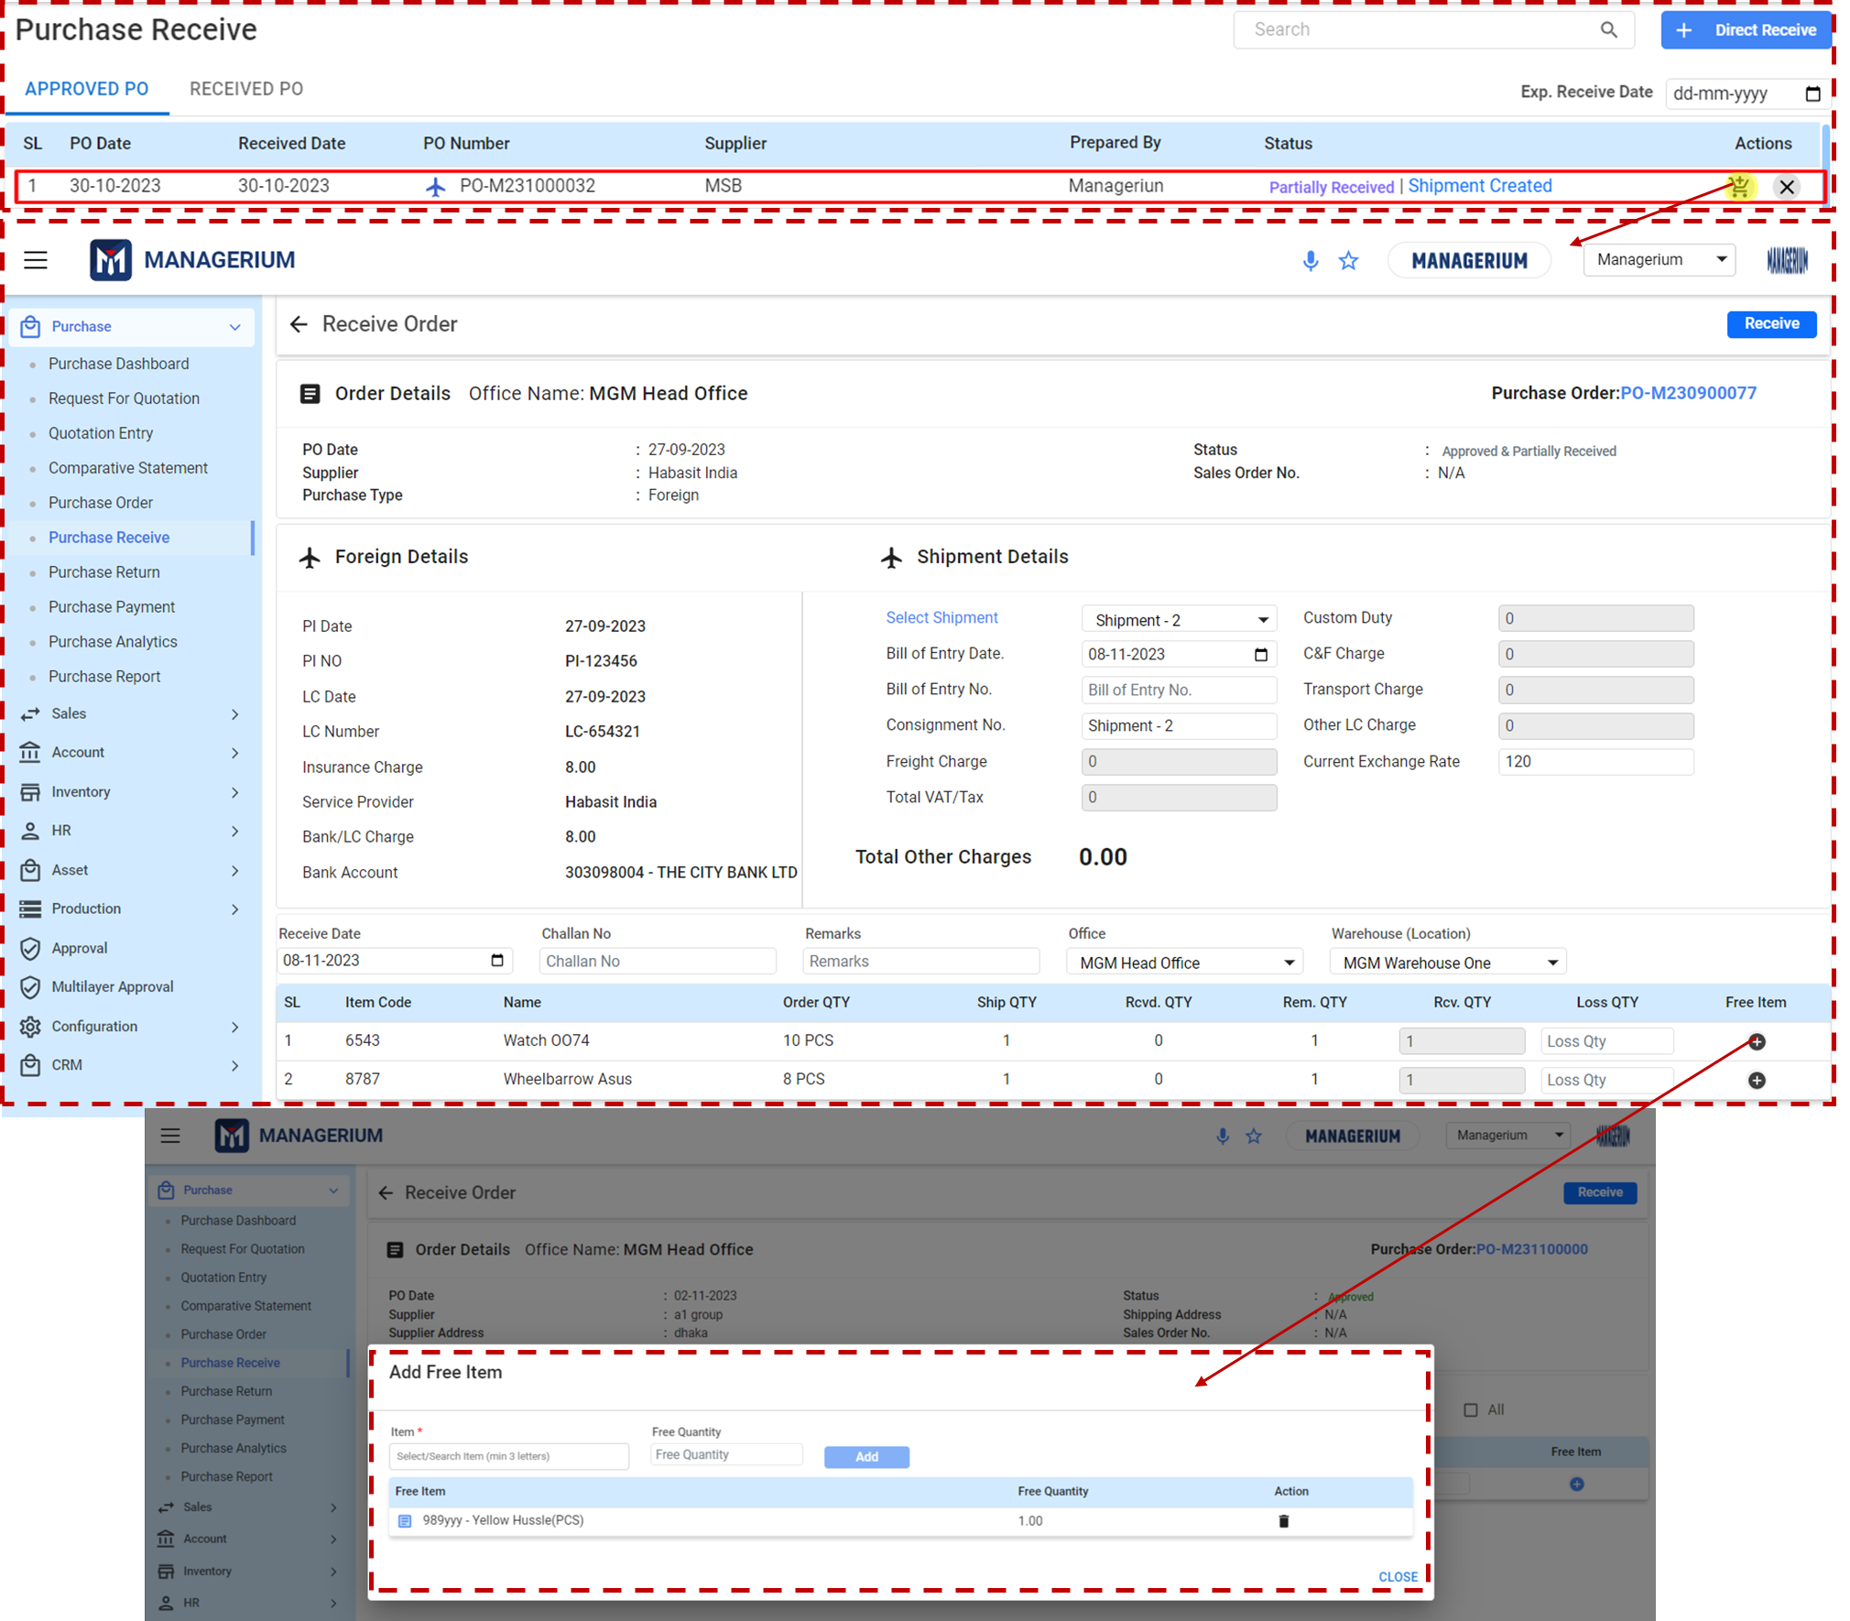

**Receive Order Information-For Foreign PO:**

**Receive Details:**

**Order Details**

* **Office Name:** Displayed at the top; confirms the office managing the order.
* **Purchase Order Number:** Located at the top right, providing the unique PO reference number.

**Order Details and Shipment:**

* **PO Date:** The date the purchase order was issued.
* **Supplier:** The name of the overseas supplier.
* **Purchase Type:** Denotes it's a foreign purchase.Status: Shows the current status of the order (e.g., 'Approved & Partially Received').

**Foreign Details:**

* **PID Date:** The date the proforma invoice was issued.
* **PID No:** The proforma invoice number.
* **LC Date:** The date the Letter of Credit was opened.
* **LC Number:** Reference number for the Letter of Credit.
* **Service Provider:** The logistics service provider or bank handling the order.
* **Bank LC Account:** The account number used for the Letter of Credit.

**Shipment Details:**

* **Select Shipment:** Choose the specific shipment users are receiving.
* **Bill of Entry Date:** The date the goods were entered at customs.
* **Consignee No., Freight Charge:** Details pertaining to the shipment’s logistics.
* **Total VAT/Tax:** The total value-added tax or duty paid for the goods.

**Order Information Column:**

* **Shipment Created:** Date and status indicating that the shipment has been logged in the system.

**Item Receipt Table:**

* **Item Code, Name, Order QTY:** Identifying details and the quantity of ordered items.
* **Ship QTY, Recv. QTY, Rem. QTY:** Quantities related to the shipment, received items, and remaining items.

**Additional Section: Add Free Item (if applicable)**

* Add any complimentary items received with the purchase, specifying the item and the free quantity.

**Finalizing the Order:**

* Confirm all details, especially shipment and foreign transaction information.
* Enter any relevant remarks or special instructions in the 'Remarks' field.
* Verify the office and warehouse location.
* Once all the information is accurate, click on the **'Receive'** button to complete the order receiving process.

**Important Considerations:**

* Double-check all foreign transaction details, including LC and PID numbers, for accuracy.
* Ensure that the correct exchange rate is used for conversion and cost calculation.
* Record all customs duties and freight charges correctly to reflect the total landed cost.

**Notes:**

* Always verify the received quantities against the physical invoice or challan.
* Ensure that free items are added correctly to maintain accurate inventory counts.
* Review all details before finalizing the order.

### ***1.6.3 View the received PO:***

**User Interface [Receive PO] :**

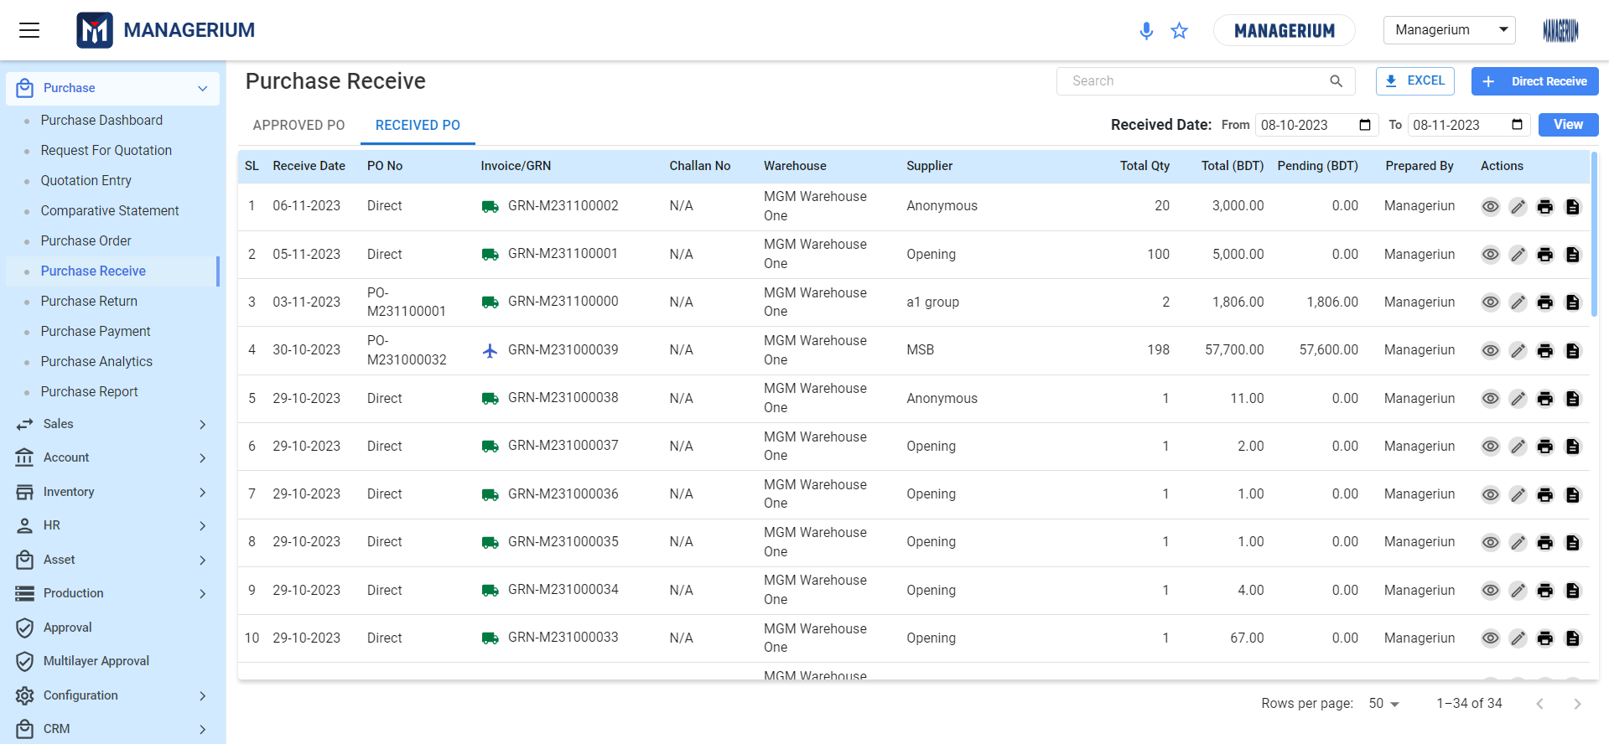

**Received PO Tab Information Details:**

* The list to ensure all received goods are accurately recorded.
* Utilize action icons to manage PO entries.
* For discrepancies or queries, consult the details using the eye icon or edit as needed.

**Received PO List:**

* This list displays all the received POs with details such as the receive date, PO number, invoice/GRN (Goods Received Note), challan number, warehouse information, supplier details, total quantity received, total value, pending amount, and the individual who prepared the record.

**Table Columns:**

* **SL:** Serial number in the list.
* **Receive Date:** The date the goods were received.
* **PO No:** Purchase order number. 'Direct' indicates a direct purchase without a PO, whereas others show specific PO numbers.
* **Invoice/GRN:** Links to the goods received note or invoice corresponding to the received items.
* **Challan No:** Delivery challan number, if applicable.
* **Warehouse:** The warehouse where the goods were received.
* **Supplier:** Name of the supplier.
* **Total Qty:** Total quantity of items received.
* **Total (BDT):** Total cost of received items in Bangladeshi Taka (BDT).
* **Pending (BDT):** Pending amount to be paid or received, if any.
* **Prepared By:** User who entered the received information.
* **Actions:** Icons for actions such as viewing, editing, deleting, or performing other functions on the received PO entry.
* ***Edit (Pencil Icon):*** Allows modification of the purchase order details.
* ***View (Eye Icon):*** Enables users to view in-depth details of the purchase order.
* ***Print (Icon):*** Allows user to print the PO details
* ***GRN (Note Icon):***  Allows users to reverse the PO and send for approval again.

**Functionality:**

* **Search:** Utilize the search bar to quickly find specific PO entries.
* **Excel:** Export the list of received POs to an Excel spreadsheet.
* **Filter by Date Range:** Set a specific date range to filter the received POs accordingly.

## 1.7 Purchase Return

Purchase Return is a dedicated section for managing the return of goods previously purchased and received. This feature allows businesses to handle situations where items need to be returned to the supplier due to various reasons, such as defects, incorrect shipments, or other discrepancies.

**Menu Path:**  **Purchase (Module)> Purchase Return>Received List/Return List**

**Features:**

**Tabs:**

* **RECEIVED LIST:** Shows items that have been received and are eligible for return.
* **RETURN LIST:** Displays items that have been processed for return.

**User Interface [RECEIVED LIST]:**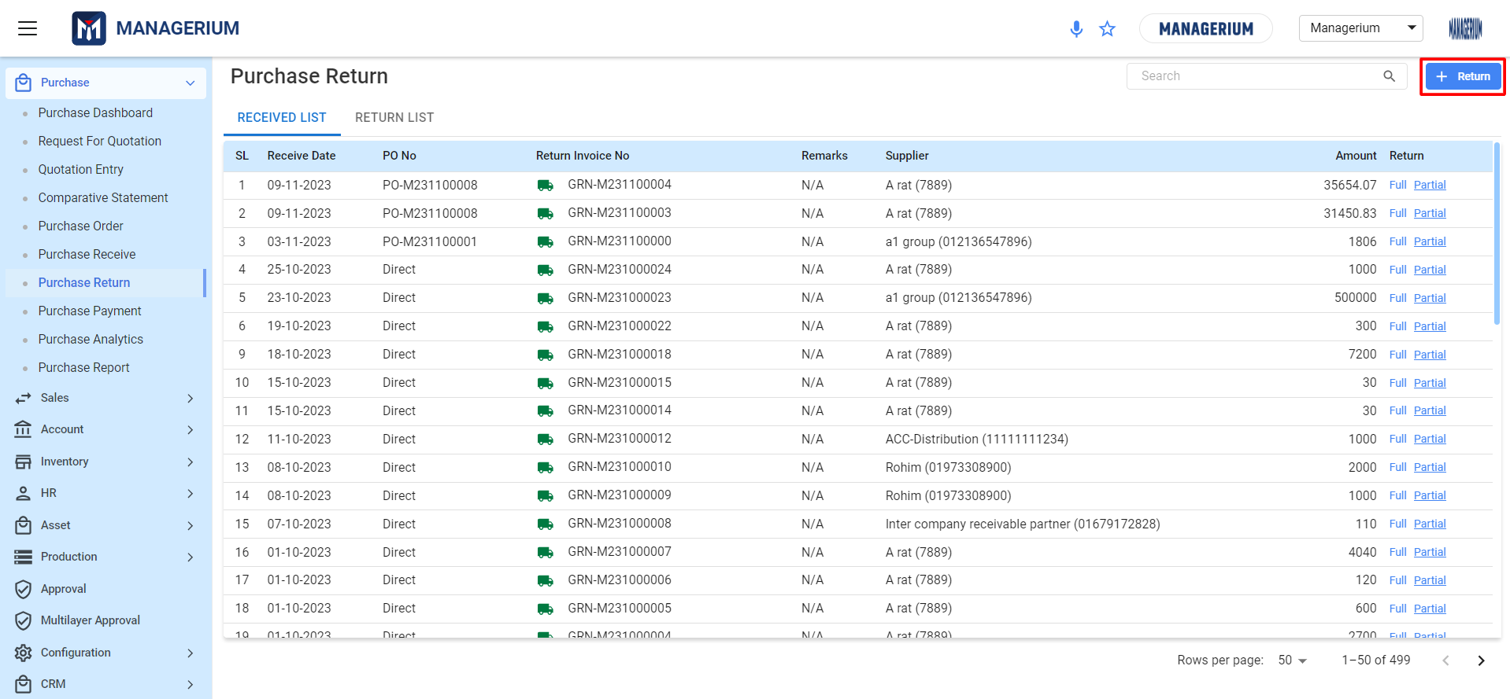

**Table Information Details:**

* **SL:** Serial number of the return entry.
* **Receive Date:** The date the item was originally received.
* **PO No:** Purchase Order number associated with the received goods.**\*\*\* Direct Received PO are shown as ‘Direct’ and others are shown included PO NO.**
* **Return Invoice No:** The generated number for the return transaction.
* **Remarks:** Any comments or notes related to the return.
* **Supplier:** The name and identifier of the supplier to which items will be returned.
* **Amount:** The value of the items being returned.
* **Return:** Options to mark the return as Full or Partial.

**Filtering and Viewing Options:**

* Use the 'Search' bar at the top right to quickly find specific POs or others by their attributes.

### ***1.7.1 Creating a Return [PO Wise]:***

**User Interface [Create Purchase Return WithOut Ref.]:**

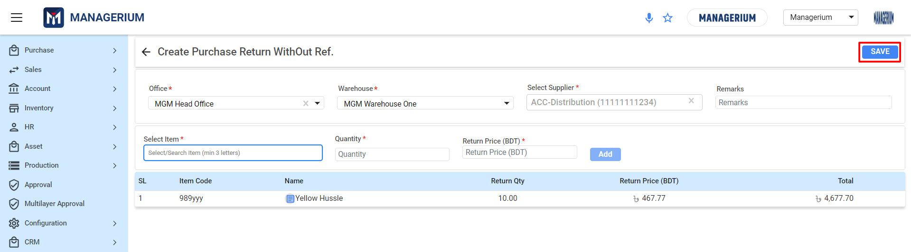

**Filling Out Return Details**

* **Office:** Select users office location from the drop-down list. This should be the office initiating the return.
* **Warehouse:** Choose the warehouse from where the items are being returned.
* **Select Supplier:** Pick the supplier to whom the items are being returned. If the supplier is not listed, add them by clicking **'+ ADD NEW'**.

**Adding Items for Return**

* **Select Item:** Begin typing the name or code of the item in the 'Select/Search Item' field. As users type, a list of items will appear. Choose the correct item from this list.
* **Quantity:** Enter the number of items users are returning in the 'Quantity' field.
* **Return Price (BDT):** Input the price at which users are returning the item. This could be based on the original purchase price or a restocking price agreed upon with the supplier.
* Click **'Add'** to place the item in the return list.

**Reviewing Return Items**

* Below the entry fields, review the items users have added to the return.
* The list will display the 'SL' (serial number), 'Item Code', 'Name', 'Return Qty', and 'Return Price (BDT)'.
* Verify that the 'Total' at the bottom reflects the correct total amount for the return.

**Remarks**

* Use the 'Remarks' field to add any notes regarding the return, such as the reason for the return or conditions discussed with the supplier.

**Finalizing the Purchase Return**

* Once all items have been added and details checked, click the **'SAVE'** button in the top-right corner to record the return.
* The system will generate a return document that can be sent to the supplier or used internally for record-keeping.

### ***1.7.2 Return Full or Partial [PO/Direct Wise]:***

**User Interface RECEIVED LIST [Return Full or Partial (PO/Direct Wise)]**

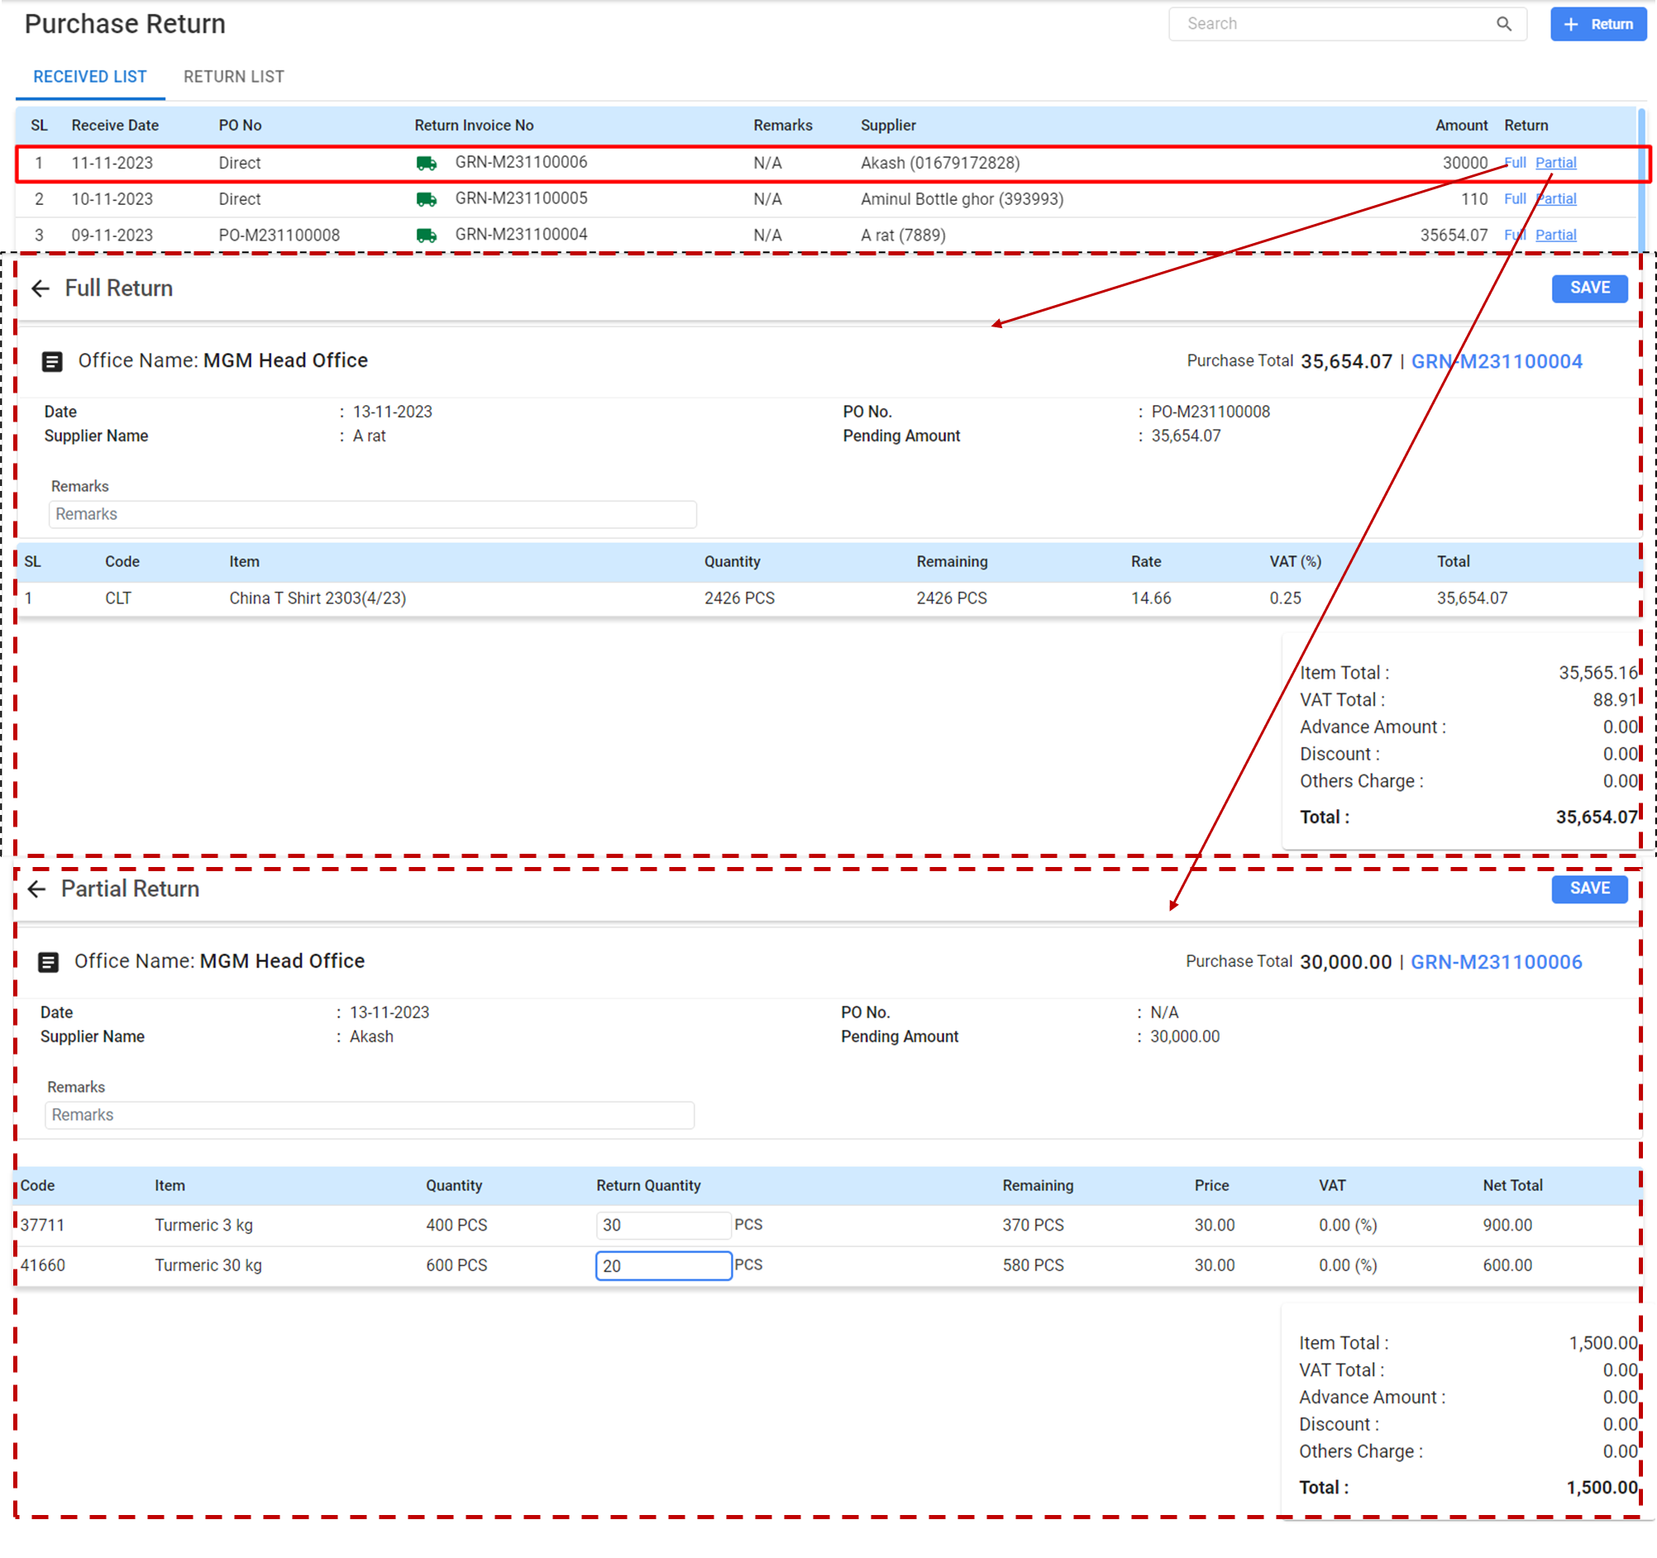

**Full Return:**

**Filling Out Full Return Information:**

* **Date:** The system will auto-fill the current date, which users can edit if necessary.
* **Office Name:** Confirm the office name, which should auto-populate based on users user profile.
* **Supplier Name:** Choose the supplier from the dropdown menu to whom the items will be returned. Here, "A rat" is selected.
* **PO No.:** Enter the number of the purchase order associated with the items being returned. This example uses "PO-M231100008".
* **Remarks:** Provide any relevant comments about the return in the remarks field.

**Return Item Details:**

* **SL (Serial Number):** The system assigns a serial number for itemization and tracking.
* **Code:** Enter the item code or select it from a list if available.
* **Item:** Confirm the item description. Here, it's "China T Shirt 2303(4/23)".
* **Quantity:** State the total quantity of items being returned. This should match the quantity received.
* **Financial Details:**
* **Rate:** Input the unit rate at which the items are being returned.
* **VAT (%):** Enter the VAT percentage applicable to the return.
* **Total:** The total return amount will automatically be calculated based on the rate and quantity.

**Reviewing and Adjusting Totals:**

* Check the **'Item Total'**, **'VAT Total'**, and any other charges or discounts to ensure the total return amount is correct.
* Confirm the **'Advance Amount**' if there was any advance payment associated with the items being returned.
* Once all details are verified and correct, review the total amount to ensure it matches with the expected return value.
* Click the **'SAVE'** button to process the return.

**Partial Return:  
Filling Out Partial Return Information:**

* **Office Name:** Ensure the office name is correct. This should be auto-filled based on users user profile.
* **Date:** Verify the date of return; it should populate with the current date.
* **Supplier Name:** Confirm the supplier’s name from whom the items were purchased.
* **PO No.:** If applicable, input the Purchase Order Number associated with the items. Otherwise, it will display "N/A".
* **Pending Amount:** Review the pending amount, if any, for the transaction.
* **Remarks:** users can enter any relevant comments or notes related to the partial return.

**Item Return Details:**

* **Code:** Review the item codes to ensure users are returning the correct items.
* **Item:** This column will display the name and size/quantity of the item.
* **Quantity:** This column shows the original quantity purchased.
* **Return Quantity:** Enter the number of items users wish to return.
* **Remaining:** This will automatically calculate and display the remaining quantity after the return.
* **Price:** Confirm the price per unit of the item.
* **VAT:** If Value Added Tax is applicable, it will be shown here. Otherwise, it will display 0.00 (%).
* **Net Total:** This will display the net total value of the returned items.

**Financial Summary:**

* **Item Total:** This is the total cost of the items being returned.
* **VAT Total:** The total amount of VAT charged on the return, if applicable.
* **Advance Amount:** If an advance payment was made, it would be reflected here.
* **Discount:** Any discounts applied to the return will show in this field.
* **Others Charge:** Any additional charges related to the return should be input here.
* **Total:** This is the final total amount for the partial return.

**Finalizing the Partial Return:**

After all the information is correctly filled in:

* Review all the details to ensure accuracy.
* Click the ‘Save’ button to record the partial return.

**\*\*\* Once it is saved for Full or Partial Return, it’ll add to the approval and add to the landing page of RETURN LIST.**

### ***1.7.3 View the RETURN LIST:***

**User Interface [RETURN LIST]**

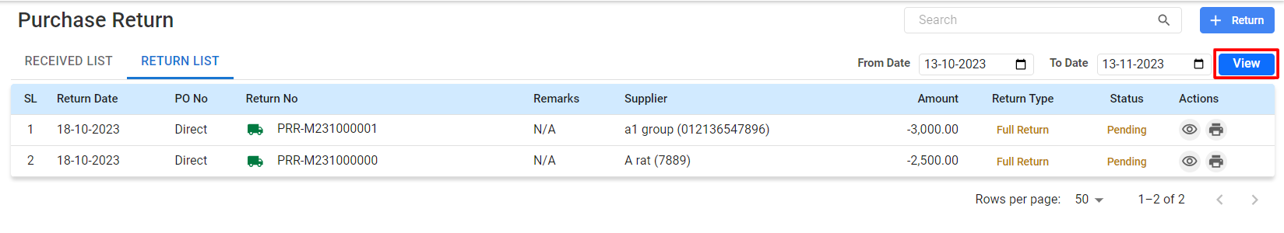

**Table Information Details:**

* **RETURN LIST**: Viewing items that have been returned.
* **SL (Serial Number):** A sequential number assigned to each return for easy reference.
* **Return Date:** The date on which the return was processed.
* **PO No:** The Purchase Order Number associated with the return.
* **Return No:** A unique identifier assigned to each return transaction.
* **Remarks:** Any notes or comments associated with the return.
* **Supplier:** The name and identification number of the supplier to whom the return was made.
* **Amount:** The total value of the items returned, typically shown as a negative number to indicate a debit.
* **Return Type:** Indicates whether the return was partial or full.
* **Status:** The current status of the return (e.g., Pending, Completed).
* Options to view and print.

**Searching and Filtering Returns:**

* Use the search bar to find specific returns by supplier, PO No, or Return No.
* Filter returns by date using the **'From Date'** and **'To Date'** fields.

## 1.8 Purchase Payment

The Purchase Payment module is designed to facilitate efficient tracking and processing of payments for purchases made by the organization.

**Menu Path: Purchase (Module) > Purchase Payment**

**Features:**

**Tabs:**

* **DUE LIST:** Indicates the payments that are yet to be settled with suppliers.
* **PENDING BILL:** Shows bills that have been partially paid and have a remaining balance.
* **PAID BILL:** Lists all bills that have been fully settled.
* **DUE INVOICES:** Highlights invoices that are due for payment and may require immediate attention.

**User Interface [Supplier Payment-Landing]**

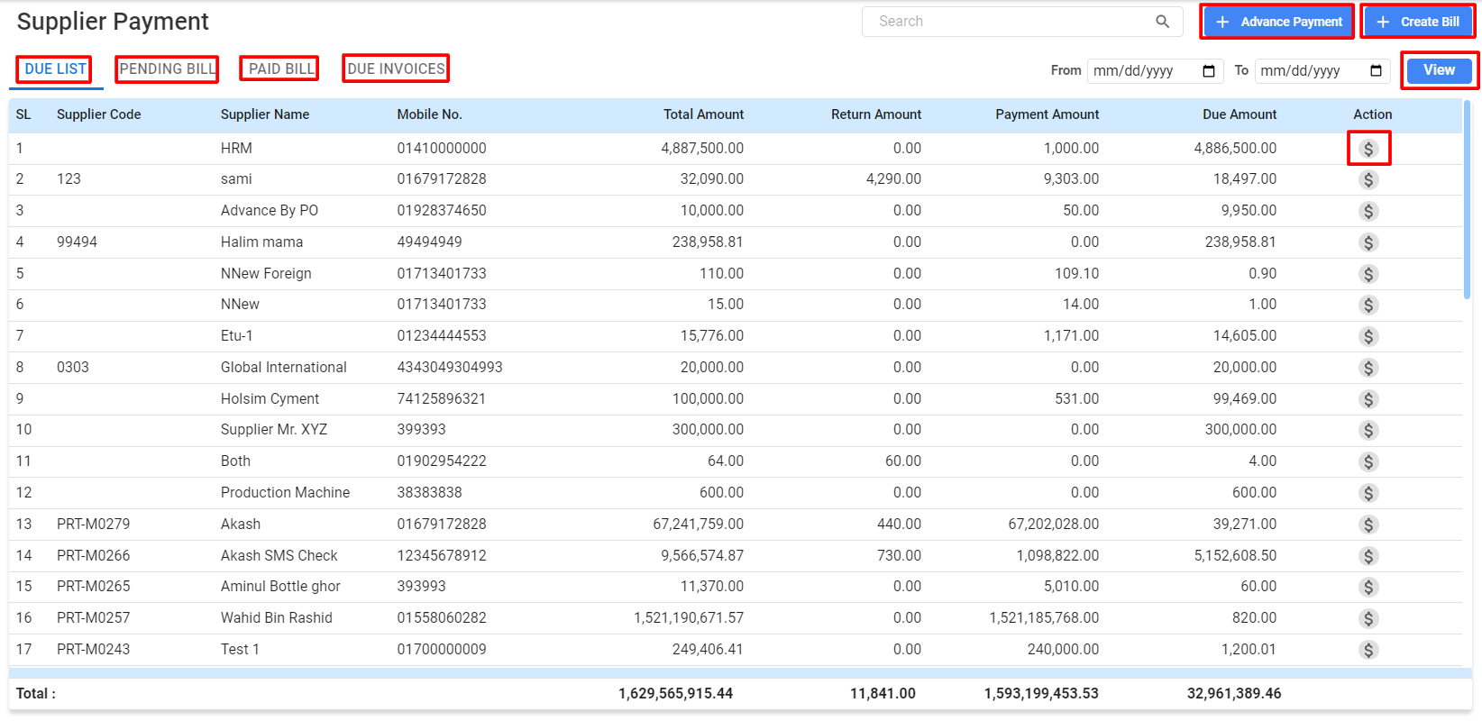

**View Details:**

* **Functional Buttons:**
  + **Advance Payment:** For making payments in advance to suppliers, likely before receiving the invoice or the goods/services.
  + **Create Bill:** For generating a new bill or invoice entry within the system.
* **Date Filters:** Allow users to filter the payment records by a specific date range to review payments within that period.
* **Search Bar:** To quickly find specific entries or suppliers within the list.
* **View Button:** Typically, this button would open up the detailed view of the transaction or payment record, providing more information or allowing for further actions.

**Table Information Details:**

* **SL:** This column lists serial numbers for easy reference to each payment entry.
* **Supplier Code:** Unique codes assigned to each supplier for tracking purposes.
* **Supplier Name:** The name of the supplier to whom payment is owed.
* **Mobile No.:** Contact number for the supplier, likely for communication purposes.
* **Total Amount:** The total invoice amount billed by the supplier.
* **Return Amount:** If any amount has been returned or credited by the supplier, it is noted here.
* **Payment Amount:** The amount that has already been paid against the total invoice amount.
* **Due Amount:** The remaining balance that needs to be paid to the supplier.
* **Action:** The dollar symbol indicates the bill payment that can be taken directly from this screen.

**Total Payment at the Bottom:** Shows the cumulative total of various amounts:

* + The total of all invoice amounts listed.
  + The total of all return amounts.
  + The total of all payment amounts made.
  + The total outstanding due amount that is yet to be paid.

***1.8.1 Advance Payment***

**User Interface [ Advance Payment -Modal ]**

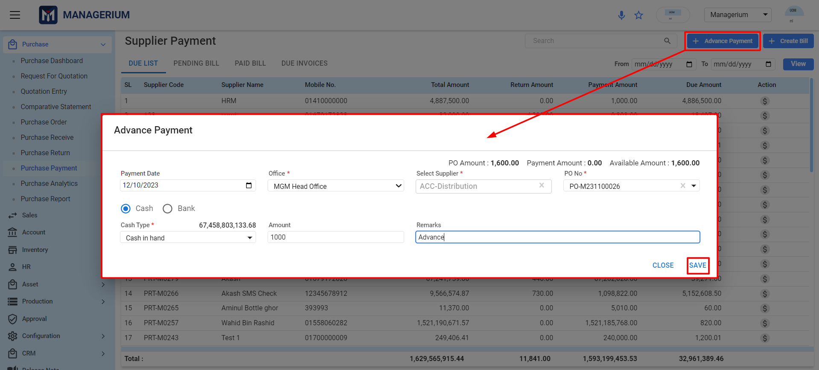

* **Payment Date:** The date on which the advance payment is being made.
* **Office:** A dropdown menu to select which office or department is making the payment. As example, the "MGM Head Office" is selected.
* **Cash/Bank:** Radio buttons to select the method of payment—whether the payment is being made in cash or through a bank.
* **Cash Type:** A dropdown that likely lists different cash accounts or types of funds from which the payment can be drawn. The current balance of the selected account ("Cash in hand") is shown next to it.
* **Amount:** The field where the user enters the amount of the advance payment.
* **Remarks:** A text box for any notes related to the advance payment. The word "Advance" is already entered here, indicating the nature of the payment.
* **PO Amount:** Displays the amount related to a specific Purchase Order (PO).
* **Payment Amount:** Shows how much has already been paid against this PO, which is currently 0.00, indicating that no payments have been made yet.
* **Available Amount:** Indicates the remaining amount that can still be paid against the PO, which matches the PO Amount, confirming that no payment has been made yet.
* **Select Supplier:** A dropdown to choose the supplier to whom the advance payment is being made.
* **PO No:** A field to select the PO Number that the advance payment is related to. A specific PO Number is already selected here.
* **Save:** The button to save the transaction.
* **Close:** A button to close the pop-up without saving the changes.

***1.8.2 Create Bill***

**User Interface [Create Supplier Bill]**

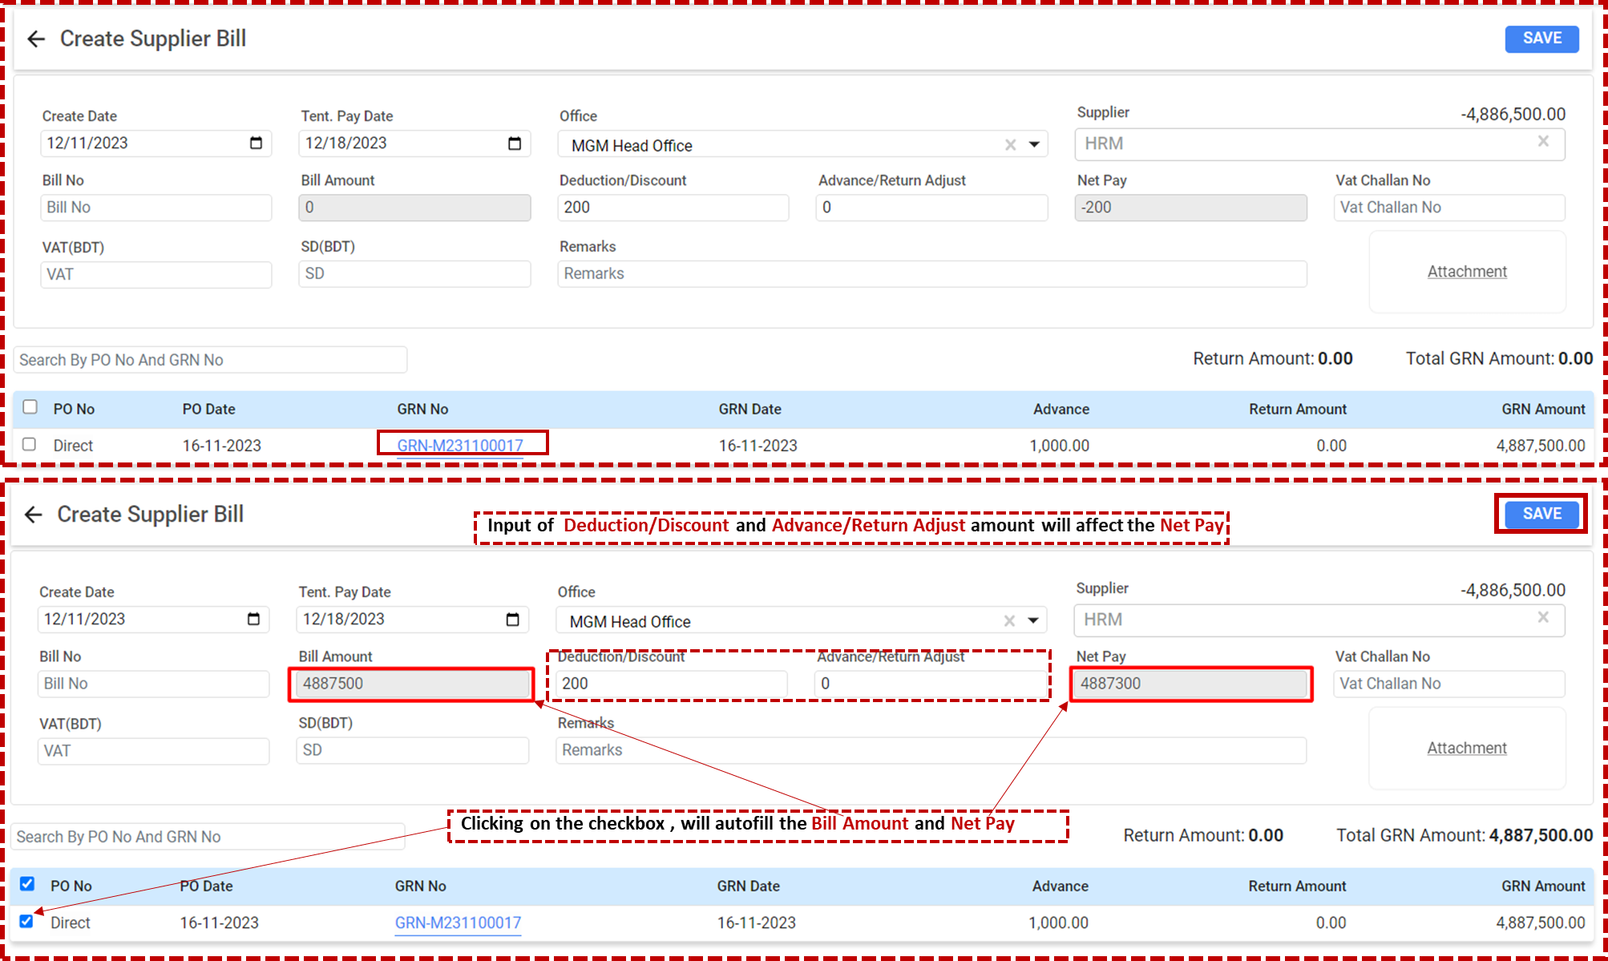

* + **Create Date:** The date when the bill is being created in the system.
  + **Tent. Pay Date (Tentative Pay Date):** The expected date by which payment should be made.
  + **Office:** The office or department within the organization that is creating the bill. In this case, "MGM Head Office" is selected.
  + **Supplier:** The name of the supplier to whom the bill will be paid. Here, "HRM" is listed as the supplier.
  + **Bill No:** The invoice or bill number provided by the supplier.
  + **Bill Amount:** The total amount of the bill as provided by the supplier. *In this example, the user is prompted to either enter a bill amount manually or select a PO (Purchase Order) and GRN (Goods Received Note) which auto-fills the bill amount.*
  + **Deduction/Discount:** Any deductions or discounts that apply to the bill, which will reduce the total amount payable.
  + **Advance/Return Adjust:** The amount of any advance payments or returns that should be adjusted against the total bill amount.
  + **Net Pay:** The net amount to be paid after all deductions, discounts, and advance/return adjustments have been applied.

*In the example, the bill amount is auto-filled to "4,887,500" with a deduction of "200", resulting in a net pay of "4,887,300".*

* + **VAT (BDT) and SD (BDT):** Fields for entering the Value Added Tax and Supplementary Duty amounts if applicable.
  + **Remarks:** Any additional notes or comments regarding the bill.
  + **Vat Challan No:** A field to enter the challan number for the VAT payment.
  + **Attachment:** An option to attach relevant documents related to the bill.
  + Search By PO No And GRN No: A feature to look up bills based on Purchase Order Number and Goods Received Note Number.
  + **GRN Details:** Below the main form, there is a section that shows the details of the selected GRN, including:

1. ***PO No***
2. ***PO Date***
3. ***GRN No***
4. ***GRN Date****: The date on which the goods were received.*
5. ***Advance:*** *Any advance payment made against this GRN.*
6. ***Return Amount:*** *Any amount returned.*
7. ***GRN Amount:*** *The total amount of the GRN.*

* **Checkbox:** A checkbox (which seems to be highlighted in the example) that, when selected, auto-fills the bill amount and net pay based on the GRN details.

**User Interface [Supplier Wise Payment to Bill Payment]**

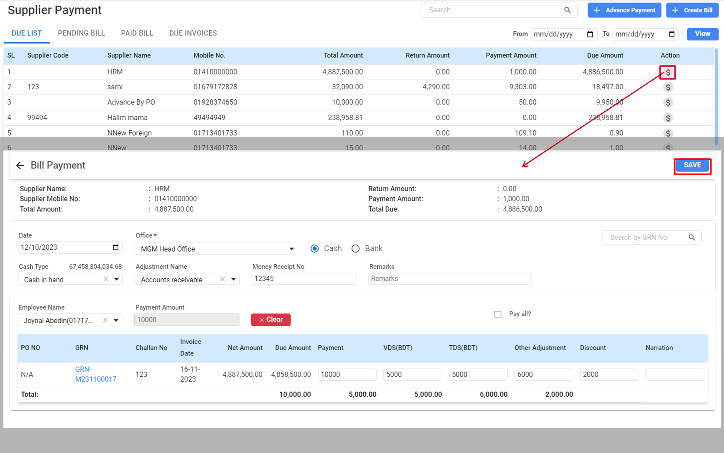

* **Supplier Information:**
  + **Supplier Name:** Displays the name of the supplier to whom the payment is being made.
  + **Supplier Mobile No.:** The contact number of the supplier.
  + **Total Amount:** The total invoice amount due to the supplier.
* **Payment Information:**
  + **Date:** The date when the payment is being recorded or made.
  + **Office:** Dropdown to select the office or department from which the payment is being processed.
  + **Cash Type:** Indicates the type of cash account from which the payment will be made, showing a balance next to it.
  + **Adjustment Name:** If there are any adjustments to be made against accounts, such as accounts receivable, it's selected here.
  + **Money Receipt No:** The receipt number associated with this payment.
  + **Remarks:** Any additional notes related to the payment.
* **Payment Details:**
  + **Employee Name:** The name of the employee processing the payment, selected from a dropdown list.
  + **Payment Amount:** The amount of money being paid. It appears an amount has already been entered.
* **Invoice Details:**
  + **PO NO:** Purchase Order Number, if applicable.
  + **GRN:** Goods Received Note, which is a document used to confirm the receipt of goods. A GRN number is provided.
  + **Challan No:** Refers to the delivery note or document number that accompanied the supplied goods.
  + **Invoice Date:** The date the invoice was issued.
  + **Net Amount:** The total amount of the invoice.
  + **Due Amount:** The amount still due after the current payment is made.
  + **Payment:** The amount of the current payment being recorded.
  + **VDS(BDT):** Value Deduction at Source in the local currency, which is a type of withholding tax.
  + **TDS(BDT):** Tax Deducted at Source in the local currency, another form of withholding tax.
  + **Other Adjustment:** Any additional adjustments to the payment amount.
  + **Discount:** Any discounts applied to the total amount.
  + **Narration:** Additional details or comments about the payment.
* **Payment Total:**
  + **Total:** Shows the total payment amount, including taxes, adjustments, and discounts.
* **Buttons:**
  + **Pay all?:** A button that may be used to quickly apply the full amount due to all outstanding invoices.
  + **Clear:** Clears the current payment information entered.
  + **Save:** To save the payment record.
* **Return and Total Due:**
  + **Return Amount:** If there has been a return of goods or a previous overpayment, it might be reflected here.
  + **Payment Amount:** Reflects the current payment being made.
  + **Total Due:** Shows the total amount due to the supplier after the current payment is made.

# **Sales Module**

The Sales module is where all sales transactions are recorded and managed. This comprehensive guide will assist users in navigating and utilizing the Sales module to track sales, manage customer information, and monitor revenue.

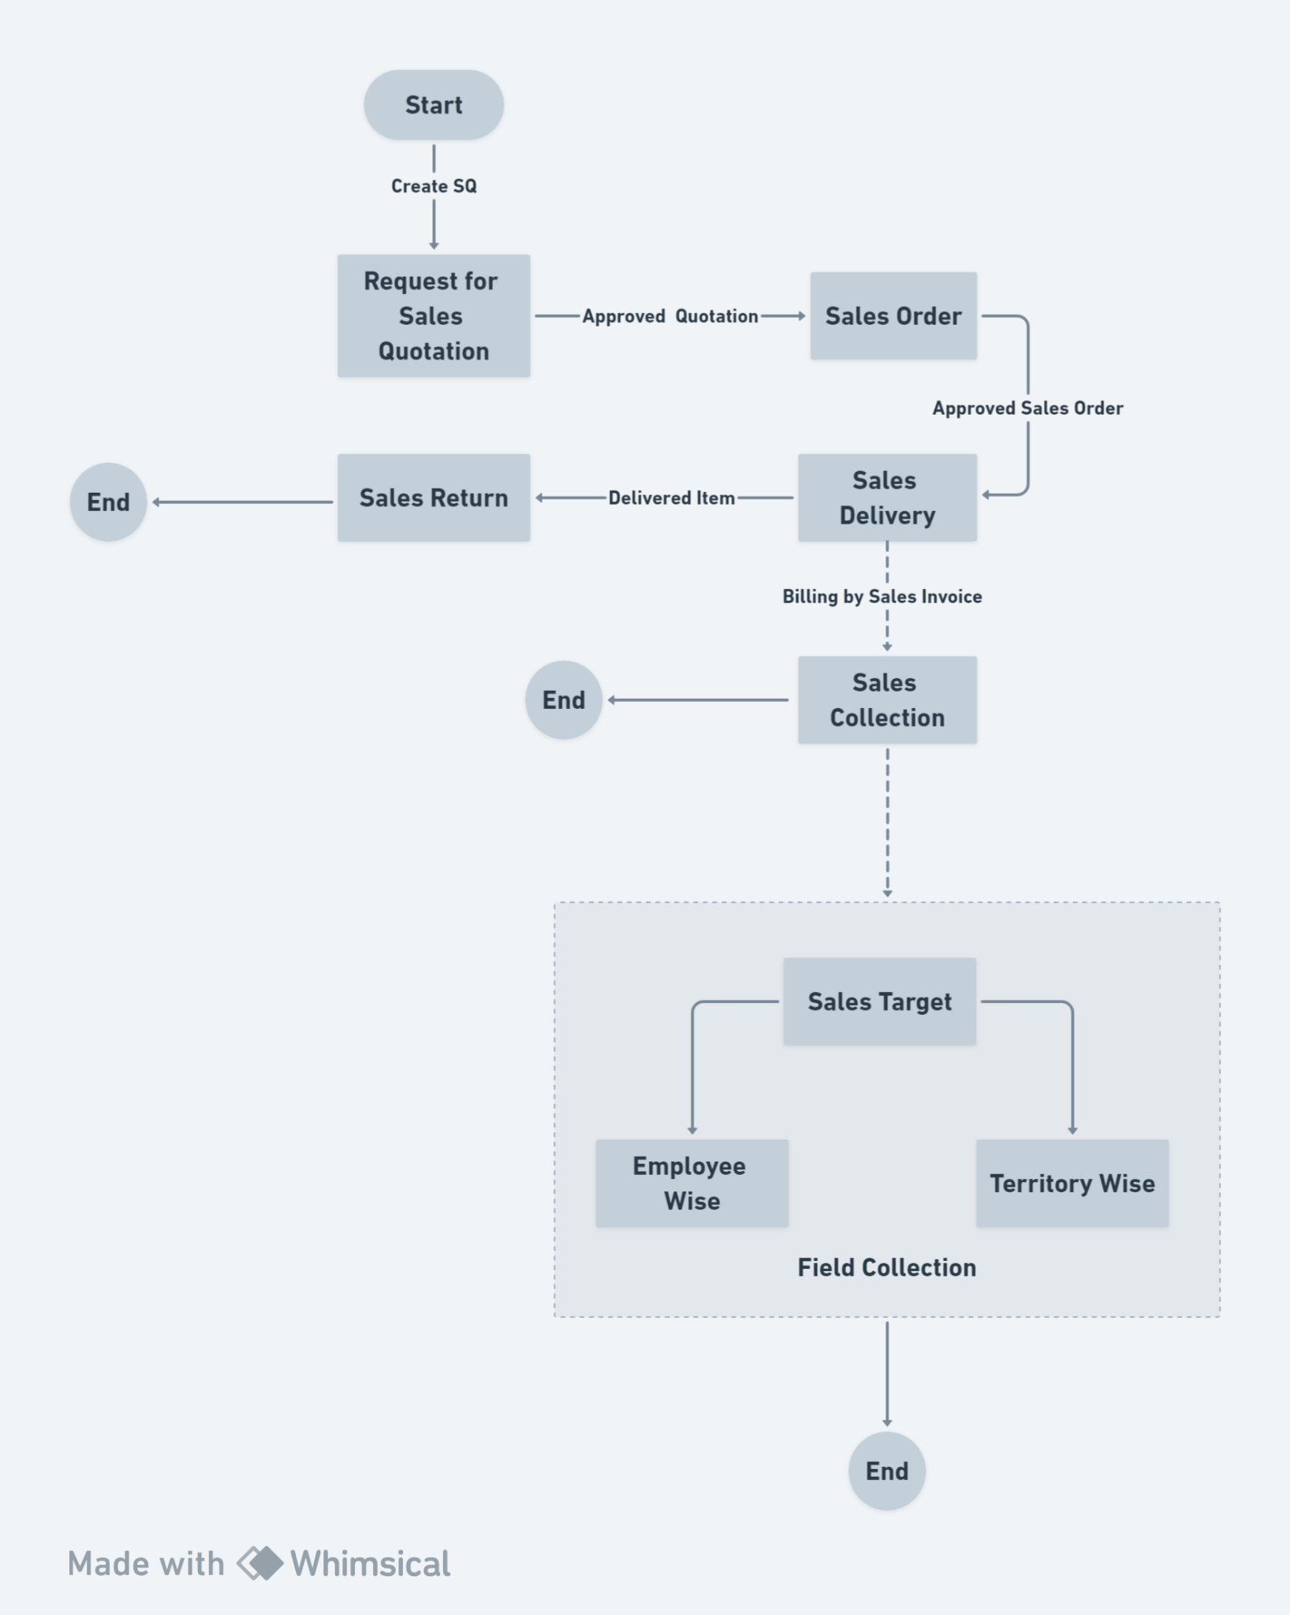

**Features Of Sales Module:**

## 2.1 Sales Dashboard

It appears to be a dashboard interface focusing visual and analytical representation of sales performance and metrics. This intuitive interface presents a comprehensive overview of the sales landscape for the business, with an array of graphical data points designed to aid in decision-making and strategic planning.

**Menu Path: Sales (Module) > Sales Dashboard**

The user will see a landing page after clicking the "Sales Dashboard" feature.

**User Interface [Sales Dashboard]:**

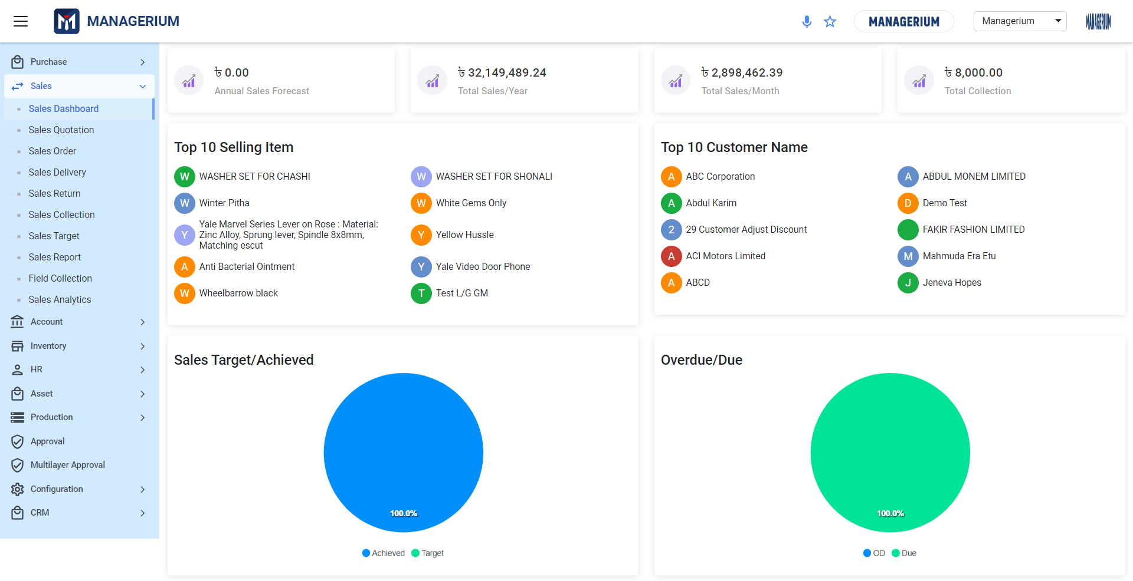

User can view the following information:

* **Annual Sales Forecast:** This section is currently not populated, indicating either a lack of data or forecasts for the year.
* **Total Sales/Year:** A summary of the total sales achieved over the year, providing a quick snapshot of the business's sales volume.
* **Total Sales/Month:** A focused view showing the total sales figures for the current month, allowing for a closer examination of short-term sales trends.
* **Total Collection:** Reflects the total amount collected, which is a crucial indicator of the business’s cash flow from sales activities.
* **Top 10 Selling Item:** A list of the best-selling items, highlighting which products are currently most popular or profitable, helping to identify which stock to prioritize.
* **Top 10 Customer Name:** This list features the most significant customers in terms of sales, which is valuable for recognizing and managing key relationships.
* **Sales Target/Achieved:** Illustrated as a pie chart, it visually compares the sales targets set against what has actually been achieved, offering a clear view of performance against goals.
* **Overdue/Due:** Another pie chart representation that provides insight into the payment collection status, distinguishing between overdue and due payments, which is critical for managing receivables.

## 2.2 Sales Quotation

This functionality enables users to create customized quotations based on customer requirements. Quotations are crafted with details that reflect the proposed terms of sale, which include specifications of products or services, pricing, and quantities. After creation, quotations undergo an approval process. Once approved, they serve as the basis for converting prospects into actual sales orders.

**Menu Path:**  **Sales (Module)> Sales Quotation**

### ***2.2.1 Sales Quotation Landing***

**User Interface [ Sales Quotation-Landing]:**

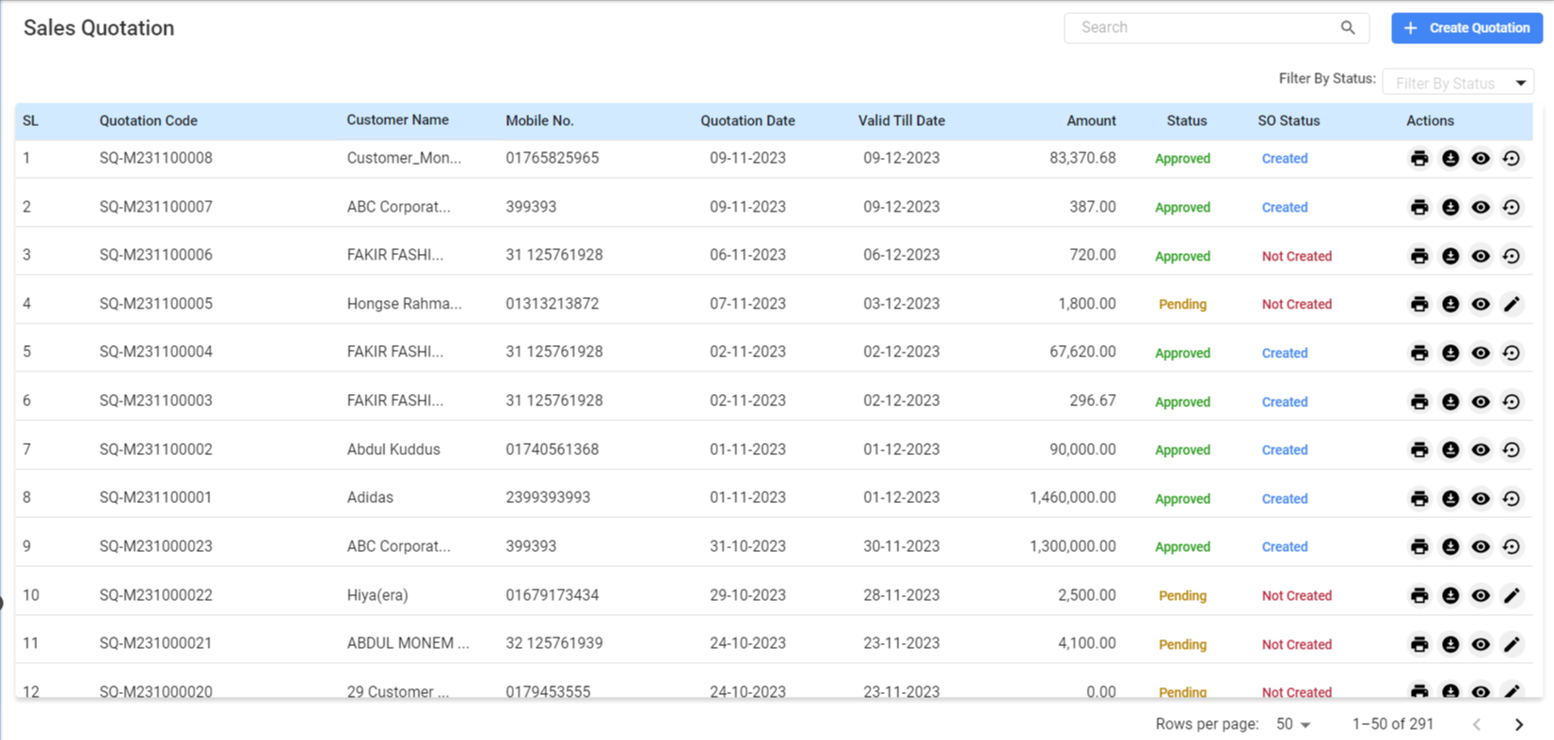

**Features:**

**Search Bar:** the search bar at the top to quickly find specific quotations by entering relevant keywords.

**Creating a New Quotation:** Clicking on the ‘Create Quotation’ button positioned in the upper-right area to initiate a new quotation entry.

**Filtering Options:**

* + Employ the date filter to display quotations within a certain period.
  + Use the view toggle to customize the number of quotations displayed per page.

**Table View:** The table view presents a systematic list of all quotations with essential details:

* + - **SL (Serial Number):** The sequential number assigned to each quotation.
    - **Quotation Code:** A unique identifier for each quotation.
    - **Customer Name:** The name of the customer who requested the quotation.
    - **Quotation Date:** The date on which the quotation was generated.
    - **Valid Till Date:** The expiration date of the quotation's validity.
    - **Amount:** The total proposed price on the quotation.
    - **Status:** Indicates the current state of the quotation (e.g., Pending, Approved).
    - **SO Status:** Shows if a Sales Order has been created from the quotation.
    - **Actions:** Icons for viewing detailed quotation, printing,excel download, view and reversing the quotation to a sales order.

Once the quotation details are complete and reviewed, click the **‘Save’** button to store the quotation in the system.

### ***2.2.2 Creating a New Sales Quotation:***

**User Interface [ Create Sales Quotation]:**

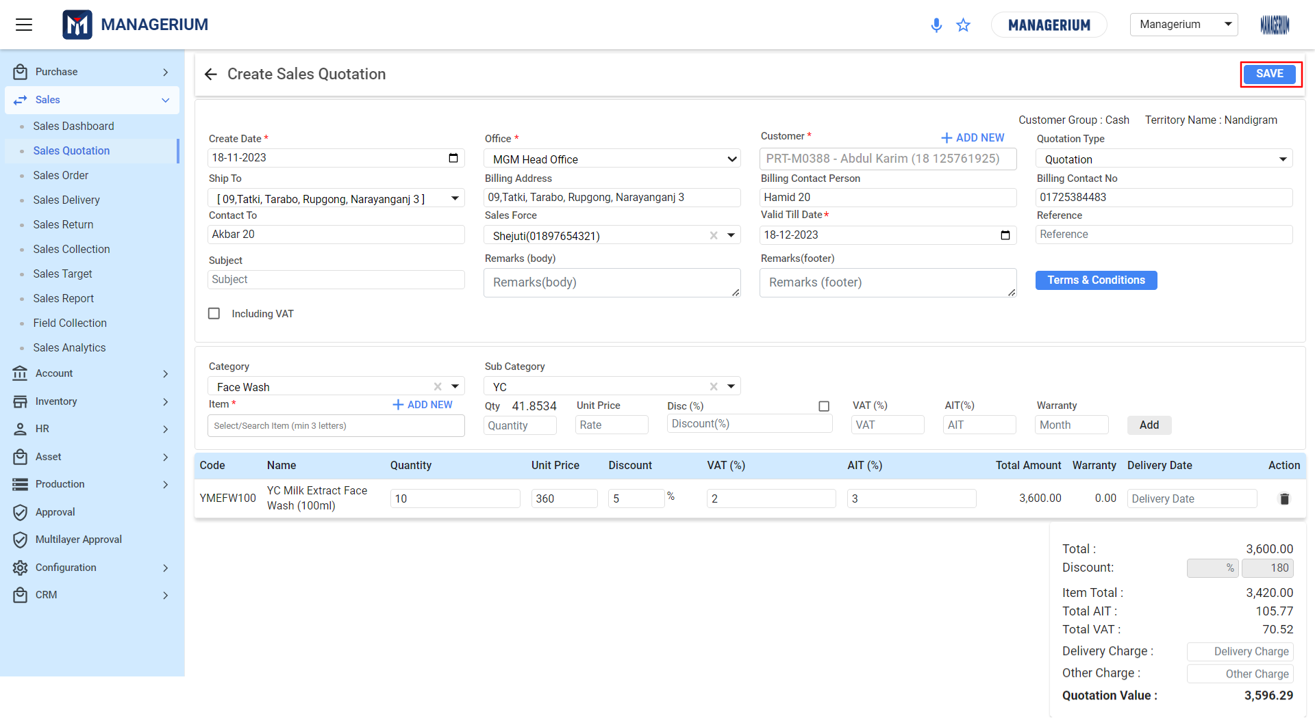

***Steps:***

* **Filling Out Quotation Details:**
  + **Create Date:** Enter the date users are creating the quotation.
  + **Office:** Select usersr office location from the dropdown menu.
  + **Customer:** Choose the customer from the list or add a new customer by clicking ‘ADD NEW’.
* **Quotation Specifics:**
  + **Ship To/Billing Address:** Enter the shipping and billing addresses for the quotation.
  + **Contact To:** Specify the contact person at the customer's end.
  + **Subject:** Write a subject line for the quotation.
  + **Including VAT:** Check this box if the quotation prices are to include VAT.
* **Adding Products or Services:**
  + **Category and Sub Category:** Select the appropriate category and subcategory for the item.
  + **Item:** Search for the item or add a new one by clicking ‘ADD NEW’.
  + **Quantity:** Enter the quantity for the item.
  + **Unit Price:** Input the price per unit of the item.
  + **Discount:** Apply any discount as a percentage if applicable.
  + **VAT and AIT:** Enter the VAT and Advance Income Tax percentages if required.
* When User includes VAT, calculation happens as follows:

**VAT:**

* Vat is calculated and subtracted. The breakdown of the calculation is:

VAT = Net Taxable Amount × Applicable VAT Rate / (100 + Applicable VAT Rate)

Thus, calculation for the above figure will be = (100 × 10) / (100 + 10)

= 9.09

**AIT:**

* AIT is calculated once VAT and SD is deducted from the Net Amount.

AIT = {Net Taxable Amount – (VAT+SD)} × (Applicable AIT Rate × 100)

Calculation will be = {100 – (9.09+4.33)} × (2×100)

= 86.58-1.73

= 84.85

So, the final result after the Vat, SD, AIT deduction is 84.85 BDT.

* When User do not include VAT, the calculation happens as follows:

***VAT:***

* Vat is calculated on total price including SD.

VAT = {(Net Taxable Amount + SD) × (VAT / 100)}

= {(100+10} × (10/100)}

=11

***AIT:***

* AIT is calculated on the total item price only.

AIT = Net Taxable Amount × (AIT / 100)

=10

So, the final result after the Vat, SD, AIT addition is 131 BDT.

* **Additional Information:**
  + Total Amount: This field will auto-calculate based on the quantity and unit price.
  + Warranty: Specify warranty terms if applicable.
  + Delivery Date: Indicate when the goods or services are expected to be delivered.
* **Terms and Financials:**
  + **Remarks:** Add any relevant notes or messages to the body or footer of the quotation.
  + **Terms & Conditions:** Review and attach the terms and conditions related to the sale.

### ***2.2.3 Sales Quotation- Terms & Conditions:***

**User Interface [ Add Terms & Conditions]:**

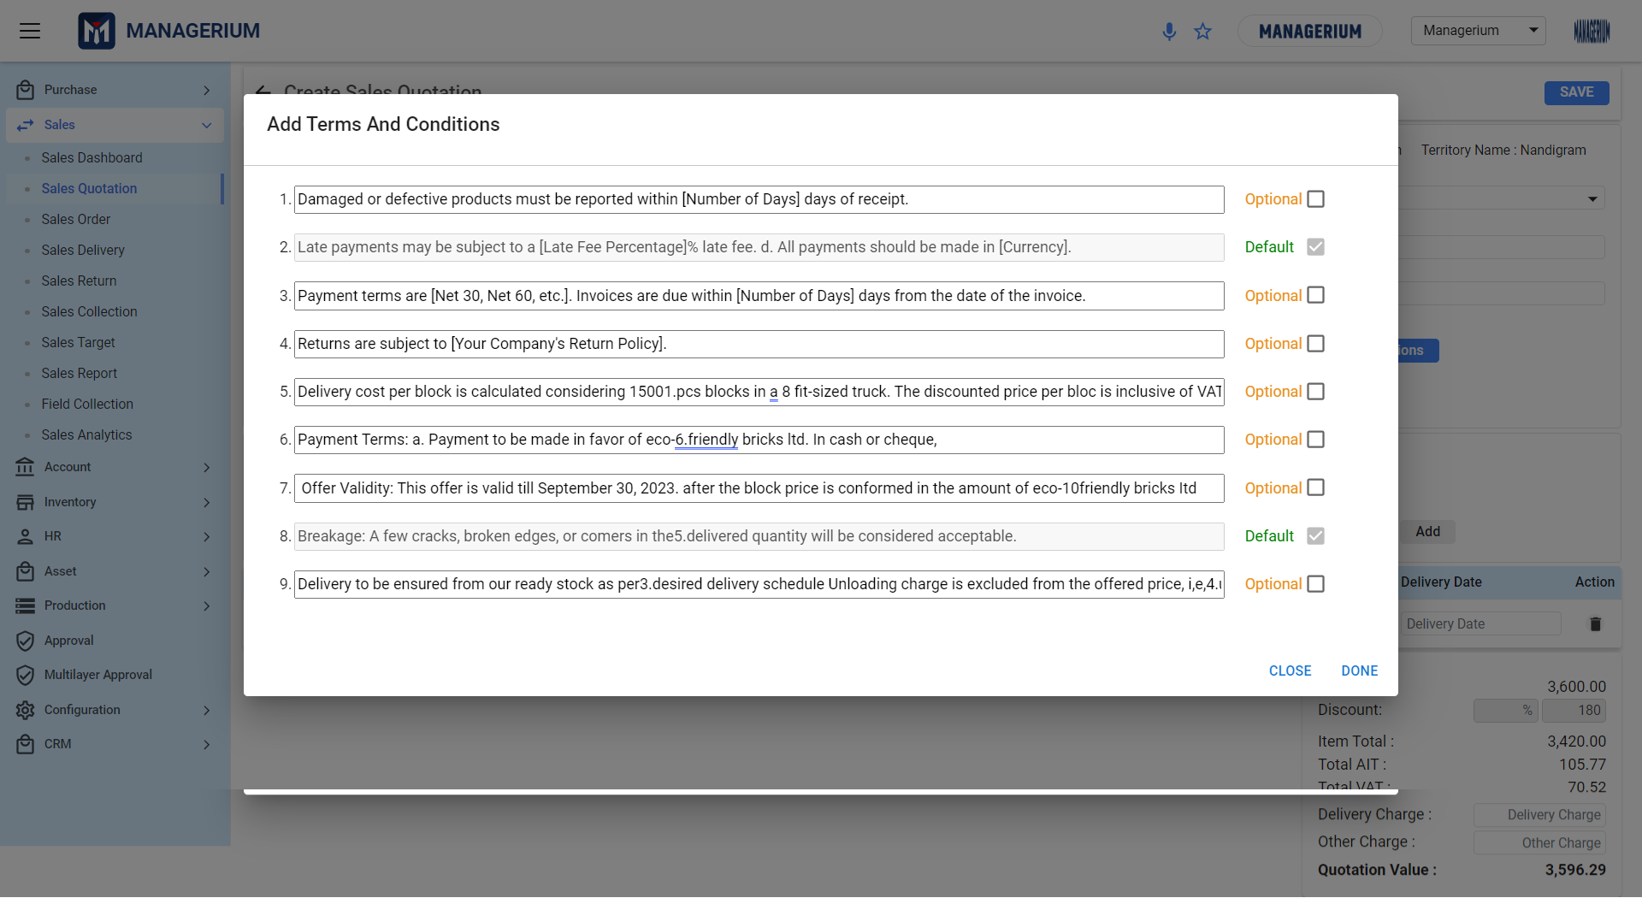

* ***Accessing Terms and Conditions:***
  + *Within the 'Create Sales Quotation' form, locate and click on the 'Terms & Conditions' button to open the terms editor.*
* ***Overview of Terms and Conditions Section:***
  + *The interface presents a list of pre-defined terms and conditions.*
  + *Each term has a checkbox to mark it as 'Default' or 'Optional'.*
  + *'Default' terms will automatically appear in every quotation. 'Optional' terms can be added as needed.*
* ***Customizing Terms:***
  + *To modify a term, click on the text field and make usersr changes. Ensure clarity and specificity to avoid misunderstandings.*
  + *To add a new term, scroll to the bottom of the list and write usersr condition in the provided space, then click 'Add'.*
* ***Organizing Terms:***
  + *Rearrange the order of terms as needed by dragging and dropping them into place.*
  + *Terms should be ordered by importance or relevance to the transaction.*
* ***Setting Default and Optional Terms:***
  + *Choose which terms will be 'Default' by selecting the corresponding checkbox. These will be included in all quotations unless manually removed.*
  + *Mark less frequently used terms as 'Optional'. These can be added to specific quotations when relevant.*
* ***Reviewing and Saving Terms:***
  + *Review all terms and conditions to ensure they are correct and complete.*
  + *Once finalized, click 'DONE' to save usersr terms and return to the quotation form.*
  + *The terms and conditions will now be attached to the quotation.*
* ***Editing Terms Post-Creation:***
  + *If users need to edit terms after saving the quotation, reopen the 'Terms & Conditions' editor from the quotation form.*
  + *Make necessary edits and save again to update the quotation.*
* ***Finalizing the Quotation:***
  + *Ensure that all other quotation details are accurate and complete.*
  + *Review the terms and conditions one final time for accuracy and completeness.*
  + *Save the entire quotation by clicking the 'SAVE' button on the quotation form.*
  + **Quotation Value:** Review the total value of the quotation, which includes total item cost, discounts, taxes, and any additional charges.
* **Finalizing the Quotation:**
  + Review all the details entered to ensure accuracy.
  + Click on the **'SAVE'** button to save the quotation.
  + Once saved, the quotation will be directed for approval or sent to the customer for review.

## 2.3 Sales Order

It confirms the seller's acceptance of the sales contract and includes details such as product quantities, descriptions, prices, and delivery terms. Users can track the status of all sales orders through the Sales Order List, which provides visibility into the pipeline. The user can handle two kinds of sales:

**Menu Path:**  **Sales (Module)> Sales Order**

**Features:**

**Tabs:**

* **SALES:** The type of sales order that will be generated for products that will be sold at once resulting in the seller losing authority over it.
* **RENTAL:**The type of sales order that will be generated for subscription or temporary usage of a product or service.
* **DELIVERY SCHEDULE:** The delivery schedule helps make sure orders are sent out on time. It's a plan that the sales team and customers can see, which makes the delivery process clear and efficient.

### ***2.3.1 New Sales Order Landing:***

**User Interface [Order Management-Sales]:**

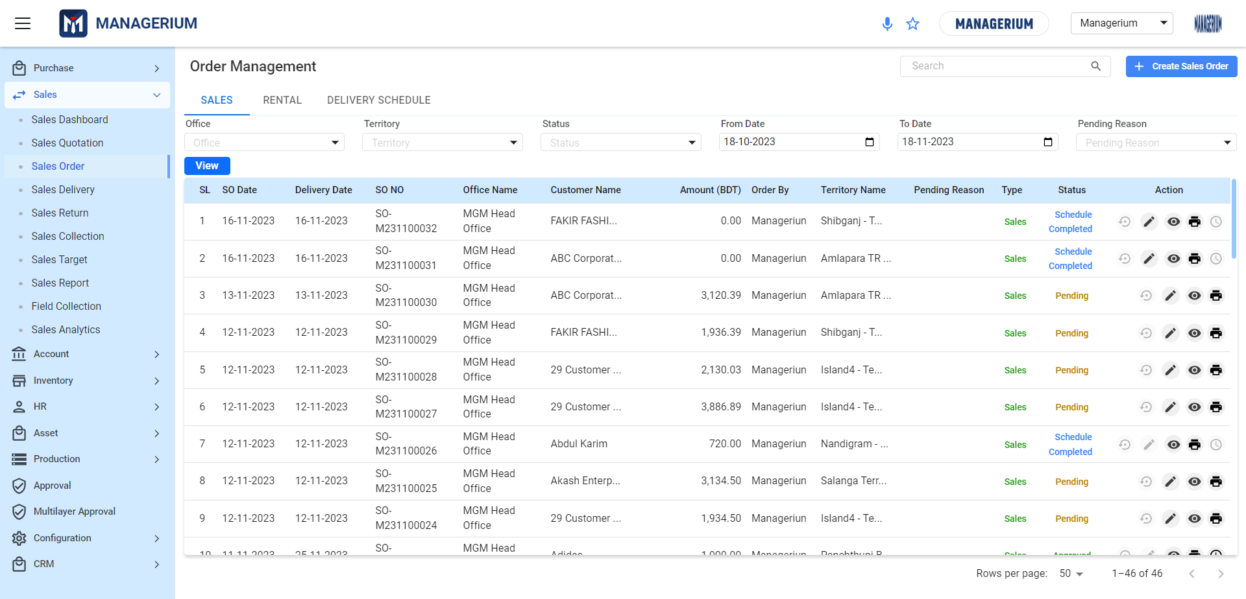

* **Search Bar:** Use the search bar to quickly locate specific sales orders. Simply type in relevant keywords or order details to filter the results.
* **+Creating Sales Order:** To begin a new sales order, click the 'Create Sales Order' button. This is located in the upper-right corner of the Order Management interface.
* **Filtering Options:**
  + **Date Filter:** Choose a date range to view sales orders created within that period.Utilize the date range selectors to filter orders between specific dates.
  + **View Adjustment:** Select how many orders users'd like to view per page for usersr convenience.Sort the view by various criteria such as office, territory, and order status to find specific orders quickly.
* **Sales Order Listings:**
  + **Serial Number (SL):** Each order is assigned a sequential number for identification.
  + **Sales Order Number (SO No.):** Every order is tracked with a unique identifier.
  + **Office Name:** The office handling the sales order.
  + **Customer Name:** The client for whom the order is processed.
  + **Amount (BDT):** The total value of the sales order in Bangladeshi Taka.
  + **Status:** Current progress status of the order (e.g., Scheduled, Pending, Completed).
  + **Action:** Direct links to manage the order, including options to edit, view, and finalize the sale.
* **Saving Sales Orders:**
  + After entering all necessary information and ensuring accuracy, click the **'Save'** button to secure the sales order in the system.

### 

### ***2.3.2 Creating a New Sales Order:***

**User Interface [ Create Sales Order]:**

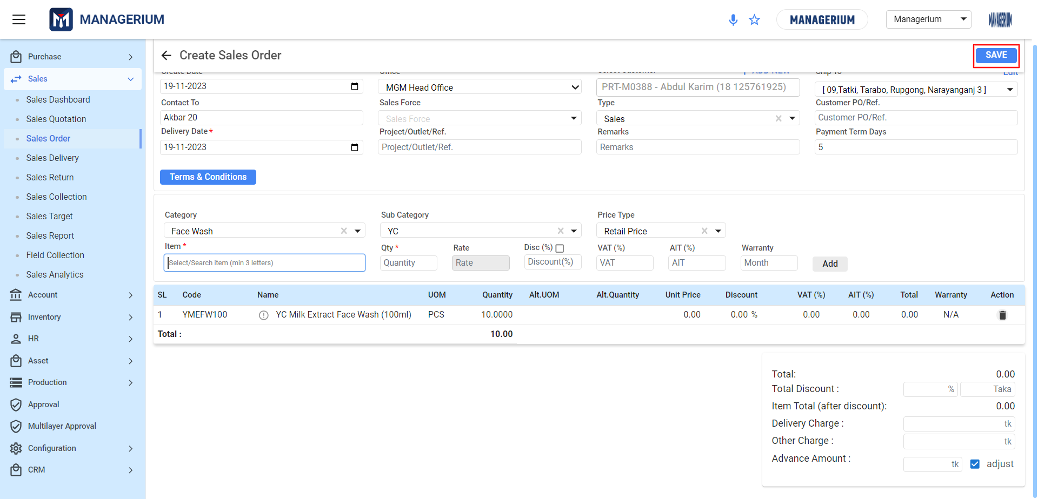

**Filling Out the Sales Order Details:**

**Order Information:**

### Create Date: Set the current date or the date when the order is being placed.

### Office: Select usersr office location from the drop-down menu.

### Sales Force: Assign the sales representative responsible for the order, if applicable.

### Customer Details:

### Customer: Choose a customer from the list or add a new one using the '+ ADD NEW' option.

### Contact Information: Enter or confirm the customer's contact details and delivery address.

### Order Specifics:

### Delivery Date: Specify when the customer expects to receive the goods.

### Terms & Conditions: Review or input terms related to the sale, such as payment terms, warranty, and delivery instructions.[Same As Before]

### Item Selection:

### Category & Sub Category: Define the category and sub-category of the items to be ordered.

### Items: Add products by selecting from a searchable drop-down list or by adding new items.

### Quantity and Pricing:

### Input the quantity and confirm the unit price for each item.

### Apply any discounts, VAT, AIT, and add warranty details if needed.[Calculation Same As Before]

### Reviewing the Order:

### Total Summary: Check the overall total, including any discounts, taxes, and additional charges like delivery or other fees.

### Advance Amount: Enter any advance payment made or to be made for the order.

### Saving the Sales Order:

### Finalize: Review all the details for accuracy.

### Save: Once verified, click the 'SAVE' button to record the sales order.

### 

### ***2.3.3 Rental Order Landing:***

**User Interface [Order Management-Rental]:**

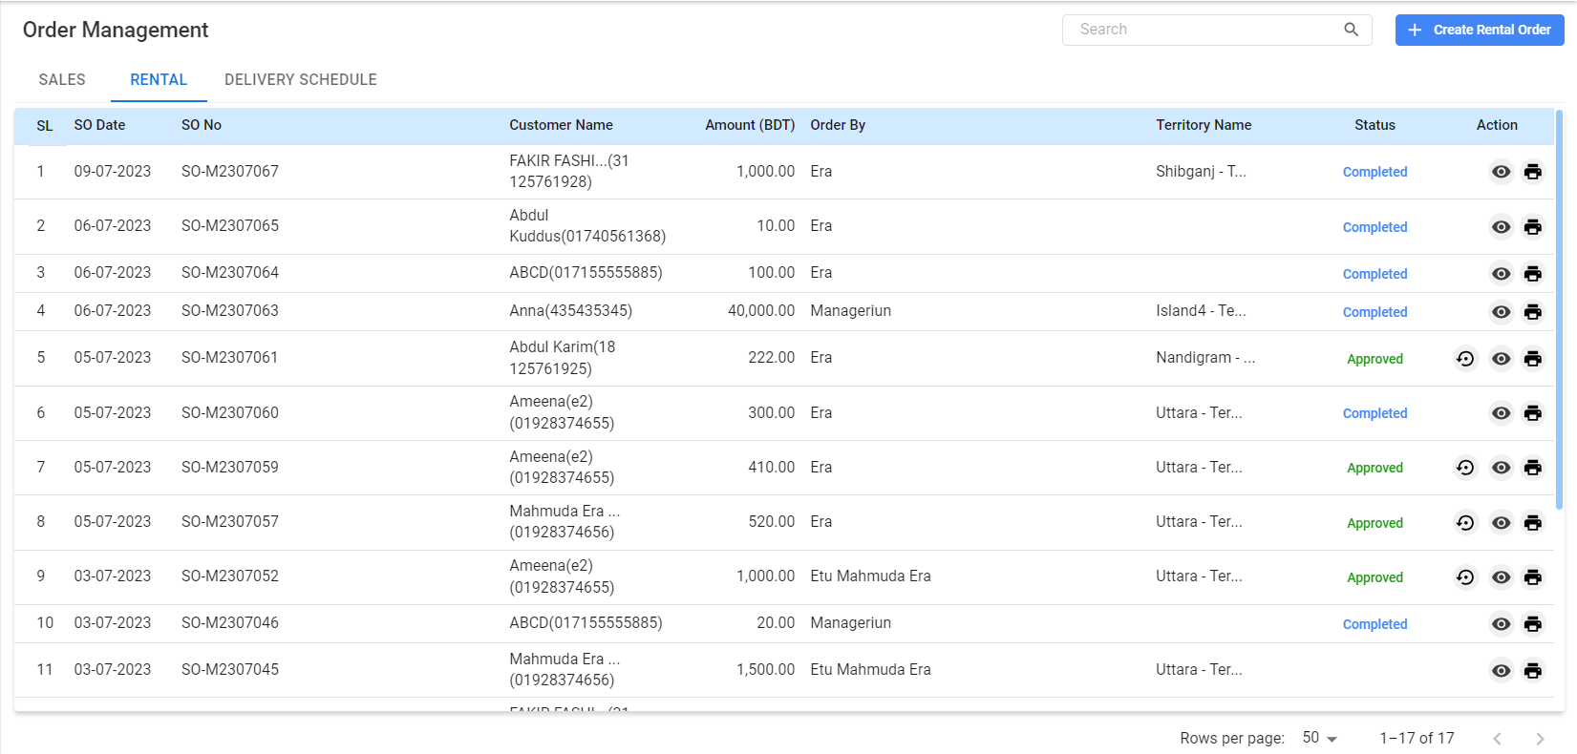

**Navigating Rental Orders:**

* The screen will display a list of all rental orders with their details.
* Use the search bar at the top of the list to find specific rental orders by entering relevant keywords.
* To create a new rental order, click on the '+ Create Rental Order' button located in the upper-right corner of the screen.

**Understanding Rental Order Details:**

* **SL (Serial Number):** Displays the order in a numbered sequence.
* **SO Date:** Shows the date the rental order was placed.
* **SO No (Sales Order Number):** Indicates the unique number assigned to the rental order.
* **Customer Name:** The name of the customer who placed the rental order.
* **Amount (BDT):** The total amount for the rental service in Bangladeshi Taka.
* **Order By:** The name of the individual or entity that created the order.
* **Territory Name:** Indicates the geographic region or territory of the rental order.
* **Status:** Shows the current status of the rental order (e.g., Completed, Approved,).

**\*\*\* Once the order has been approved and delivered to the customer the status gets ‘Completed’.**

* **Actions:** This column provides various action buttons:
  + ***View (Eye Icon):*** Enables users to view in-depth details of the sales order.
  + ***Print Icon:*** Enables users to print in-depth details of the sales order.
  + ***Reverse Icon:*** Depending on the action for tasks enables users to reverse the order.

### ***2.3.4 Creating Rental Order :***

**User Interface [Creating Rental Order]:**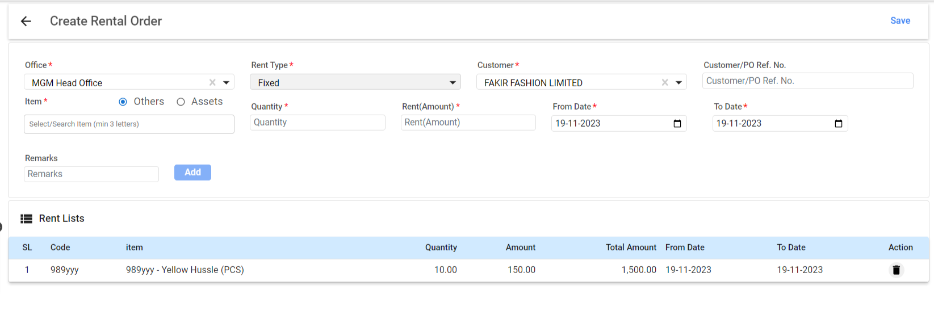

* **Filling Out Rental Order Information:**
  + **Office:** Select the office from which the order is being managed.
  + **Rent Type:** Choose the type of rental (e.g., Fixed, Variable, etc.).
  + **Item:** Search for and select the item to be rented out.
  + **Quantity:** Enter the number of items the customer wants to rent.
  + **Rent (Amount):** Specify the rental price for the item(s).
  + **From Date:** Pick the start date of the rental period.
  + **To Date:** Select the end date of the rental period.
  + **Customer:** Choose the customer from the dropdown menu or add a new customer.
  + **Customer/PO Ref. No.:** Enter a reference number if applicable.
* **Adding Items to the Rental Order:**
  + Click on the **'Add'** button after entering the item details to include them in the rental order.
* **Reviewing the Rent List:**
  + Below the entry form, review the 'Rent Lists' section to ensure all items and details are correct.
  + The list will display the item code, name, quantity, individual amount, total amount, and the rental period.
* **Saving the Rental Order:**
  + After verifying all information is accurate, click the **'Save'** button at the top right to finalize the rental order.

## 

### ***2.3.5 Delivery Schedule Landing :***

**User Interface [ DELIVERY SCHEDULE]:**

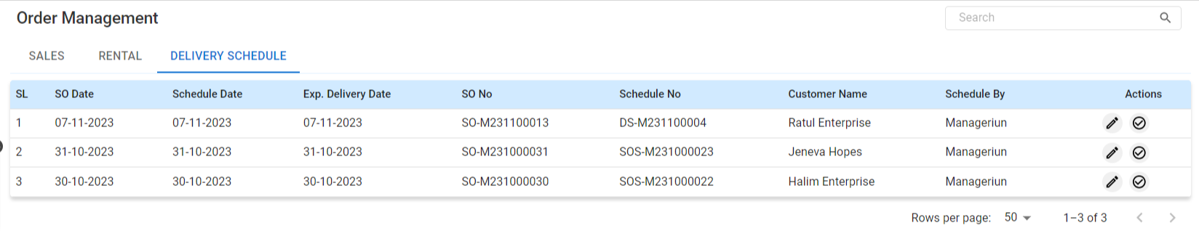

* **Delivery Schedule Table Details:**
  + The interface lists scheduled deliveries with details such as SL (Serial Number), SO Date (Sales Order Date), Schedule Date, Exp. Delivery Date (Expected Delivery Date), SO No (Sales Order Number), Schedule No, Customer Name, Scheduled By, and Actions.
* **Scheduling a Delivery[From Sales Order Landing]:**
  + To schedule a new delivery, locate and click on the **Clock Icon** from Sales Order's Action to specify the delivery schedule.

**\*\*\*Once it is saved for scheduled delivery it’ll add here.**

* **Viewing and Editing Scheduled Deliveries:**
  + Use the search bar to quickly find specific delivery schedules.
  + The 'Actions' column contains icons for editing or approving additional details of a scheduled delivery.
* **Completing Delivery Schedules:**
  + Once a delivery is completed, update the schedule status accordingly to maintain accurate records.Then it’ll affect the Sales Delivery Menu.

## 2.4 Sales Delivery:

It offers the ability to deliver products based on approved sales orders or through direct delivery entries. Users can confirm deliveries, print necessary documents like invoices and shipping challans, and manage post-delivery documentation.

**Menu Path:**  **Sales (Module)> Sales Delivery**

**Features:**

**Tabs:**

* + **APPROVED SO:** View sales orders that have been approved and are ready for delivery.
  + **DELIVERY LIST:** Monitor the progress and status of deliveries.

### ***2.4.1 Approved PO Landing :***

### **User Interface [APPROVED SO-Landing Page]:**

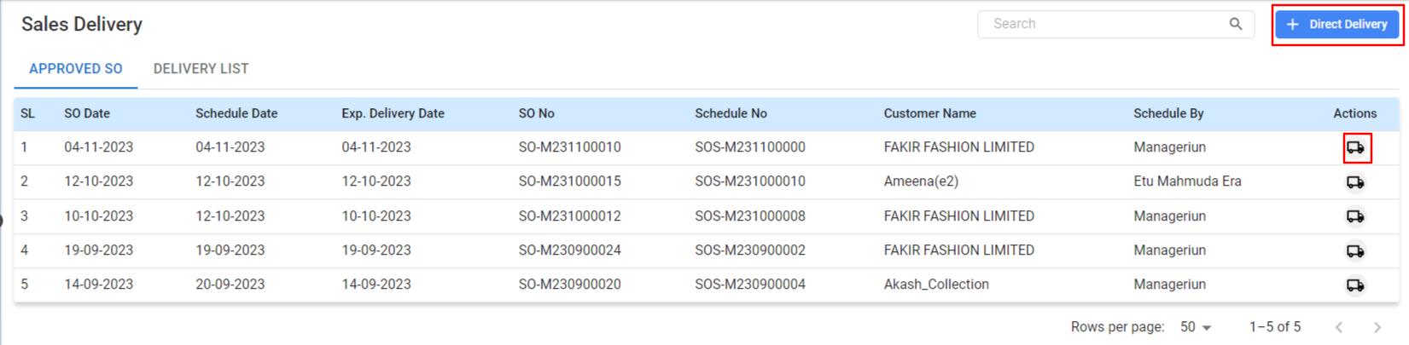

**Main Table:**

* + Displays essential details of sales deliveries such as SL (Serial Number), SO Date (Sales Order Date), Schedule Date, Exp. Delivery Date (Expected Delivery Date), SO No (Sales Order Number), Schedule No, Customer Name, Scheduled By, and Actions.

**Managing Deliveries:**

* **Search Bar:**
  + Use the search bar to quickly locate specific deliveries using relevant terms.
* **Direct Delivery:**
  + Click on the 'Direct Delivery' button to initiate a delivery process for an order not listed or for immediate dispatch.
* **Delivery Actions:**
  + Use the 'Actions' icons to deliver SO.

### ***2.4.2 Delivery For SO from table:***

### **User Interface [Delivery For SO]:**

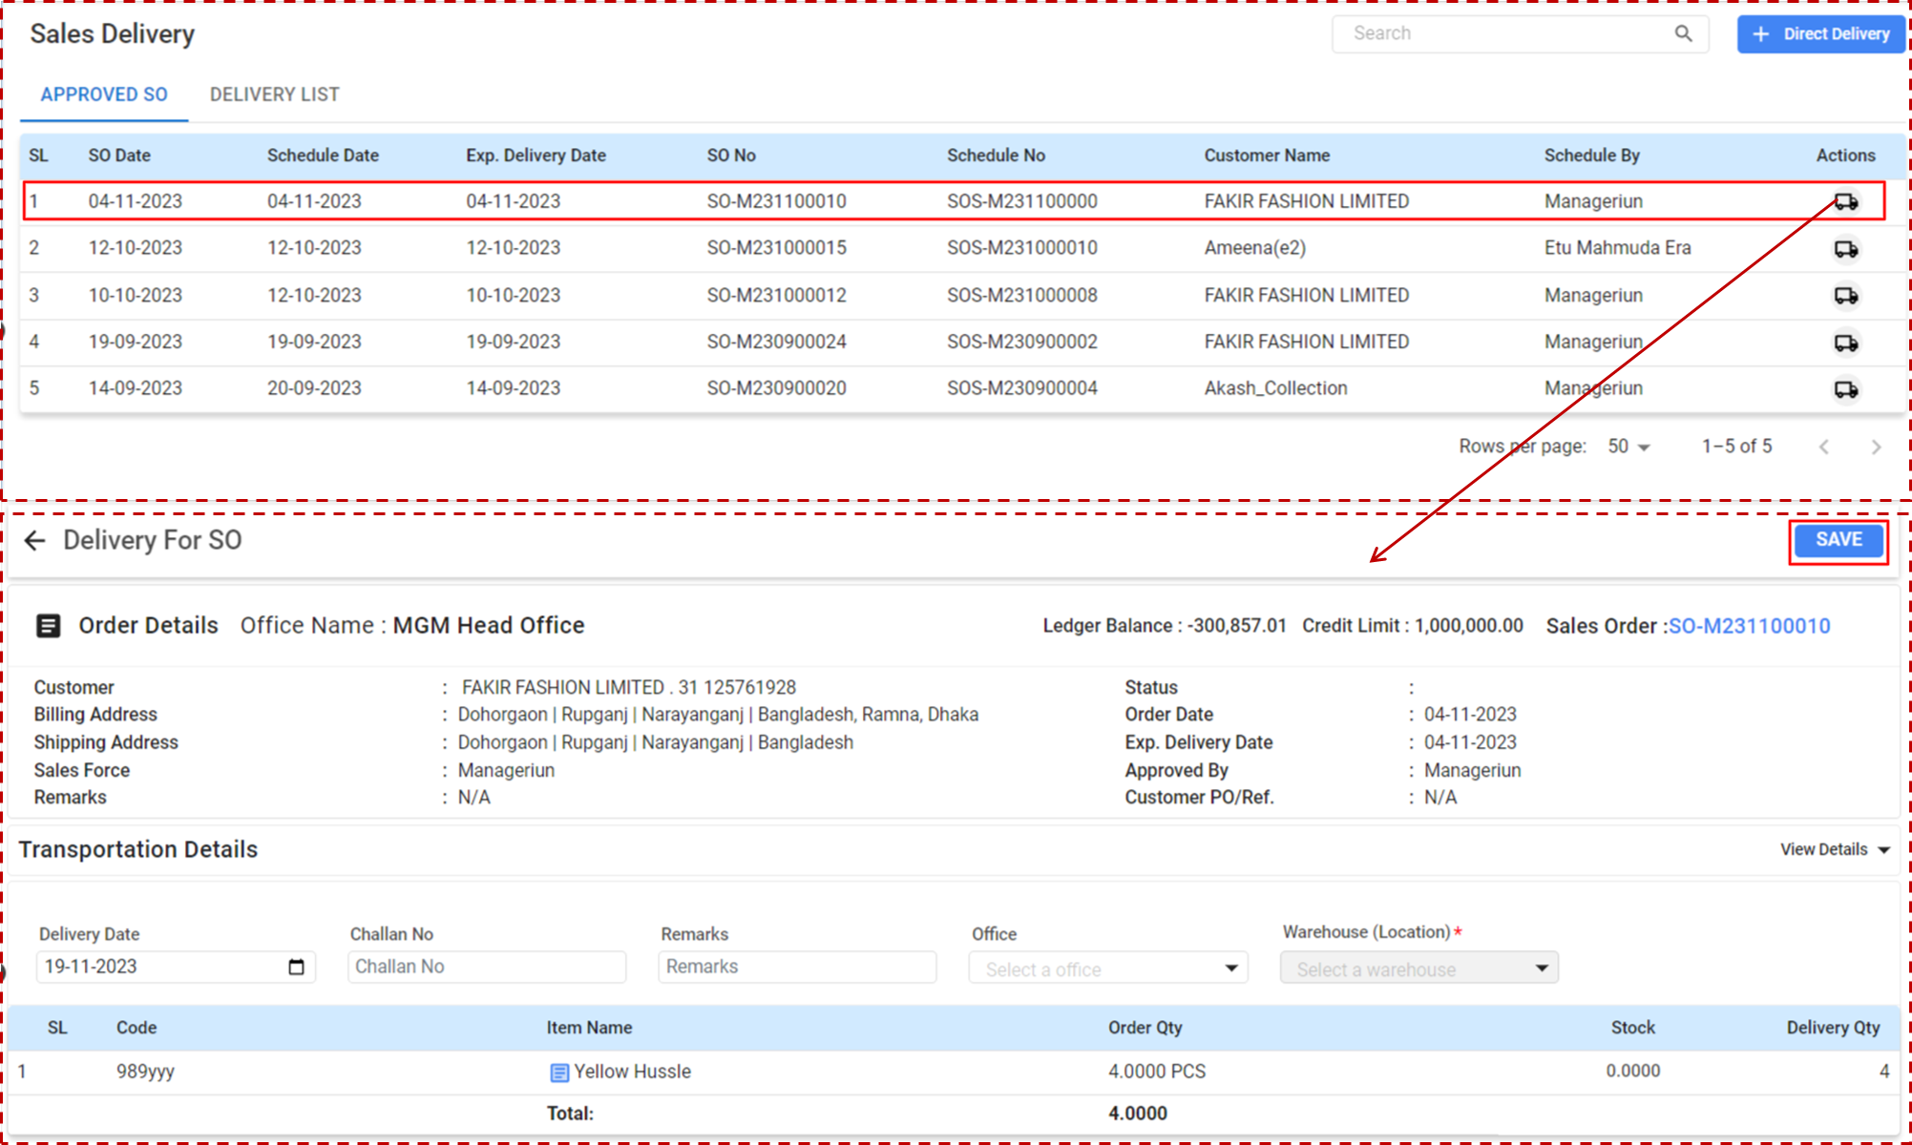

**Accessing Delivery Details for SO:**

* **Upper Table View:**
  + Displays Sales Orders due for delivery with details such as SO Date, Schedule Date, Exp. Delivery Date, SO No, Customer Name, Scheduled By, and Actions.
* **Detailed Delivery View:**
  + Shows complete details of the selected Sales Order, including Customer Information, Billing Address, Shipping Address, and the assigned SalesForce.

**Procedure for Executing Delivery:**

* **Reviewing Order Details:**
  + Confirm the Sales Order information, including customer and billing details.
  + Ensure the correct Sales Order is selected for delivery.
* **Entering Transportation Details:**
  + Set the actual Delivery Date when the items are to be dispatched.
  + Enter the Challan No, which is the reference number for the delivery note.
  + Provide any necessary Remarks related to the delivery.

### 

### **User Interface [Transportation Details]:**



* **Adding Items to Deliver:**
  + Review the list of items under the 'SL' (Serial Number) and 'Code' columns.
  + Check the 'Order Qty' against 'Stock' to ensure adequate inventory.
  + Specify the 'Delivery Qty', which should match or be less than the available stock.
* **Selecting Office and Warehouse:**
  + Choose the office from which the order is being dispatched.
  + Select the appropriate Warehouse (Location) where the items are stored.
* **Saving the Delivery Details:**
  + Once all the details are confirmed and entered, click the **'Save'** button to finalize the delivery process.

### ***2.4.3 Direct Delivery:***

### **User Interface [Direct Delivery]:**

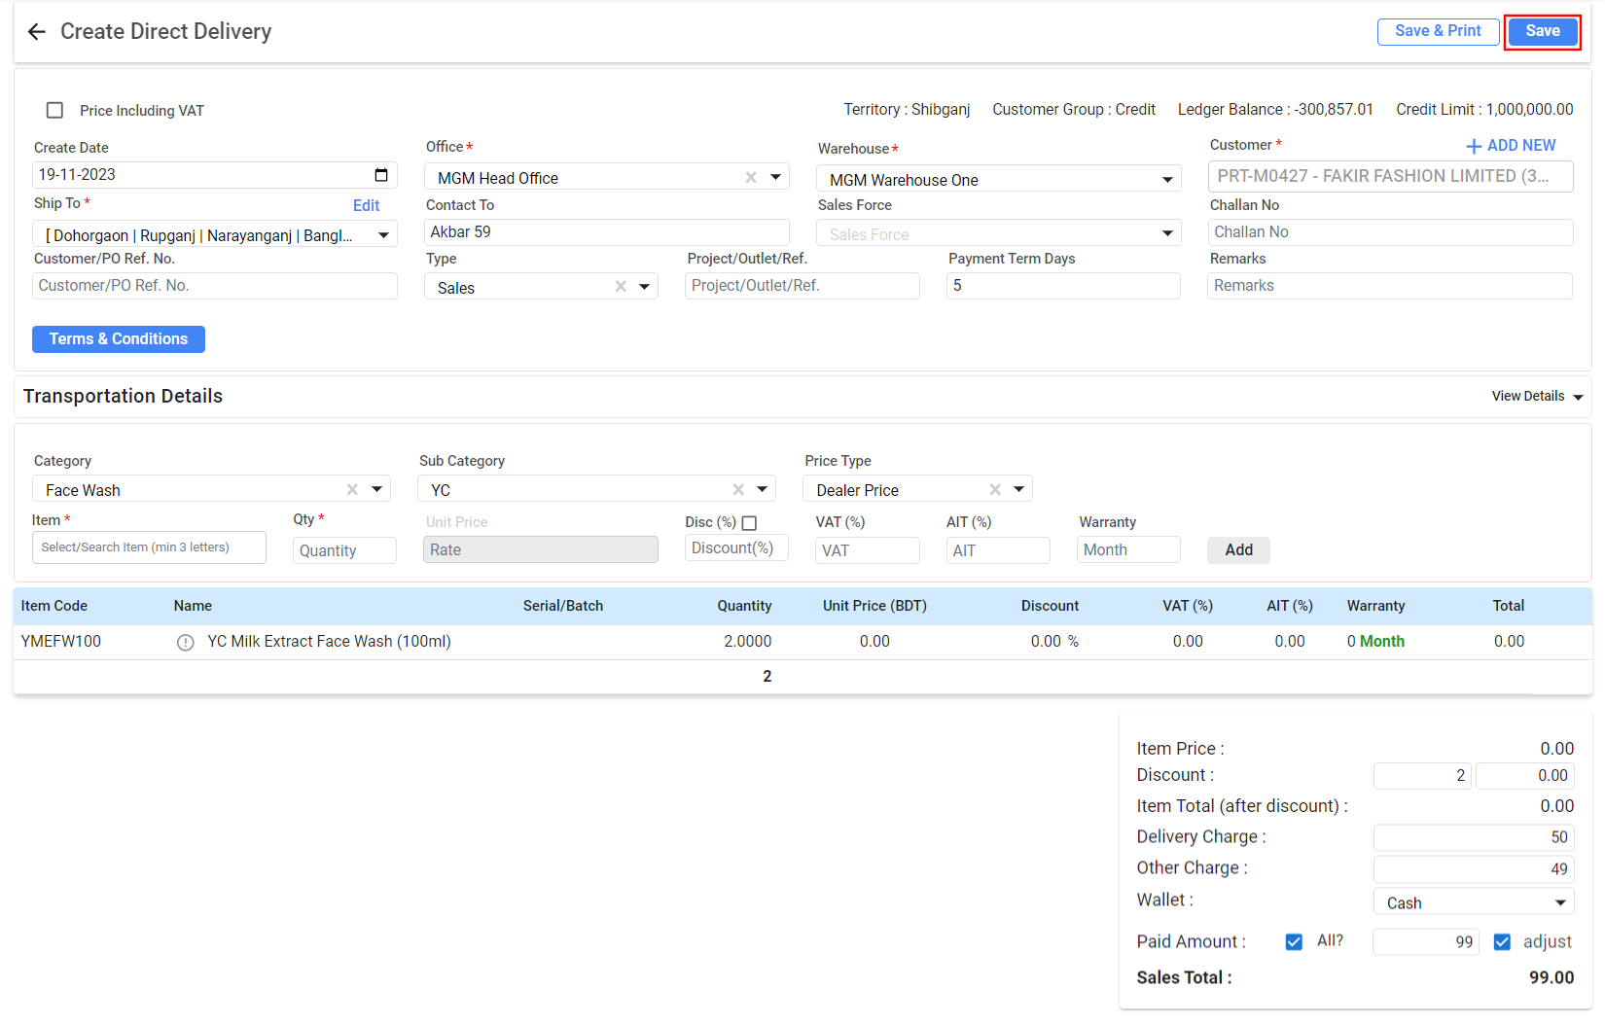

* **Enter Delivery Information:**
  + **Create Date:** The current date will autofill or can be selected manually.
  + **Office:** Choose the office from which the delivery will be dispatched.
  + **Customer:** Select the customer receiving the delivery. Use the 'ADD NEW' option if the customer is not in the database.
* **Transportation and Item Details:**
  + **Shipping To:** Edit or confirm the delivery location.
  + **Category/Sub Category:** Select the appropriate category for the items being delivered.
  + **Item:** Choose the specific item to deliver. Begin typing the name and select from the auto-suggested list.
  + **Quantity:** Enter the number of items to be delivered.
* **Pricing Details:**
  + **Price Type:** Select the applicable price type, such as Dealer Price or Retail Price.
  + **Unit Price:** Input the price per item.
  + **Discount, VAT, AIT:** Enter any applicable discount percentages and tax details.
* **Additional Information:**
  + Payment Term Days: Specify the number of days allowed for payment post-delivery.
  + **Warehouse:** Choose where the items are stored.
  + **Sales Force:** Assign a sales representative if needed.
* **Finalize Delivery:**
  + Review all entered details for accuracy.
  + Click 'Add' to include the item in the delivery list.
* **Review and Complete Transaction:**
  + Check the 'Item Total', 'Delivery Charge', and 'Other Charge' fields.
  + If applicable, select the 'Wallet' method and input the 'Paid Amount'.
  + Review the 'Sales Total', which is the final amount including all charges.
* **Save and Print:**
  + Once verified, click 'Save' to record the delivery.
  + Use the 'Save & Print' option to save and immediately print a delivery note.

### ***2.4.4 Delivery List:***

### User Interface [Delivery List]:

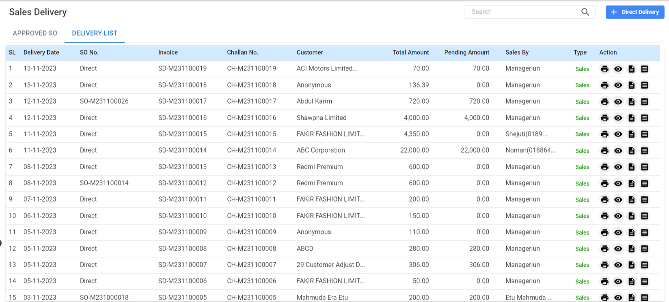

* Navigate to Delivery List: Under the 'Sales Delivery' section, click on the 'Delivery List' tab to view all recorded deliveries.
  + **SL (Serial Number):** A unique identifier for each delivery entry.
  + **Delivery Date:** The date when the delivery was executed or is scheduled for.
  + **SO No. (Sales Order Number):** The reference number of the associated sales order, if any.
  + **Invoice:** The invoice number generated for the delivery.
  + **Challan No.:** The delivery challan or note reference number.
  + **Customer:** The name of the customer who received the delivery.
  + **Total Amount:** The total cost of goods delivered.
  + **Pending Amount:** Any outstanding amount that is yet to be paid.
  + **Sales By:** Indicates which sales representative is responsible for the sale.
  + **Type:** Classifies the delivery as direct or linked to a sales order.
  + **Action:** Icons for managing the delivery details.
    - ***Printer(icon):*** Clicking this icon will initiate the printing process for the delivery note.
    - **View(icon):** This icon represents the option to view more details.
    - ***List(icon):*** *The* icon labeled as 'Challan' or represented by a document symbol might be used to view, print, or download the delivery challan specifically.
    - ***Doc (icon):*** Mushak-6.3 refers to a specific type of document in details

## 2.5 Sales Return:

It accommodates the return process, whether it's for the entire order (Full Return), part of the order (Partial Return), or returns without a specific reference (Return Without Ref.). This process is critical for managing reverse logistics and customer satisfaction.

**Menu Path:**  **Sales (Module)> Sales Return**

**Features:**

**Tabs:**

* **DELIVERY LIST:** Shows Invoice & details that have been delivered and are eligible for return.
* **RETURN LIST:** Displays Invoice & details that have been processed for return.

### 

### **User Interface [ DELIVERY LIST landing]:**

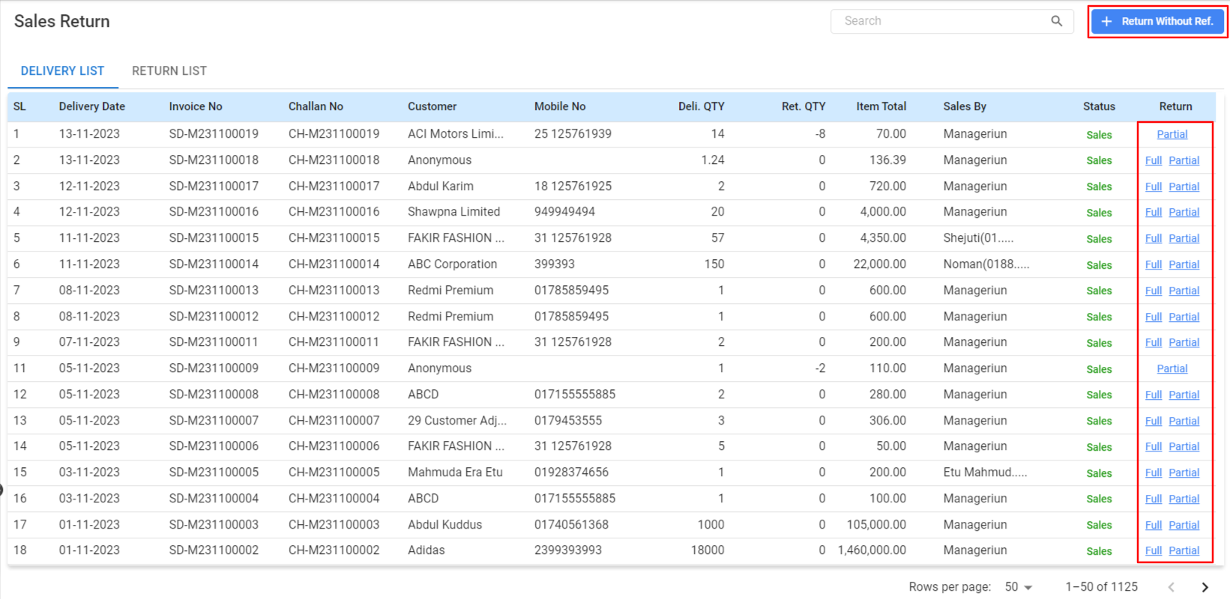

**Sales Return Overview:**

**Table Details:**

* Displays all sales returns with details like Delivery Date, Invoice No., Challan No., Customer, Mobile No., Delivered Quantity (Del. QTY), Returned Quantity (Ret. QTY), Item Total, Sales By, Status, and Return options.
* **Search Bar:** Use this to quickly find specific returns by entering relevant details.
* **Return Without Ref.:** Click this button to initiate a return process for items without referring to a specific sales order or delivery note.
* **Return Options:** Each line item has 'Full' or 'Partial' return options, indicating whether all or part of the items are returned.

**Processing a Return:**

* Locate the item to be returned in the list.
* Use the 'Full' or 'Partial' button to select the type of return.
* The system may prompt users to enter the quantity being returned if a partial return is selected.
* Add any relevant notes or reasons for the return in the provided fields if necessary.

### ***2.5.1 Creating a Return [SO Wise]:***

**User Interface [Create Sales Return WithOut Ref.]:**

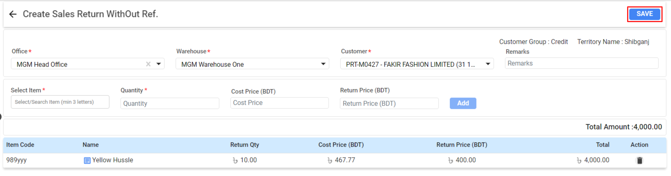

**Filling Out Return Details**

**Creating a Return Without Ref.:**

* **Office:** Select the office from which the return is being processed.
* **Warehouse:** Choose the warehouse that currently houses the item.
* **Customer:** Select the customer from whom the return is received.
* **Item Selection:** Search for and select the item to be returned.
* **Quantity:** Enter the quantity of the item being returned.
* **Cost Price (BDT):** If known, enter the cost price of the item being returned.
* **Return Price (BDT):** Enter the price at which the item is to be returned.
* **Remarks:** Add any relevant comments or reasons for the return.

**Adding Items to Return:**

* After filling out the information for an item, click the **‘Add’** button to include it in the return list.

**Reviewing and Saving the Return:**

* Review the added items in the return list below the entry fields.
* Verify the quantities and return prices.
* If users need to make changes, users can edit or remove items using the action buttons next to each item.

**Finalizing the Return:**

* Once users have reviewed and confirmed the return details, click the **‘Save’** button located at the top-right corner to finalize the return.

### ***2.5.2 Return Full or Partial [SO/Direct Wise]:***

**User Interface RECEIVED LIST [Return Full or Partial (SO/Direct Wise)]**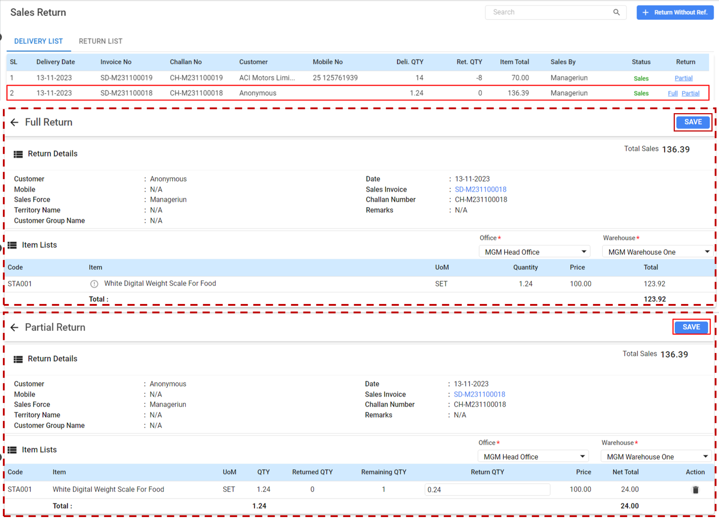

**Full Return:**

* **Return Details:**
  + **Customer:** Select the customer from whom the return is being made.
  + **Mobile:** Enter the mobile number of the customer if necessary.
  + **Sales Force:** This field may auto-populate based on the user handling the return.
  + **Territory Name:** Indicate the sales territory associated with the return.
  + **Customer Group Name:** Choose the customer group, if applicable.
* **Item Lists:**
  + Review the item(s) being returned, already listed with details such as code and description.
  + Verify the quantity, unit of measure (UoM), and price for accuracy.
* **Financial Details:**
  + Confirm the total sales amount of the return which is automatically calculated based on the item details.
  + If necessary, adjust the quantity or price to reflect the accurate return amount.
* **Finalizing the Return:**
  + After ensuring all details are correct, click on the **‘Save’** button to complete the full return process.
  + The return will be recorded in the system, adjusting inventory and financial records accordingly.

**Partial Return:**

* **Return Details:**
  + **Customer:** Confirm the customer’s name for whom the partial return is being processed.
  + The rest of the details such as Mobile, Sales Force, Territory Name, and Customer Group Name should be verified or filled out as needed.
* **Item Return Details:**
  + **Code:** Check the item code to ensure the correct item is being returned.
  + **Item:** Confirm the item description.
  + **Quantity:** Review the original quantity sold.
  + **Return Quantity:** Specify the number of items being returned.
  + **Remaining:** The system will calculate the remaining quantity after the return.
  + **Price:** Ensure the price per unit is accurate.
  + **VAT:** Verify the VAT percentage, if applicable.
* **Financial Summary:**
  + Review the Item Total, VAT Total, and any other financial details like Advance Amount or Discount to confirm they are correct.
  + Total: The final total amount should reflect the partial return value.
  + Click the ‘Save’ button to complete the return process.

**\*\*\* Once it is saved for Full or Partial Return, it’ll add to the approval and add to the landing page of RETURN LIST.**

### ***2.5.3 View the RETURN LIST:***

**User Interface [RETURN LIST]**

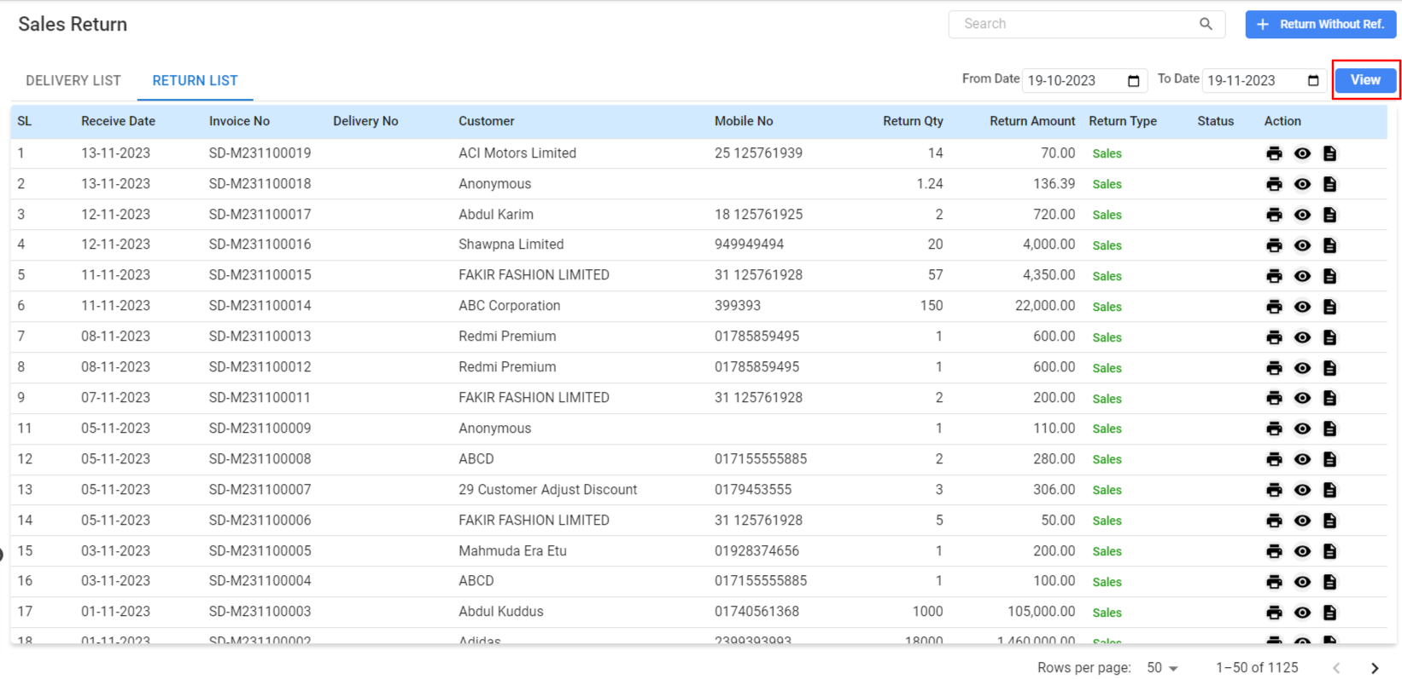

**Table Information Details:**

* **SL (Serial Number):** Each return is given a sequential number for identification and tracking.
* **Receive Date:** This column shows the date when the return was received and processed.
* **Invoice No:** The invoice number associated with the returned items.
* **Delivery No:** The delivery number linked to the invoice for the items returned.
* **Customer:** The name of the customer from whom the items were returned.
* **Mobile No:** Contact number of the customer for communication if needed.
* **Return Qty:** The quantity of the items that have been returned.
* **Return Amount:** Total value of the returned items.
* **Return Type:** Indicates the nature of the return, whether it's a full return or a partial return.
* **Status:** Current processing status of the return (e.g., Sales, Pending).
* Action: Icons for various actions such as viewing details, editing, or processing further actions related to the return.

**Using the Sales Return List:**

* Viewing Detailed Information: Click the 'View' icon under the Action column to open detailed information about a specific return.
* Processing Returns: Utilize the icons under the Action column to take necessary actions like editing return details or updating the status.
* Filtering Returns: Use the date filter by specifying a 'From Date' and 'To Date' to view returns within a certain period.
* Searching for a Specific Return: Type relevant keywords into the search bar to quickly locate specific returns by customer name, invoice number, or other criteria.

## 

## 

## 2.6 Sales Collection:

The Sales Collection is focused on the financial aspect of sales, handling all incoming payments against sales invoices. It features separate sections for outright sales and rentals, providing a detailed breakdown of due payments and facilitating the tracking of collected amounts against individual invoices.

**Menu Path:**  **Sales (Module)> Sales Collection**

**Features:**

**Tabs:**

* **DUE LIST:** Shows all outstanding invoices awaiting payment.
* **DUE BILL:** Lists all bills that are due for payment.
* **COLLECTED BILL/INVOICE:** Displays all invoices/bills where the payment has been collected.
* **DUE INVOICE:** Exhibits invoices that are currently due for payment.

**User Interface [Sales Collection-Sales]:**

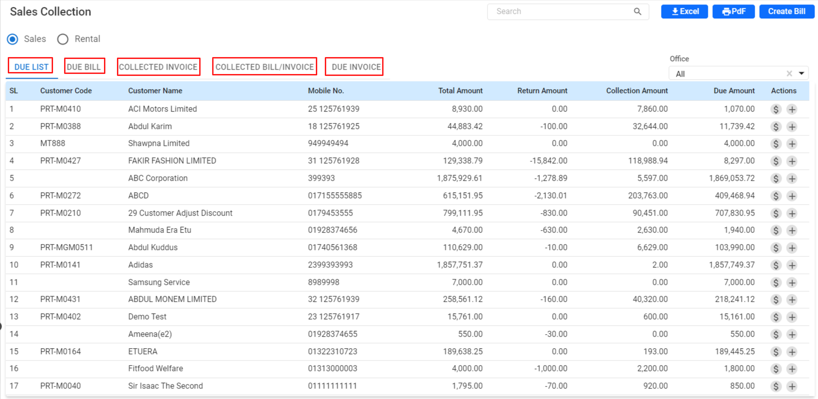

**Searching and Filtering:**

* Utilize the search bar to quickly find specific customer accounts or invoices by entering relevant keywords.
* The Office dropdown allows users to filter the collections based on office location or department.

**Exporting Data:**

* For reporting or analysis, use the ‘Excel’ or ‘PDF’ button to export the data into a spreadsheet or a PDF document.

**Table Information Details:**

* **SL (Serial Number):** An automatic sequence number for organizing the list.
* **Customer Code:** The unique identifier assigned to each customer.
* **Customer Name:** The name of the customer linked to the sales invoice.
* **Mobile No.:** Contact number of the customer for follow-ups or queries.
* **Total Amount:** The complete amount billed to the customer.
* **Return Amount:** Any amounts returned, displayed as a negative value when applicable.
* **Collection Amount:** The sum of payments collected against the sales invoice.
* **Due Amount:** The remaining amount that the customer needs to pay.
* **Actions:** Quick links to process collections, adjust bills, or view details.

**Using the Sales Collection Module:**

* **Processing Payments:**
  + Click on the ‘$’ icon under the Actions column to record a payment received against a particular invoice or Challan.
  + This will open a new window where users can enter the payment details such as amount, payment method, and any remarks.
* **Reviewing Account Status:**
  + The ‘Due Amount’ column provides quick visibility into outstanding balances.
  + Use this information to follow up with customers or to issue reminders for payment.
* **Managing Invoices and Bills:**
  + The various tabs help users segregate and focus on specific areas, whether tracking overdue invoices or managing collected payments.

**User Interface [Sales Collection-Rental]:**

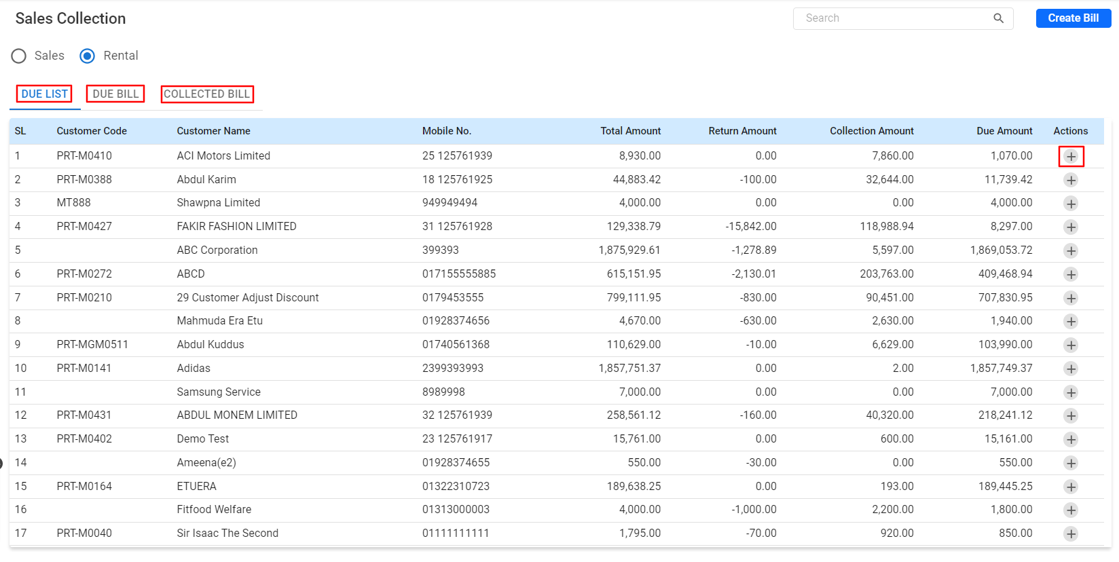

* **Tabs:**
  + **DUE LIST:** Displays rental invoices that have not yet been paid and are due.
  + **DUE BILL:** Lists all rental bills awaiting payment.
  + **COLLECTED BILL:** Shows all rental bills where payment has been collected.

**Table Information Details:**

* **SL (Serial Number):** A sequential identifier for each entry in the list.
* **Customer Code:** Unique code assigned to the customer for rental transactions.
* **Customer Name:** The name of the customer associated with the rental invoice.
* **Mobile No.:** Contact number of the customer, useful for communication about payments.
* **Total Amount:** The total billed amount for the rental transaction.
* **Return Amount:** Any refunds or adjustments made to the rental bill.
* **Collection Amount:** The amount that has been collected against the rental invoice.
* **Due Amount:** The outstanding balance that the customer is required to pay.
* **Actions:** Icons for initiating payment collection or viewing detailed account information.

**Using the Rental Collection Module:**

* **Recording Payments:**
  + To record a received payment, click the ‘+’ icon in the Actions column next to the relevant invoice by Due Invoice Bill from specific Customer Information.
  + Input the details of the payment, including the amount, date, and any pertinent notes.

***2.6.1 +Create Bill:***

The Bill Collection is a financial feature that enables users to process and track payments from customers. It facilitates the collection of dues for sales or services rendered, allowing for both partial and full payment entries.

**User Interface [+Create Bill]**

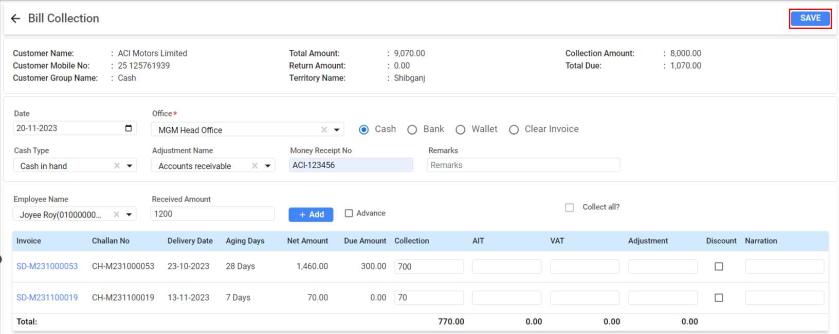

**Bill Collection Details:**

* **Customer Information:**
  + **Customer Name:** The name of the customer from whom the collection is being made.
  + **Customer Mobile No.:** The contact number of the customer for any follow-up.
  + **Customer Group Name:** The category to which the customer belongs, which can affect the payment terms.
* **Transaction Details:**
  + **Date:** The current date, which users can change manually if necessary.
  + **Office:** Select the office location responsible for the transaction.
  + **Cash Type:** Choose the form of payment, such as cash in hand or bank transfer.
  + **Adjustment Name:** Select the type of accounting adjustment if needed, like accounts receivable.
* **Payment Receipt Information:**
  + Employee Name: The staff member responsible for receiving the payment.
  + Received Amount: The amount of money received from the customer.
  + Money Receipt No.: The reference number for the transaction receipt.
  + Remarks: Any relevant notes about the collection.
* **Invoice and Payment Details:**
  + Invoice/Challan No.: Reference numbers for the sales invoice or delivery challan.
  + Delivery Date and Aging Days: Details when the product was delivered and the number of days since the invoice date.
  + Net Amount and Due Amount: The total billed amount and the outstanding amount to be collected.
  + Collection: Enter the amount being collected for each invoice.
* **Additional Financial Adjustments:**
  + **AIT:** Any Advance Income Tax that may have been collected.
  + **VAT:** Value Added Tax details if applicable.
  + **Adjustment:** Record any financial adjustments made.
  + **Discount:** Apply any discounts to the collected amount.
  + **Narration:** Space for additional details about the payment.
* **Finalizing the Collection:**
  + Check the Total at the bottom to ensure all payments are correctly entered.
  + **Use the Collect all?** checkbox if the customer is clearing all their dues.
  + Review all details for accuracy before proceeding.
* **Saving the Collection:**
  + After all payment entries are made and reviewed, click the **Save** button to record the collection.
  + The system will update the customer’s account balance and reflect the payment in users financial records.

## 2.7 Sales Target:

Sales targets are benchmarks set for individuals or teams to achieve in a specified period. The Sales Target module allows users to set and monitor these targets.

**Menu Path:**  **Sales (Module)> Sales Target**

**Features:**

**User Interface [Sales Target]**

* 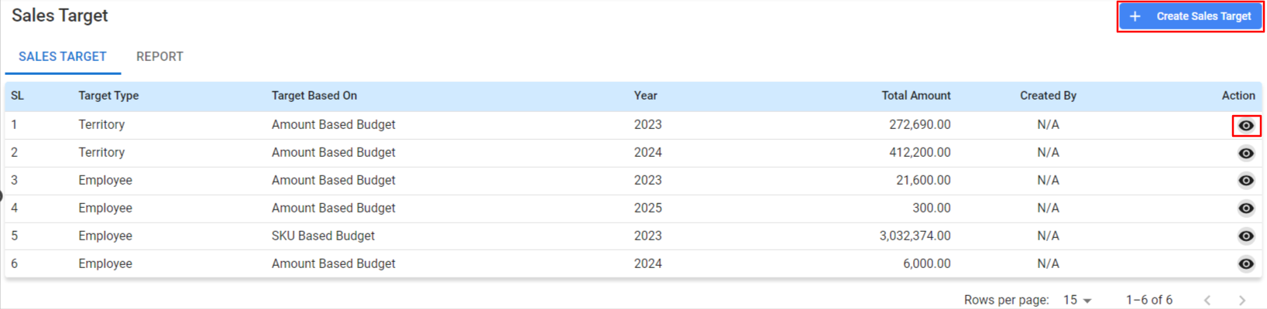
* **Sales Target Details:**
  + **SL (Serial Number):** An automatically assigned number for each target for identification.
  + **Target Type:** The category of the target, which can be set by territory, employee, etc.
  + **Target Based On:** The criteria for the target, such as amount-based budget or SKU-based budget.
  + **Year:** The fiscal year for which the target is being set.
  + **Total Amount:** The monetary goal that needs to be achieved.
  + **Created By:** The user who created the target (automatically filled based on login).
* **Action Buttons:**
  + **View:** Click the view icon to review the details of a sales target.

***2.7.1 Create Sales Target***

**User Interface [+Create Sales Target]**

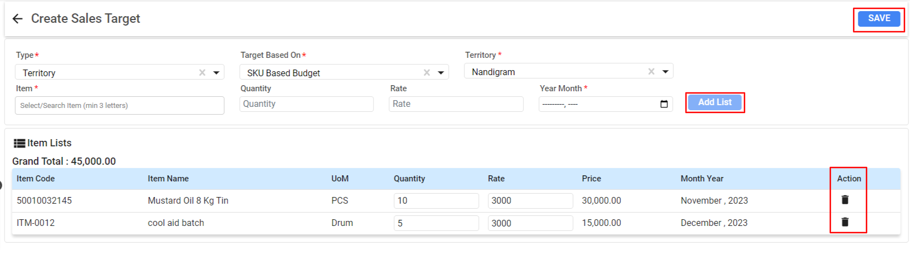

**Setting Up Sales Target Details:**

* Click on the **'+ Create Sales Target'** button to initiate the process.
* **Type:**
  + Select the type of target, such as 'Territory' from the dropdown menu.
* **Target Based On:**
  + Choose the basis for the target, like 'SKU Based Budget', which sets the target based on the number of stock keeping units.
* **Territory:**
  + Specify the territory for which the sales target is being set, for example, 'Nandigram'.
* **Item List:**
  + Click 'Add List' to include specific products in usersr sales target.
* **Item Details:**
  + **Item Code:** Enter the unique identifier for the item users're setting a target for.
  + **Item Name:** Specify the name of the product.
  + **UoM (Unit of Measurement):** Define the unit of measurement, such as 'PCS' for pieces.
  + **Quantity:** State the quantity of the product that constitutes the target.
  + **Rate:** Enter the selling price per unit of the product.
  + **Price:** This field will auto-calculate the total price based on the rate and quantity.
  + **Month Year:** Select the month and year for which the target is applicable.
* **Action Icons:**
  + **Delete:** Use the trash bin icon to remove an item from the target list.

**Finalizing the Sales Target:**

* **Review users Entries:**
  + Ensure that all information entered is accurate and reflects usersr sales goals accurately.
* **Saving the Target:**
  + Once the user verifies the information, click the **'SAVE'** button to finalize the creation of the sales target.

## 2.8 Field Collection:

The Field Collection is designed to track and manage payments collected from customers outside the office environment. This section provides a step-by-step guide on how to use the Field Collection module effectively.

**Menu Path:**  **Sales (Module)> Field Collection**

**Features:**

**Tabs:**

Accessing two main tabs:

**FIELD COLLECTION-** for entering new collections and

**FIELD COLLECTION REPORT-** for viewing reports on collections.

***2.8.1 Field Collection Landing***

**Viewing and Managing Collections:**

* Use the search bar to quickly find specific collections by customer name, receipt number, or date.
* Filter collections based on the office or employee who collected the payment using the dropdown menus provided.

**Utilizing the Field Collection Report:**

* Switch to the ‘FIELD COLLECTION REPORT’ tab to see comprehensive reports on all field collections.
* This report can be customized using various filters like date ranges, collection types, and collected by personnel for analytical and reconciliation purposes.

**User Interface [Field Collection]**

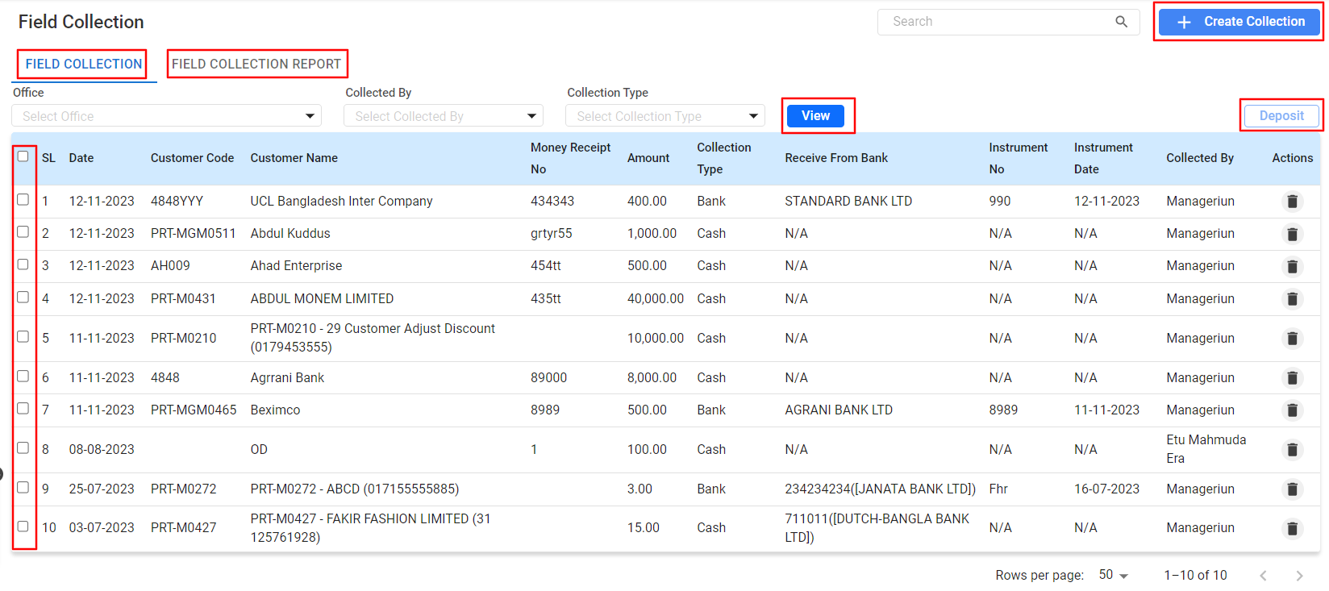

**Creating a New Field Collection Entry:**

* To add a new field collection, click on the **‘+ Create Collection’** button located in the top-right corner of the ‘Field Collection’ tab.

**Utilizing the Field Collection Report:**

* Switch to the ‘FIELD COLLECTION REPORT’ tab to see comprehensive reports on all field collections.
* This report can be customized using various filters like date ranges, collection types, and collected by personnel for analytical and reconciliation purposes.

**Field Collection Entries:**

* **SL (Serial Number):** A sequential number for reference.
* **Date:** The date the collection was made.
* **Customer Code:** A unique identifier for the customer.
* **Customer Name:** The name of the customer from whom the collection is received.
* **Money Receipt No:** The reference number for the receipt issued upon collection.
* **Collection Amount:** The total amount collected.
* **Collection Type:** The method of collection, such as Cash or Bank.
* **Receive From Bank:** The bank name, if the collection was made through a bank.
* **Instrument No and Date:** Details of the cheque or bank instrument, if applicable.
* **Collected By:** The employee who collected the payment.

To delete an entry, click the trash bin icon in the same column.

***2.8.2 Field Collection- Deposit***

**User Interface [Field Collection-Deposit]**

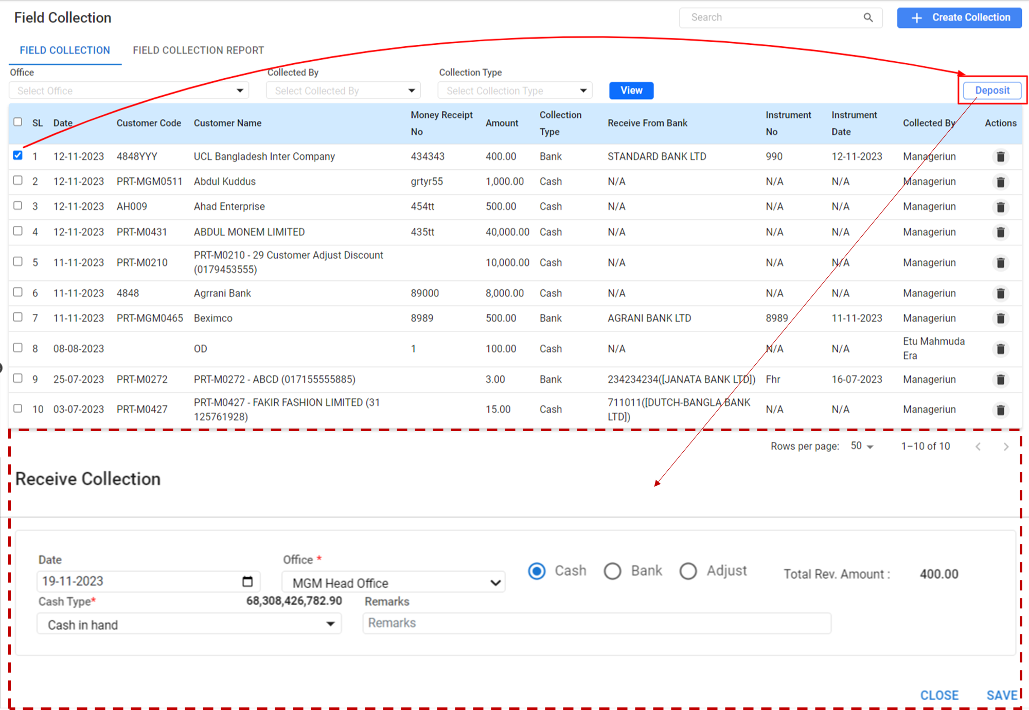

**Depositing Collected Funds:**

* After collections are made, users can deposit the funds to the company account by clicking on the ‘Deposit’ button. This will record the entry as deposited in the company's financial records.

**Selecting Collections for Deposit:**

* Review the list of field collections displayed on the screen. Each entry includes details such as the date, customer code, customer name, amount, and collection type.
* To select a collection for deposit, click on the entry users want to deposit. This will highlight the row.

**Initiating the Deposit:**

* After selecting the collections, click on the 'Deposit' button located at the top-right corner of the list. This will take users to the "Receive Collection" section.
* In the "Receive Collection" area, users will enter the details of the deposit.

**Filling Out Deposit Details:**

* **Date:** The system will auto-populate the current date, which can be changed if needed.
* **Office:** Confirm the office name where the deposit will be recorded. This should be auto-filled based on usersr user profile.
* **Cash Type:** Select the form of cash users are depositing, such as 'Cash in hand', 'Bank', or 'Adjust'.
* **Total Rev. Amount:** This field will show the total amount users are about to deposit. Confirm that this matches the sum of the selected collections.
* **Action:** To delete an entry, click the trash bin icon in the same column.

**Completing the Deposit Process:**

* Once all the details are filled in, review to ensure the accuracy of the information.
* Input any relevant remarks in the 'Remarks' section if necessary.
* Check the total revenue amount to verify it corresponds with the sum of the collections users are depositing.
* Click the **'SAVE'** button to finalize the deposit. This will update the company's financial records with the new deposit entry.

**Final Notes:**

It is important to regularly update and manage users field collections to maintain accurate financial records. Ensure that all collections are accounted for and deposited accordingly to reflect in company's cash flow statement.

## 

# **Accounting Module**

## 

## 

## 3.1 Accounting Dashboard

The Accounting Dashboard provides a comprehensive view of a company's financial health, including account balances, cash management, income and expenses, cash flow, financial ratios, and monthly statistics.

**Menu Path: Accounting (Module) > Accounting Dashboard**

The user will see a landing page after clicking the "Accounting Dashboard" feature.

**User Interface [Landing]**

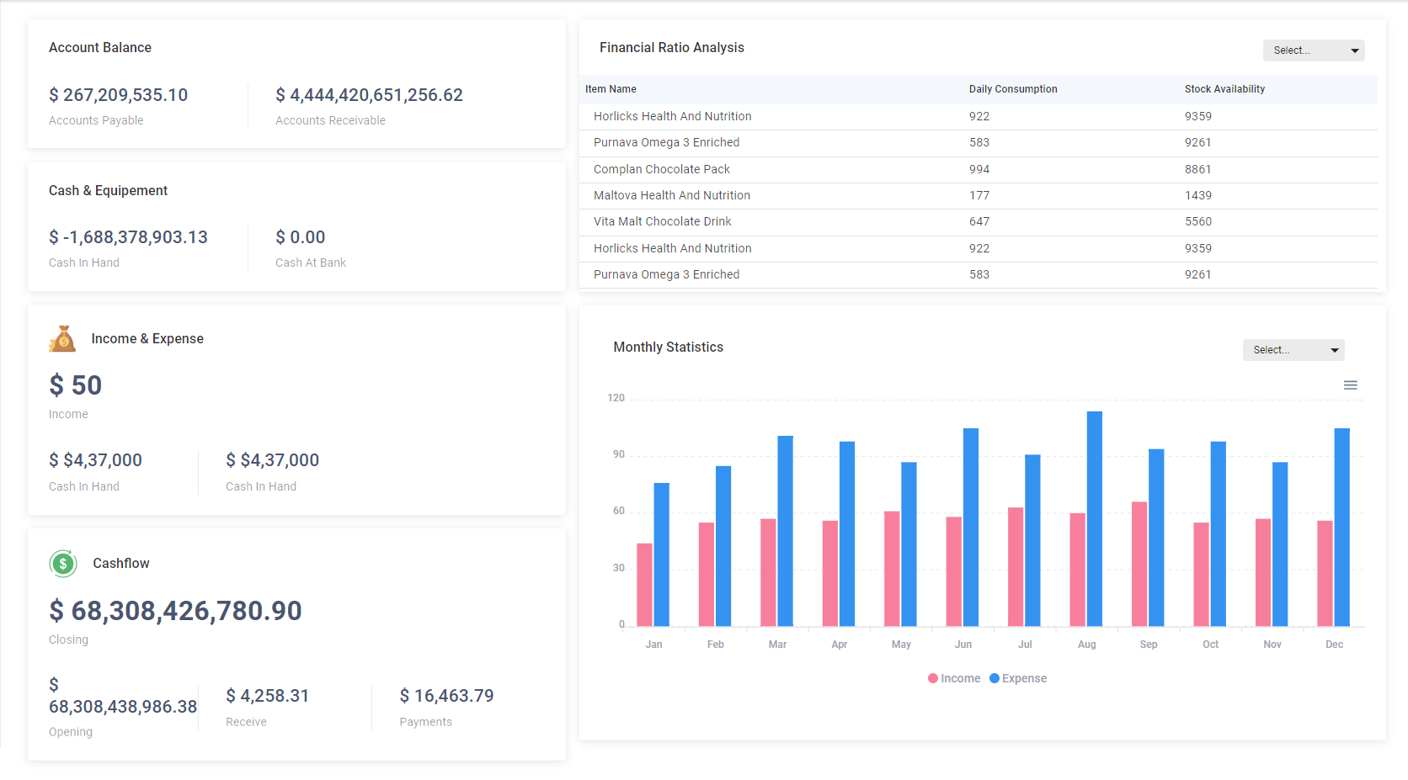

User can view the following information:

**Account Balance:**

* **Accounts Payable:** Displays the total amount users company owes to suppliers or creditors.
* **Accounts Receivable:** Shows the total amount owed to users company by customers or debtors.

**Cash & Equipment:**

* **Cash In Hand:** Total cash available in the company's physical possession, which currently displays a negative value indicating a deficit.
* **Cash At Bank:** Total cash present in the company's bank accounts.

**Income & Expense:**

* Displays the current income which is a basic monetary gain.
* Shows two identical values under "Cash In Hand," which might indicate an error, as income and cash in hand should not necessarily match.

**Cashflow:**

* Represents the total amount of money being transferred into and out of business, particularly liquid assets.
* **Closing:** The closing balance for the current period.
* **Opening:** The opening balance at the beginning of the period.
* **Receive:** Total cash received within the period.
* **Payments:** Total cash paid out within the period.

**Financial Ratio Analysis:**

* **Lists inventory items with two key metrics:**
  + **Daily Consumption:** The average number of units consumed per day.
  + **Stock Availability:** The number of units currently available in stock.

**Monthly Statistics:**

* A bar graph displays income (in blue) and expenses (in pink) for each month, allowing users to quickly assess users financial performance over the year.

**Using the Dashboard:**

* **Navigation:** Use the menu on the left to switch between different financial categories.
* **Updating Figures:** Click on any figure to drill down into detailed reports.
* **Financial Ratio Analysis:** Use the 'Select...' dropdown to filter items based on different criteria.
* **Monthly Statistics:** Hover over the bars in the graph to view exact figures for income and expenses.

## 3.2 Bank Account

**Menu Path:**  **Accounting (Module) >Bank Account**

The user will see a landing page after clicking the "Bank Account" feature.

***3.2.1 Bank Account (Landing Page)***

**User Interface [Landing]**

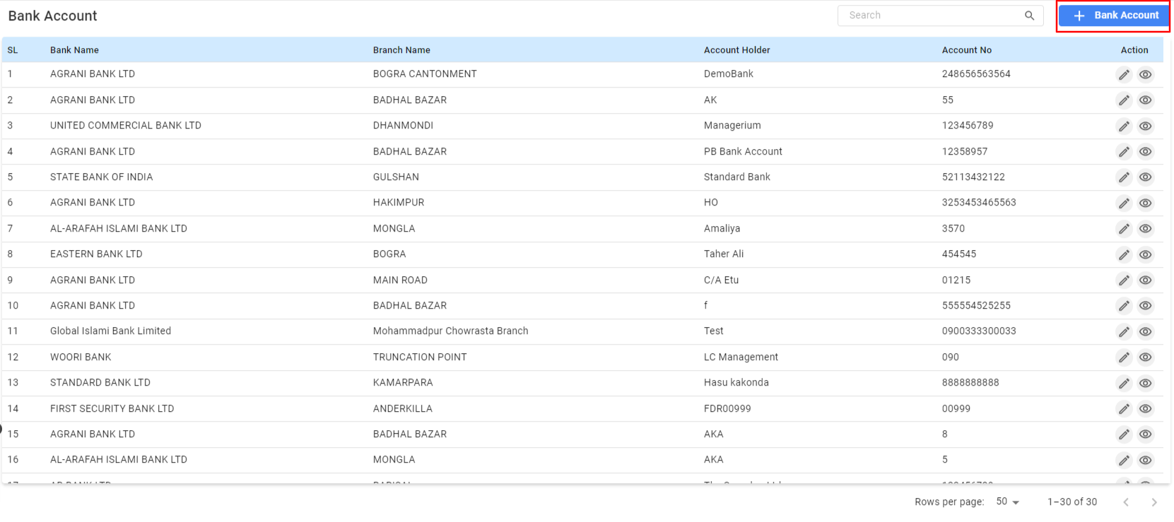

**Navigating the Bank Account Landing Page:**

* **Adding a New Bank Account:**
  + Click the **"+ Bank Account"** button to add a new bank account.
  + Fill in the required fields, such as Bank Name, Branch Name, Account Holder, and Account Number.
  + Save the new account details.
* **Viewing Bank Account Details:**
  + **SL (Serial Number):** A unique identifier for each bank account entry.
  + **Bank Name:** The name of the financial institution where the account is held.
  + **Branch Name:** The specific branch of the bank.
  + **Account Holder:** The name of the individual or entity that owns the account.
  + **Account No:** The unique number assigned to the account by the bank.
* **Actions:**
  + Use the action icons to edit or view more details about each bank account.
* **Searching and Filtering:**
  + Use the search bar to quickly find specific bank accounts.
  + Filter the accounts by bank name, branch, or account holder.
* **Exporting Data:**
  + Export the list of bank accounts to Excel or PDF formats for offline analysis and reporting.

***3.2.2 Creating Bank Account:***

Here, creating a bank account is a straightforward process. This is a guides to follow the steps to add a new bank account.

* **Accessing the Create Bank Account Page:**
* **Filling in Account Information:**
  + **Account Name:** Enter the name users want to assign to this bank account for identification within Managerium. Example: Managerium.
  + **Bank Name:** Select the bank's name from the drop-down menu where the account is held, such as 'AL-ARAFAH ISLAMI BANK LTD'.
  + **Branch Name:** Choose the branch name from the drop-down menu, such as 'JUBILEE ROAD'.
  + **Bank Account Number:** Input the unique number assigned to the bank account.
  + **Bank Short Name:** Enter an abbreviation or a short form for the bank name for quick reference.
  + **Bank Account Type:** Select the type of bank account from the drop-down menu, such as 'Recurring Deposit Account'.
* **Assign Business (If applicable):**
  + Assign the account to a specific business unit if this feature is supported, like 'Managerium'.
* **Saving the Bank Account:**
  + After verifying all the information is correct, click the **'SAVE'** button to add the bank account to the system.

**3.3 Chart Of Accounts**

The Chart of Accounts can significantly affect financial reporting. It needs to be ensured with the proper authorization and understanding of the implications before making modifications.

**Menu Path:**  **Accounting (Module) > Chart of Accounts**

**User Interface [Chart Of Accounts]:**

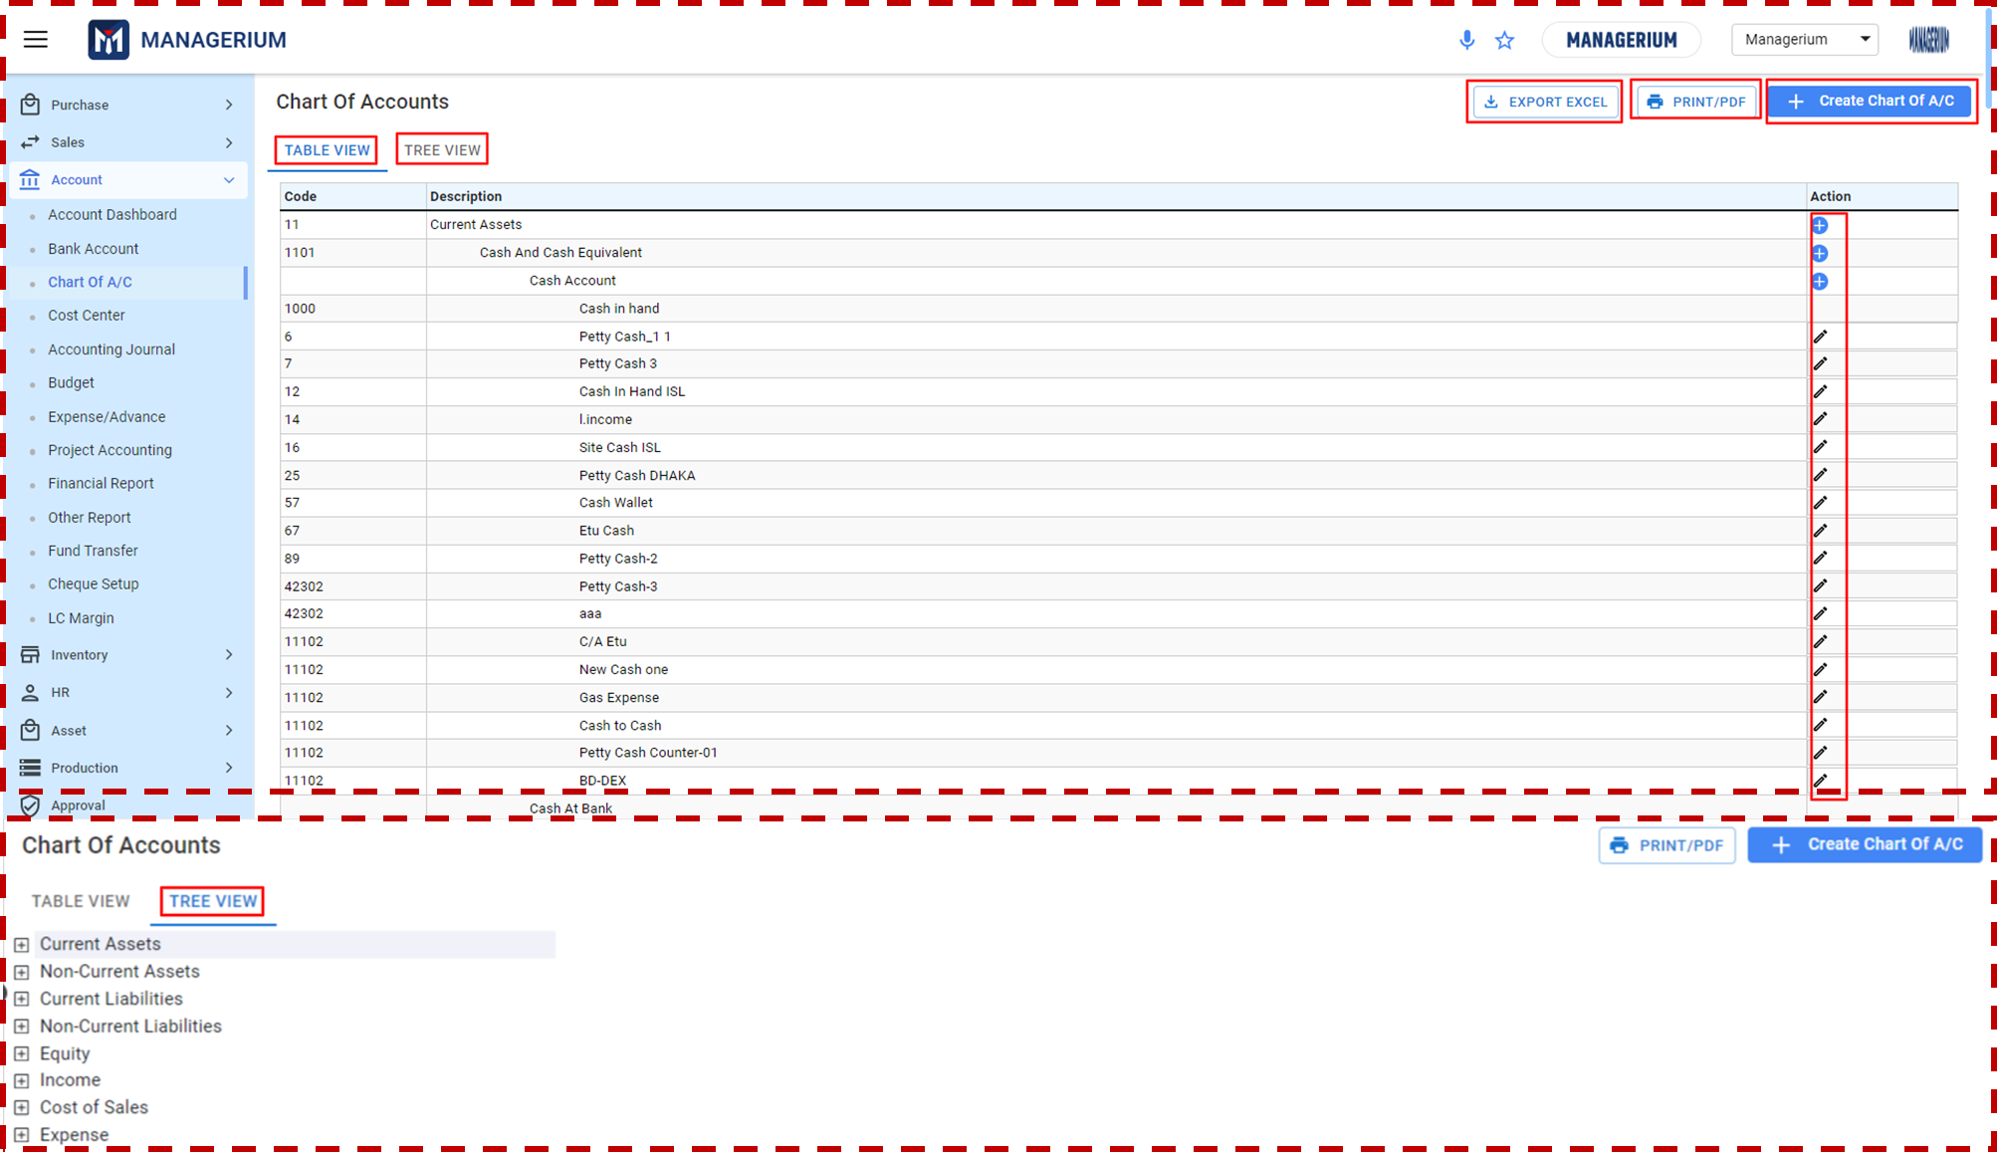

**Accessing the Chart of Accounts:**

* The interface displays the financial structure of the company, listing all accounts in a categorized manner.
* Users can switch between **'TABLE VIEW'** and **'TREE VIEW'** for different visual representations of accounts.

**Navigating through Account Categories:**

* **Current Assets:** Lists accounts like Cash, Bank Balances, Receivables, and Inventory.
* **Non-Current Assets:** Includes long-term assets like Property, Plant and Equipment, Intangible Assets, etc.
* **Current Liabilities:** Displays accounts related to short-term obligations.
* **Non-Current Liabilities:** Covers long-term financial responsibilities like Long-term Borrowings.
* **Equity:** Contains accounts like Retained Earnings and Capital.
* **Income:** Records all operating and other income accounts.
* **Expenses:** Lists all expense accounts, including Cost of Sales, Operating Expenses, and more.

**Using the Chart of Accounts:**

* Analyze and review the financial structure and make informed decisions based on the categorized accounts.
* Use the Chart of Accounts for posting transactions in Accounting Journal.
* Maintain a clear and organized financial reporting structure.

**Managing Accounts:**

* Use the action buttons next to each account to edit or delete accounts as necessary.
* Ensure the Chart of Accounts remains updated to reflect the current financial state of the company.

**Printing and Exporting:**

* To print or download the Chart of Accounts, click the 'PRINT/PDF' button.
* This will generate a printable or downloadable version of the Chart of Accounts.

***3.3.1 Creating Chart Of Accounts***

**User Interface [Create Chart Of Accounts]:**

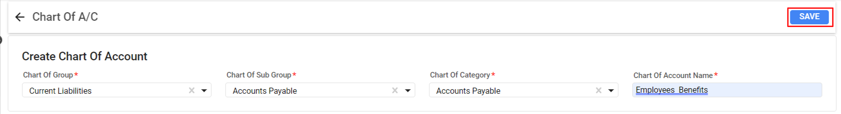

**Adding a New Account**:

* Click the 'Create Chart Of A/C' button in the top right corner.
* Fill in the necessary information such as account name, type, and any relevant details.
* Save the new account by clicking the 'Save' button.

**Filling in Account Information:**

* **Chart Of Group:** Select the main group under which the account will be categorized. For example, choose Current Liabilities for accounts related to short-term financial obligations.
* **Chart Of Sub Group:** Choose the appropriate sub-group that further categorizes the account, such as Accounts Payable for money owed by the company to its creditors.
* **Chart Of Category:** Specify the category which best describes the nature of the account within the chosen sub-group, like Accounts Payable if it's directly related to the sub-group selection.
* **Chart Of Account Name:** Enter a descriptive name for the new account, such as Employees Benefits to indicate the account's purpose.

**Saving the New Account:**

Review the information users have entered to ensure accuracy.

Click the **Save** button to add the new account to users Chart of Accounts.

## 3.4 Cost Center

The cost centers should align with the business organization's financial management practices and reporting structure. Consulting with a financial manager or accountant if the user is uncertain of how to establish a cost center.

**Menu Path:**  **Accounting (Module) > Cost Center**

***3.4.1 Cost Center (Landing Page)***

**User Interface [Landing]**

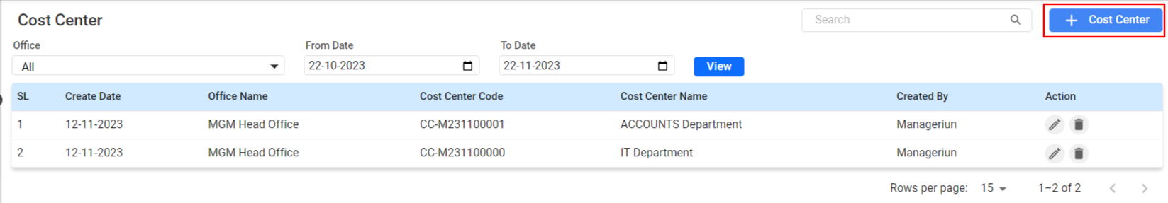

**Accessing the Cost Center Page:**

* Select Cost Center to open the cost center management page.
* **Office Filter:** users can filter cost centers based on office location by selecting an option from the 'Office' dropdown menu.
* **Date Filters:** Filter cost centers by creation date using the 'From Date' and 'To Date' fields.
* **View Button:** After setting users filters, click the ‘View’ button to refresh the list according to the selected criteria.

**Cost Center List Overview:**

* **SL (Serial Number):** Displays a sequential number for reference.
* **Create Date:** Shows the date the cost center was established.
* **Office Name:** Indicates the office to which the cost center is associated.
* **Cost Center Code:** A unique identifier assigned to each cost center.
* **Cost Center Name:** The name given to the cost center, typically indicative of its function or department (e.g., ACCOUNTS Department, IT Department).
* **Created By:** The username of the individual who created the cost center.
* **Action:** Column for actions users can perform, such as edit or delete a cost center.

***3.4.2 Creating a New Cost Center:***

**User Interface [Creating a New Cost Center]:**

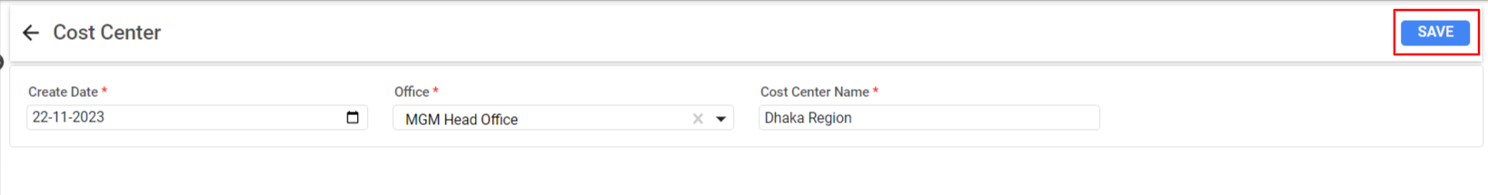

Click on the **+ Cost Center** button located in the upper right corner to create a new cost center.

users will be directed to a form where users can enter details for the new cost center.

**Filling Out the Create Cost Center Form:**

* **Create Date:** The system will automatically populate this field with the current date, which can be adjusted if necessary.
* **Office:** Select the appropriate office from the dropdown list. This should correspond to the location where the cost center will be utilized or managed.
* **Cost Center Name:** Enter a descriptive name for the cost center, which will be used to identify it in transactions and reports. For example, "Dhaka Region" as shown in the form.

**Saving the Cost Center:**.

* Once users have confirmed that all details are correct, click the **SAVE** button in the upper right corner of the form.

## 3.5 Accounting Journal

The Accounting Journal the central repository for all financial transactions is where all recorded. It is essential to ensure accuracy when recording transactions as they impact financial reporting and business insights. Only authorized users should access and manage the Accounting Journal.

**Menu Path:**  **Accounting (Module) >Accounting Journal**

***3.5.1 Accounting Journal (Landing Page):***

**User Interface [Accounting Journal-Landing]:**

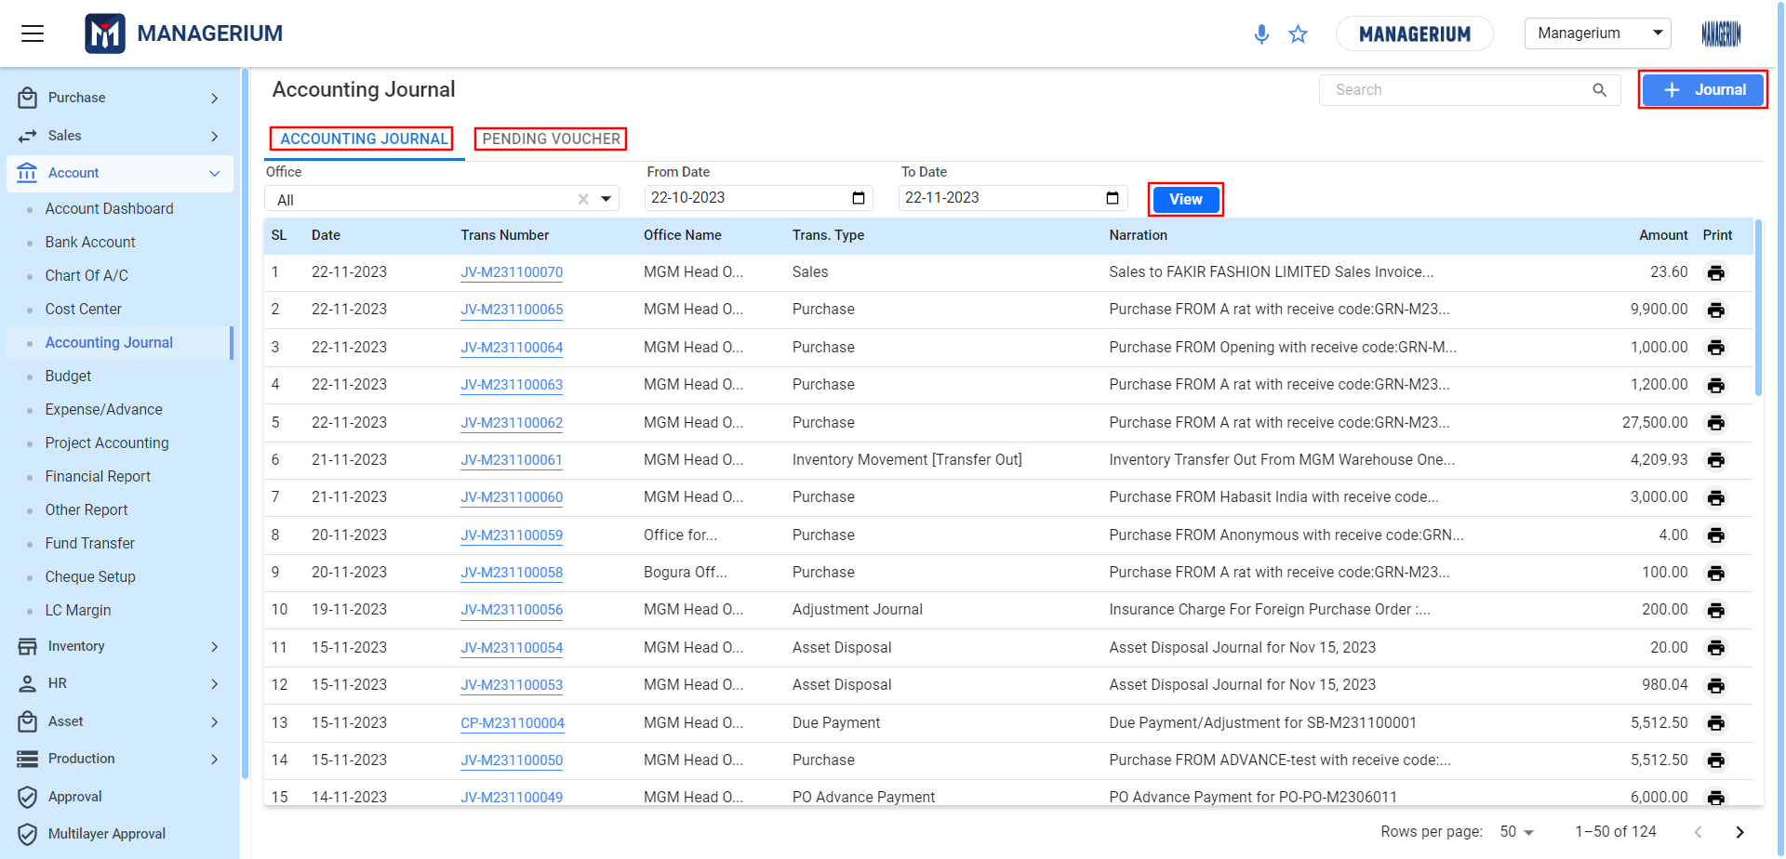

**Accessing Accounting Journal:**

**Tab:**

* **Accounting Journal:** Displays a list of all financial transactions.
* **Pending Voucher:** Shows transactions that are yet to be completed or verified.

**Filtering Transactions:**

* Use the Office dropdown to filter transactions by office.
* Set a From Date and To Date to filter transactions within a specific period.
* Click View to refresh the list based on the selected filters.

**Journal Entries List:**

* **SL:** Serial number of the entry for reference.
* **Date:** The date the transaction was made.
* **Trans Number:** A unique identifier for the transaction.
* **Office Name:** The name of the office where the transaction was recorded.
* **Trans. Type:** Type of transaction (e.g., Sales, Purchase).
* **Narration:** A brief description of the transaction.
* **Amount:** The total value of the transaction.
* **Print:** Option to print the transaction record.

**Accounting Journal Details View:**

**User Interface [Accounting Journal-Details View]:**

* 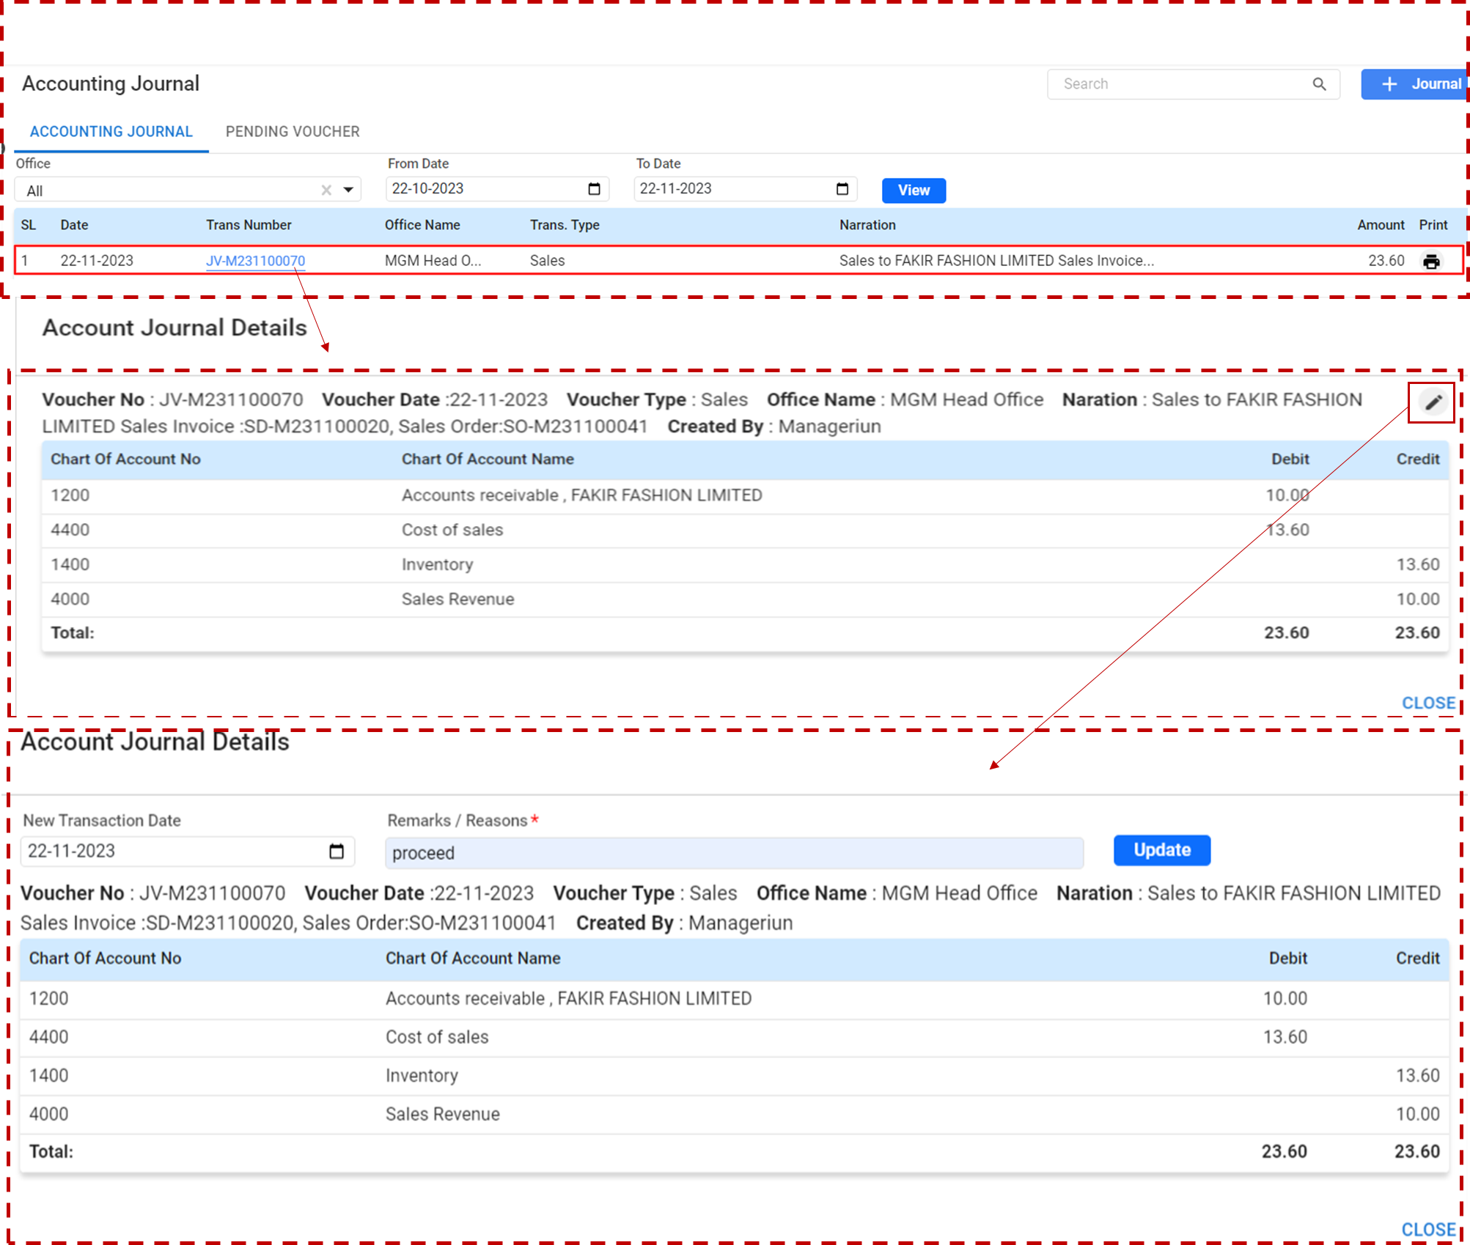

Clicking on the Trans Number ID (hyperlinked) the details will be show:

* **Voucher No:** The unique identifier for the transaction.
* **Date:** When the transaction was entered into the system.
* **Voucher Type:** The category of the transaction (e.g., Sales, Purchase).
* **Office Name:** The office or department where the transaction originated.
* **Narration:** A brief description or memo attached to the transaction.
* **Created By:** The user who entered the transaction into the system.
* **Chart of Account No:** The numerical code corresponding to the specific account in the chart of accounts.
* **Chart of Account Name:** The name of the account affected by the transaction.
* **Debit:** The amount debited from the account.
* **Credit:** The amount credited to the account.

**Reviewing and Updating Transactions:**

**To Edit:**

* Check the Debit and Credit columns to ensure the transaction balances and the correct accounts have been debited and credited.
* If a user needs to make any changes, enter the new details in the fields provided under the Account Journal Details section.
* Add any necessary remarks in the Remarks/Reasons field to document why the change is necessary.
* Once all edits are complete, click **Update** to save the changes.

**Finalizing and Closing the Details Page:**

* Review all details thoroughly to ensure accuracy.
* If no changes are needed, or after updating, click the Close button to exit the details page and return to the main Accounting Journal page.

***3.5.2 Pending Voucher (Landing Page):***

**User Interface [Accounting Journal-Landing]:**

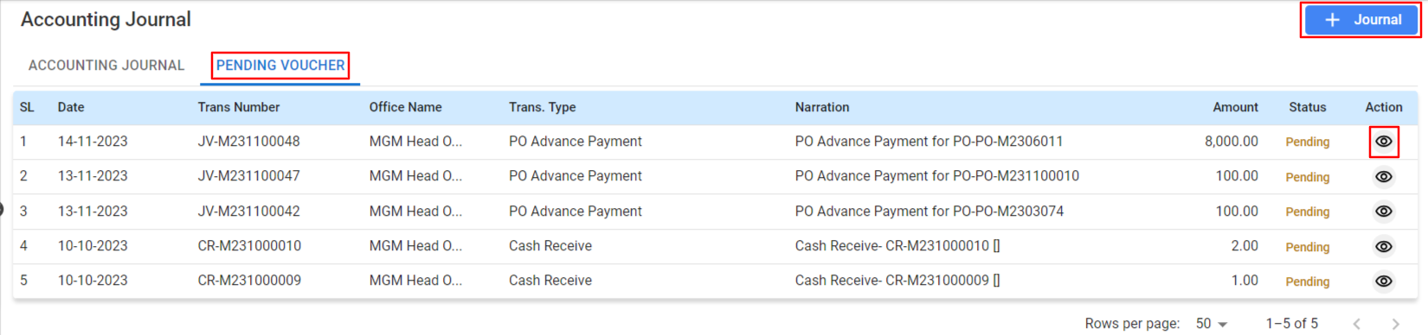

**Accessing Pending Vouchers:**

* Click on the Pending Voucher tab to view all vouchers awaiting completion.
* **SL:** Serial number assigned to each pending voucher for reference.
* **Date:** The date when the voucher was created.
* **Trans Number:** The transaction number associated with the voucher.
* **Office Name:** The office that initiated the transaction.
* **Trans. Type:** The type of transaction, such as PO Advance Payment or Cash Receive.
* **Narration:** A brief description or note regarding the transaction.
* **Amount:** The monetary value involved in the voucher.
* **Status:** Shows the current status, typically "Pending" for these transactions.
* **Action:** Buttons to view more details about the voucher.

**Accessing Journal Create Details:**

* **Voucher No:** The unique identifier for the transaction.
* **Date:** When the transaction was entered into the system.
* **Voucher Type:** The category of the transaction (e.g., Sales, Purchase).
* **Office Name:** The office or department where the transaction originated.
* **Narration:** A brief description or memo attached to the transaction.
* **Created By:** The user who entered the transaction into the system.
* **Chart of Account No:** The numerical code corresponding to the specific account in the chart of accounts.
* **Chart of Account Name:** The name of the account affected by the transaction.
* **Debit:** The amount debited from the account.
* **Credit:** The amount credited to the account.

**Reviewing and Updating Transactions:**

* Check the Debit and Credit columns to ensure the transaction balances and the correct accounts have been debited and credited.
* If you need to make any changes, enter the new details in the fields provided under the Account Journal Details section.
* Add any necessary remarks in the Remarks/Reasons field to document why the change is necessary.
* Once all edits are complete, click Update to save the changes.

**Finalizing and Closing the Details Page:**

* Review all details thoroughly to ensure accuracy.
* If no changes are needed, or after updating, click the Close button to exit the details page and return to the main Accounting Journal page.

***3.5.3 Creating a New Journal Entry:***

Creating a journal entry is a fundamental process in financial accounting. This function allows users to record transactions that affect the financial statements.

Click the **+ Journal** button to open the transaction entry form.

**User Interface [Journal Create]:**

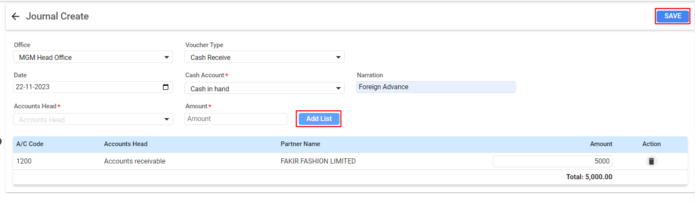

**Accessing Accounting Journal Details:**

* **Voucher No:** The unique identifier for the transaction.
* **Date:** When the transaction was entered into the system.
* **Voucher Type**: The category of the transaction (e.g., Sales, Purchase).
* **Office Name:** The office or department where the transaction originated.
* **Narration:** A brief description or memo attached to the transaction.
* **Created By:** The user who entered the transaction into the system.
* **Chart of Account No:** The numerical code corresponding to the specific account in the chart of accounts.
* **Chart of Account Name:** The name of the account affected by the transaction.
* **Debit:** The amount debited from the account.
* **Credit:** The amount credited to the account.

**Reviewing and Updating Transactions:**

* Check the Debit and Credit columns to ensure the transaction balances and the correct accounts have been debited and credited.
* If a user needs to make any changes, enter the new details in the fields provided under the Account Journal Details section.
* Add any necessary remarks in the Remarks/Reasons field to document why the change is necessary.
* Once all edits are complete, click Update to save the changes.

**Finalizing and Closing the Details Page:**

* Review all details thoroughly to ensure accuracy.
* If no changes are needed, or after updating, click the **Close** button to exit the details page and return to the main Accounting Journal page.

## 3.6 Budget

The Budget allows users to manage and review all budget-related activities within a business organization. It includes regular reviews of budget statuses to ensure that they align with current financial goals and reflect the current approval and implementation stages.

**Menu Path:**  **Accounting (Module) >** **Budget**

***3.6.1 Budget Landing- Landing:***

**User Interface [Budget Landing]:**

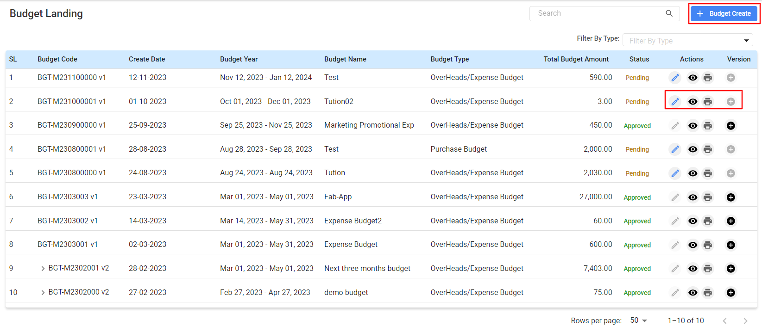

**Accessing to Budget Landing:**

Once on the Budget Landing page, the user will see a list of all created budgets along with details such as Budget Code, Create Date, Budget Name, Budget Type, Total Budget Amount, Status, and available Actions.

* **SL (Serial Number):** A sequential identifier for each budget entry.
* **Budget Code:** A unique code assigned to each budget for identification.
* **Create Date:** The date when the budget entry was created.
* **Budget Name:** The name given to the budget for easy reference.
* **Budget Type:** The category of the budget such as Overheads/Expense Budget or Purchase Budget.
* **Total Budget Amount:** The total amount allocated to the budget.
* **Status:** Current status of the budget (e.g., Pending, Approved).
* **Actions:** Options to view details, edit, or delete the budget. It may also include an option to add a new version of the budget.
* **Version:** Indicates the version number of the budget if multiple iterations have been made.

**Managing Budgets:**

* **View:** Click the eye icon to view detailed information for a specific budget.
* **Edit:** Use the pencil icon to modify an existing budget.
* **Delete:** Click the trash icon to remove a budget entry from the system.
* **Add Version:** Select the plus icon to create a new version of an existing budget

**\*\*\* Once the status gets approved user can’t edit the budget but it that case the option to add a version of that budget.**

**Filtering and Searching:**

* Utilize the search bar to quickly find specific budget entries.
* Use the Filter By Type dropdown to narrow down budgets by type/category.

## 

***3.6.2 Creating a New Budget:***

Creating a budget within this system allows to allocate financial resources to different departments or projects effectively.

**Adding a New Budget:**

* To create a new budget, click on the **+ Budget Create** button. This will navigate you to a form where you can enter details for a new budget.

**User Interface [Create Budget]**

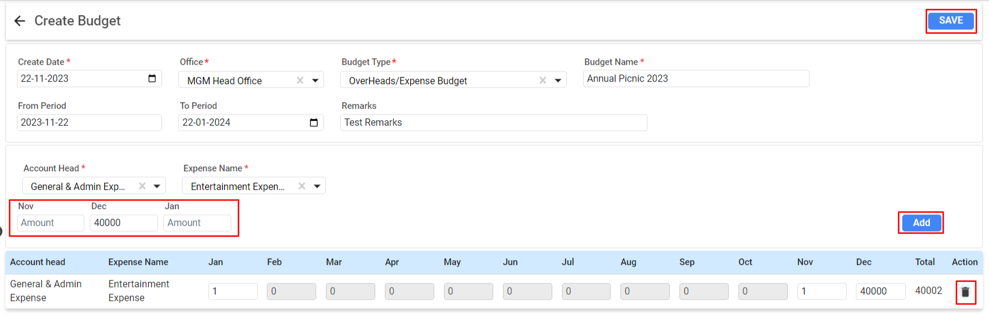

**Filling Out Budget Information:**

* **Create Date:** The system will auto-populate the current date, but you can change it if necessary.
* **Office:** Select the office for which you are creating the budget from the dropdown menu.
* **Budget Type:** Choose the type of budget, such as Overheads/Expense Budget.
* **Budget Name:** Enter a descriptive name for the budget, such as "Annual Picnic 2023".
* **From Period - To Period:** Define the time frame for the budget, ensuring it covers the required duration for the planned expenses.
* **Remarks:** Include any notes or justifications for the budget in this field.

**Inputting Budget Details:**

* **Account Head:** Select the relevant account head from the dropdown menu that will be affected by this budget.
* **Expense Name**: Choose or enter the name of the expense that the budget will cover.
* **Monthly Allocation:** Enter the amount you are allocating to each month. For instance, input "40000" in the November field to set aside $40,000 for that month.

**Adding Budget Items:**

* After entering the details for a particular expense, click the **Add** button to include it in the budget. It will appear in the table below with the allocated amounts for each month.
* Repeat the process to add multiple expenses to the budget.

**Reviewing and Saving the Budget:**

* **Total:** Check the total budget amount calculated based on the monthly allocations you've entered.
* Review the entire budget to ensure all entries and amounts are correct.
* Once satisfied with the budget details, click the **SAVE** button to create the budget.

**Editing and Deleting Budget Items:**

* To remove expenses from the budget, click the **trash can icon** next to the entry you wish to delete.

## 3.7 Expense/Advance

The Expense/Advance section is designed for the management and tracking of expenses and advances issued to employees or partners. The user must ensure that all expenses/advances are approved by the authority.

**Menu Path:**  **Accounting (Module) > Expense/Advance**

**User Interface [Expense/Advance]:**

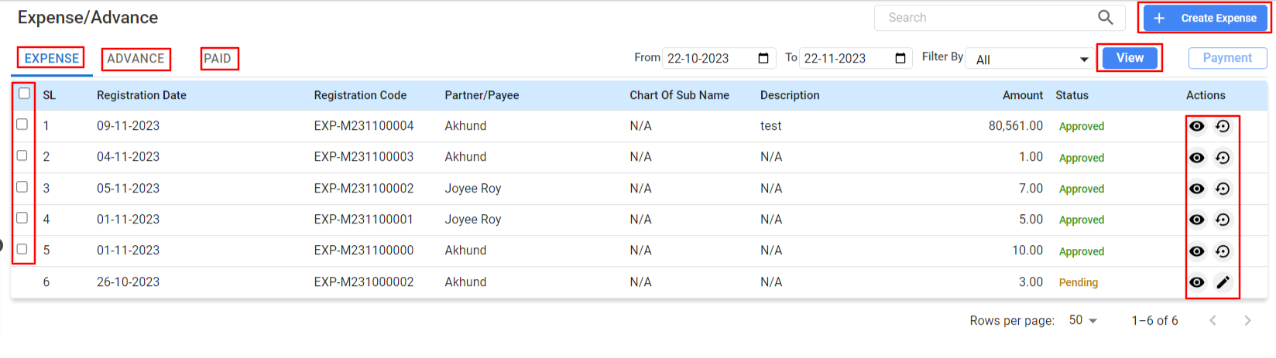

**Features:**

***Tabs:***

* **Expense:** Created expenses are shown
* **Advance:** Created advances are shown
* Paid: Expenses and advances that have been paid out are shown.
* **Viewing Expenses/Advances:**
* **SL (Serial Number):** A unique identifier assigned to each expense/advance for reference.
* **Registration Date:** The date the expense/advance was recorded in the system.
* **Registration Code:** A unique code generated by Managerium for tracking purposes.
* **Partner/Payee:** The name of the individual or entity to whom the expense/advance was issued.
* **Chart Of Sub Name:** The specific account or sub-account associated with the expense/advance, if applicable.
* **Description:** A brief note or explanation about the expense/advance.
* **Amount:** The monetary value of the expense/advance.
* **Status:** The current processing state of the expense/advance (e.g., Approved, Pending).
* **Actions:** Icons for viewing details, editing, or reversing the expense/advance.

**Filtering and Searching:**

* Use the From Date and To Date fields to filter expenses/advances within a specific time frame.
* Utilize the Filter By dropdown to view expenses/advances based on their status or other criteria.
* Enter keywords into the search bar to quickly find specific expenses/advances.

Processing Payments:

* For expenses/advances that have been approved and are ready for payment.Selecting the checkbox beside the SL the expense code, click the **Payment** button to proceed with the transaction.

***3.7.1 Creating an Expense Entry:***

Click on the **+ Create Expense** button to enter a new expense.

**User Interface [Create Expense] :**

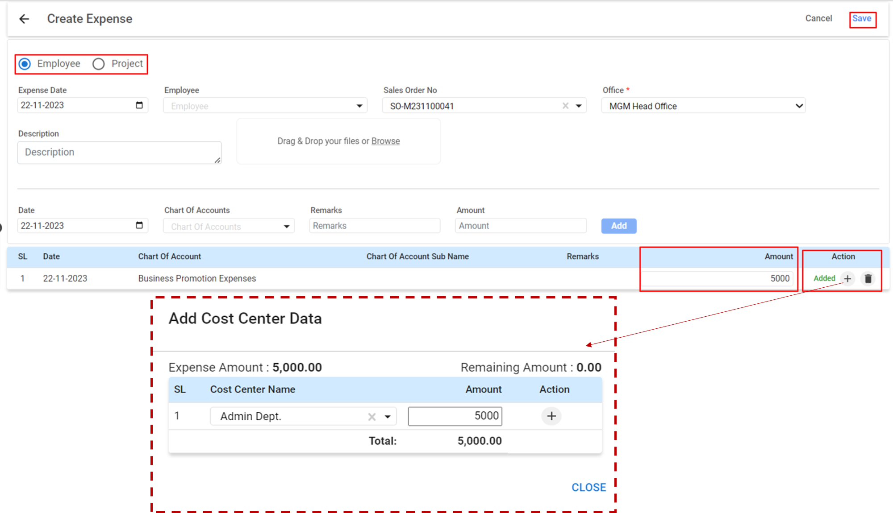

* Select the type of expense:
  + **Employee:** If the expense is related to an employee, select this option.
  + **Project:** If the expense is related to a specific project, select this option.
* **Fill in the expense details:**
  + **Expense Date:** Choose the date when the expense was incurred.
  + **Employee:** If the expense is for an employee, select the employee from the dropdown list.
  + **Sales Order No:** If the expense is linked to a specific sales order, enter or select the sales order number.
  + **Office:** Select the office to which the expense is related from the dropdown menu.
  + **Description:** Provide a description of the expense for reference.
* Upload any related documents by dragging and dropping files or browsing to select them.
* **Input financial details:**
  + Enter the date again for the specific expense entry.
  + Select the appropriate Chart Of Accounts that the expense should be recorded under.
  + Add any relevant Remarks for the expense.
  + Enter the Amount of the expense.
* Click on the **Add** button to list the expense.

**Adding Cost Center Data:**

* After listing the expense, allocate it to a cost center by clicking on the **Add Cost Cente**r Data section.
  + **Expense Amount:** This field will auto-populate with the amount you entered in the expense. For example, BDT 5,000.00.
  + **SL (Serial Line):** This is a system-generated number for tracking.
  + **Cost Center Name:** Select the cost center (e.g., Admin Dept.) from the dropdown list.
  + **Amount:** Enter the amount of the expense that should be allocated to the chosen cost center.
  + Click the **+ button** from Actions to assign the amount to the cost center.
* Once all details are entered and reviewed, click on the **Save** button to finalize the creation of the expense and its allocation to the cost center.

***3.7.2 Creating an Advance Entry:***

Click on the **+ Create Advance** button to enter a new expense.

**User Interface [Create Advance]:**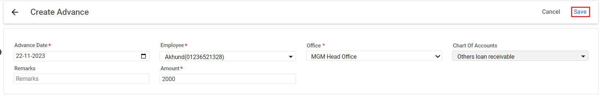

* **Enter the following details:**
  + **Advance Date:** Select the date the advance is given to the employee.
  + **Employee:** Choose the employee receiving the advance from the dropdown list.
  + **Office:** Select the office from where the advance is being processed.
  + **Chart Of Accounts:** Choose the appropriate account to track this transaction, as "Others loan receivable."
  + **Remarks:** Provide any necessary comments or notes regarding the advance.
  + **Amount:** Input the total amount of the advance payment being given to the employee.
* Click the **Save** button to record the advance. Once it gets approved and paid this will update the accounting records and reflect the advance in the employee's financial details.

***3.7.3 Paid Landing:***

On the 'Expense/Advance' section and click on the 'PAID' tab view manage transactions that have been settled.

**User Interface [Create Advance]:**

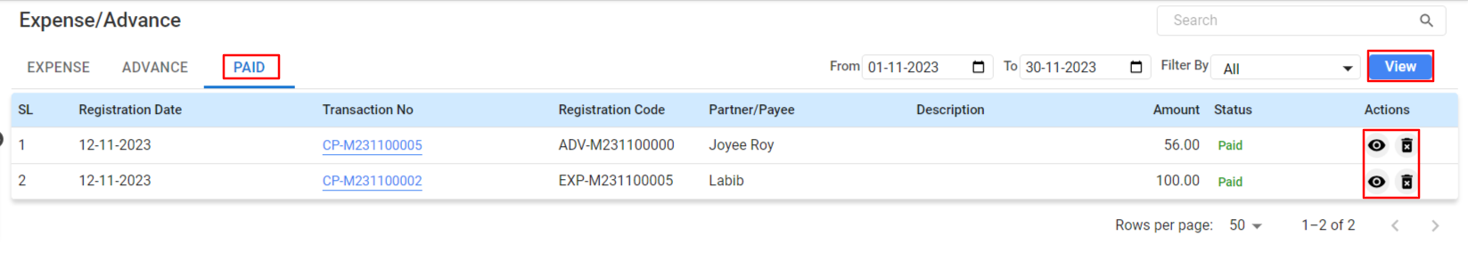

**Paid Expenses/Advances:**

* You will see a list of paid expenses and advances. The table includes:
  + **SL (Serial Number):** An identifier for the transaction order.
  + **Registration Date:** The date on which the transaction was registered.
  + **Transaction No:** A unique reference number for the transaction.
  + **Registration Code:** The code associated with the transaction.
  + **Partner/Payee:** The person or entity to whom the payment was made.
  + **Description:** A brief detail of the transaction.
  + **Amount:** The total sum that was paid out.
  + **Status:** This column will show as 'Paid', indicating the transaction is complete.
* To view detailed information about a transaction, click the 'View' icon in the Actions column.To remove a transaction from the record, which should only be done under correct circumstances and typically requires appropriate permissions, click the 'Delete' icon (trash can).

## 3.8 Project Accounting

**1. Filling Out the Project Description**

* **Type:** Begin by selecting the project type from the provided dropdown options.
* **Owner:** Choose the project owner from a list.
* **Name:** Enter the project's name into the designated text field.
* **Customer:** Use the search feature to select a customer from a list.
* **Location**: Type in the project's physical location.
* **Start/End Date:** Choose the respective start and end dates from a calendar.
* **Expected Value:** Enter the financial expected value for the project.
* **Work Order No.**: If available, type in the work order number associated with the project.
* **With Output:** Tick this box if the project will result in a physical or tangible output.

Ensure all details are correct before saving this section.

**2. Assembling the Project Team**

* **Team Member:** Pick a team member's name from the dropdown to add to your project.
* **Role:** Designate a specific role to each team member from another dropdown list.

After adding all team members and their roles, save this part of the form.

**3. Outlining Project Costing**

***For expenses:***

* **Cost Element:** Identify each cost by selecting the appropriate cost element.
* **Budget Amount:** Input the allocated budget for the selected cost element.
* **Responsible:** Assign responsibility for the cost to a team member.

Add each expense line by line and save the total expense details.

***For inventory:***

* Item: Pick the necessary inventory items from a list.
* Qty (Quantity): Specify the amount needed for the project.
* Price: Enter the cost per unit of each item.

Add items individually, specifying quantity and price, and then save the inventory list.

After completing all sections, conduct a final review to ensure accuracy. When all information has been verified, click the final 'Save' button to officially create the new project in the system.

## 3.9 Fund Transfer

The 'Fund Transfer' section is designed to manage and track the movement of funds between different accounts or departments within your organization. It ensures that all transfers are recorded and can be tracked for financial management purposes.

**Menu Path:**  **Accounting (Module) > Expense/Advance**

**User Interface [Fund Transfer]:**

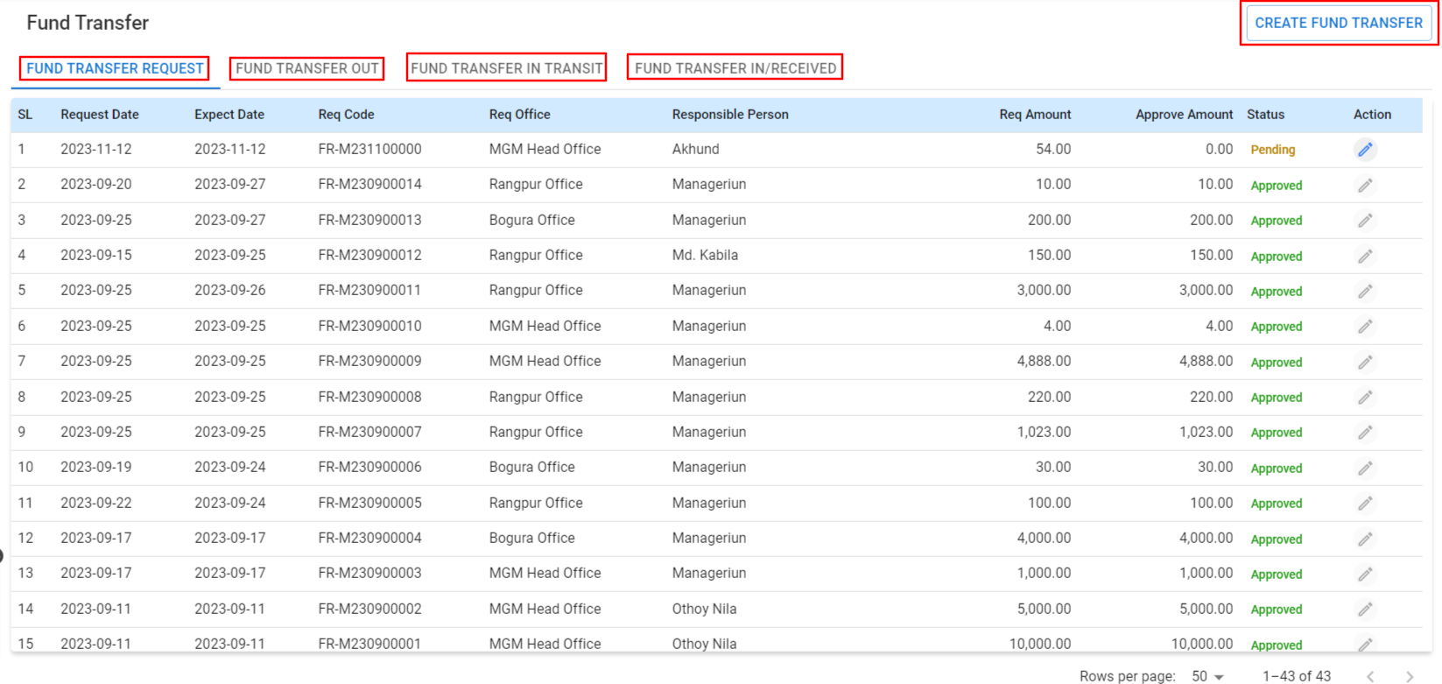

**Features:**

***Tabs:***

* **FUND TRANSFER REQUEST:** View and manage incoming requests for fund transfers.
* **FUND TRANSFER OUT:** Monitor funds that have been sent out from your accounts.
* **FUND TRANSFER IN TRANSIT:** Track funds that are currently being transferred but have not yet been received.
* **FUND TRANSFER IN/RECEIVED:** Confirm and record the funds that have been transferred and received into the intended accounts.

**Accessing Fund Transfers all table data (tab-wise):**

* + **Request Date:** The date on which the transfer request is made.
  + **Expect Date:** The anticipated date for the transfer to be completed.
  + **Req Code:** A unique code assigned to the transfer request for tracking.
  + **Req Office:** The office or department requesting the transfer.
  + **Responsible Person:** The individual responsible for overseeing the transfer.
  + **Req Amount:** The amount of money requested for transfer.
  + **Approve Amount:** The amount that is approved for transfer (may be equal to or less than the requested amount).
  + **Sent Amount:** The total transferred out.
  + **Received Amount:** The recipient’s received amount.
  + **Remaining Amount:** The amount is what's pending.
  + **In/Receive:** Tracks incoming funds.
  + **Status:** The current status of the transfer (e.g., Pending, Approved).

**Creating a Fund Transfer:**

* Click on the **‘CREATE FUND TRANSFER’** button to initiate a new transfer.
* Fill in the required fields:

**User Interface [Fund Transfer]:**

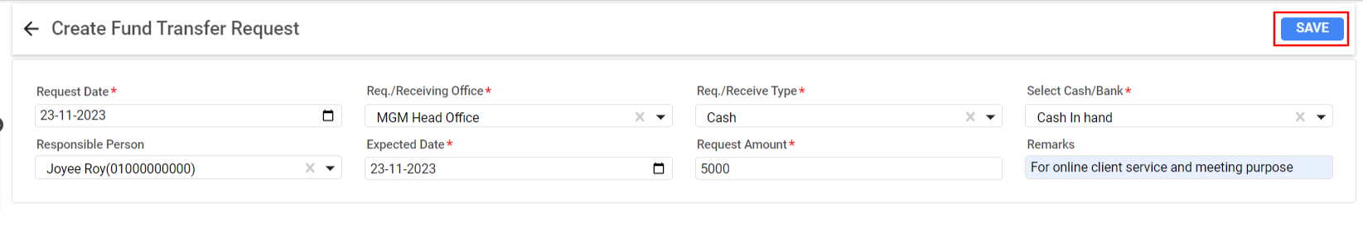

**Creating a Fund Transfer Request in Managerium:**

* **Request Date:** Select the date when the fund transfer request is made. This field usually defaults to the current date but can be changed if necessary.
* **Req./Receiving Office:** Choose the office that will receive the funds from the dropdown menu.
* **Responsible Person:** Assign a person who will be responsible for the transfer. Enter their name or select from a list if it's available.
* **Expected Date:** Set the expected date for the transfer to be completed, which is the same as the request date here, indicating an immediate transfer is intended.
* **Req./Receive Type:** Specify the type of transfer, such as cash, cheque, bank transfer, etc. Here, "Cash" has been selected.
* **Select Cash/Bank:** Choose the source of the funds, like a specific cash account or bank account. "Cash In hand" is chosen in this instance.
* **Request Amount:** Enter the amount of money to be transferred. In this example, it is "5000".
* **Remarks:** Provide any necessary comments or details about the transfer. The remark given is "For online client service and meeting purpose".

Review all details to ensure they are correct. Once confirmed, click the **'SAVE'** button to submit the fund transfer request for processing.

## 3.10 Cheque Setup

The cheque setup allows for the management and issuance of cheques within the system, maintaining a clear record of each cheque issued.

**Menu Path:**  **Accounting (Module) > Cheque Setup**

**Features:**

**Cheque Setup Landing Page:**

**Tab:**

* **Cheque Register:** This tab is for accessing the records of all cheques that have been set up. It's a ledger of cheque books within the system.
* **Outgoing Cheque Report:** This section provides a report on all cheques that have been issued and are outgoing from the company’s accounts.
* **Incoming Cheque Report:** This tab contains a detailed report on all cheques that have been received by the company.
* **Receive Cheque Report:** Here, you can view a report of all cheques that have been cleared and acknowledged as received in the company’s banking transactions.
* **New Cheque:** This button is used to initiate the process of setting up a new cheque or cheque book in the system. It’s for when you have a new set of cheques or a new cheque book that needs to be registered for issuing or receiving payments.

The tabs are designed to give users a full overview and control over both incoming and outgoing cheques, ensuring that all financial transactions involving cheques are meticulously recorded and easy to review.

To create a new cheque setup or to view details, simply click on the corresponding tab and follow the prompts to enter or access the required information.

***3.10.1 Creating a Cheque Setup in Managerium:***

**User Interface [Fund Transfer]:**

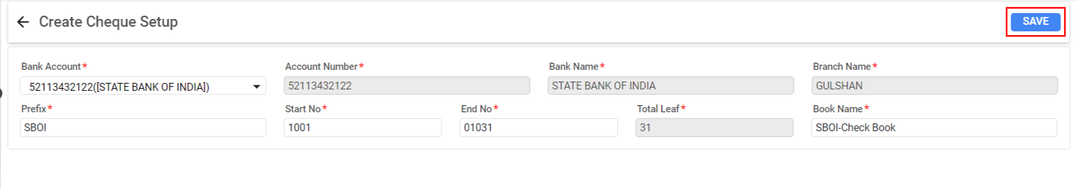

**Creating a Cheque Setup in Managerium:**

* **Bank Account:** Select the relevant bank account from the dropdown menu that the cheque book belongs to. For example, "52113432122(STATE BANK OF INDIA)" is selected here.
* **Account Number:** This field is automatically filled based on the selected bank account. Verify that the displayed account number, "52113432122," is correct.
* **Prefix:** Enter a prefix that will be used to identify the cheques. In this instance, "SBOI" could stand for State Bank of India.
* **Start No:** Input the starting number of the cheque leaf. This is where your cheque numbering will begin. Here it is "1001."
* **End No:** Enter the last number of the cheque leaf in the series. This example uses "01031," indicating a series of 31 cheques.
* **Total Leaf:** Indicate the total number of cheque leaves in the cheque book. As per the start and end numbers, this is "31."
* **Bank Name:** This is auto-populated based on the bank account selected and should match the bank where the account is held, in this case, "STATE BANK OF INDIA."
* **Branch Name:** Enter the name of the bank branch where the account is located. The branch name here is "GULSHAN."
* **Book Name:** Assign a name to the cheque book for easy identification. For example, "SBOI-Check Book" could be a name that signifies this particular cheque book for the State Bank of India account.

After filling out all the necessary fields and ensuring the information is accurate, click the **'SAVE'** button to complete the setup process for the new cheque book.

## 3.11 LC Margin

LC Margin is essential for tracking financial guarantees for international trade. It helps maintain financial integrity of LC transactions and ensures compliance with banking regulations. The LC Margin page provides a summary of all LC margins..

**Menu Path:**  **Accounting (Module) > Cheque Setup**

***3.11.1 LC Margin- Landing Page***

**User Interface [ LC Margin]:**

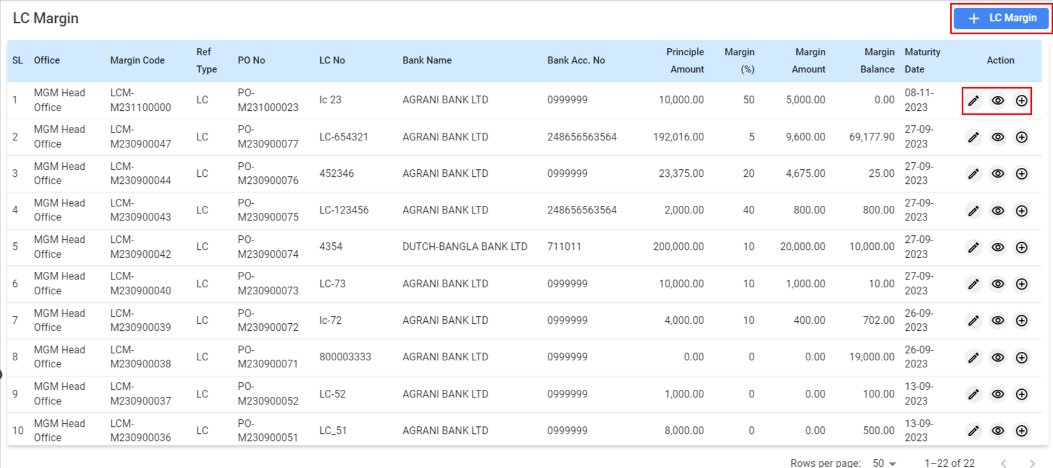

**Features:**

* **LC MarginLanding Page:**
  + **SL (Serial Number):** Lists the entries in sequential order.
  + **Office:** Indicates the office or department within your organization that is handling the LC.
  + **Margin Code:** A unique identifier for the margin amount associated with a specific LC.
  + **Ref Type:** Shows whether the reference is for an LC, a Purchase Order (PO), or another type.
  + **PO No:** The Purchase Order number related to the LC.
  + **LC No:** The number assigned to the specific Letter of Credit.
  + **Bank Name:** The bank that issued the LC.
  + **Bank Acc. No:** The account number from which the margin money will be held.
  + **Principle Amount:** The main amount of the transaction or LC.
  + **Margin (%):** The percentage of the principal amount that is held as a margin.
  + **Margin Amount:** The actual cash amount held as a margin.
  + **Margin Balance:** Remaining margin amount after any deductions or additions.
  + **Maturity Date:** When the LC is due to mature or expire.
  + **Action:** Icons to view details, edit, or delete the LC margin entry.

**‘+’ Add LC Margin:** To add a new LC Margin entry.

**View:** To inspect the details of an LC Margin.

**Edit:** To modify an existing LC Margin entry.

***3.11.2 LC Margin- Landing Page***

**User Interface [Create LC Margin]:**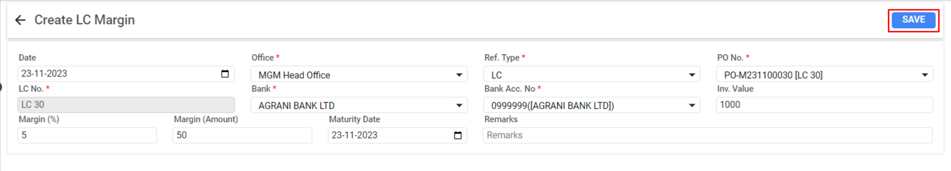

**Creating LC Margin in Managerium:**

* + **Date:** The date when the LC Margin is being created.
  + **Office:** Select the office from a dropdown menu that is responsible for the LC.
  + **LC No.:** Input the number of the Letter of Credit.
  + **Bank:** Choose the bank issuing the LC from a dropdown menu.
  + **Bank Acc. No:** Enter the bank account number associated with the LC.
  + **Margin (%):** Specify the percentage of the LC amount that will be held as a margin.
  + **Margin (Amount):** The calculated amount of money held as a margin based on the percentage entered.
  + **Maturity Date:** Set the date when the LC is due to mature or expire.
  + **Ref Type:** Indicate the type of document that the LC is related to (typically LC).
  + **PO No.:** Select the associated Purchase Order number from a dropdown list.
  + **Inv. Value:** Enter the invoice value related to the LC.
  + **Remarks:** Add any pertinent comments or notes regarding the LC Margin.

Once all the details are filled in and verified, click the **'Save**' button to record the LC Margin in the system.

# **4. Inventory Module**

The Inventory Module manages stock levels, tracks inventory movements, and maintains accurate record-keeping for all inventory items within an organization.

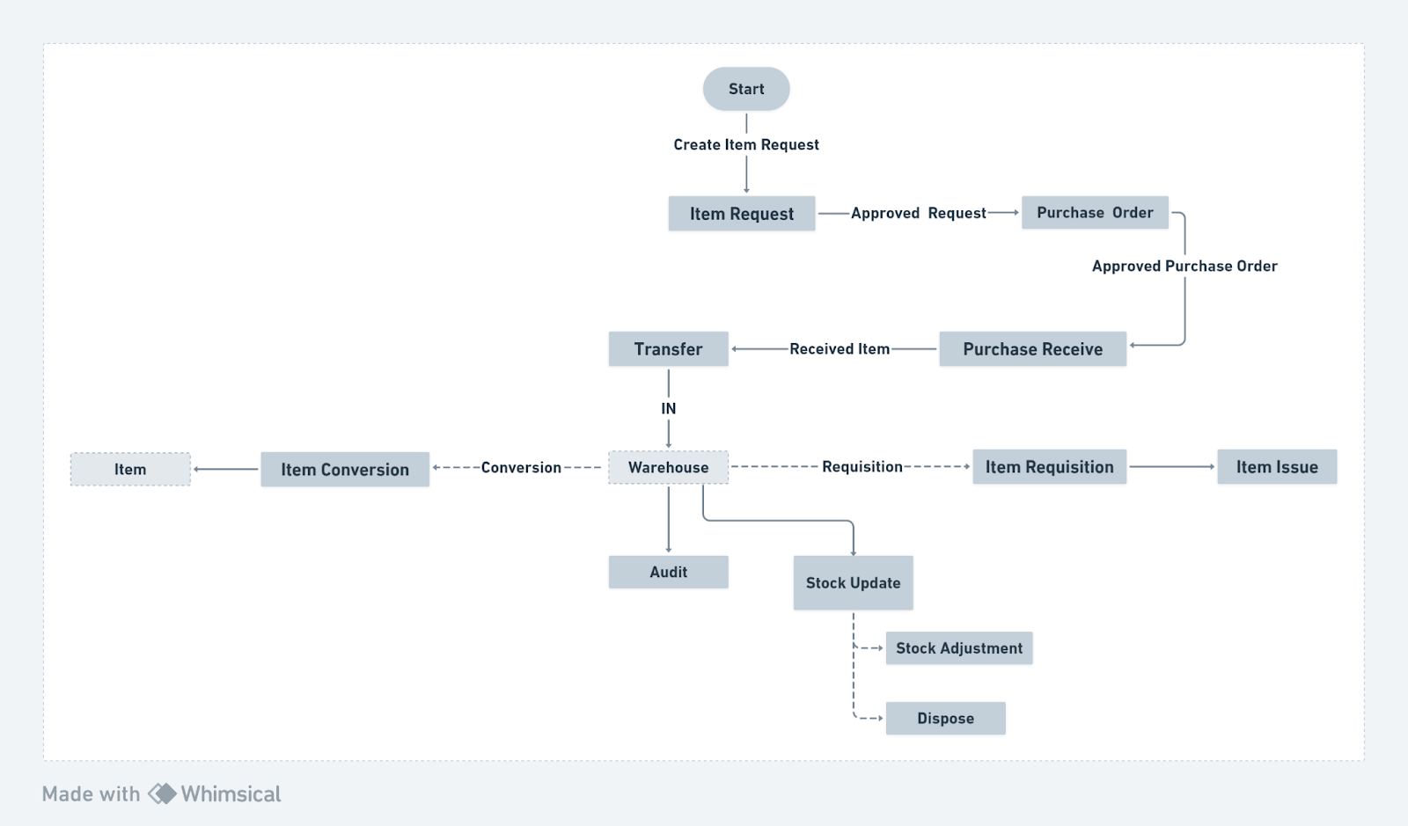

## 4.1 Inventory Dashboard

The Inventory Dashboard provides a comprehensive view of a company's inventory metrics, enabling quick assessment of stock levels, asset valuation, and inventory turnover.

**Menu Path: Inventory (Module) >**  **Inventory Dashboard**

The user will see a landing page after clicking the " Inventory Dashboard" feature.

**User Interface [Landing]**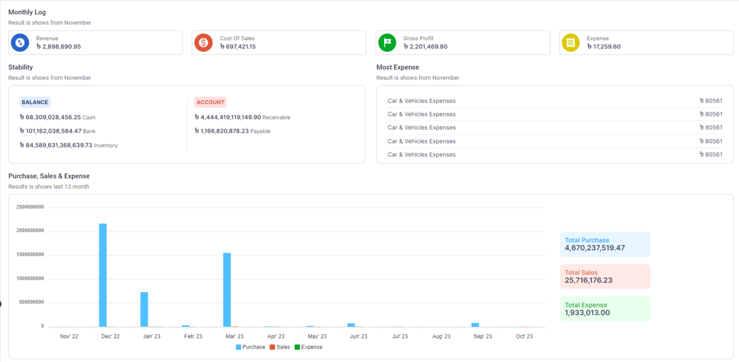

**Features:**

* **Total Balance:** Displays the current total value of the inventory.
* Opening Balance: Shows the value of the inventory at the beginning of the period.
* **Inventory OUT:** Represents the total value of inventory items that have been sold or used.
* **Inventory IN:** Indicates the total value of new inventory items that have been purchased or produced.
* **Detailed Sections:**
* **Valuation:** A donut chart visualizing the proportion of different inventory types (MRO, Asset, Raw, Finished Goods) as per the selected time period.
* **Coverage Days:** Allows monitoring of how many days the current stock will last based on daily consumption.
* **Item Moving Frequency:** Displays the items that are most frequently sold or used (e.g., Coffee shown as 60% of the movement).
* **Transaction Value:** Lists the top transactions by value, like Purchase, Initial Balance, and Receive from Production.
* **Inventory Turnover Ratio:** Shows the rate at which inventory is used or sold within a given period.

**Using the Dashboard:**

* Select the desired time frame and category to view specific inventory valuation and coverage days.
* Review the Item Moving Frequency to understand which items are moving fastest through the inventory.
* Monitor the Transaction Value to identify the most significant inventory-related financial activities.
* Keep an eye on the Inventory Turn Over Ratio to ensure efficient inventory management.

**Additional Features:**

* Filtering options to view inventory statistics for specific items, categories, or time periods.
* Quick links for detailed inventory reports and analysis.
* Real-time updates to reflect inventory changes as they happen.

## 

## 4.2 Item Request

The Inventory Request allows users to submit requests for items needed from the inventory. It ensures the availability of items for operational requirements and streamlines the internal supply chain process.

**Menu Path: Inventory (Module) >**  **Inventory Dashboard**

**Features:**

**Tab:**

* **Request List:** Displays all inventory requests with their current status, quantities, and the action by whom it was taken.
* **Request Summary:** Offers a summarized view of requests, facilitating quick oversight and decision-making.
* **Request Details:** Provides detailed information about each request, including the expected and actual quantities, dates, and status.

**User Interface [Landing]:**

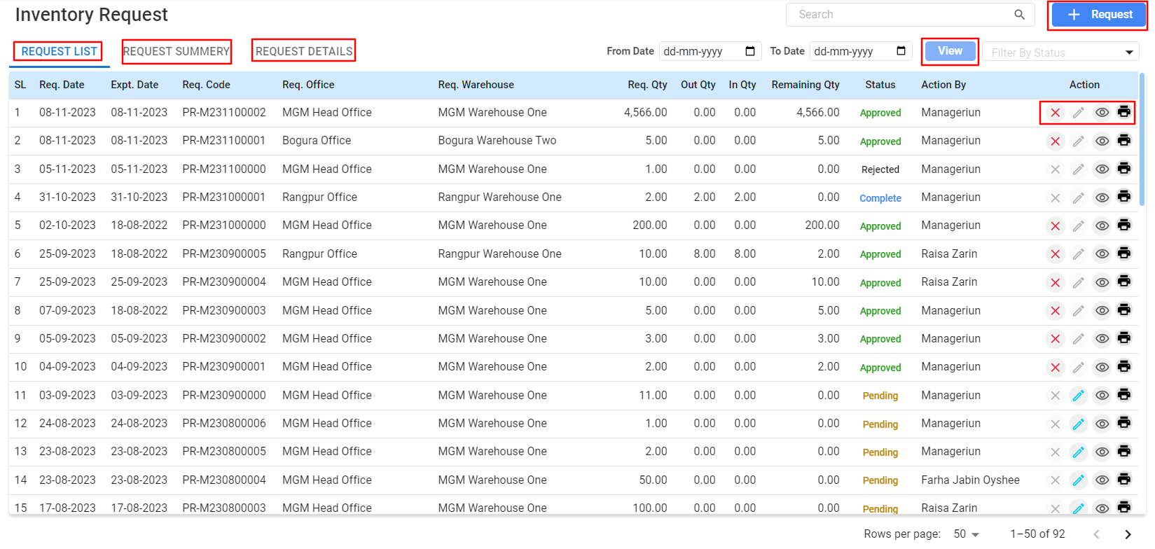

* **Table Details:**
  + **Req. Date:** The date on which the request is made.
  + **Exp. Date:** The expected date by which the items are needed.
  + **Req. Code:** A unique identifier for the request.
  + **Req. Office:** The office or department making the request.
  + **Req. Warehouse:** The warehouse from which the items are requested.
  + **Req. Qty:** The quantity of the item requested.
  + **Out Qty:** The quantity that has been issued out.
  + **In Qty:** The quantity that has been received.
  + **Remaining Qty:** The quantity still required to fulfill the request.
  + **Status:**The request can be marked with various statuses such as Approved, Rejected, Complete, or Pending.
  + **Actions:**To modify a request, click the pencil icon under the "Action" column.To view,edit,close or print.

**Filtering Options:**

Use the filter options to view requests by status, date, or office for easy management.

#### 4.2.1 Creating an Inventory Request:

Create Item Request is a process by which users can formally request specific items from the inventory. This feature ensures that the necessary items are tracked and allocated efficiently for various operational needs.

* Click on the “+ Request” button to create a new inventory request.

#### Steps to Create an Item Request:

**User Interface [Create Item Request]:**

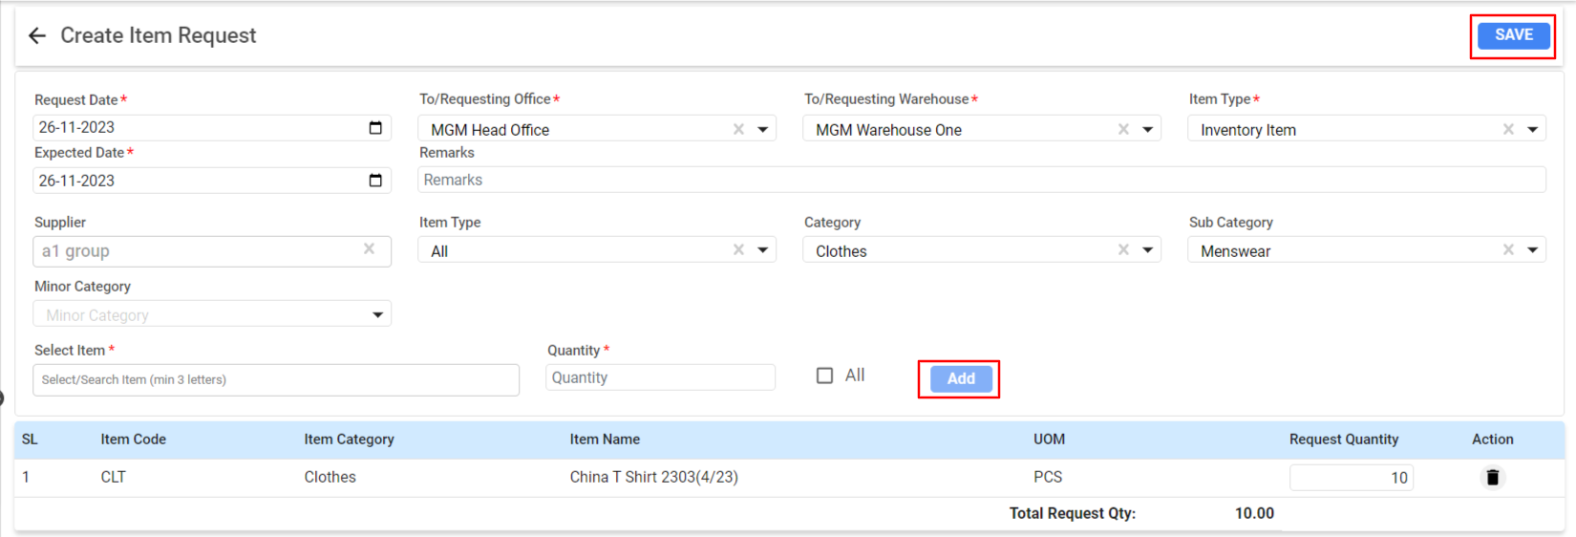

**Table details:**

* **Request Date:** The date on which the request is being made.
* **Expected Date:** The date by which the items are needed.
* **To/Requesting Office:** The office that is making the request.
* **To/Requesting Warehouse:** The warehouse from which the items are being requested.
* **Supplier:** The supplier of the item, if applicable.
* **Item Type:** Choose from the dropdown list (e.g., All, Inventory Item).
* **Category and Sub Category:** Specify the category and subcategory of the item if necessary.

**Select the Item:**

* Use the search function to find the item. Type in at least three letters of the item name to begin the search.
* **Item Code:** Will auto-populate once the item is selected.
* **Item Category:** Will auto-populate based on the item selected.
* **Item Name:** Confirm the name of the item.
* **Quantity:** Enter the number of items requested.
* **UOM (Unit of Measurememt):** Will auto-populate based on the item selected.
* Add the item to the request list by clicking the **“Add”** button.
* Review the Total Request Qty to ensure the correct amount is requested.
* Add any additional Remarks that may be necessary to inform the approver or supplier.
* Save the request by clicking the **“Save”** button.

## 

## 4.3 Transfer

The Transfer allows for the movement of inventory items between different locations or warehouses. This feature is crucial for managing stock levels across various parts of the organization and ensuring that items are available where needed.

**Menu Path: Inventory (Module) > Transfer**

**User Interface [Transfer-Landing]:**

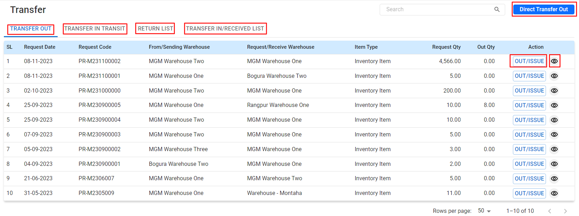

**Features:**

**Tab:**

Review the Transfer Lists:

* + **TRANSFER OUT:** Lists all items that have been requested to be transferred out of a warehouse.
  + **TRANSFER IN TRANSIT:** Shows items that are currently being moved between locations.
  + **RETURN LIST:** Details items that have been returned to the warehouse.
  + **TRANSFER IN/RECEIVED LIS**T: Displays items that have been successfully transferred and received by the requesting location.
* **Initiating a Transfer:**
  + Click on the “Direct Transfer Out” button to begin the process of transferring items.
  + Fill out the necessary details for the transfer, including the From/Sending Warehouse, Request/Receive Warehouse, item details, and quantities.
  + Use the **“OUT/ISSUE”** button to execute the transfer for the listed items.
* **Completing a Transfer:**
  + Confirm the quantities that are being transferred out and received.
  + Update the status to reflect the progress of the transfer (e.g., In Transit, Completed, Received).

#### 4.3.1 Creating an Direct Transfer:

Direct Transfer is allows for immediate transfer of inventory items between different offices and warehouses without the need for a transfer request. This function facilitates.

**User Interface [Direct Transfer]:**

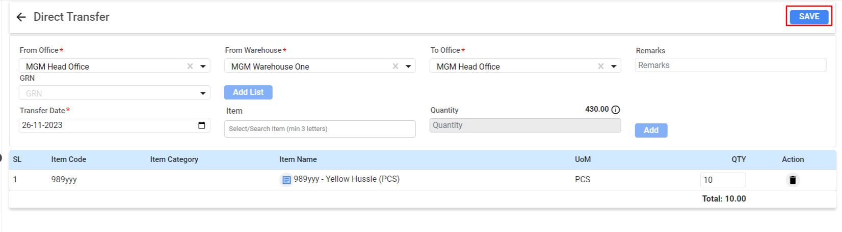

**Transfer Details:**

* **From Office:** Select the office from where the inventory items will be transferred.
* **From Warehouse:** Choose the warehouse that currently holds the stock.
* **To Office:** Select the destination office where the stock needs to be sent.
* **To Warehouse:** Choose the destination warehouse to receive the items.

Adding Items to Transfer:

* Click on **“Add List”** to begin adding inventory items to the transfer list.
* In the **"Item"** field, search and select the inventory item to be transferred.
* Enter the **"Quantity"** of the item that needs to be transferred.
* Click on **“Add”** to include the item in the transfer list.
* The added items will appear in the list below with the option to edit or remove them if necessary.
* Review and Save:
  + Review all details and the list of items to ensure accuracy.
  + Include any **"Remarks"** that may be necessary for context or instructions related to the transfer.
  + Once verified, click the **“SAVE”** button to finalize the direct transfer.

## 4.4 Item Conversion

Item Conversion allows users to change inventory items from one state or type to another. This is useful for situations where raw materials are turned into finished goods or when repackaging products into different quantities.

**Menu Path: Inventory (Module) > Item Conversion**

#### 4.4.1 Item Conversion-Landing:

**User Interface [Item Conversion-Landing]:**

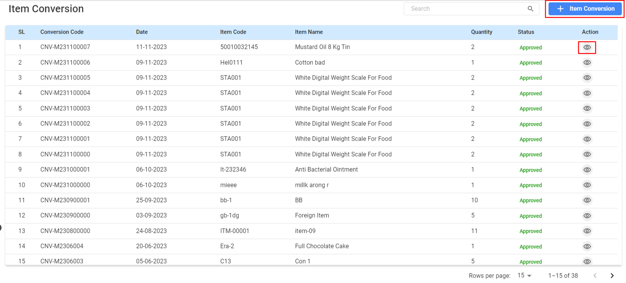

**Features:**

#### Steps

#### Item Conversion:

* **Navigate to Item Conversion:** Go to the Inventory module and select the "Item Conversion" option to view existing conversions or to create a new one.
* **Review Existing Conversions:** The Item Conversion page lists all the conversions with their respective details such as Conversion Code, Date, Item Code, Item Name, Quantity, and Status. You can review this list to track the status and details of past conversions.
* **Approval Process:** After creation, the conversion once approved, the status will change from 'Pending' to 'Approved'.

***4.4.2 Create New Item Conversion:***

**User Interface [Item Conversion-Landing]:**

Creating an item conversion in Managerium involves changing the state, form, or packaging of an inventory item. This feature is critical for managing stock that undergoes transformation or repackaging before sale or use.

* Click on the "+ Item Conversion" button to initiate a new item conversion.

**User Interface [Create Item Conversion]:**

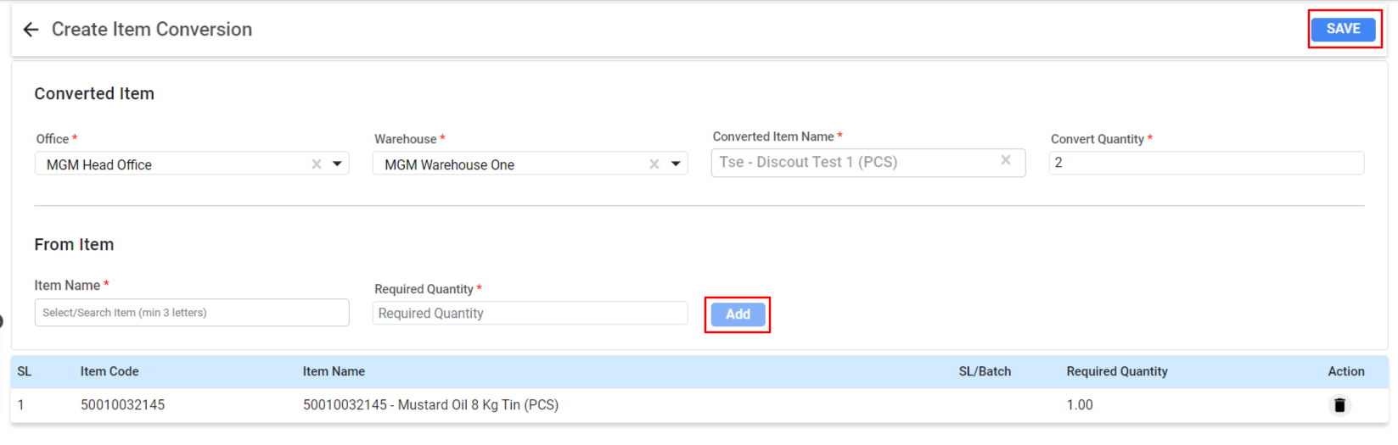

#### Steps for Creating an Item Conversion:

* Access Item Conversion: In the Inventory module, select **"Create Item Conversion"** to start the process of converting one item to another.
* Input Conversion Details:
  + **Office:** Select the office where the conversion is taking place.
  + **Warehouse:** Choose the warehouse from where the item is being converted.
  + **Converted Item Name:** Enter the name of the new item after conversion.
  + **Convert Quantity:** Specify the number of items you want to convert.
* **Specify From Item:**
  + **Item Name:** Use the search function to find the item you want to convert from. This will be the item that is transformed into a new product.
  + **Required Quantity:** Enter the amount of the original item that will be used for the conversion.
* **Add Items to Conversion List:**
  + Click on the **"Add"** button to include the item in the conversion list.
  + The item will appear below with its code, name, SL/Batch, required quantity, and action options.
* **Review and Confirm Conversion Details:**
  + Check all the details for accuracy.
  + Ensure the required quantity of the 'From Item' is available in the warehouse.
  + Verify the 'Converted Item' details are correct.
* **Save the Conversion:**
  + Once all details are confirmed, click the **"Save"** button to record the conversion.
  + The conversion will now be listed in the Item Conversion list and is subject to approval as per the organizational process.

## 4.5 Item Requisition

Item Requisition is the process of officially requesting items from the inventory. This could be for various purposes such as production, office use, or project requirements.

**Menu Path: Inventory (Module) > Item Requisition**

#### 4.5.1 Item Requisition-Landing:

**User Interface [Item *Requisition*-Landing]:**

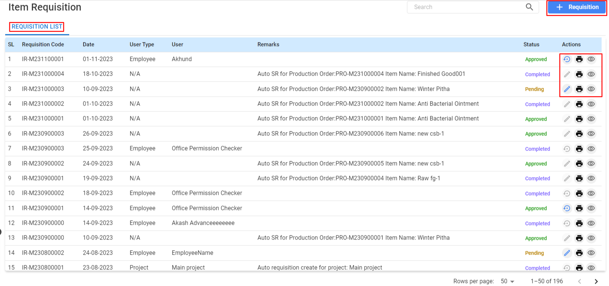

#### Features: Steps

#### Creating an Item Requisition:

**Navigate to Item Requisition:** From the inventory module, select "Requisition" to initiate a new item requisition.

**Input Requisition Details:**

* **Requisition Date:** Enter the date when the requisition is made.
* **Expected Date:** Provide the date by which the items are needed.
* **Office:** Select the office where the requisition is originating.
* **User Type:** Choose if the requisition is made by an Employee or for a Project.
* **User:** Select the user or project name from the dropdown.

**Enter Item Details:**

* **Supplier:** If applicable, choose the supplier from whom the item is being requisitioned.
* **Item Type:** Specify the type of item being requested, such as Inventory Item or Asset.
* **Category and Sub Category:** Choose the relevant category and sub-category for the item.
* **Select Item:** Use the search function to find the item you want to requisition.
* **Quantity**: Enter the number of items required.

**Add Items to Requisition List:**

* Click the **"Add"** button to include the selected item in the requisition list.
* The selected items will be displayed with details such as item code, category, and quantity.

**Review and Confirm Requisition:**

* Verify the details of each item added to the requisition.
* Ensure that the quantities requested are accurate and necessary.

**Save the Requisition:**

* Click the **"Save"** button to submit the requisition for processing.
* Upon saving, the requisition will be sent for approval as per the company's requisition workflow.

## 4.6 Item Issue

Item Issue involves distributing or allocating items from the inventory to the relevant departments or projects following an approved requisition.

**Menu Path: Inventory (Module) > Item Issue**

#### 4.6.1 Item Issue-Landing:

**User Interface [Item *Issue*-Landing]:**

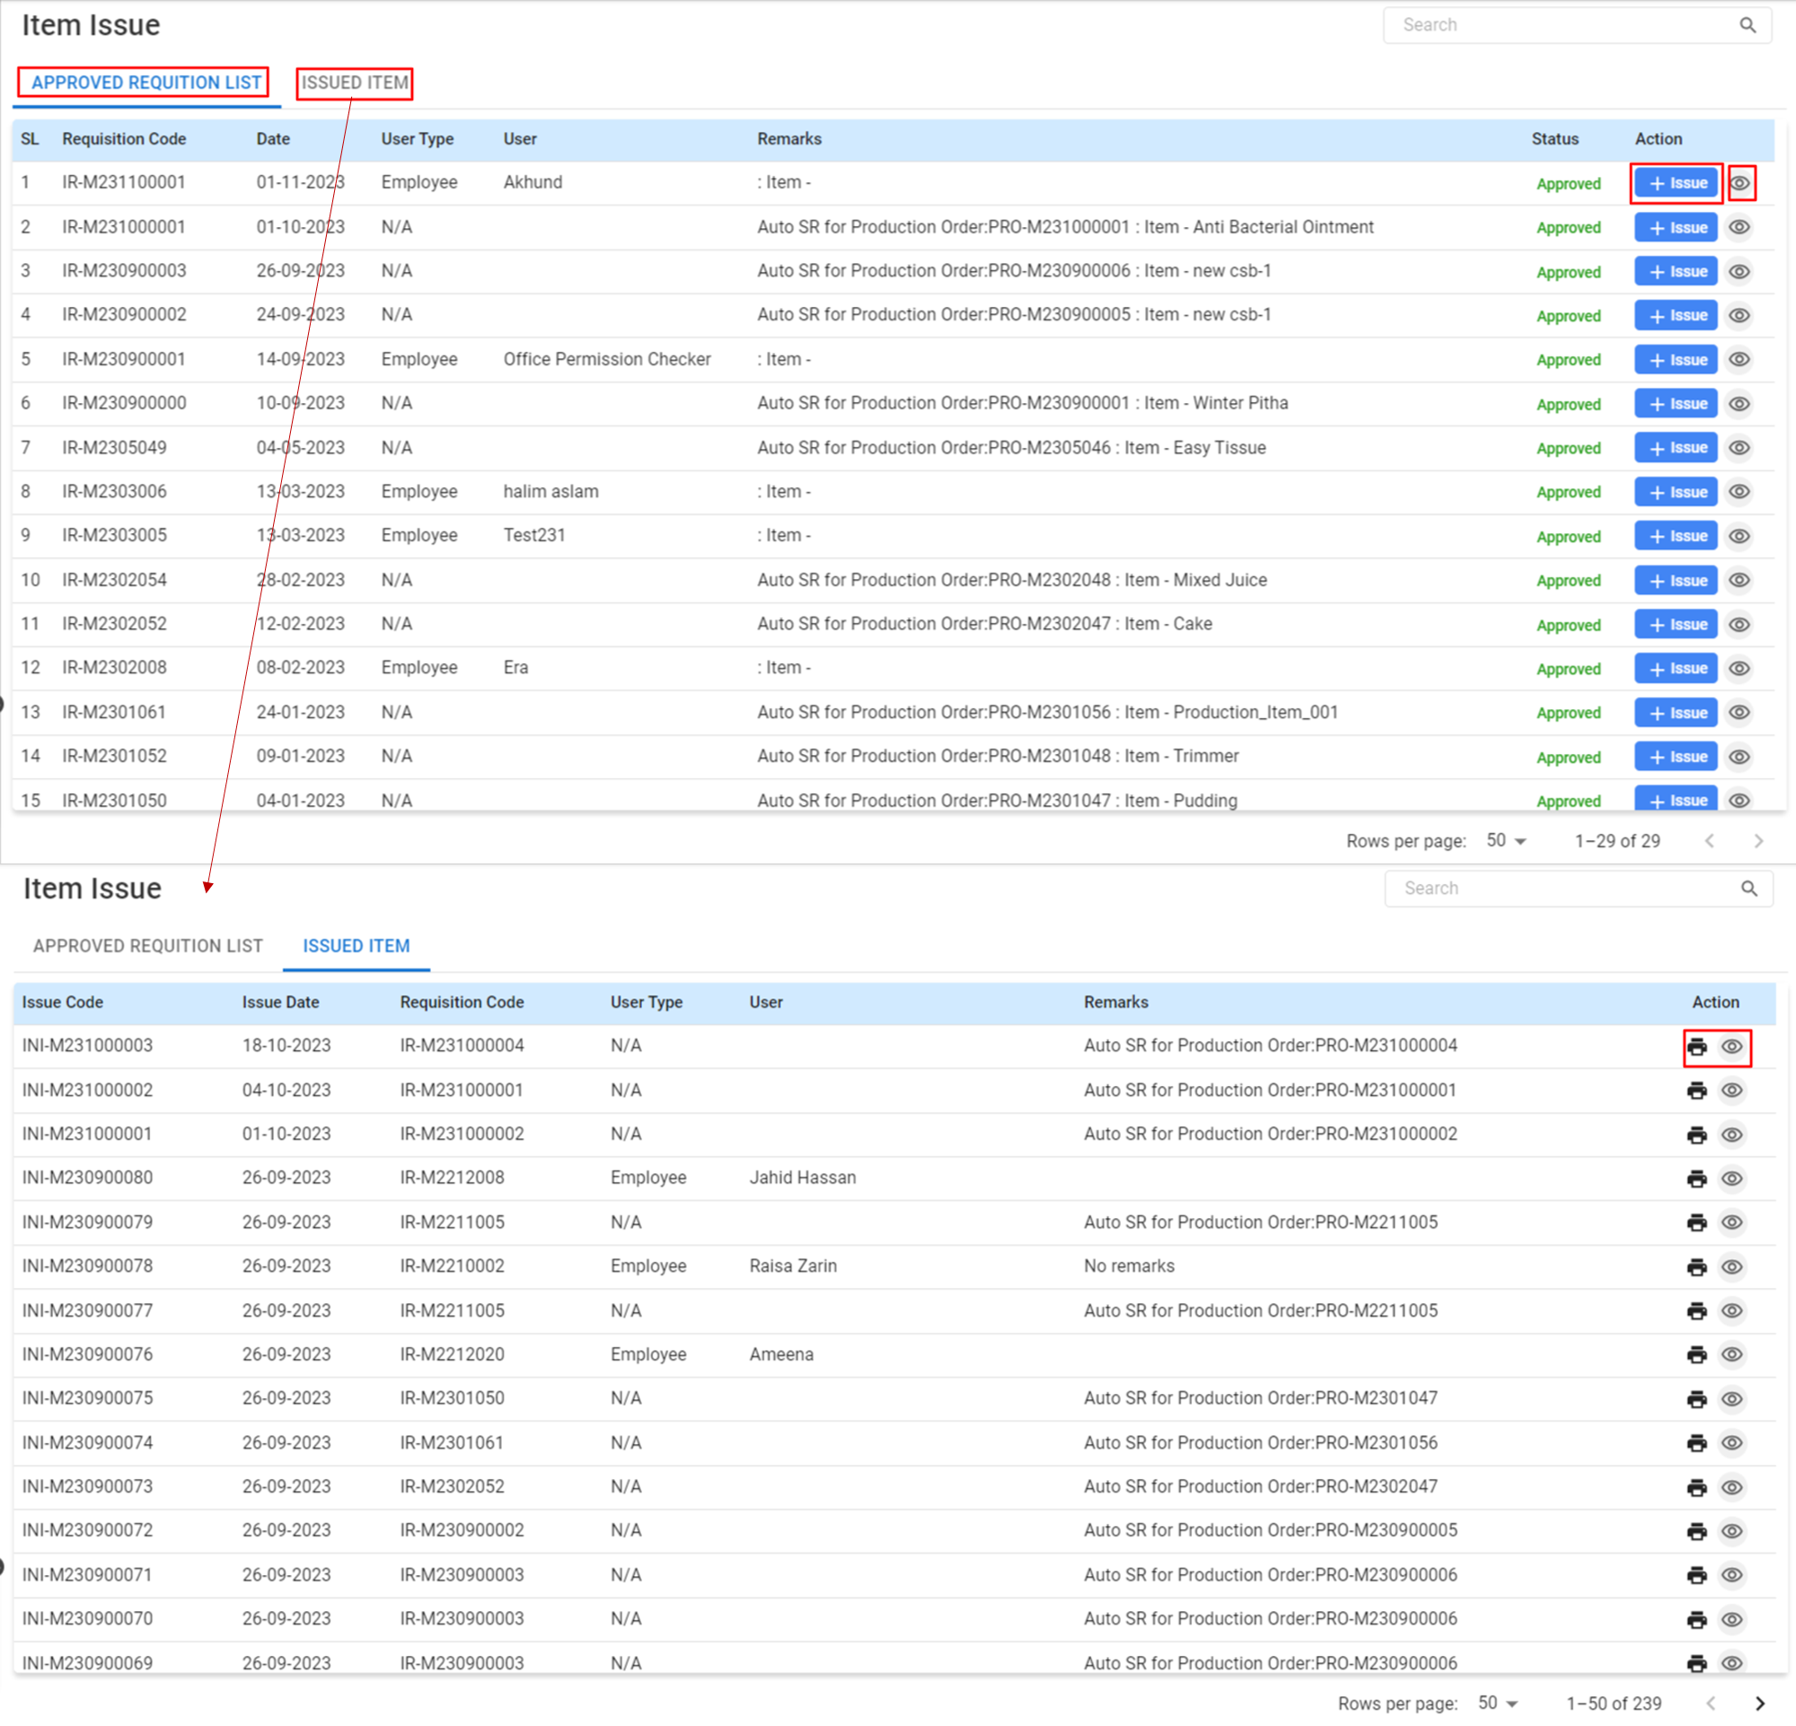

#### Steps for Issuing Items:

* **Review Approved Requisitions:** The "Approved Requisition List" tab will show all requisitions that have been approved and are ready for items to be issued.
* Select a Requisition to Issue:
  + Locate the requisition for which you want to issue items.
  + Click the “Issue” button corresponding to the requisition.
* **Issue Details:**
  + The system will display the "Issue Item" interface, showing details such as Issue Code, Date, User Type, User, and Remarks.
  + Confirm the items and quantities to be issued as per the requisition.
* The **"Issued Item"** tab will maintain a record of all the items that have been issued.
* Only issue items that are approved and ensure that the quantity matches the requisition.
* In case of discrepancies, make appropriate notes in the remarks section for clarity.

#### After Issuing the Items:

* The inventory levels will be automatically updated to reflect the issued items.
* The department or project that requested the items should receive a notification of the issue.
* It’s important to track the items to ensure they are received by the requesting party and used for the intended purpose.
* **Add Items for Issue:**
  + If needed, adjust the quantity of items to be issued in case of partial fulfillment.
  + Use the “Add” button if you need to issue additional items that are part of the requisition.
* **Finalize the Issue:**
  + Once all items and quantities are correctly entered, review the details.
  + Ensure the right items are issued to the correct user or project as requested.
* **Save the Issue:**
  + Click the “Save” button to complete the process of issuing items.
  + The status will change from “Approved” to “Issued” in the Approved Requisition List.

#### 4.6.2 Create Item Issue:

The "Issue Create" allows for allocating specific inventory items to users or departments based on an approved requisition.

**User Interface [Item *Issue*-Create]:**

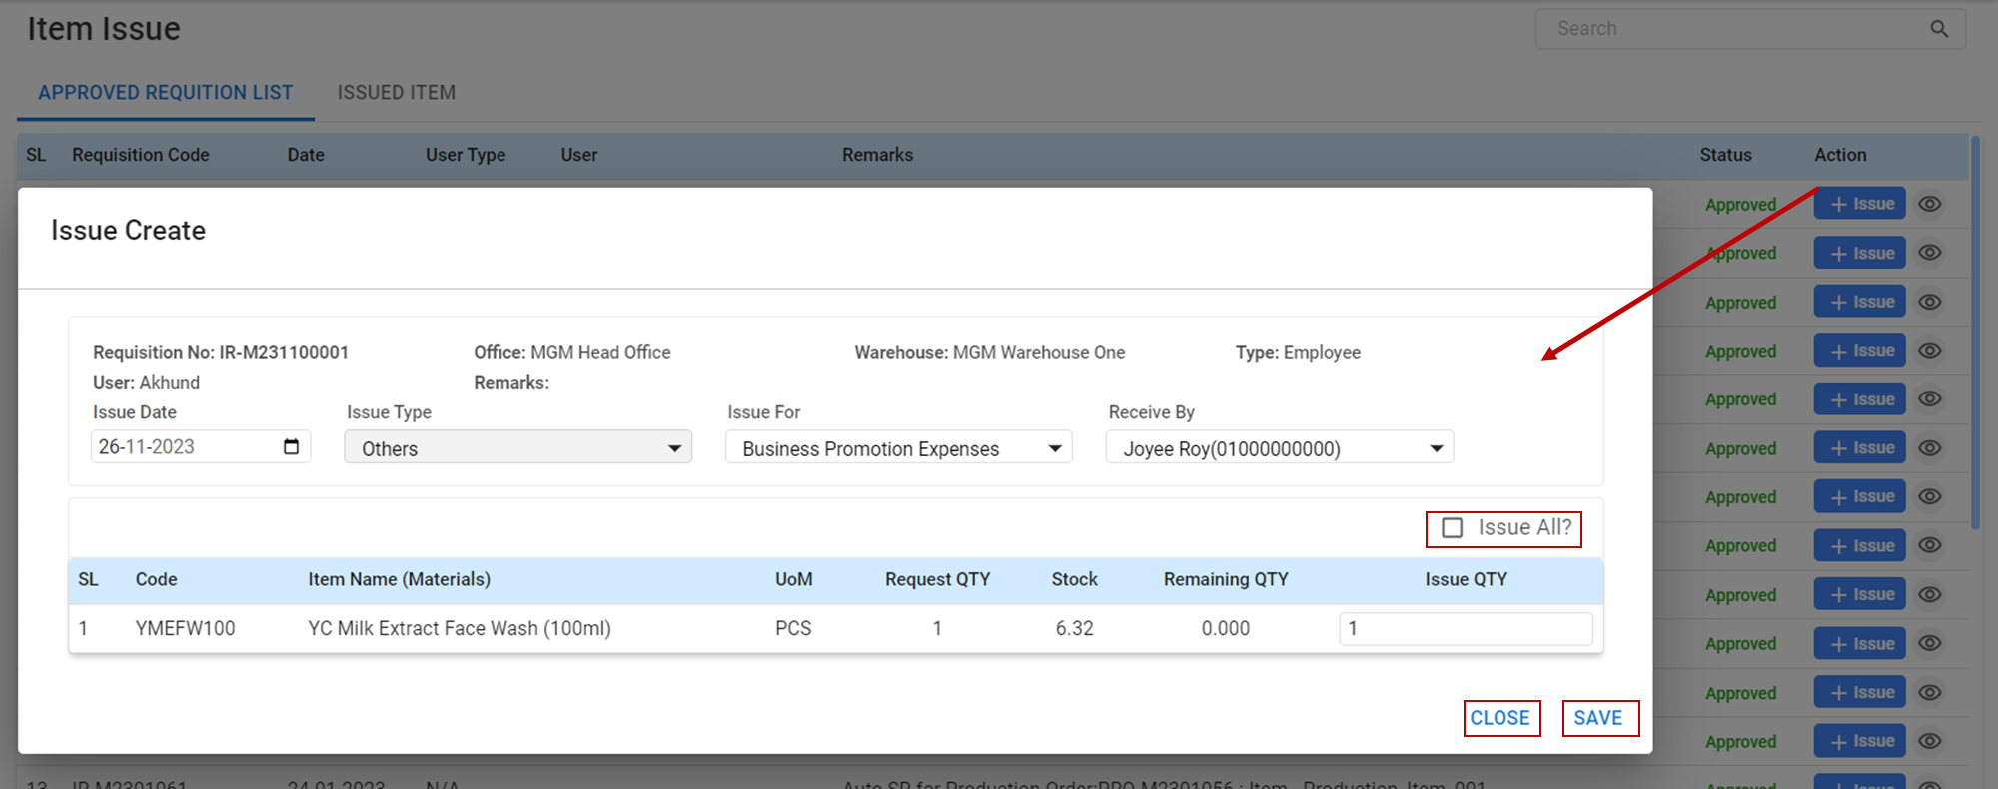

#### Steps

#### Creating an Item Issue:

* Navigate to Issue Create: Access the "Issue Create" section from the inventory or requisition module.
* **Enter Issue Details:**
  + **Requisition No:** Automatically populated based on the selected requisition.
  + **Office:** Select the office from which the items are to be issued.
  + **Warehouse:** Choose the warehouse where the items are stored.
  + **Issue Date:** Set the date when the items are being issued.
  + **Issue Type:** Specify the type of issue (e.g., Business Promotion Expenses).
  + **Receive By:** Select the employee who will receive the items.
* **Item Details:**
  + Review the list of items that are to be issued, along with their codes, names, and units of measure (UoM).
  + Confirm the "Request QTY" which is the quantity requested.
  + Verify the "Stock" to ensure that there is enough inventory for the issue.
  + Enter the "Issue QTY" which is the actual quantity you are issuing.
* **Issue All Option (if available):**
  + If all items from the requisition are to be issued, use the **“Issue All?”** option to automatically populate the issue quantity for all items.
* **Saving the Issue:**
  + Once all the details are confirmed and the issue quantities are set, click the **“Save”** button to finalize the issue.
  + The system will record the issue and adjust inventory levels accordingly.

## 4.7 Stock Adjustment

The Stock Adjustment is used to modify the inventory levels within the system. This may include adjustments due to stocktakes, write-offs, exchanges, or any other changes that affect inventory levels.

**Menu Path: Inventory (Module) > Stock Adjustment > Stock Update**

#### 4.7.1 Stock Update-Landing:

**User Interface [Stock Update-Landing]:**

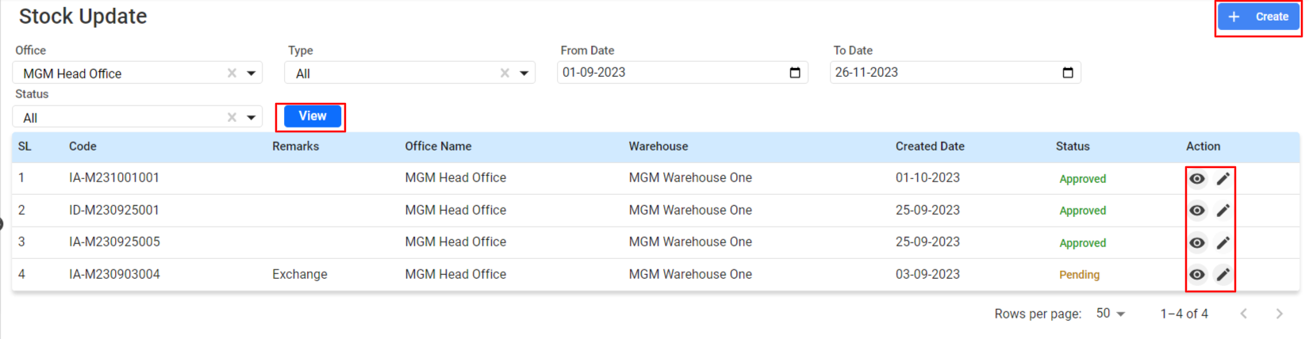

#### Steps

#### Updating Stock:

**Access Stock Update Section:** Locate and click on the "Stock Update" option within the inventory module.

**Filtering Options:**

* **Office:** Select the office for which you are updating stock, if applicable.
* **Type:** Choose the type of update you're performing if there are categories such as 'Received', 'Damaged', etc.
* **Status:** Filter the updates by status (e.g., 'All', 'Approved', 'Pending').
* **From Date - To Date:** Select the date range for the stock updates you wish to view.

**Viewing Stock Updates:**

* Click the **“View”** button to display a list of stock updates within the filtered criteria.
* Review the list of updates including the code, remarks, office name, warehouse, created date, and status.

### **Stock Adjustment**

Stock Adjustment ensures the accuracy of stock levels in the system. It allows for corrections to be made when the system stock differs from the actual physical stock due to various reasons such as expiry, damage, loss, or errors in recording.

#### Steps for Making a Stock Adjustment:

* **Access Stock Adjustment Section:** Go to the Inventory module and select "Stock Adjustment."
* **Filling in Stock Adjustment Details:**
  + **Office:** Choose the office location where the stock adjustment is to take place.
  + **Warehouse:** Select the specific warehouse from where the stock adjustment is occurring.
  + **Created Date:** Enter the date when the stock adjustment is being made.
* **Entering Item Details for Adjustment:**
  + **Item:** Search and select the item that needs adjustment.
  + **System Stock:** The system will automatically populate the current system stock level.
  + **Physical Stock:** Enter the actual physical stock count.
  + **Reason:** Select or add the reason for the adjustment (e.g., Expired, Damaged).
  + Click **“Add”** to put the item on the adjustment list.
* **Reviewing and Saving the Adjustment:**
  + Review the list of items to be adjusted along with the up/down quantity and corresponding amount.
  + Input any necessary remarks related to the adjustment.
  + Click the **“Save”** button to commit the adjustments to the system.

### **Dispose**

The Dispose is used when items need to be removed from the inventory due to reasons such as expiry, damage beyond repair, or any other reason that renders the stock unusable.

#### Steps for Disposing of Items:

* **Access Dispose Section:** Navigate to the section where items can be marked for disposal.
* **Entering Disposal Details:**
  + **Office:** Select the office related to the disposal.
  + **Warehouse:** Choose the warehouse where the items to be disposed of are located.
  + **Created Date:** Specify the date of disposal.
* **Selecting Items for Disposal:**
  + **Item:** Search and select the item to be disposed of.
  + **Current Stock:** The system will display the current stock level.
  + **Dispose Of Qty:** Enter the quantity of the item that is to be disposed of.
* **Completing the Disposal:**
  + Add the item to the disposal list by clicking the “Add” button.
  + Input any remarks that provide details or the reason for the disposal.
  + Review the total disposal cost amount that will be removed from the inventory valuation.
  + Click **“Save”** to finalize the disposal and update the system’s stock levels accordingly.

## 4.8 Audit Setup

## 4.9 Audit

# **5. HR Module**

The HR Module serves as managing various human resource functions within an organization. It centralizes employee information, simplifies HR processes, and supports multiple HR activities, including recruitment, onboarding, payroll, leave management and compliance reporting.

### 

### ***5.1.2 Types of Users***

Types of Users of

* **Super Admin** (HR/Management/Authority)
* **Normal Use**r (Authorized Employees)

Super Admin: The authority of the Module or an authorized person assigned by the management could access the software system. Having access to all features of the HR module, the super admin would be given all authority of the system.

Normal User: Only those employees who have been assigned as system users by the super admin can access the specific features of the HR Module.

#### 5.1.3 Home Page

After logging in, the user will come to the homepage of the People Desk. Here the user can see all the authorized modules (*Some are for users, while others are specific to admins*) of the system.

* **Dashboard**- The dashboard is an essential module of the application and is accessible to three types of users: employees, supervisors, and management.
* **Attendance-** The feature enables businesses and organizations to track and record employee attendance. It streamlines attendance management processes and ensures accurate tracking of employee working hours.
* **Leave & Movement-** When an employee needs to take leave or travel to a client's office or meeting outside the office, they must apply for leave and movement. Certain components must be configured before an employee's leave and movement can be updated. In the process of creating a leave and movement, approval and configuration are all interrelated.
* **Configuration/Policies**- Employee behavior is influenced by policies that businesses create to hire, select, enable, and encourage goal-achieving behaviors. Policies help authorities keep track of employees and are created with data.
* **Payroll-** Payroll administrators generate, calculate and issue employees' salaries and allowances. They define payroll elements, policy, bonus setup, and overtime policy based on company policy.
* **Report**- Here, each module-based action is presented as a report.
* **Salary Disbursement-** Salary disbursement is the process of paying employees for their work, typically on a regular basis. It is a critical administrative task for employers.
* **Approval -** In this process, a set of criteria is used to make a decision on whether to approve or reject something.

## 

In this module there are some features that will make managing users and employees easier. Administration is the execution or management of company activities, which involves making or putting into action important decisions.

**Menu Path:** HR *(Module)* **>** Configuration/Policies *(Features)* **>** …..

Here is the process of allocating and managing the configuration & Policies to dedicate to specific tasks. The administrator can set up and assign the holiday, calendar, off day, leave, roster, salary, overtime, notice board, and others for each employee or a group of employees.

### ***5.1.4 Holiday***

A pre-configured approval route is used to process holiday creation.

**Menu Path:** HR *(Module)* **>** Configuration/Policies *(features)* **>** HOLIDAY *(sub- features)*

The admin will see a landing page after clicking the *"Holiday"* feature. Here the admin can see all the existing holiday setup data.

**User Interface [Landing] :**

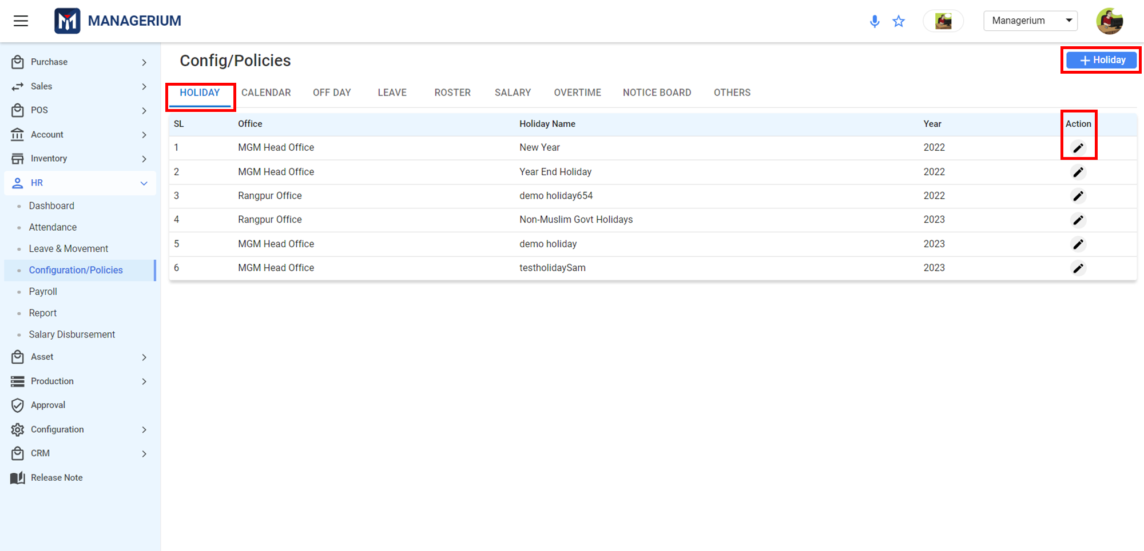

The ***"+Holiday"*** field is used to create or assign a new holiday group to the system.

**User Interface [Create Holiday] :**

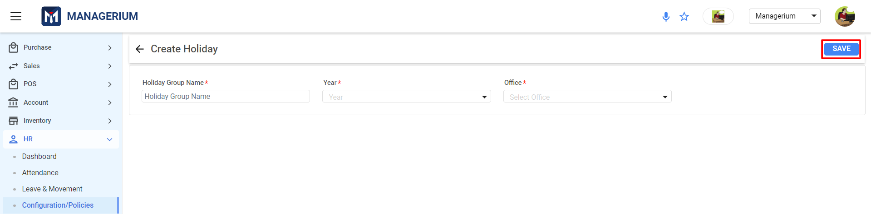

After filling in all the required fields, the administrator can click on the ***"SAVE"*** button to complete the process.

After creating the Holiday, the user must update the holiday from the **Action** field from the landing page. Clicking on the **edit** icon there will appear the **Update Holiday.**

By setting the **From Date**, **To Date,** and **Description** of the holiday, and clicking the **Add** button, the information details will be added to the right side.

**User Interface [Update Holiday]:**

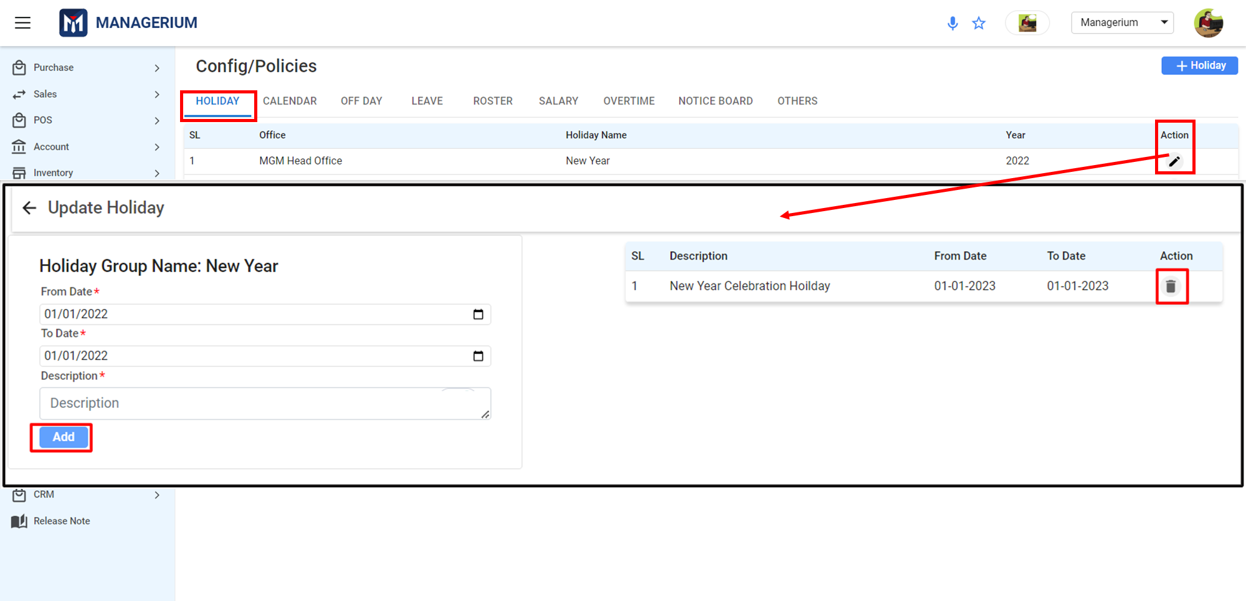

If it is needed to delete details, the user can delete them from the Action field.

### ***5.1.5 Calendar***

Calendars describe the capacity and working times of operational resources to define a work schedule based on a working time template of an organization.

The admin will see a landing page after clicking the *"Holiday"* feature. Here the admin can see all the existing holiday setup data.

**Menu Path:** HR (Module) **>** Configuration/Policies (Feature) **>** CALENDAR *(Sub-feature)*

**User Interface [Landing] :**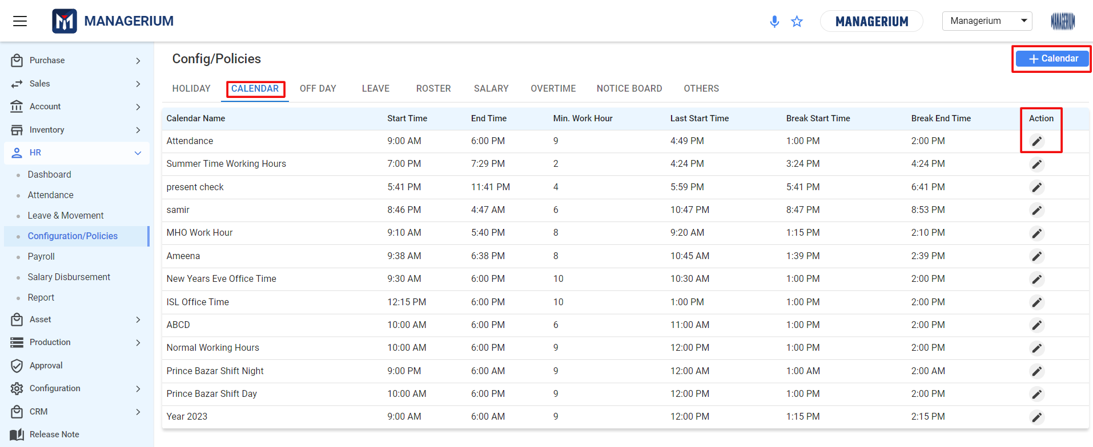

The ***"+ Calendar"*** button is used to create or assign a new holiday group to the system. After filling in all the required fields, the administrator can click ***"SAVE"*** to complete the process.

**User Interface [Create Calendar]:**

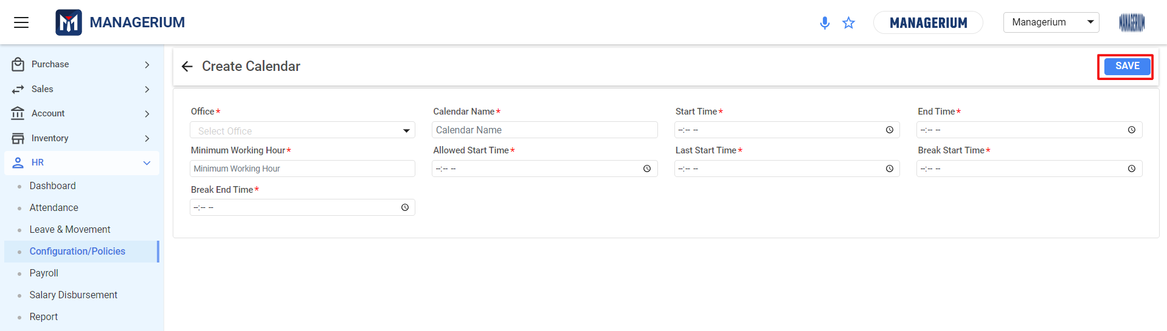

After creating the Calendar, the user can edit the calendar from the **Action** field from the landing page. Clicking on the **edit** icon there will appear the **Edit Calendar.**

**User Interface [ Calendar]:**

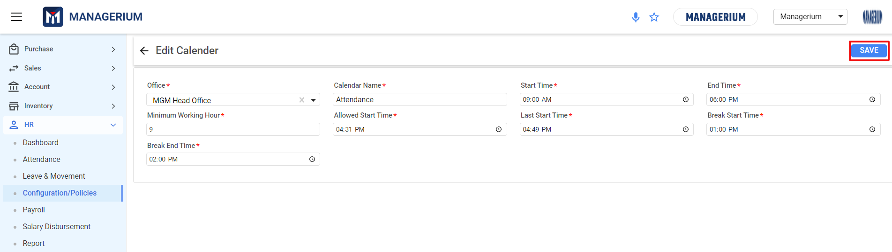

* **Off-day-** In every organization, the administration assigns days off to employees according to the organization's policy. Employees are entitled to these holidays based on the company's policy. The holidays vary from employee to employee and are defined in the company's policy.

**Menu Path:** HR *(Module)* **>** Configuration/Policies (Features) **>** OFF DAY *(sub- features)*

**User Interface [Landing]:**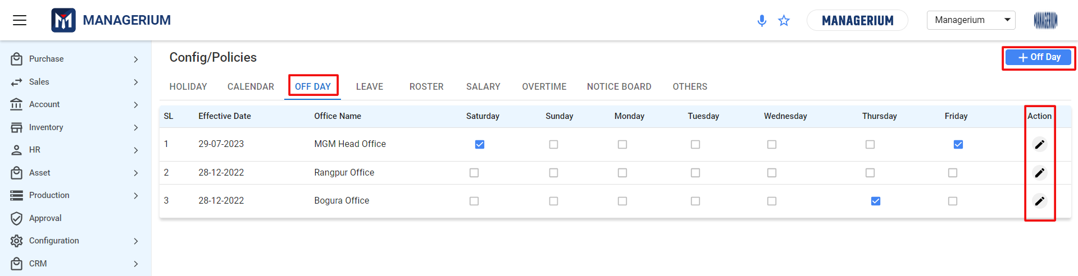

The ***"+ Off Day"*** button is used to create or assign off-days to the system.

**User Interface [Create Off Day]:**

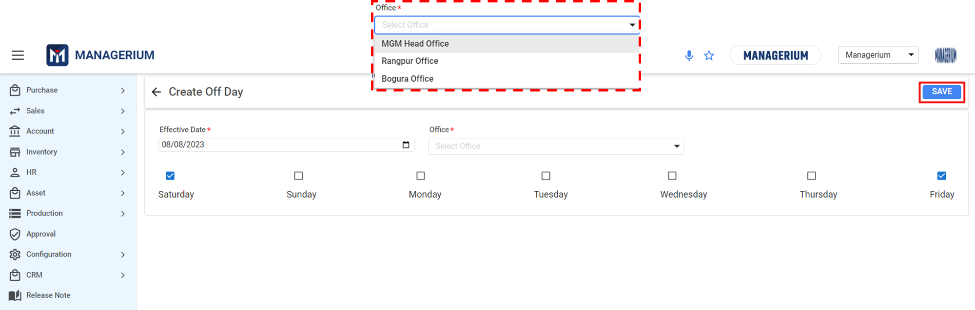

After filling in the required date and number of days in a week, the administrator can click on the ***"SAVE"*** button to complete the process.

**Note\*** : The seven days of the week (Sat-Fri) are off-days and will be shown on the calendar setup.

After creating the Off Day, the user can edit the calendar from the **Action** field from the landing page. Clicking on the **edit** icon there will appear the **Edit Off Day.**

* **Leave-** Organizations typically offer a variety of leave types, such as medical leave and personal leave. Employees can apply for leave when they need it, according to their employment type, such as intern, probationary, or full-time.

**Menu Path:** HR **>** Configuration/Policies (Features) **>** LEAVE

**User Interface [Landing]:**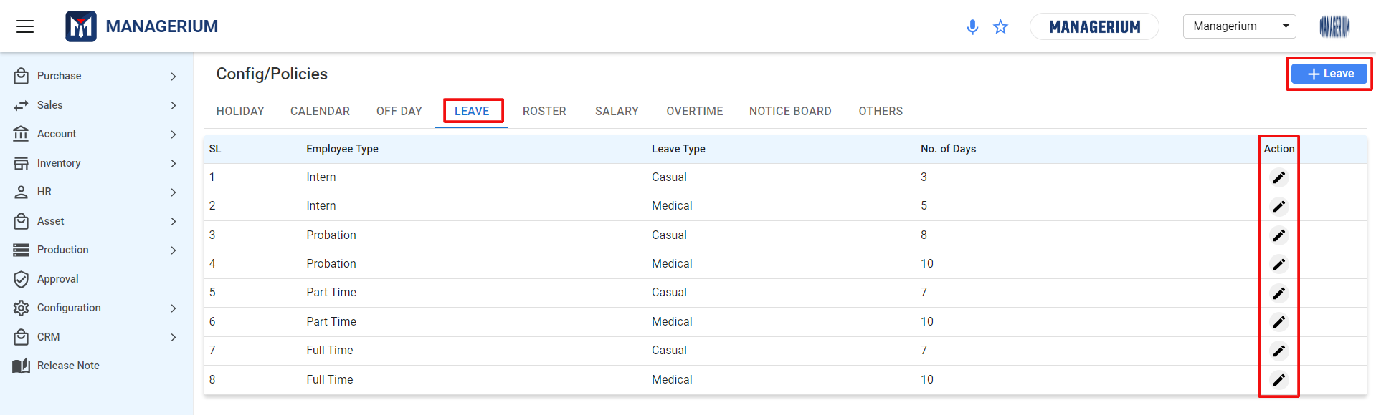

The ***"+ Leave"*** field is used to create or assign a new leave based on employment type to the system.

**User Interface [Create Leave]:**

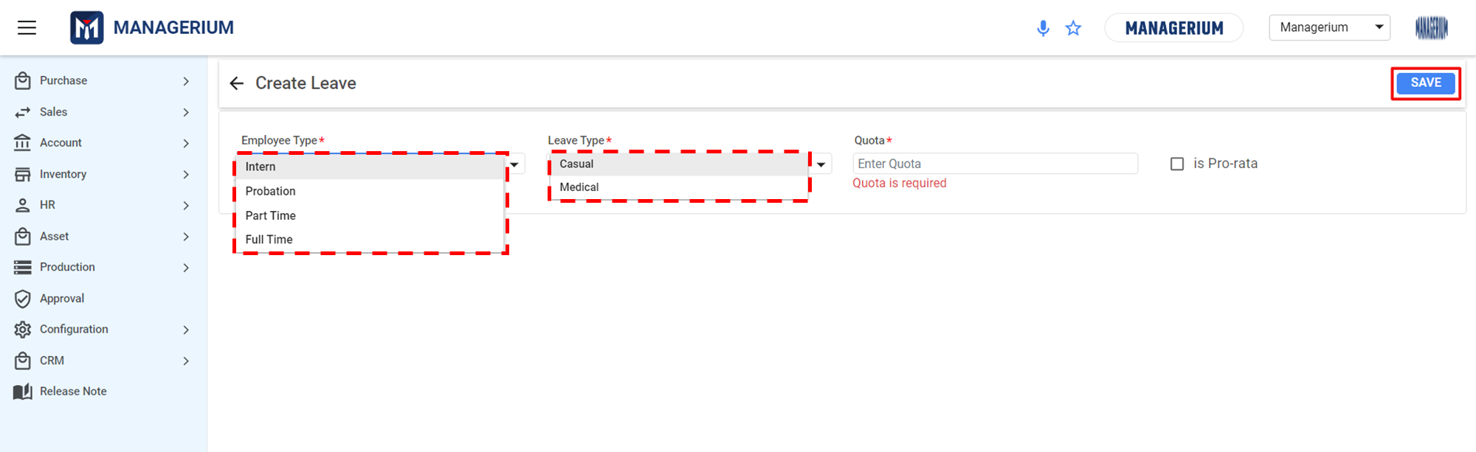

After filling in all the required fields, the administrator can click ***"SAVE"*** to complete the process.

After creating the Leave, the user can edit the Leave details from the **Action** field from the landing page. Clicking on the **edit** icon there will appear the **Edit Leave.**

### ***5.1.6 Roster***

Roster means changing the shift of employees after a certain period of time based on the company's policy. Every organization has its own roster setup to follow. Through this feature, the authority can schedule how employees or organizations within the organization will take turns on duty or on leave.

**Menu Path:** HR *(Module)* **>** Configuration/Policies *(Features)* **>** ROSTER *(sub- features)*

**User Interface [Landing]:**

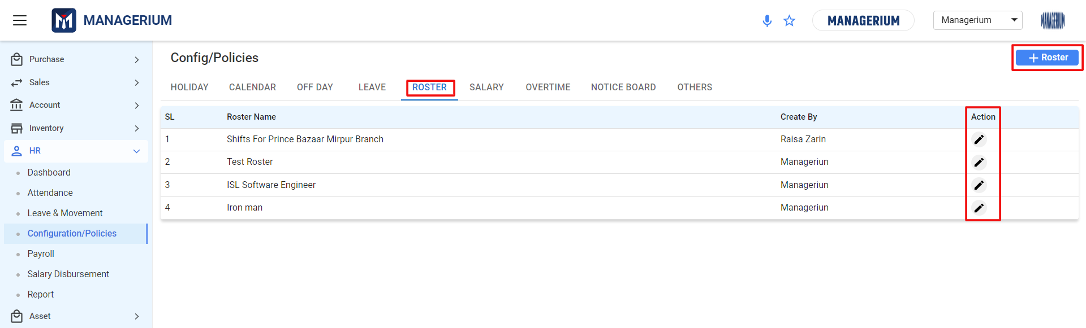

The ***"+ Roster"*** button is used to create or assign a new roster based on organiztion work scheduling type to the system.

**User Interface [Create Roster Group]:**

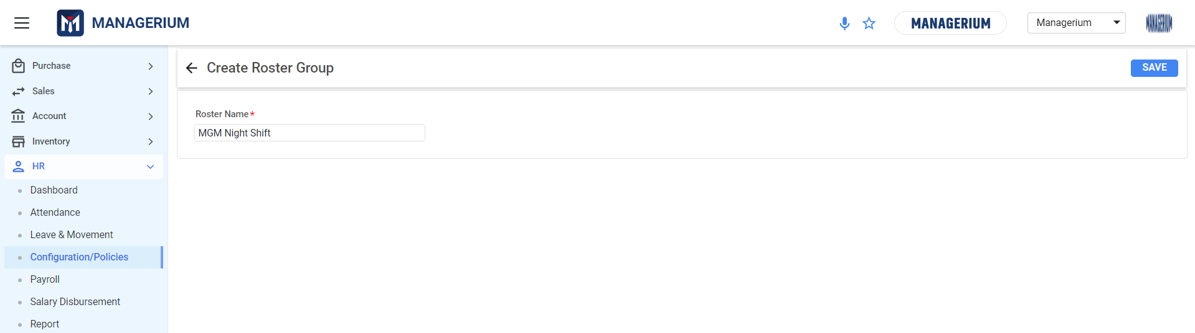

After filling in all the required fields, the administrator can click on the ***"SAVE"*** button to complete the process.

After creating the Roster Group, the user must update the Roster Group from the **Action** field from the landing page. Clicking on the **edit** icon there will appear the **Update Roster Group.**

By setting the **Calendar,** **No Of Change Days,** and **Next Calendar** of the roster, and clicking the **Add** button, the information details will be added to the right side.

**User Interface [Update Roster]:**

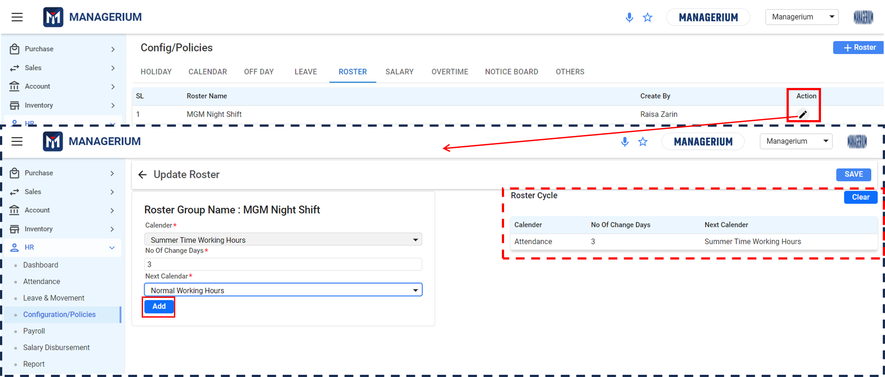

If it is needed to delete Roster details, the user can clear them by clicking on the ***“Clear”*** button.

After filling in all the required fields, the user can click on the ***"SAVE"*** button to complete the process.

**NOTE:** The user must add two calendars with a new calendar, to manage roster for the employees. That means each created roster occupied two roster calendars to manage.

### ***5.1.6 Salary***

This feature will help the user to create a salary structure that satisfies the needs of usersr employees.

**Menu Path:** HR *(Module)* **>** Configuration/Policies *(Features)* **>** SALARY *(sub- features)*

The admin will see a landing page after clicking the *"Salary"* feature. Here the admin can see all the existing holiday setup data.

**User Interface [Landing]:**

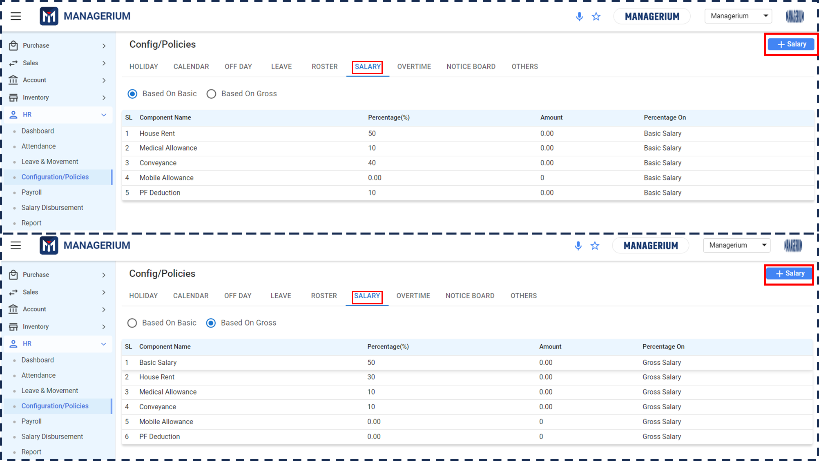

The ***"+ Salary"*** field is used to create or assign a salary structure to the system.

**User Interface [Create Salary Structure] :**

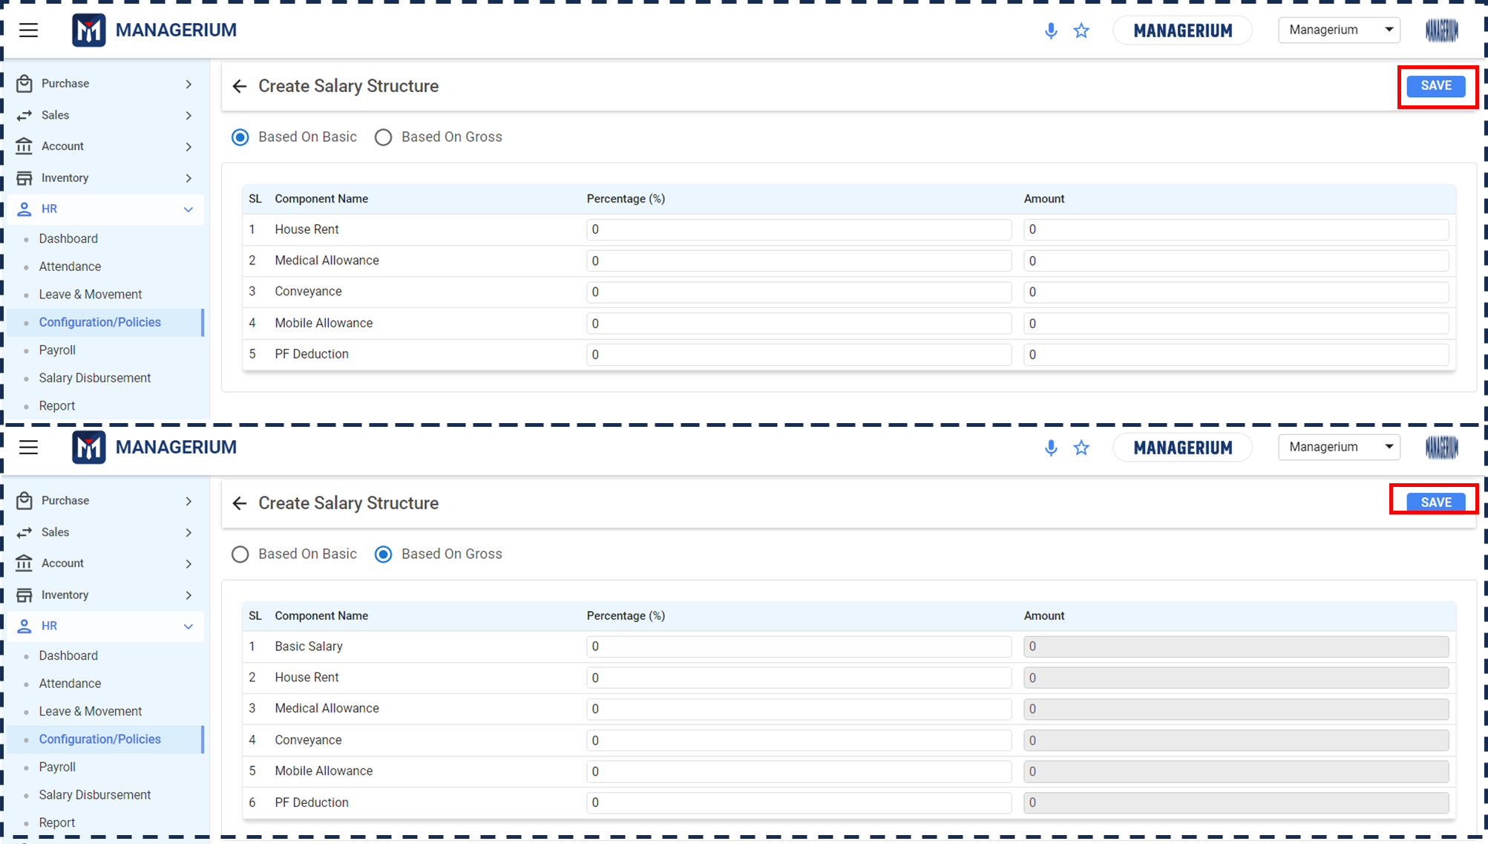

After filling in all the required fields, the user can click on the ***"SAVE"*** button to complete the process.

### ***5.1.7 Overtime***

Based on the company's policy the admin can input the overtime for the employees with this feature. They’ll get overtime facilities for their overtime according to the organization’s overtime policy. The admin can manually enter all the details regarding overtime.

**Menu Path:** HR (Module) **>** Configuration/Policies (Features) **>** OVERTIME

The admin will see a landing page after clicking the *"Overtime"* feature. Here the admin can see all the existing overtime setup data.

**User Interface [Landing]:**

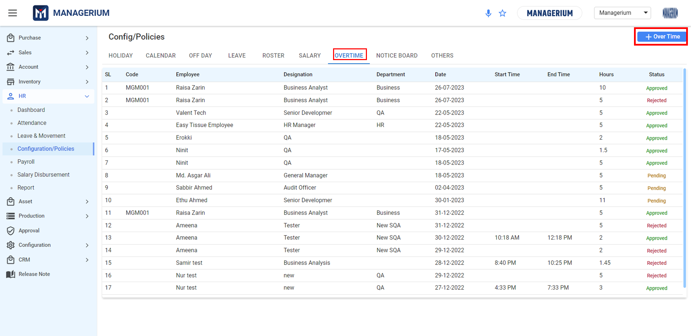

The ***"+ Over Time"*** field is used to create or assign a salary structure to the system.

**User Interface [Create Over Time] :**

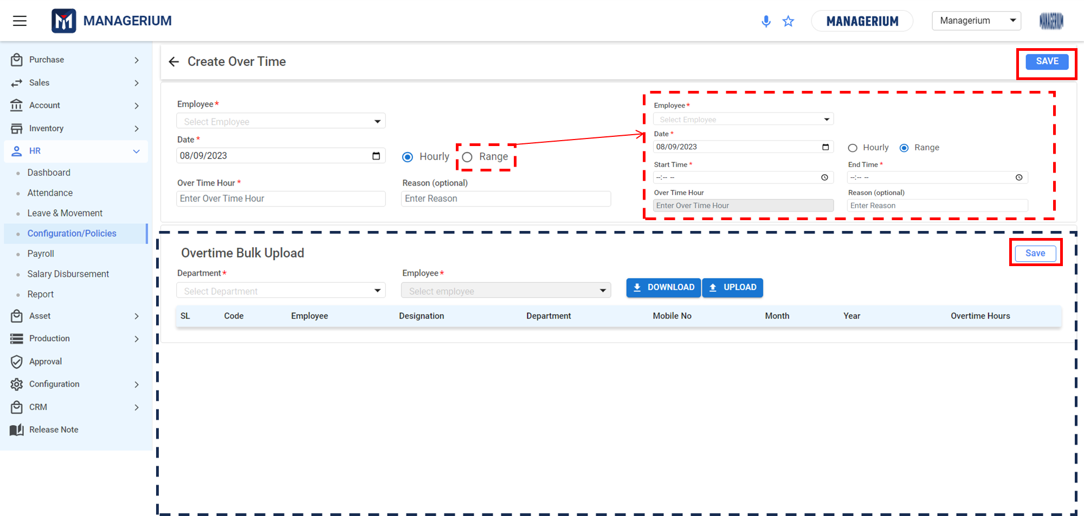

**Data Table:**

|  |  |  |
| --- | --- | --- |
| **Create Over time** |  |  |
| **Employee** | Calendar Set Up | Mandatory Field |
| **Date** | Calendar Set Up | Mandatory Field |
| **Hourly/ Range** | Check button | Mandatory Field |
| **Over Time Hour** | Input Field | Mandatory Field |
| **Reason** | Input Field | Optional Field |
| **Start Time** | Calendar Set Up | Mandatory Field |
| **End Time** | Calendar Set Up | Mandatory Field |

After filling in all the required fields, the user can click on the ***"SAVE"*** button to complete the process.

**NOTE:** Users can bulk upload data by downloading an Excel template, inputting the mandatory data, and saving the file by clicking on the **Save** button.

### ***5.1.8 Notice Board***

The user can use the announcement module to upload important notices or announcements for all employees or department wise. It's a convenient and efficient way to communicate with everyone at once.

**Menu Path:** HR (Module) (Module) **>** Configuration/Policies (Features) **>** NOTICE BOARD *(Sub-features)*

The admin will see a landing page after clicking the *"Notice Board"* feature. Here the admin can see all the existing Notice details.

**User Interface [Landing]:**

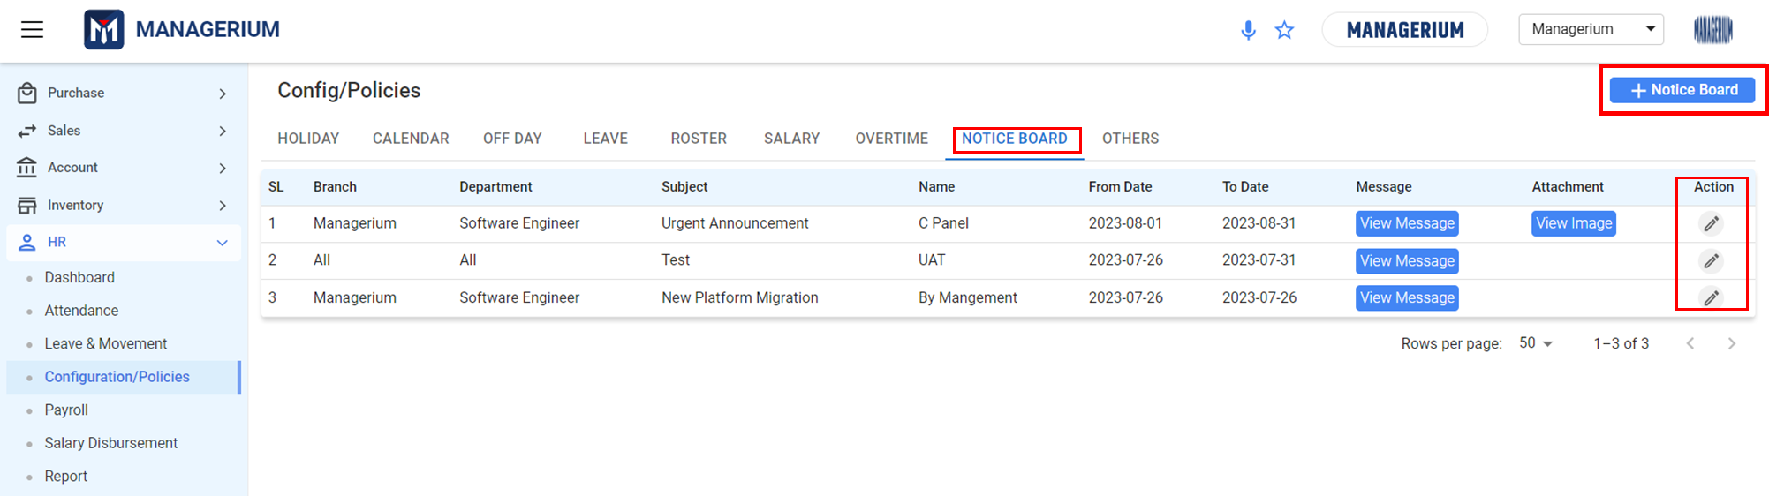

The ***"+ Notice Board"*** field is used to create or assign a salary structure to the system.

**User Interface [Create Notice Board] :**

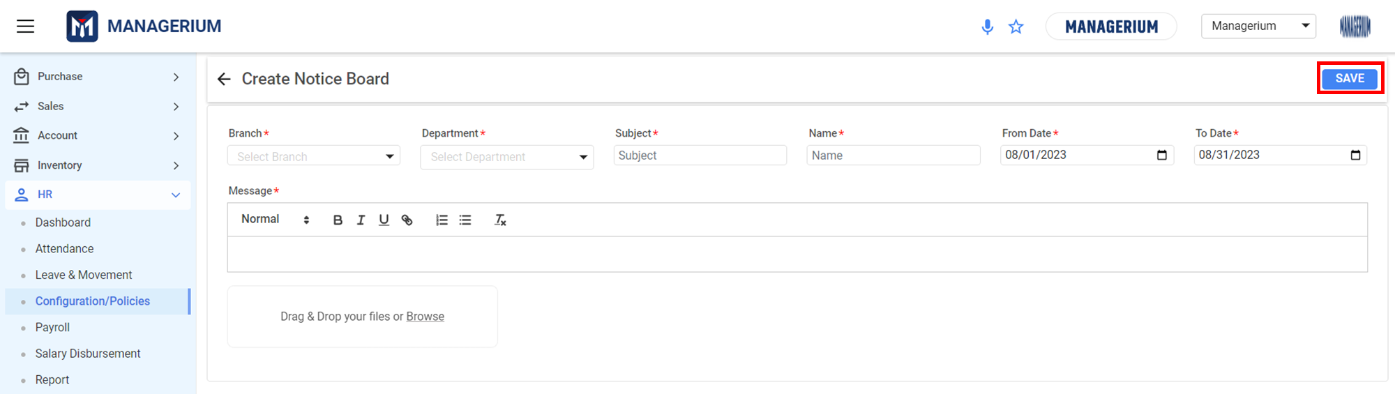

After filling in all the required fields, the user can click on the ***"SAVE"*** button to complete the process.

After creating the Holiday, the user must update the holiday from the **Action** field from the landing page. Clicking on the **edit** icon there will appear the **Edit Notice Board.**

**Data Table:**

|  |  |  |
| --- | --- | --- |
| **Create Notice Board** |  |  |
| **Branch** | Select From The Dropdown | Mandatory Field |
| **Department** | Calendar Set Up | Mandatory Field |
| **Subject** | Check button | Mandatory Field |
| **Name** | Input Field | Mandatory Field |
| **From Date** | Calendar Set Up | Mandatory Field |
| **To Date** | Calendar Set Up | Mandatory Field |

### ***5.1.8 Others:***

The user can set up the attendance penalty and overtime configuration based on the organization policy in *Others* features.

**User Interface [Landing Page] :**

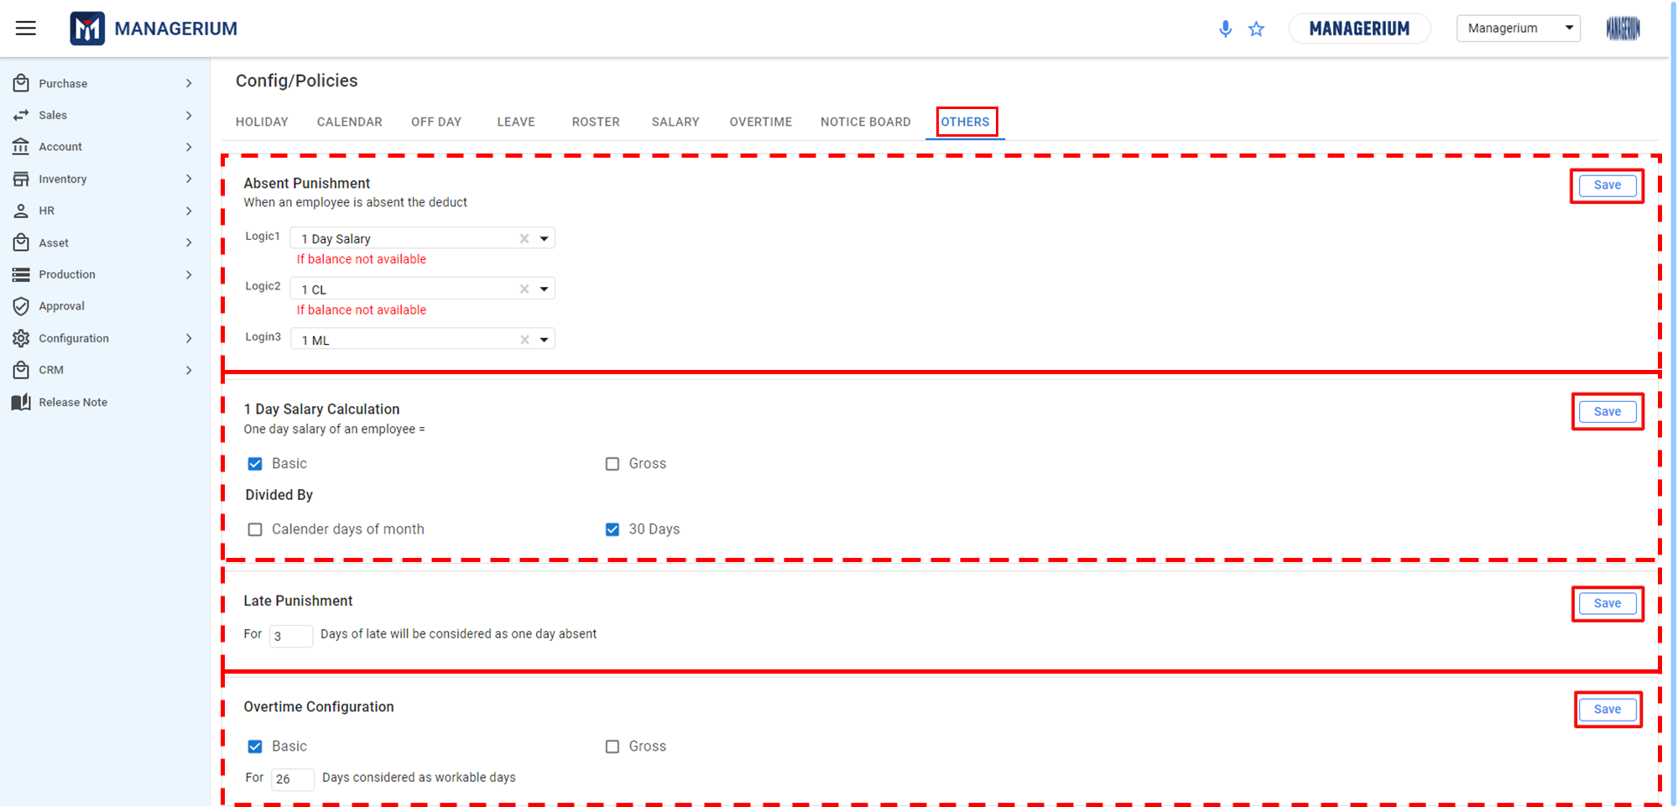

The following are the working features:

* **Absent Punishment**

Employees are allotted a certain number of leave days (Medical, Casual), from which their absences should be deducted. If the balance is not available, the deduction logic specified in the system should be followed.

**User Interface:**

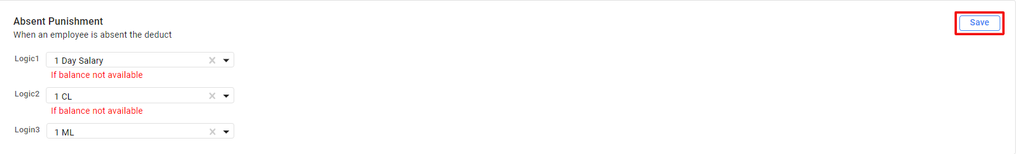

* **1 Day Salary Calculation**

.To calculate one day's salary for an employee, one can divide the employee's basic or gross salary by the total number of calendar days in the month. This calculation can be used to determine an employee's daily pay for purposes such as calculating overtime pay or sick leave pay.

One Day Salary = (Basic or Gross Salary) / (Total Calendar Days in the Month)

**User Interface:**

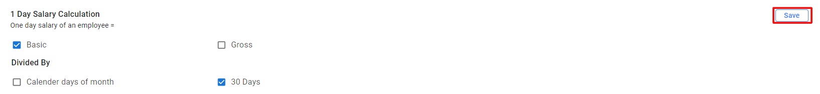

* **Late Punishment**

To implement a late punishment policy where a certain number of days of lateness will be treated as equivalent to one day of absence. The user must input the number of days.



* **Overtime Configuration**

For instance, set up an overtime configuration based on a certain number of days considered workable days. The user must input the number of days.



## *5.2.1 Dashboard*

After successful authentication, users see the software's dashboard. It's the home screen with an overview of the software's features. The dashboard is essentially the surface of an employee's monthly activities. There are several portions of various occurrences.

### ***5.2.1.1 Types of View***

The user is the one who utilizes a targeted system. Depending on employees' or users' work responsibilities, roles, and permissions, give individuals varying levels of access.

**NOTE:**

**\*\*** This dashboard feature can be found and seen from **"Employee self-service"**(Normal User) and from the individual **"Dashboard (Employee)"** feature.

**Normal User:** The dashboard interface allows users to view their daily check-in and check-out times, attendance status, working hours, leave, and movement tracking.

**User Interface:**

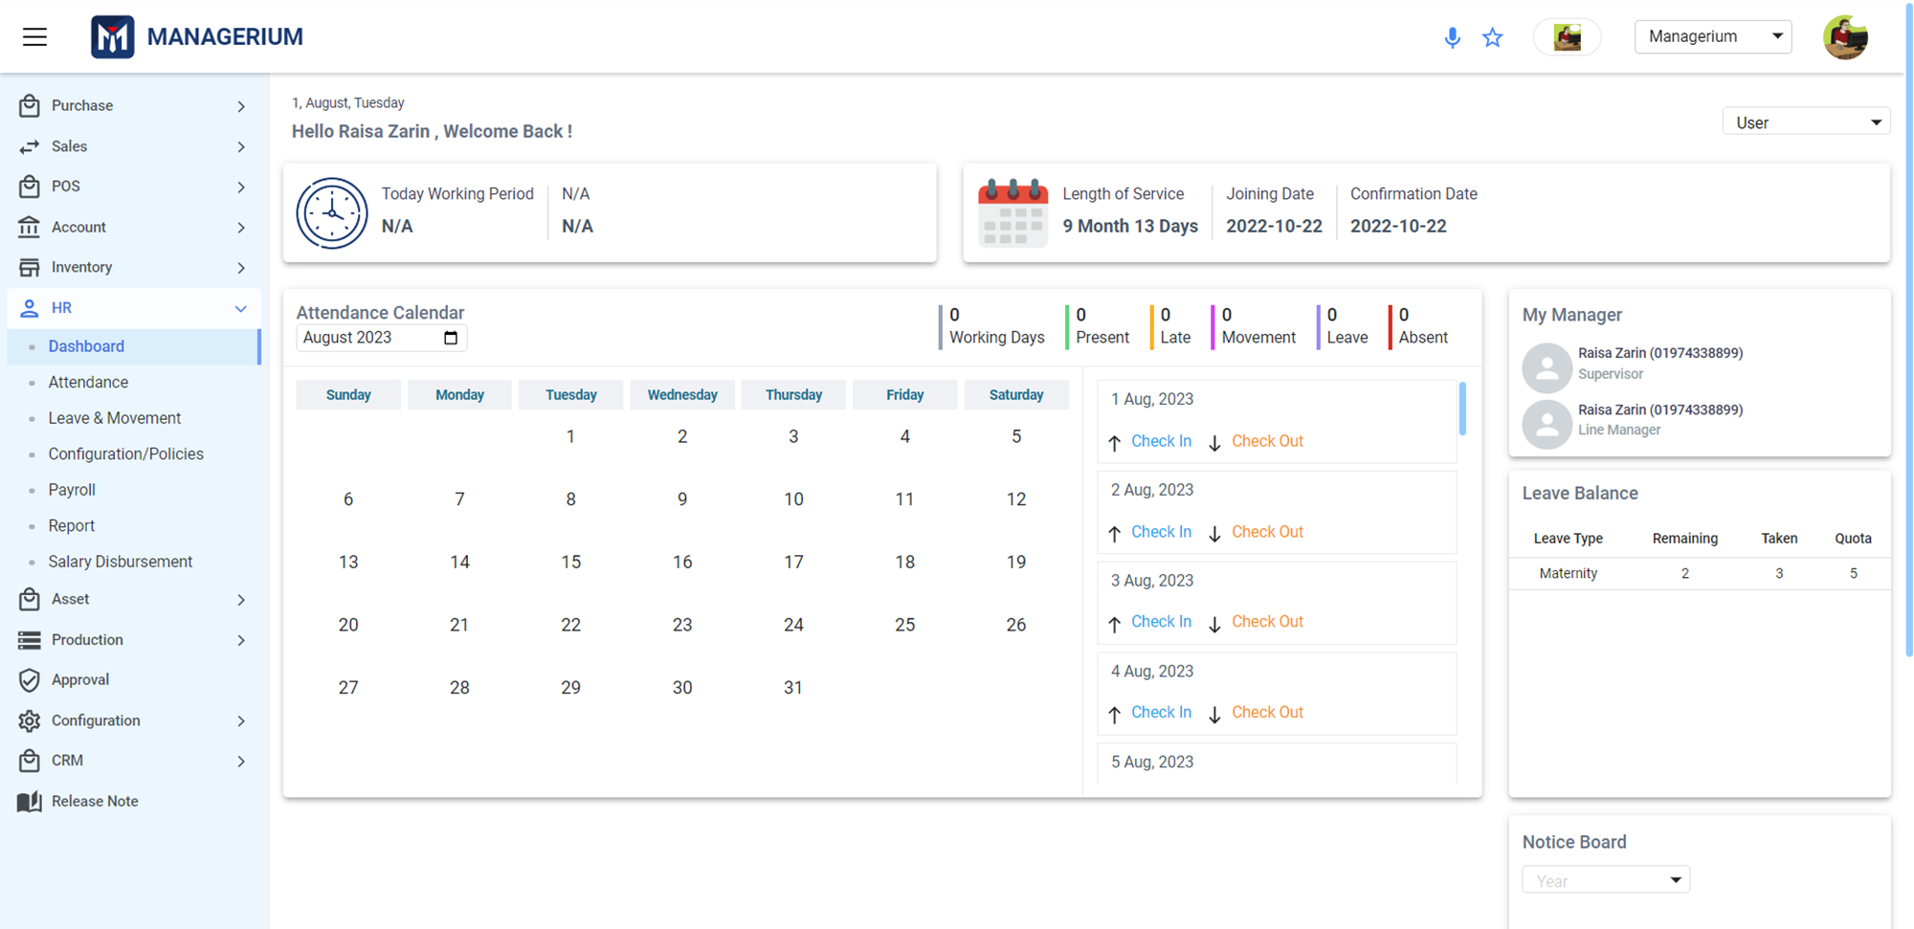

* At the top of the dashboard, **the date** and **employee name** will be shown at the top of the dashboard.
* Below that, **today's** and **general working hours** will be shown below.
* Besides that, **length of service**, **joining date**, and **confirmation date** will be shown.
* An Attendance Calendar will show the employee's working days, present days, late days, movement activities, leave days, and absences for the current month.
* Besides the attached calendar, check-in and check-out times will be shown for every day, in addition to the attached calendar.
* Besides this, an employee’s "supervisor" name and "line manager" name will be shown.
* Below that, the following is a list of the employee's sick and casual leave days, both used and remaining.
* In the last panel, the employee’s application for any kind of service will be shown there.

**Super Admin:**

**User Interface [Master User View]:**

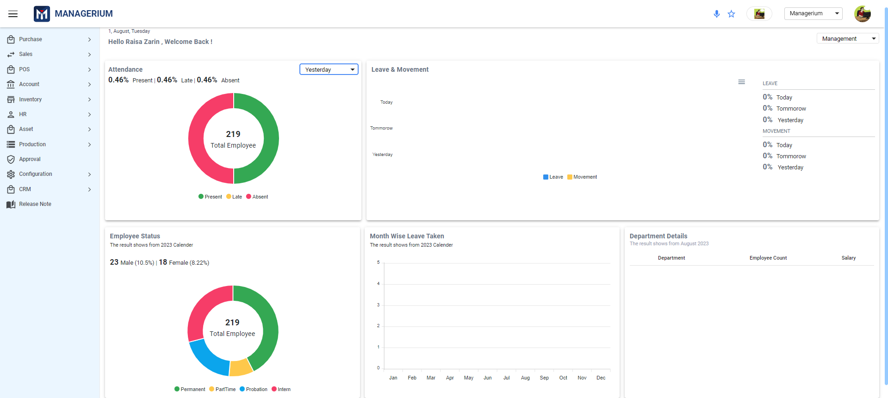

## *5.3.1 Attendance*

Through this feature, the user & admin can maintain the time management for the employees. The admin can view the employee’s daily attendance (In Time, Out Time), attendance date, the employee’s details.

**Menu Path:** HR (Module) > Attendance

After clicking "Attendance", the user will see a landing page where the previously created attendance details are shown.

**User Interface:**

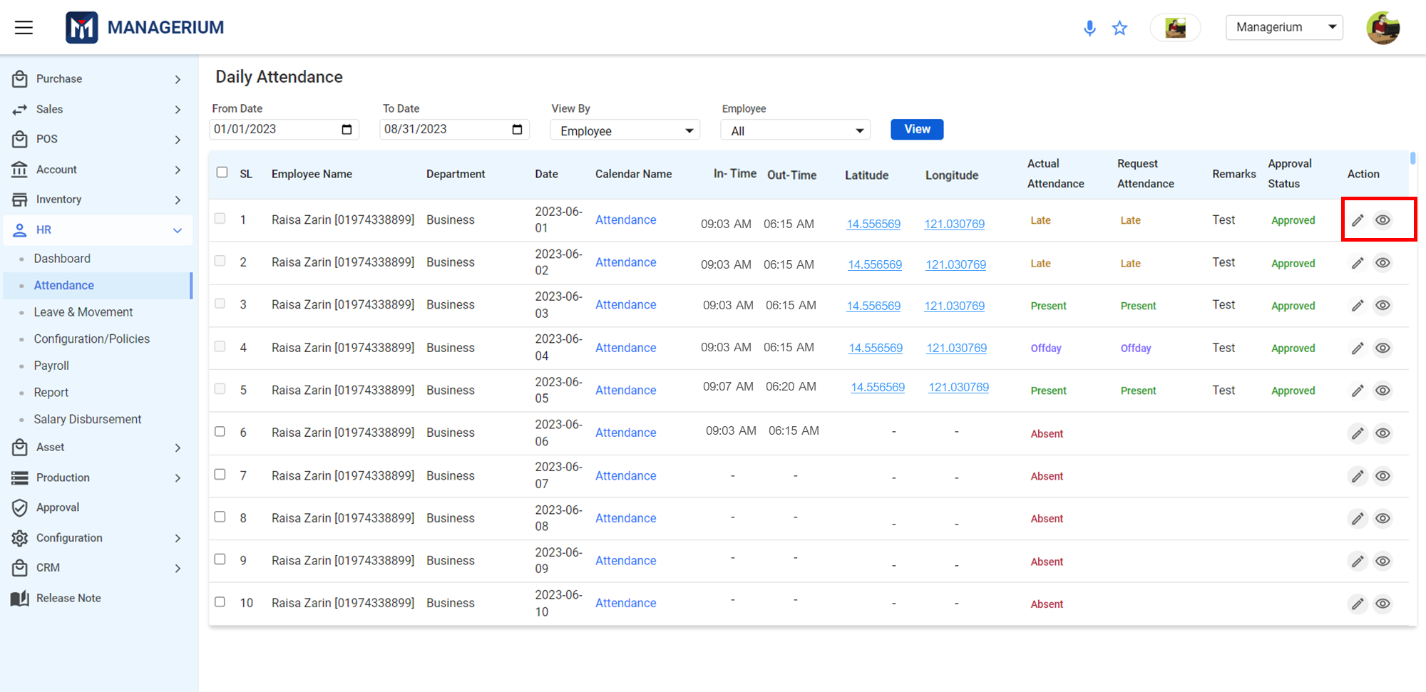

Users/ Admin can request a change to their or other employees' attendance status from the **Action** menu.

**User Interface [Attendance Request]:**

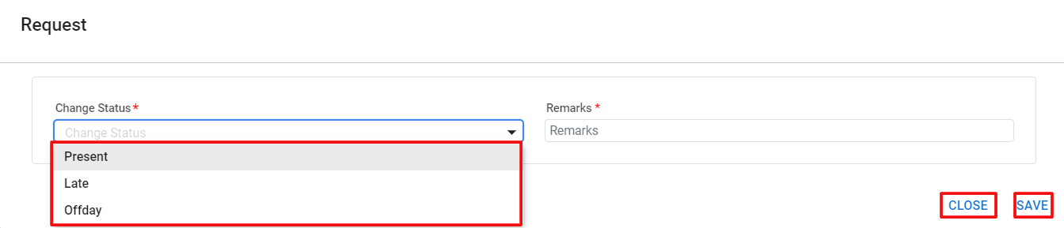

From the Change Status Dropdown, the user only can select **Present, Late** and **Offday** to request. Then will click SAVE to process the request.

**Data Table:**

|  |  |  |
| --- | --- | --- |
| **Create Employee** |  |  |
| **Change Status** | Select From Dropdown | Mandatory Field |
| **Remarks** | Input Field | Mandatory Field |

Once the status is updated, it will be marked as **Pending**. The status can be edited from **Action** while it is Pending.

**Note: \*\*\*** From Action, when the Approval Status gets **Approved,** the Request Attendance can not be edited. Only the View option is active or viewing purpose.

Admin/supervisor approves applications. Employee updates show status: approved, pending or rejected.

## *5.4.1 Leave and Movement*

Every organization needs a leave and movement policy that employees must follow. The policy is set by the administration and may vary depending on the employee's position.

**Menu Path:** HR *(Module)* **>**Leave & Movement *(Feature)*

After clicking *"Leave & Movement"*, the user will see a landing page where the Leave & Movement application can be created. By selecting the radio button, leave and movement wise the landing page with features will be shown.

### ***5.4.1.1 Leave***

**Leave:** Employees can apply for leave for personal or other reasons.

**User Interface [Landing]:**

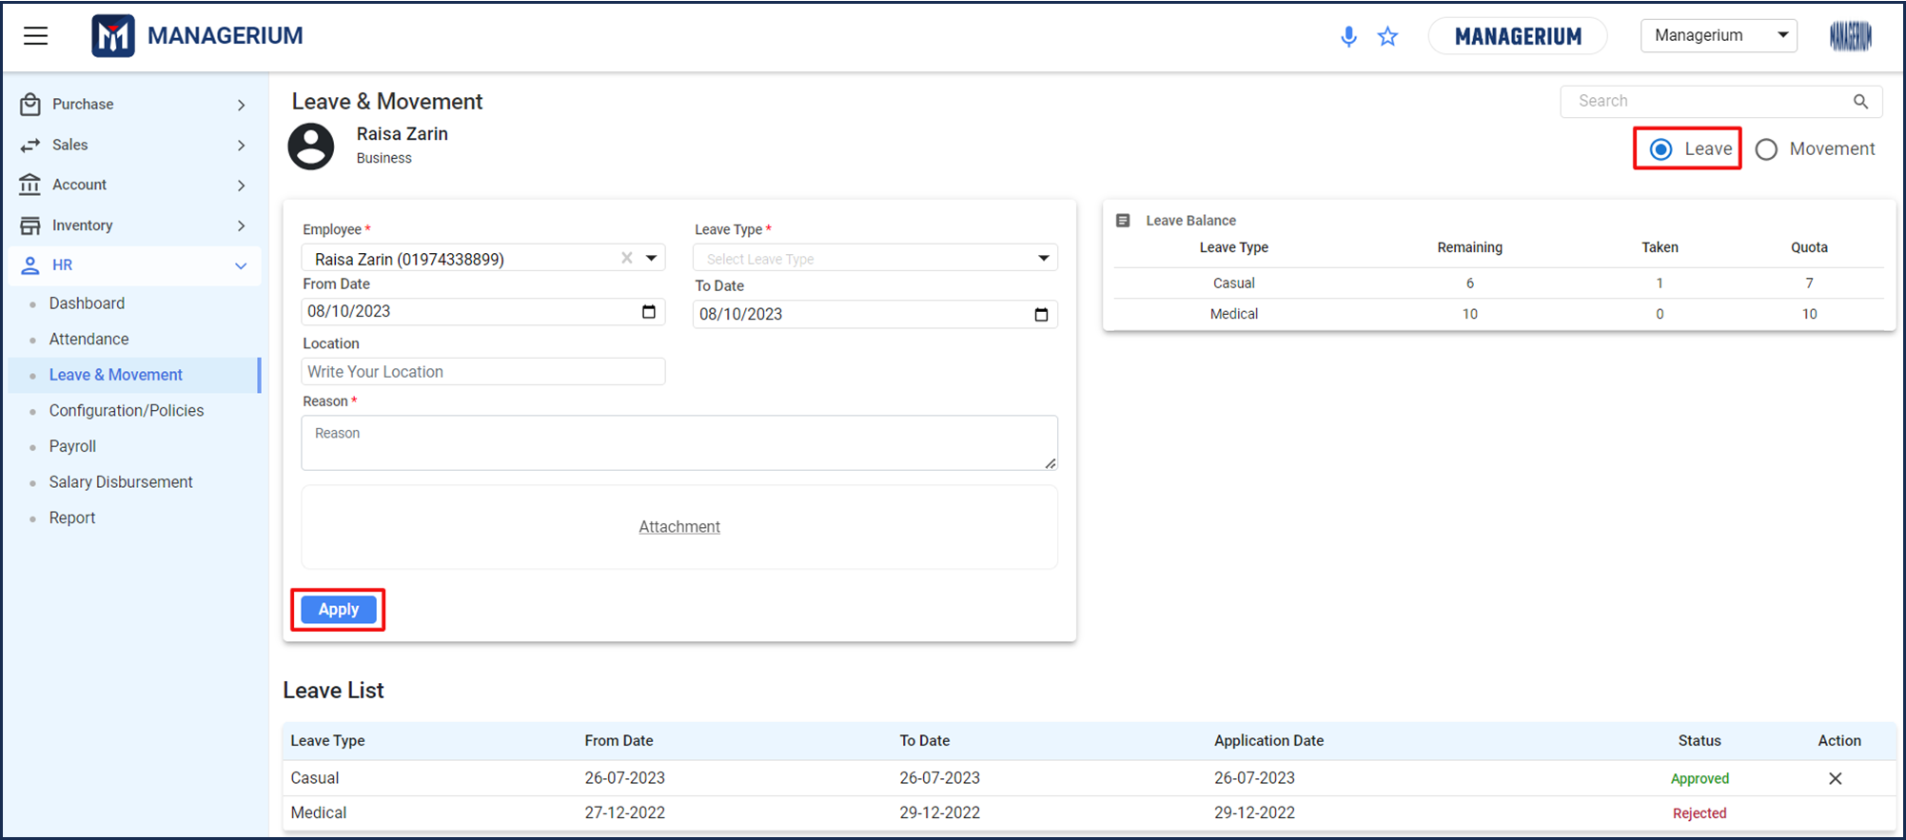

After filling in all the required fields, the administrator can click on the ***"Apply"*** button to complete the process.

Then the application will be added to the **Leave List** as a row table where status will be shown as pending until the admin/supervisor approves/rejects the application.

### 

### ***5.4.1.2 Movement***

**Movement:** Official out-of-office work counts as movement leave.

**User Interface [Landing]:**

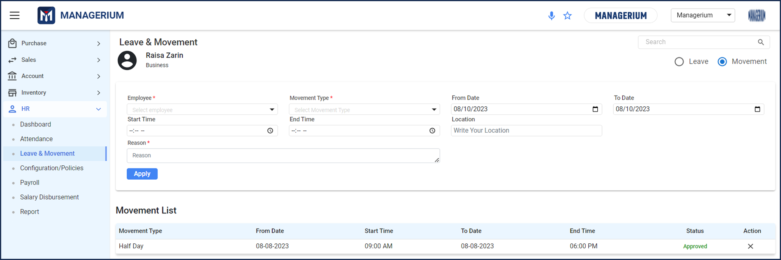

After filling in all the required fields, the administrator can click on the ***"Apply"*** button to complete the process.

Then the application will be added to the **Movement List** as a row table where status will be shown as pending until the admin/supervisor approves/rejects the application.

## 

## *5.5 Payroll*

Payroll is the regular payment of salaries to employees by an organization. It is typically based on the employee's hours worked, and can be generated monthly by an admin.

**Menu Path:** HR *(Module)* **>** Payroll *(Feature)*

After clicking *"Payroll"*, the user will see a landing page where the previously created payroll details are shown.

**User Interface [Landing]:**

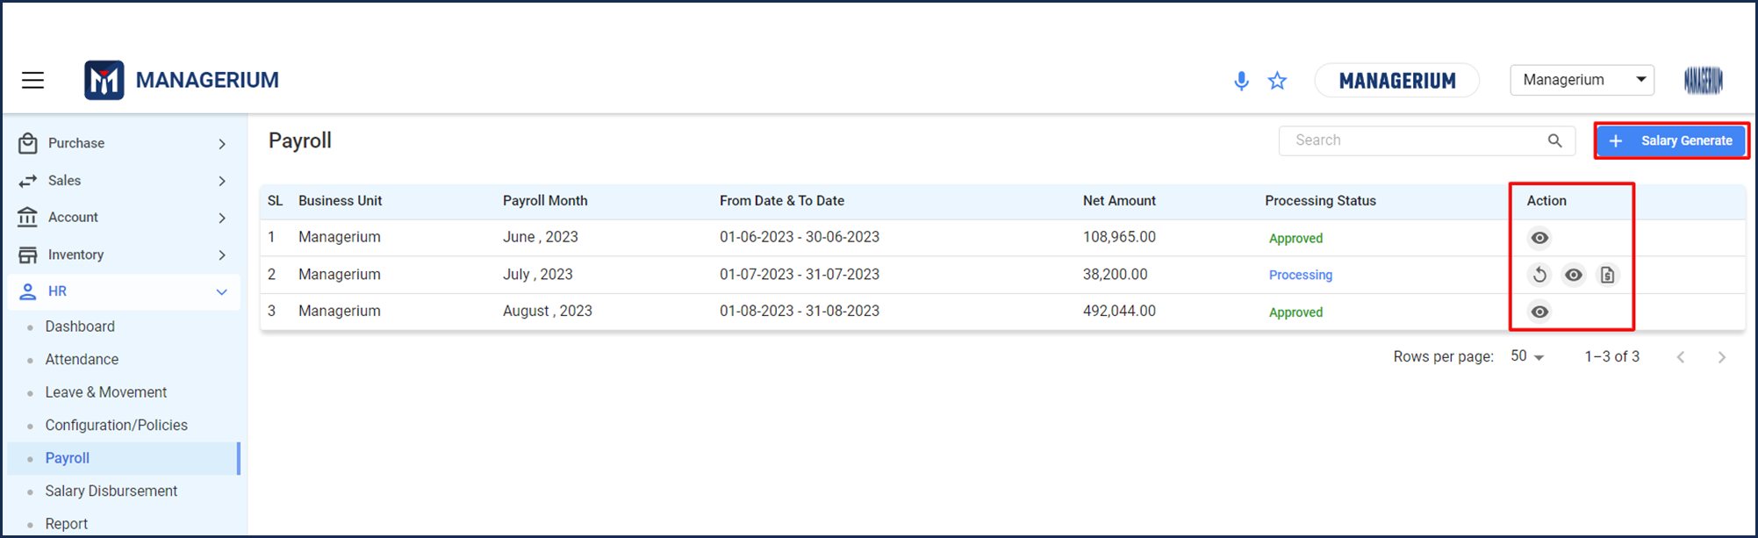

Once the salary generate is created, until it is approved from the **Action** table, it goes through three phases: generate, process, and approve.There is another option called **"Re-generate"** while it can be regenerated before approval, but not after.

**\*NOTE: \*\*\*** The approval or rejection status will be shown at the end of the row. After sending it for approval, it’ll go to the approval module for approval or rejection by the supervisor or admin.

### 

### ***5.5.1 Regenerate [ ]***

From the Payroll landing page if it is needed to regenerate the salary, the user can click on the icon to regenerate the salary. After clicking on the **Regenerate** button, there will be a “**Regenerated Successfully**” message.

**NOTE:** The branch name and payroll month will be freezed as only the Description field will be open to input.

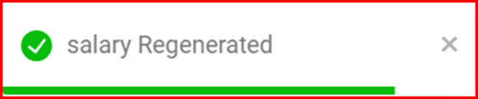

**User Interface:**

Clicking on the Payslip, the payslip view will be shown.

**User Interface [Payslip View]:**

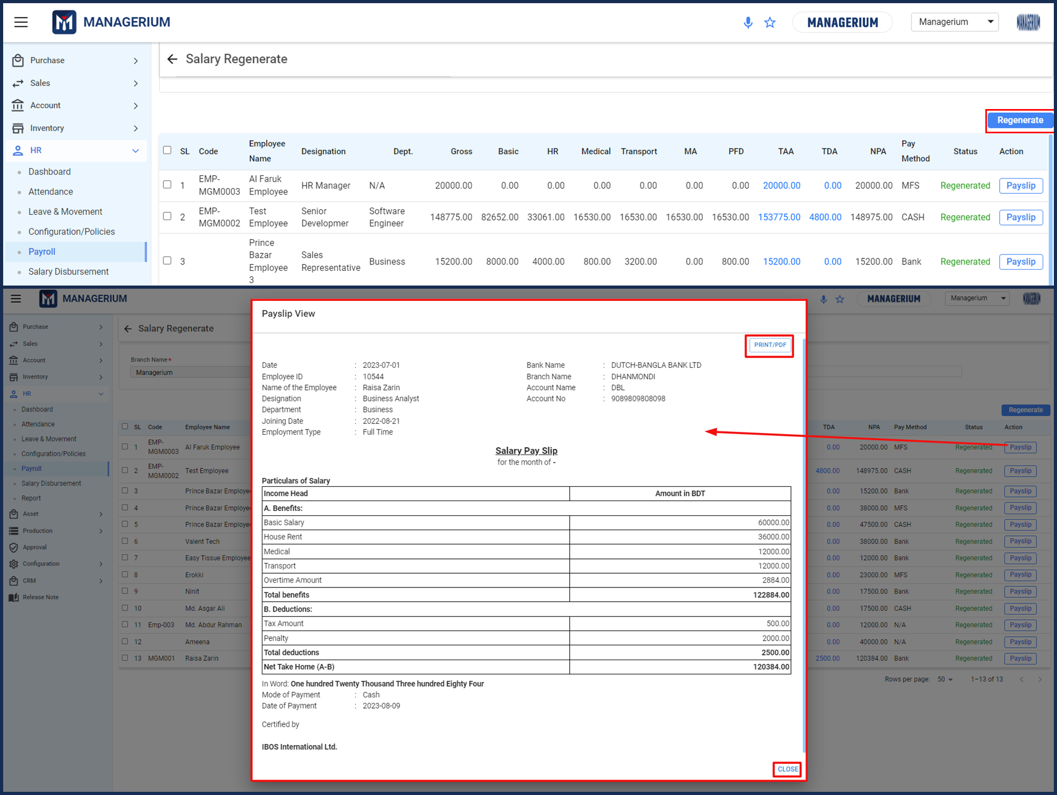

### 



### ***5.5.2 View [ ]***

From the Payroll landing page if it is needed to view the salary, the user can click on the icon to view the salary details. Clicking on the **Payslip**, the payslip view will be shown.

**User Interface:**

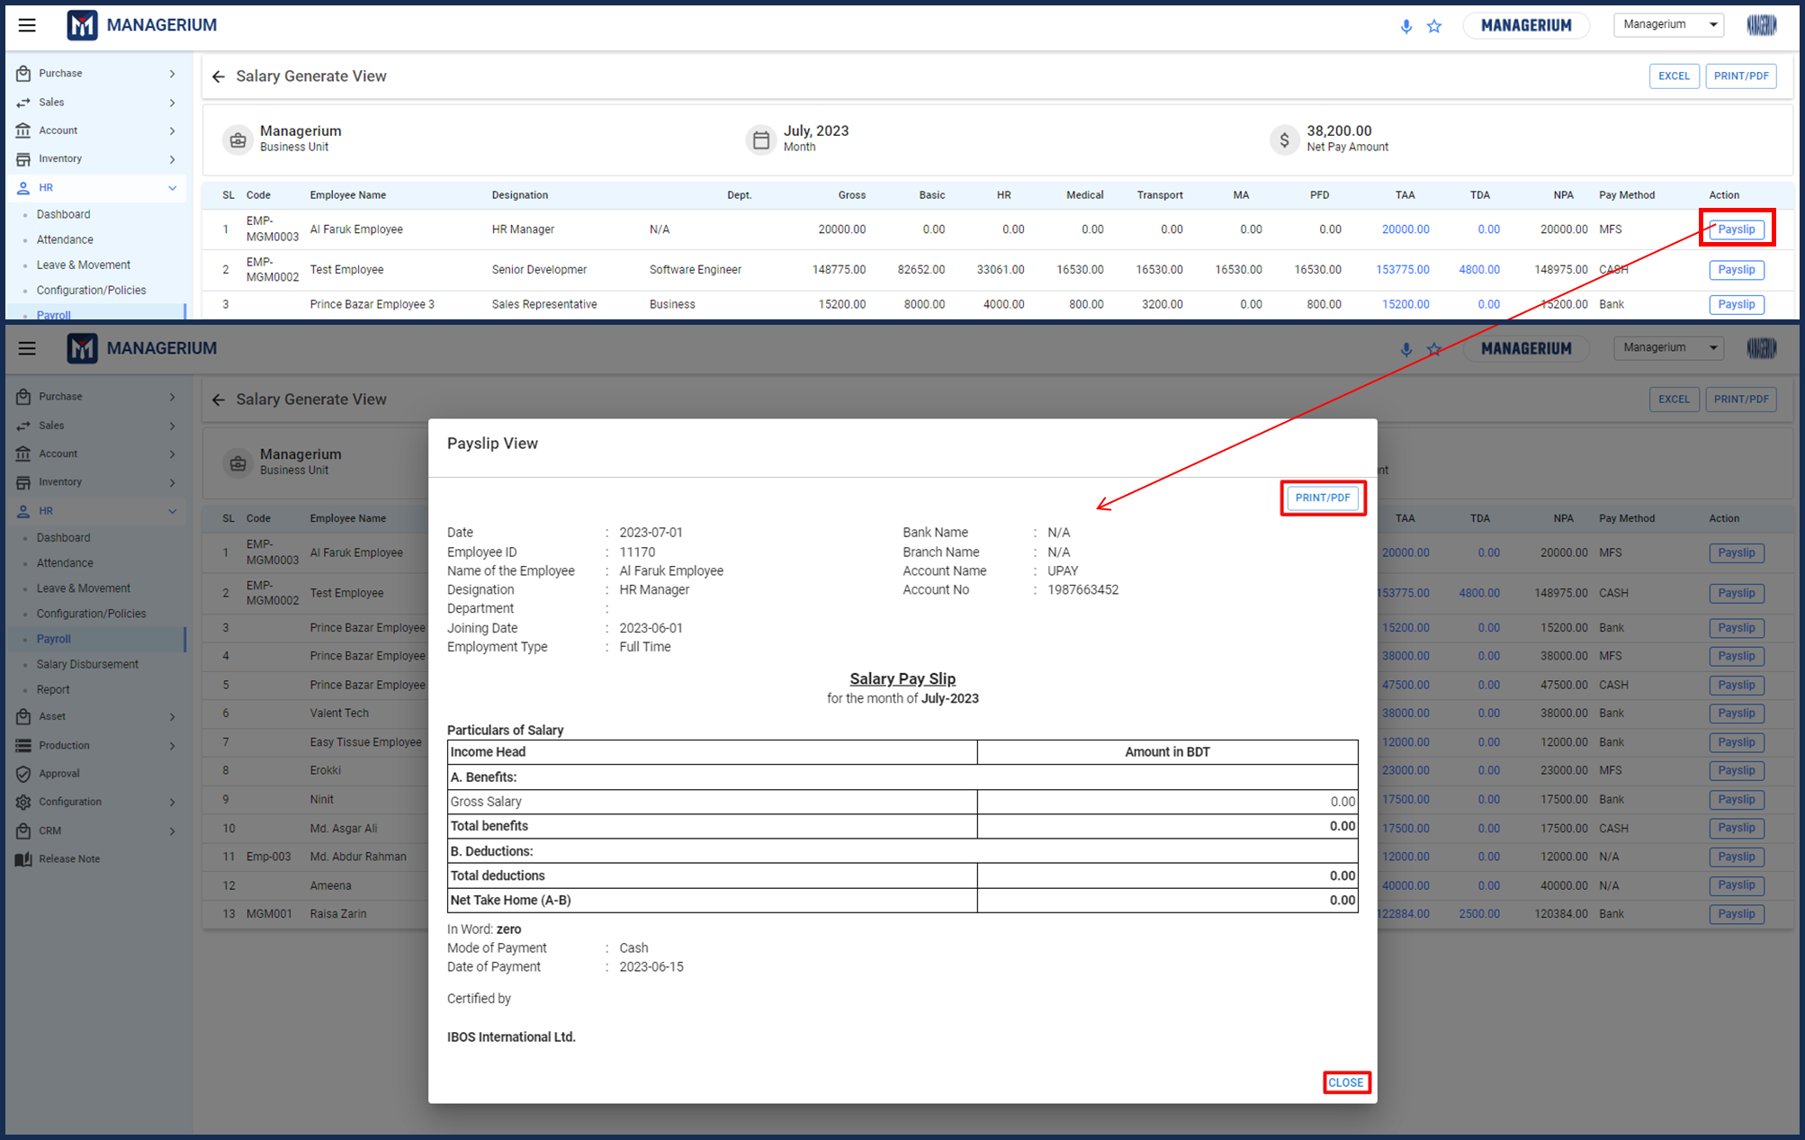



### ***5.5.3 Salary Sheet Generate [ ]***

From the Payroll landing page if it is needed to generate the salary, the user can click on the icon to generate the salary sheets. After clicking on the button, there will be a message for surety .

**User Interface:**

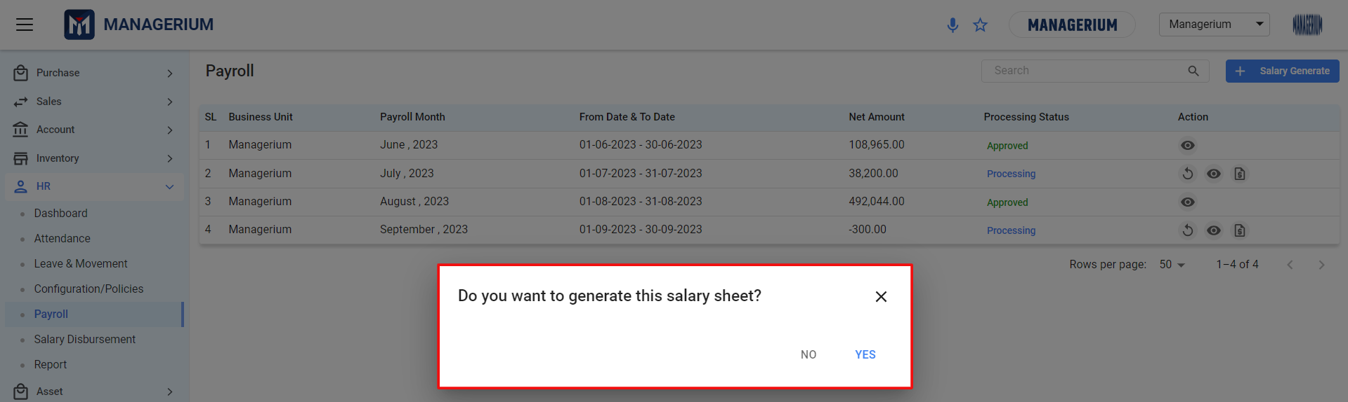

**User Interface [Salary Generate]:**

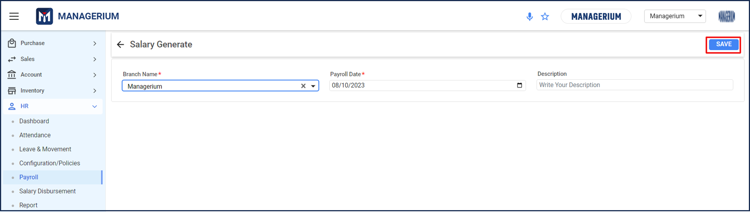

After filling in all the required fields, the administrator can click on the ***"SAVE"*** button to complete the process.

## 5.8 Salary Disbursement

Salary disbursement is the process of paying employees their salaries. It entails the distribution of funds from an employer to its employees based on the agreed-upon compensation and payment schedule.

**Menu Path:** HR *(Module)* **>** Salary disbursement *(Feature)*

After clicking *"Salary disbursement"*, the user will see a landing page where the previously created payroll details are shown.

**User Interface [Salary Disbursement Landing]:**

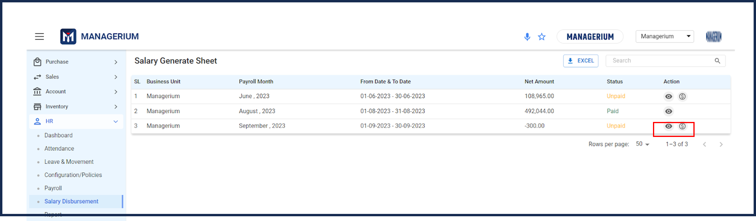

* From the Salary Sheet Generate landing page if it is needed to disburse the salary, the user can click on the icon to disburse the salary. After clicking on the **view** icon, there will be a salary generated view.

**User Interface [Salary Generate View]:**

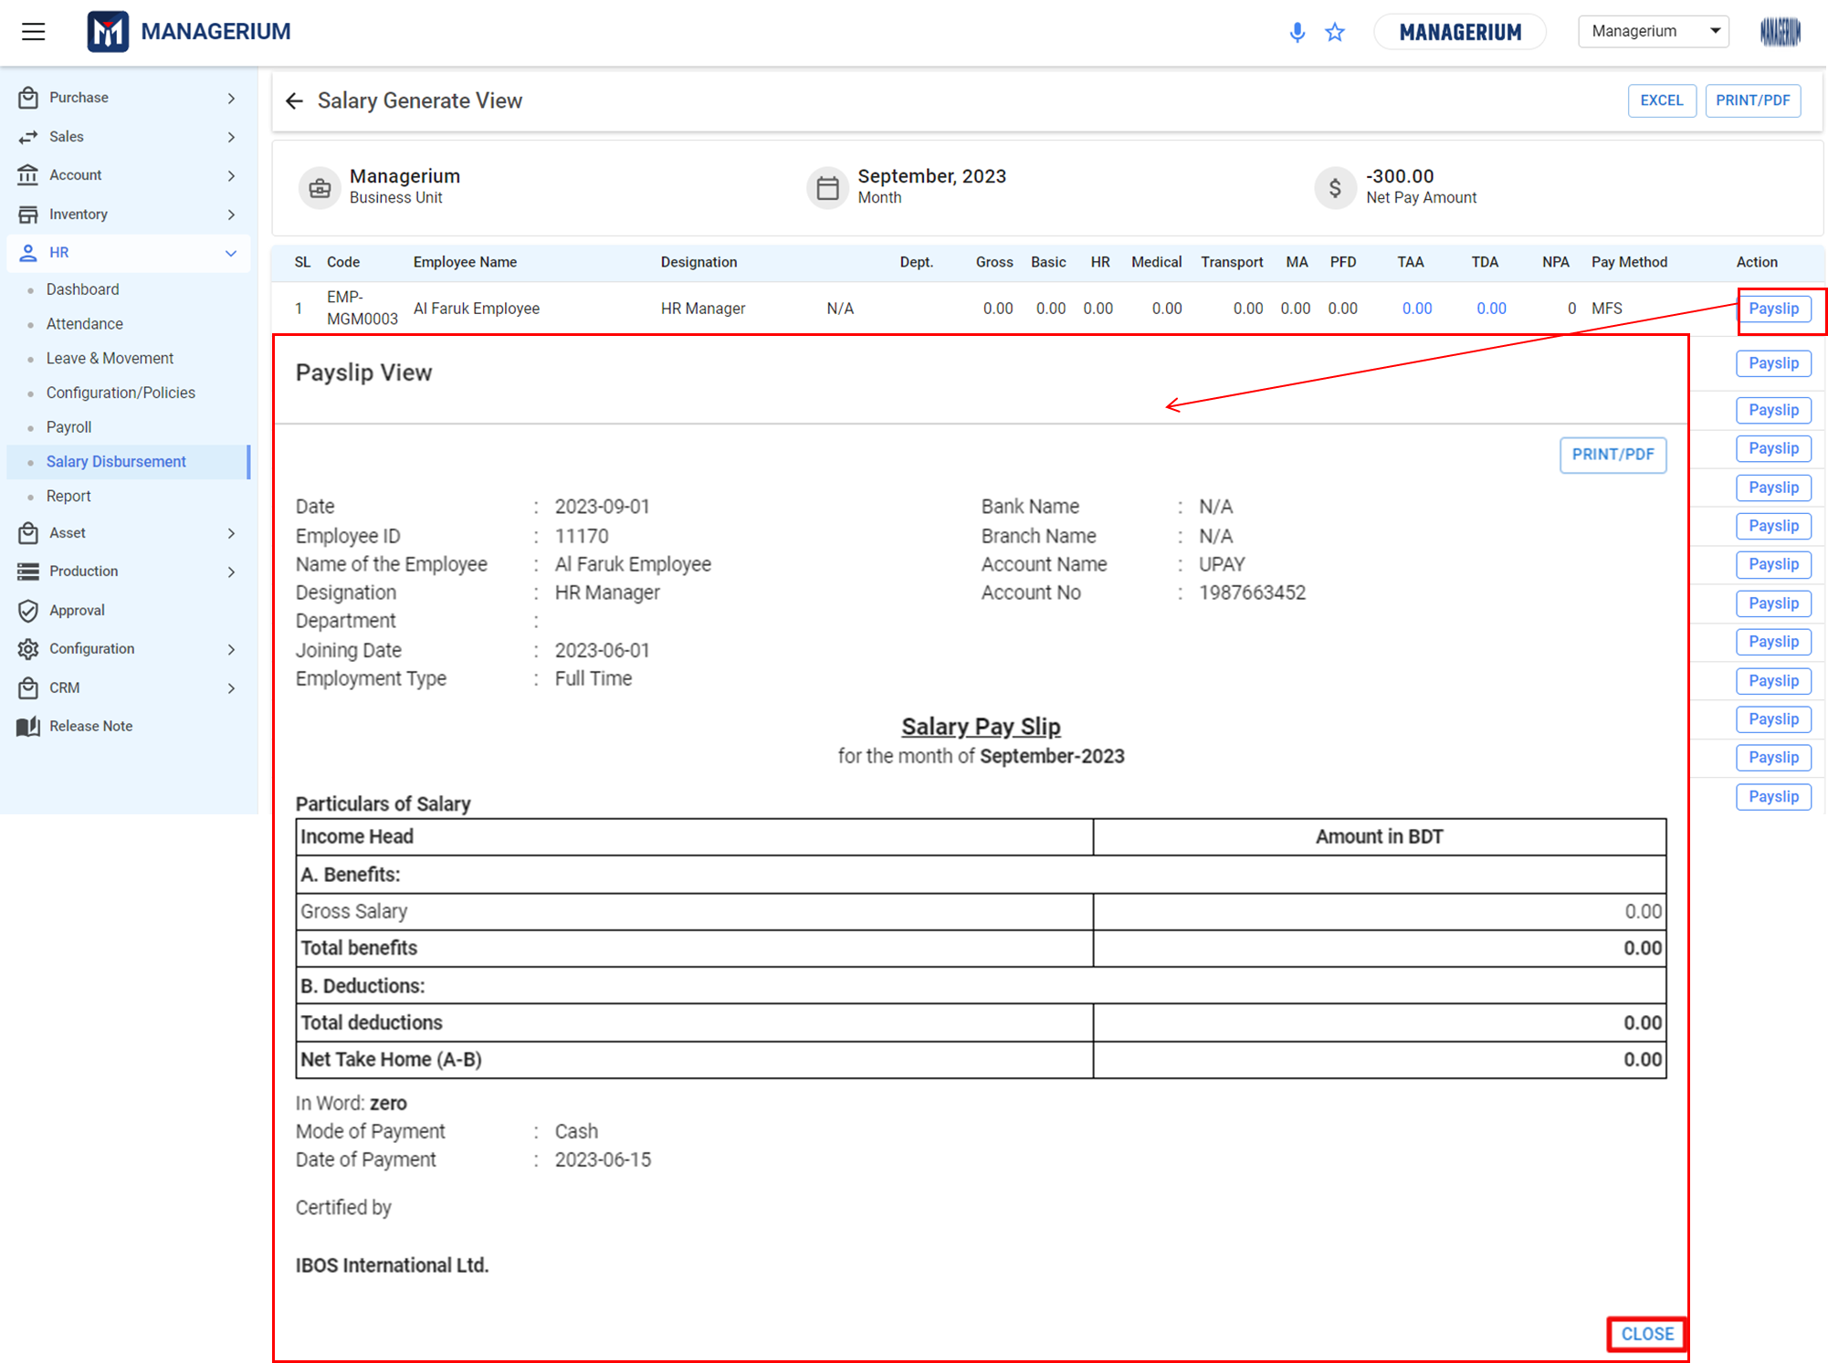

* After clicking on the **dollar** icon, there will be a salary-generated view where the salary can be paid.

**User Interface [Salary Generate- Payment]:**

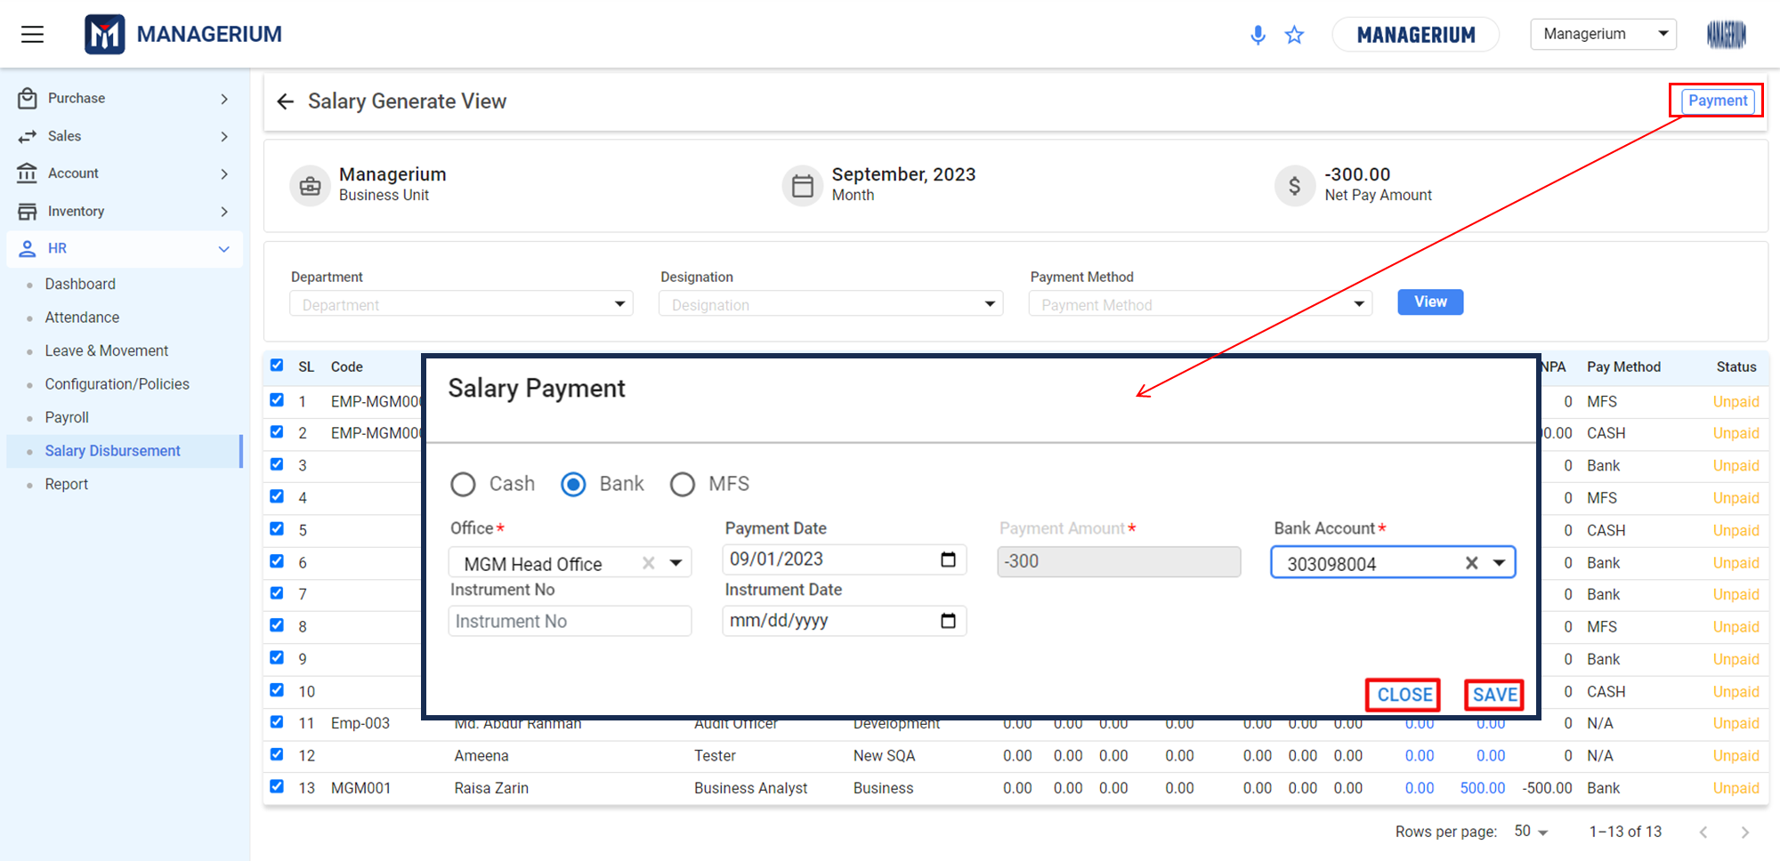

# **6. Asset**

## 6.1 Asset Dashboard

The Asset Dashboard gives a comprehensive and immediate view of an organization's assets, including current valuations, maintenance costs, and other critical metrics. It serves as a tool for monitoring the health and performance of the company's physical and intangible assets.

**Menu Path: Asset (Module) > Asset Dashboard**

The user will see a landing page after clicking the "Accounting Dashboard" feature.

**User Interface [Landing]**

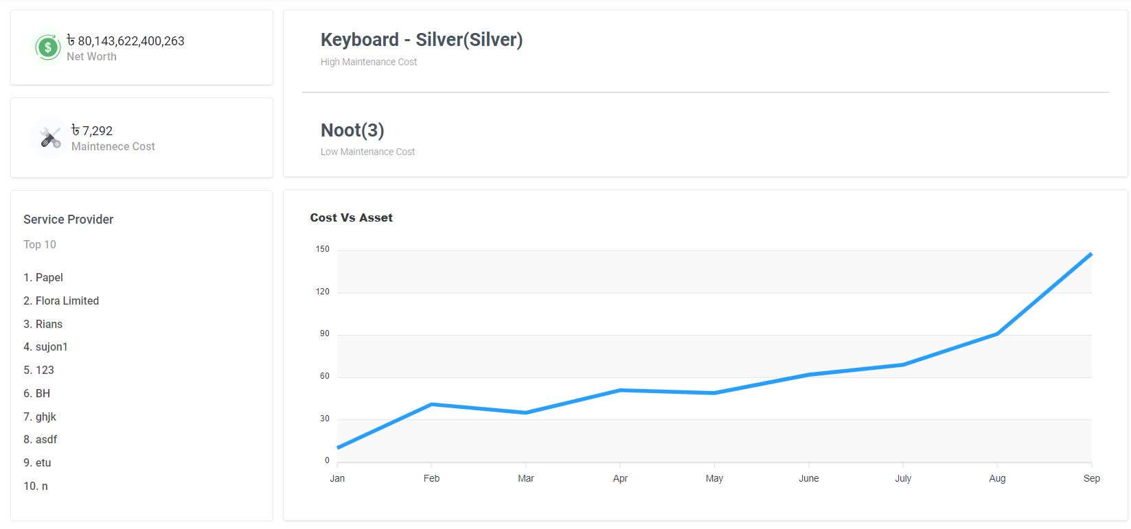

#### Key Features:

* **Net Worth Tracking:** Displays the total current valuation of all the company's assets.
* **Maintenance Cost Overview:** Provides insight into the costs associated with the upkeep of the assets.
* **Service Provider Engagement:** Lists the top service providers by engagement, allowing for quick assessments of vendor relationships and costs.
* **Cost vs. Asset Analysis:** A graphical representation of costs incurred against assets over time, aiding in understanding investment returns and upkeep efficiency.
* **High and Low Maintenance Assets Identification:** Quick identification of assets with high and low maintenance costs, which can help in budgeting and operational planning.

## 6.2 Registration

* Asset Registration is the process of entering new assets into the company's asset management system. This is a critical step in asset management that ensures all assets are accounted for, tracked, and managed effectively from the point of purchase.
* **Menu Path: Asset (Module) > Asset Registration**

#### 6.2.1 Asset Registration-Landing:

* **User Interface [Asset Registration-Landing]:**
* 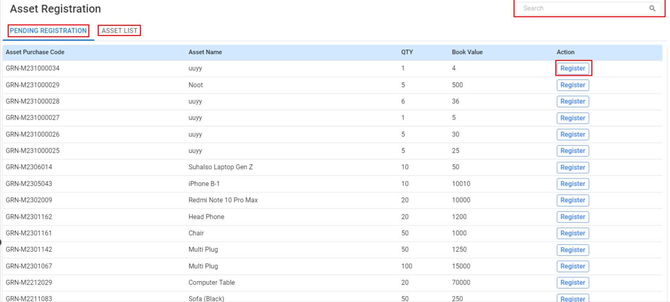
* **Key Features:**
* **Pending Registration Tab:** Displays a list of assets that have been purchased but not yet registered.
* **Asset List Tab:** Provides a comprehensive list of all registered assets.
* **Register Action:** Allows the user to register a new asset into the system, updating the inventory and financial records.
* How to Register an Asset:
* **Navigate to the Pending Registration Tab:** Review the list of assets awaiting registration.
* **Verify Asset Details:** Check the purchase code, asset name, quantity, and book value for accuracy.
* **Register the Asset:** Click on the ‘Register’ button to proceed with the asset registration process.
* **Enter Asset Information:** Fill in the required fields such as asset code, asset name, quantity, and book value.
* **Finalize Registration:** After verifying all details are correct, save the entry to register the asset officially.

#### 6.2.2 Asset Registration-Landing:

* **User Interface [Asset Register]:**
* 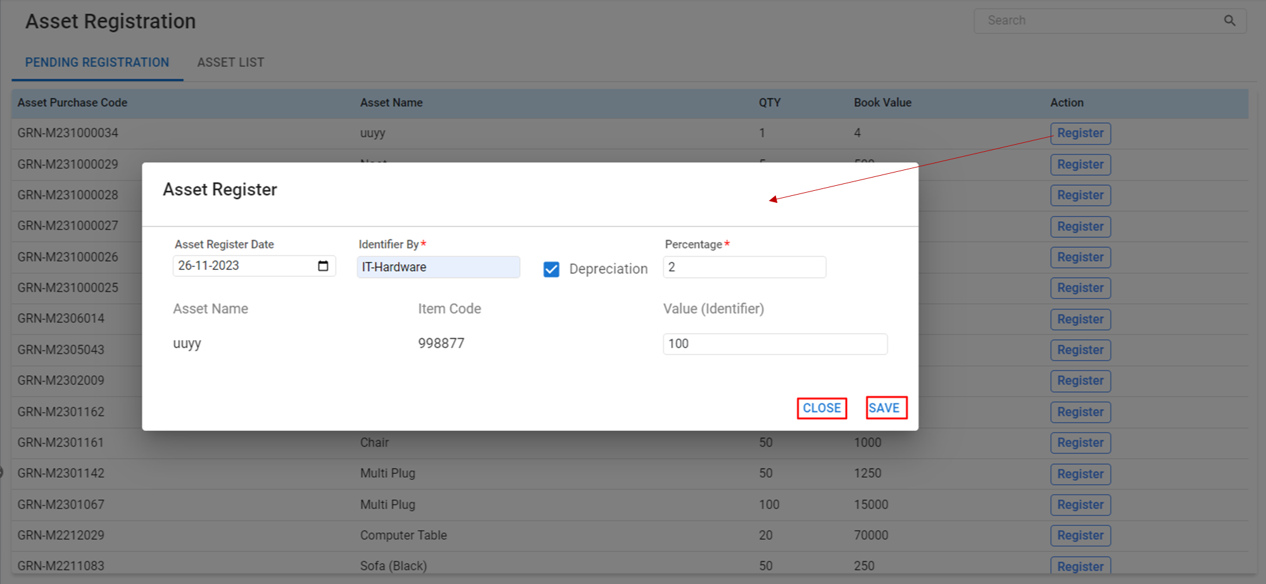

**Features Details:**

* **Asset Register Date:** The date on which the asset is being registered into the system.
* **Identifier:** A unique code or classification (like IT-Hardware) that helps in identifying and categorizing the asset.
* **Item Code:** A specific code assigned to the asset for tracking purposes.
* **Depreciation Percentage:** The rate at which the asset will depreciate over time.
* **Value (Identifier):** The initial value or cost of the asset at the time of registration.

**Steps to Register an Asset:**

* **Select the Asset:** Choose the asset from the pending registration list by clicking the ‘Register’ button next to it.
* **Enter Asset Details:** Fill out the form with the asset's registration date, identifier, item code, and initial value.
* **Set Depreciation:** Enter the depreciation percentage to automatically calculate depreciation over time.
* **Review and Save:** Before saving, review all the details to ensure accuracy.
* Finalize Registration: Click on the **‘Save’** button to finalize the registration of the asset in the system.

#### 6.2.3 Asset List-Landing:

The Asset List serves as a comprehensive directory of all the assets registered within the organization. This list helps in tracking the status, value, and depreciation of assets for effective management and accounting purposes.

**User Interface [Asset List-Landing]:**

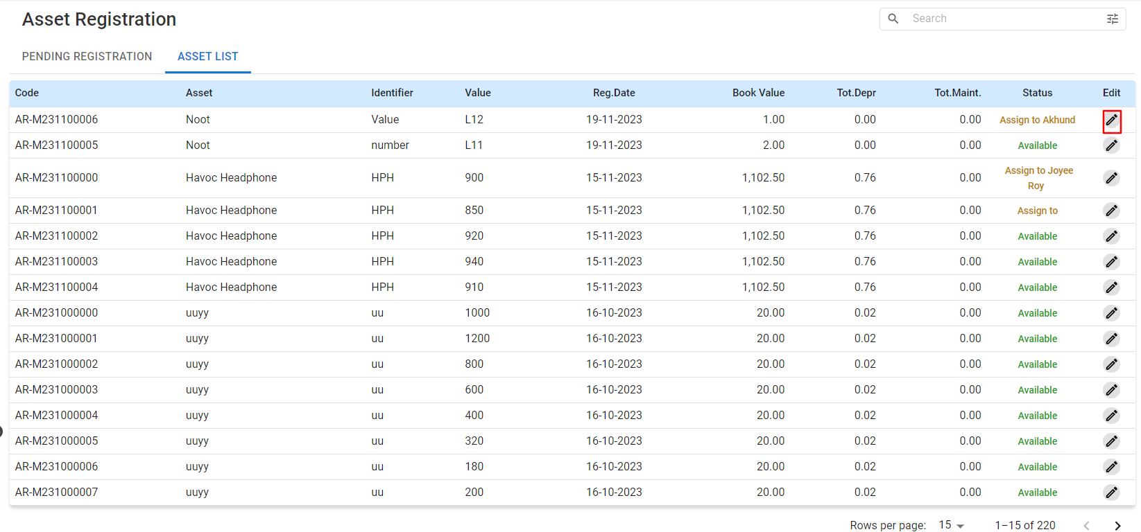

**Landing Details:**

* **Code:** A unique identifier assigned to each asset for tracking.
* **Asset:** The name or description of the asset.
* **Identifier:** Classification or category code to identify the type of asset.
* **Value:** The purchase value or cost of the asset.
* **Reg.Date (Registration Date):** The date on which the asset was registered.
* **Book Value:** The value of the asset after accounting for depreciation.
* **Tot.Depr (Total Depreciation):** The accumulated depreciation of the asset.
* **Tot.Maint (Total Maintenance):** The total maintenance cost incurred for the asset.
* **Status:** Indicates whether the asset is assigned, available, or under maintenance.
* **Edit:** Allows for modification of the asset details.

## 

## 6.3 Assign

* The Asset Assign is designed to allocate company assets to employees or departments, ensuring accountability and proper tracking of asset utilization.
* **Menu Path: Asset (Module) > Assign**

#### 6.3.1 Asset Assign-Landing:

* **User Interface [Asset Assign-Landing]:**

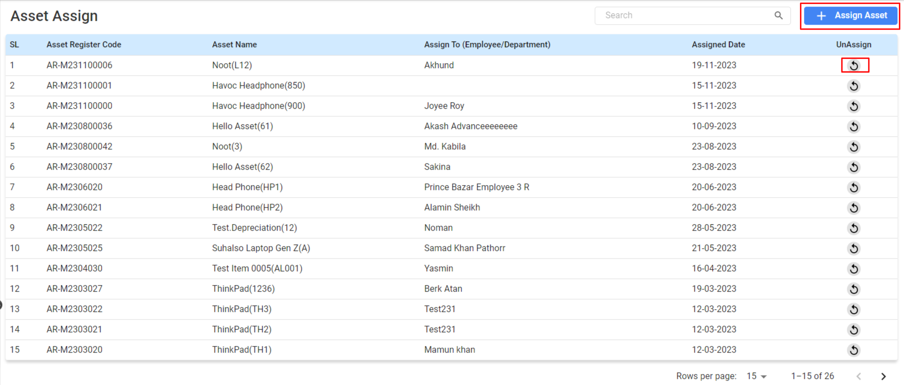

#### 

#### 

#### 

#### 

#### 

#### 

#### 

#### Landing Details:

* **Asset Register Code:** Unique identifier for the asset in the registry.
* **Asset Name:** The name or description of the asset.
* **Assign To (Employee/Department):** The employee or department to which the asset is assigned.
* **Assigned Date:** The date on which the asset was allocated to the user.
* **UnAssign:** An option to unassign the asset, returning it to the available pool.

#### 6.3.2 Asset Assign:

**User Interface [Asset Assign]:**

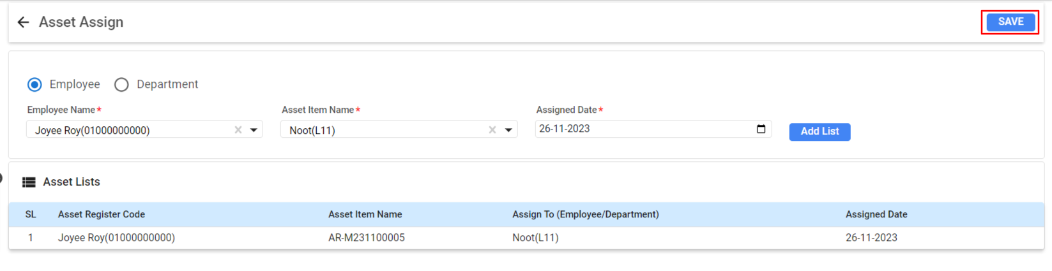

* **Employee/Department Selection:** Choose whether the asset is being assigned to an individual employee or a department.
* **Employee Name:** Select the employee to whom the asset will be assigned from a dropdown list of employees.
* **Asset Item Name:** Select the asset to be assigned from a dropdown list of available assets.
* **Assigned Date:** Set the date on which the asset is assigned.

#### Using Asset Assign:

* **Access Asset Assign:** Go to the Asset Assign module in the Managerium interface.
* **Choose Assignment Type:** Select whether the asset will be assigned to an 'Employee' or 'Department'.
* **Select Employee/Department:** Use the dropdown menu to select the employee or department.
* **Select Asset:** Use the dropdown menu to choose the asset item name that is being assigned.
* **Set Assigned Date:** Choose the date on which the asset is to be assigned.
* **Add to List:** Click **'Add List'** to add the asset to the assignment list.
* Use the **'Save'** button to record the assignment procedure in the system.

## 

## 6.4 Maintenance

Asset Maintenance keeps track of the maintenance activities for the assets owned by the organization.

**Menu Path: Asset (Module) > Maintenance**

#### 6.4.1 Maintenance-Landing:

**User Interface [Asset Assign-Landing]:**

**Table Details:**

* **Asset Register Code:** A unique identifier for the asset within the organization.
* **Asset Name:** The name or description of the asset.
* **Maintenance Schedule:** Specifies the period from start to end date for scheduled maintenance.
* **Cost:** The cost associated with the maintenance of the asset.

#### 6.4.1 Send Asset to Maintenance:

**User Interface [Asset Assign-Landing]:**

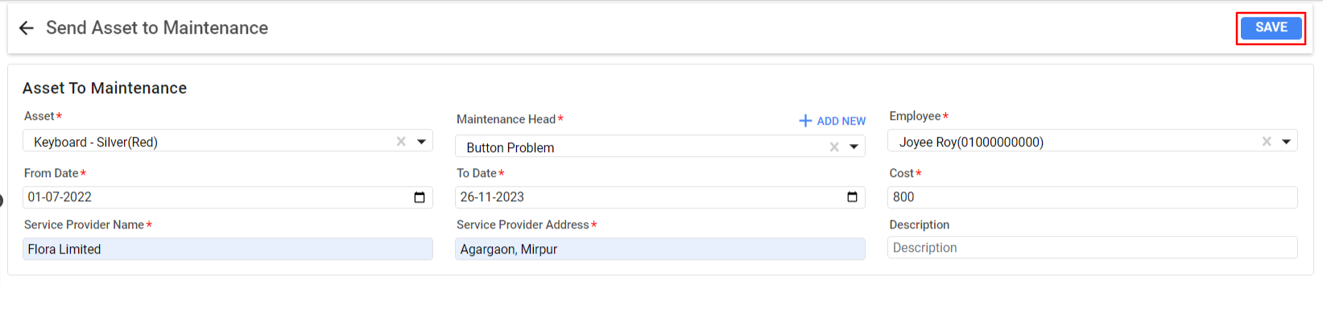

**Table Details:**

* **Select Asset:** Choose the asset that requires maintenance.
* **Specify Maintenance Details:** Input the nature of the maintenance issue, select the service provider, and fill in the associated costs.

**Using Send Asset to Maintenance:**

* **Fill in Asset Details:** Select the asset from the drop-down list or add a new asset if not already listed.
* **Maintenance Period:** Input the 'From Date' and 'To Date' for the maintenance duration.
* **Maintenance Details:** Fill in the maintenance issue, the name and address of the service provider, and the cost.
* **Employee Assignment:** Select the employee responsible for this maintenance task.
* **Save Record:** Click **‘Save’** to record the maintenance activity.

## 6.5 Depreciation

The Asset Depreciation allows for the systematic recording of the reduction in value of assets over time due to wear and tear, obsolescence, or age.

**Menu Path: Asset (Module) > Depreciation**

#### 6.5.1 Asset Depreciation-Landing:

**User Interface [Asset Assign-Landing]:**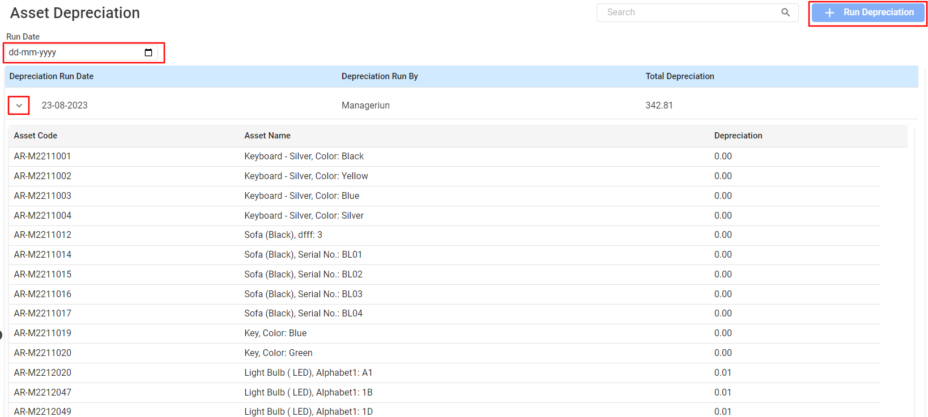

#### Functionality:

* **Run Depreciation:** Calculate and record the depreciation of assets for a specific period based on selecting the **Run Date.**

#### Asset Depreciation Landing Details:

* **Access Asset Depreciation:** Navigate to the Asset Management section and select the Asset Depreciation option.
* **Run Date:** Enter the date for which you want to calculate depreciation.
* **Depreciation Run Date:** Select the specific date you want to run the depreciation process.
* **Reviewing Asset List:** Review the list of assets and their respective book values and total depreciation before running the process.

## 6.6 Asset Disposal

The Disposal module is designed to manage the disposition of assets. This can include selling off assets that are no longer needed (SALES) or disposing of them if they are not sellable (DESTROY).

**Menu Path: Asset (Module) > Disposal**

#### 6.6.1 Disposal-Landing:

**User Interface [Asset Disposal-Landing]:**

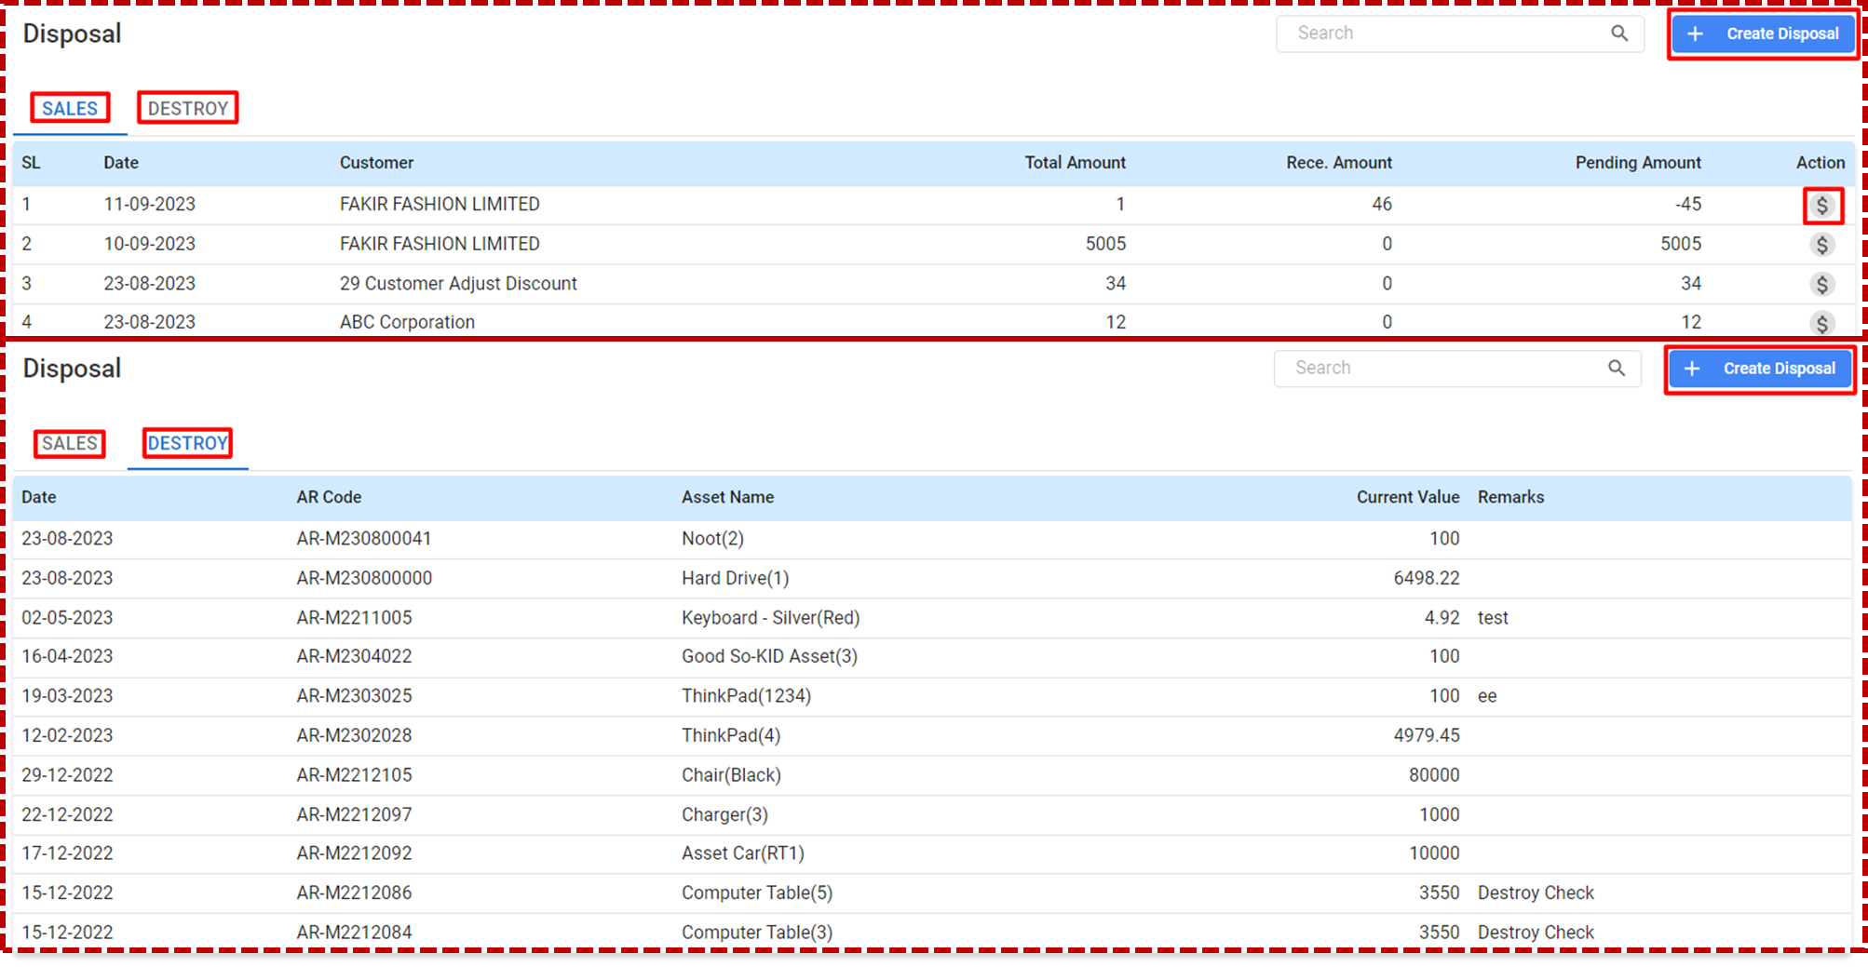

**Tab:**

* **SALES**-the current view showing sales.
* **DESTROY**- with the current view showing sales.

#### 6.6.2 Recording a Disposal

### **Sales Disposal**

**To record a sales disposal:**

* Click on the **‘SALES’** tab within the Disposal module.
* Review existing sales disposals, which are listed with details such as date, customer, total amount, received amount, pending amount, and actions.
* To create a new sales disposal, click on the ‘Create Disposal’ button.

### **Destroy Disposal**

**To record a destroy disposal:**

* Click on the ‘DESTROY’ tab within the Disposal module.
* Review existing destroy disposals, which are listed with details such as date, AR Code, asset name, current value, and remarks.

To create a new destroy disposal, click on the ‘Create Disposal’ button.

#### 6.6.3 +Create Disposal [ Sales & Destroy]:

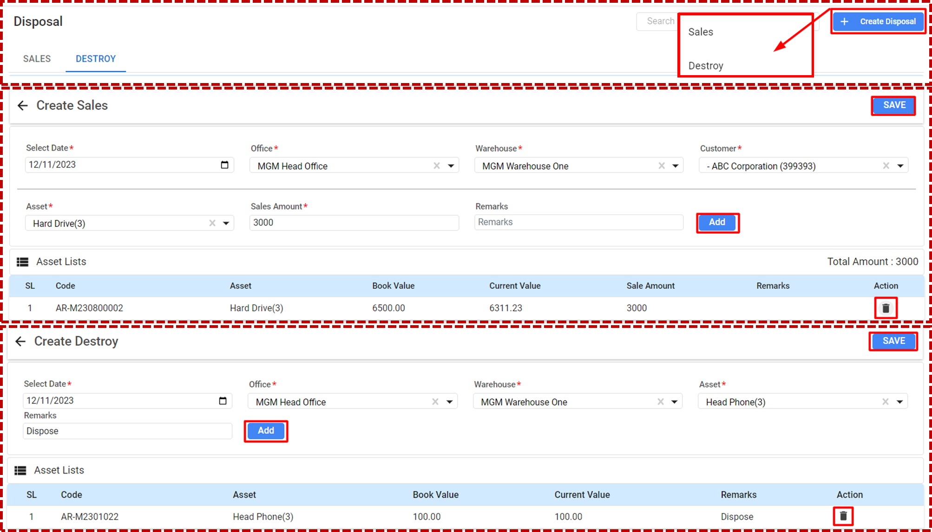

### **Accessing Create Sales**

* From the main dashboard, navigate to the 'Disposal' module.
* Click on the **'SALES'** tab.
* Select the **‘+ Create Disposal’** button.

### **Header Information:**

* **Select Date:** Choose the date on which the sale is taking place.
* **Office:** Select the office responsible for the sale.
* **Warehouse:** Choose the warehouse from which the asset is being sold.
* **Asset:** Use the dropdown to select the asset you are selling.
* **Sales Amount:** Enter the amount for which the asset is being sold.
* **Customer:** Select the customer purchasing the asset from the dropdown menu.
* **Remarks:** Add any notes relevant to the sale.

### **Asset Lists/ Table Section:**

* Confirm the asset details in the **'Asset Lists'** section, which will include:
  + **SL:** Serial number in the list.
  + **Code:** The unique asset code.
  + **Asset:** The name of the asset.
  + **Book Value:** The original value of the asset.
  + **Current Value:** The depreciated value of the asset.
  + **Sale Amount:** The price at which the asset is being sold.
* Click the **‘Add’** button if you need to include multiple assets in the sale.
* Review the '**Total Amount'** to ensure it reflects the correct sales value.
* To finalize, click the **‘Save’** button to record the sale.

#### 6.6.3 Create Destroy (Disposal)

### **Accessing Create Destroy**

* From the 'Disposal' module, click on the 'DESTROY' tab.
* Choose the ‘+ Create Disposal’ button to start a new record for asset destruction.

### **Recording an Asset Destruction**

* **Select Date:** Set the date on which the asset is being destroyed.
* **Office:** Select the office overseeing the asset destruction.
* **Warehouse:** Specify the warehouse where the asset is located.
* **Asset:** Use the dropdown to select the asset to be disposed of.
* **Remarks:** Enter details or reasons for the destruction of the asset.

### **Asset Lists Section**

* Confirm the asset details in the 'Asset Lists' section, which will display:
  + **SL:** Serial number in the list.
  + **Code:** The unique asset code.
  + **Asset:** The name of the asset.
  + **Book Value:** The original value of the asset.
  + **Current Value:** The current value at the time of disposal.
* **Saving the Purchase Order:**

Clicking on the action button to delete the asset as destroyed.After completing the process, click the ‘**Save’** button to finalize the destruction record.

# 

# **7. Production**

The production process involves converting raw materials into finished goods that have value to customers. Along with detailed inventory of materials and components needed for production, as for manufacturing a certain quantity of products.

## 7.1 Production Dashboard

**Menu Path: Production (Module) > Production Dashboard**

The user will see a landing page after clicking the "Accounting Dashboard" feature.

**User Interface [Landing]**

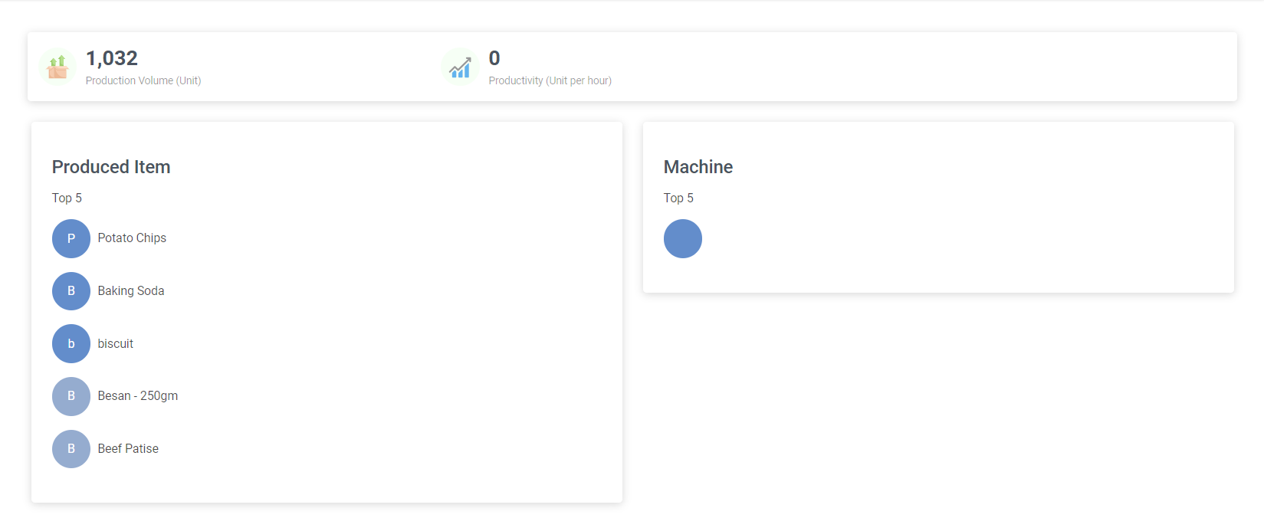

## Dashboard Metrics

### **Production Volume (Unit)**

* Displays the total number of units produced within a set timeframe.
* Helps in assessing the output volume of the production facility.

### **Productivity (Unit per hour)**

* Shows the average number of units produced per hour.
* Aids in evaluating the efficiency and speed of the production process.

### **Produced Item**

* Lists the top 5 produced items, providing a quick overview of what items are being produced the most.
* Each item is represented by a colored circle and the item name.

### **Machine Utilization**

* (Though not visible in the provided image, it is typically present on such dashboards)
* Would usually list the top machines by usage or hours operated.
* Essential for tracking the performance and maintenance schedule of production machinery.

## 7.2 Bill Of Material

A Bill Of Material detailed inventory of materials and components needed for production.comprehensive list that outlines all the raw materials, components, and assemblies required to construct a product. It acts as a recipe for production, detailing the quantities and specifications of inputs needed to create an end product.

**Menu Path: Production (Module) > Bill Of Material**

**User Interface [Bill Of Material-Landing]**

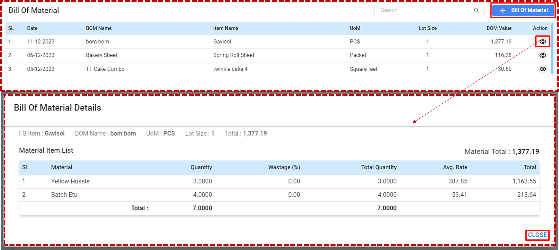

**Accessing the Bill of Material [Landing]:**

**Upon entering the BOM section, you will see a list of BOM records which include:**

* **SL:** Serial number of the BOM entry.
* **Date:** The date when the BOM was created.
* **BOM Name:** The name assigned to the BOM.
* **Item Name:** The name of the finished good the BOM is associated with.
* **Unit of Measure (UoM):** The unit of measurement for the BOM quantities.
* **Lot Size:** The batch size for which the BOM is calculated.
* **BOM Value: T**he total value of materials required for the lot size.
* **Actions:** Icons to view more details.

#### 7.2.1 Bill of Material Details:

#### FG Item and BOM Information

* The interface displays the finished good (FG) item name, the BOM name, the unit of measure (UoM), lot size, and the total value of materials.
* **FG Item:** The final product for which the BOM is listed.
* **BOM Name:** The identifier or title given to the BOM.
* **UoM:** The unit of measurement for the BOM quantities.
* **Lot Size:** The batch quantity for which the BOM is calculated.
* **Total:** The aggregated cost of the materials listed.

### **Material Item List**

* **SL:** Serial number of each material within the BOM.
* **Material:** The name or description of the material.
* **Quantity:** The amount of each material required.
* **Wastage (%):** The percentage of material expected to be wasted during production.
* **Total Quantity:** The sum of the quantity needed plus wastage.
* **Avg. Rate:** The average cost per unit for the material.
* **Total:** The total cost for the material based on the required quantity and average rate.

### **Reviewing and Editing Material Details**

* Review each material listed to ensure the quantities and costs are accurate.
* If adjustments are needed, use the action buttons to edit or delete materials.

### **Material Total**

* Located at the bottom is the ‘Material Total’, which represents the sum total of all materials required for the BOM.

#### 7.2.2 +Create Bill of Material:

**Menu Path: Production (Module) > Bill Of Material> [+Bill Of Material]**

**User Interface [Bill Of Material-Create]**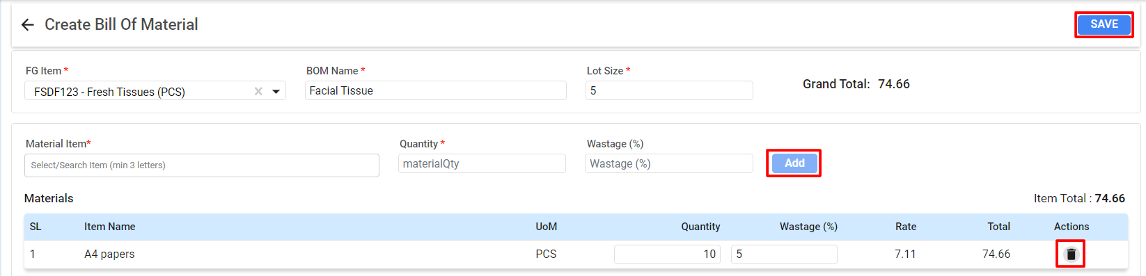

When creating a new Bill of Material:

**Step 1: Enter BOM Details**

**FG Item:** Select the finished goods item from the dropdown menu.

#### BOM Name: Enter a name for the new Bill of Material for easy identification.

#### Lot Size: Specify the number of finished goods that this BOM will produce.

### **Step 2: Add Materials**

* **Material Item:** Begin typing the name of the material and select it from the search results.

#### Quantity: Enter the quantity of the material required.

#### Wastage (%): If applicable, enter the percentage of material that may be wasted during production.

### **Step 3: Reviewing Materials List**

#### The materials list will display all added materials with their unit of measure (UoM), quantity, wastage percentage, rate, and total cost.

#### SL: The serial number of the material in the BOM.

#### Item Name: The name of the material.

#### UoM: The unit of measurement for the material.

#### Quantity: The amount needed for production.

#### Wastage (%): Expected wastage during production.

#### Rate: Cost per unit of the material.

#### Total: Total cost for the quantity needed.

### **Step 4: Save the BOM**

#### Confirm the ‘Grand Total’, which is the sum of the cost of all materials.

#### Review the entire BOM to ensure all materials and quantities are correct.

#### Once verified, click the ‘Save’ button to finalize the BOM.

## Editing and Deleting Materials

#### To edit a material entry, click on the input field to type.

#### To remove a material from the BOM, click the trash bin icon in the ‘Actions’ column.

#### 

## 7.3 Production Order

The Production Order feature, which is key to managing production workflow to help users understand how to effectively use it.

**Menu Path: Production (Module) > Bill Of Material**

Click on **‘Production Order’** to view existing orders or create new ones on the landing page.

#### 7.3.1 Production Order-Landing

**User Interface [Production Order-Landing]**

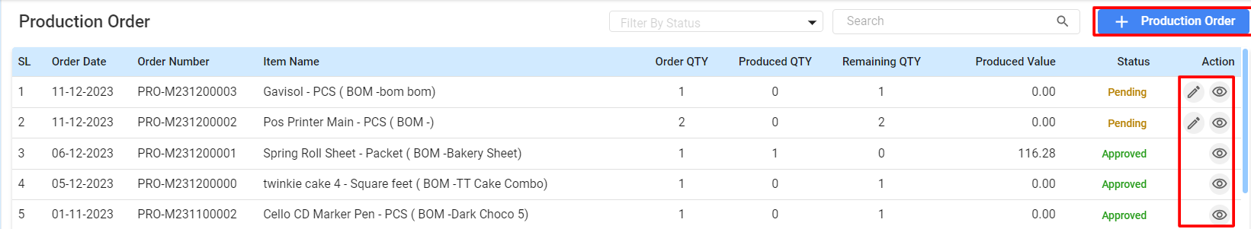

### **Table Details: Viewing Orders**

* The main Production Order screen displays all orders with their details:
  + **SL:** Serial number of the order.
  + **Order Date:** The date when the order was created.
  + **Order Number:** Unique identifier for the order.
  + **Item Name:** Name of the product to be produced.
  + **Order QTY:** Quantity ordered.
  + **Produced QTY:** Quantity that has been produced.
  + **Remaining QTY:** Quantity that is yet to be produced.
  + **Produced Value:** The financial value of the quantity produced.
  + **Status:** Current status of the order (e.g., Pending, Approved).

### **Editing Orders**

* To edit an order, click the pencil icon under the ‘Action’ column**.*** The icon will be disabled once status of the production order get “Approved” from “Pending”**

### **Monitoring Order Progress**

* Track the progress of each order by reviewing the **‘Produced QTY’** and **‘Remaining QTY’** fields.
* Update the status as the order moves through different stages of production.

### **Filtering and Searching**

* Use the **‘Filter By Status’** dropdown to sort orders by their status.
* Use the **Search Bar** to find specific orders by item name, order number, or other criteria.

## 

#### 7.3.2 Creating Production Order

Click the **‘+ Production Order’** button to start a new order.

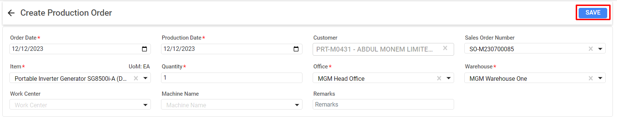

### **Tables Order Details:**

* **Order Date:** Enter the date when the production order is created.
* **Production Date:** Specify the date when production is scheduled to start.
* **Customer:** Choose the customer for whom the production is being carried out. This field may autofill based on integration with the sales module.
* **Sales Order Number:** If the production order is tied to a specific sales order, input or select the corresponding sales order number.
* **Item:** Select the item to be produced from the dropdown list.
* **UoM (Unit of Measure):** Confirm the unit of measure, typically set by default based on the item selected.
* **Quantity:** Input the number of units required for the production order.
* **Office:** Indicate the office or department within the company responsible for managing the production order.
* **Warehouse:** Select the warehouse from where the raw materials will be sourced or where the finished product will be stored.
* **Work Center:** If applicable, choose the work center where the production will take place.
* **Machine Name:** Select the machine to be used, if the production process requires it.

### **Reviewing the Order**

* Confirm the details of the order, ensuring the quantity and product specifications are correct. Click **‘Save’** to record the new production order.

#### 7.3.2 Production Order Approval

In the Production Order Approval process, once the production order is approved, it will be forwarded to the Item Requisition Approval process. After it is approved, it needs to be issued from the Inventory's Item Issue process to enter the production.

**User Interface [Order Approval- Stages]**

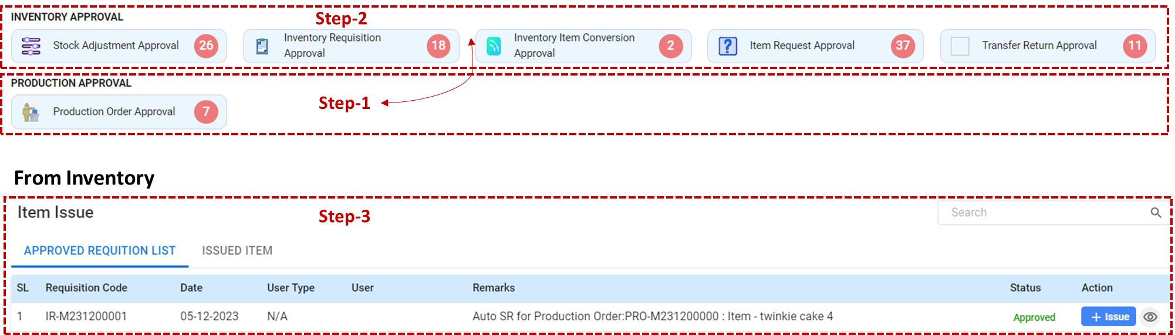

## 

## Step-by-Step Approval Process

### **Step 1: Production Order Approval**

* **Purpose:** This is the initial stage where production orders are reviewed and either approved or sent back for revision.
* **Process:** Click on the **‘Production Order Approval’** tab.
* **Action:** Review the listed production orders, verify the details, and click on the corresponding action button to approve or reject the order.

### **Step 2: Inventory Requisition Approval**

* **Purpose:** Following the production order approval, an inventory requisition is created and must be approved to allocate the necessary materials from inventory.
* **Process:** Select the **‘Inventory Requisition Approval’** tab, which becomes active after the production order is approved.
* **Action:** Assess the material requisition requests for accuracy and availability, then approve the requisition to proceed with the material allocation.

### **Step 3: Item Issue**

* **Purpose:** With the approved requisition, materials can be officially issued from inventory for production use.
* **Process:** Navigate to the **‘Item Issue’** section found under the **‘Approved Requisition List’**.
* **Action:** Finalize the issuing process by selecting **‘Issue’** for the approved items, which records the removal of items from inventory and their allocation to the **Production Entry.**

## 7.4 Production Entry

* 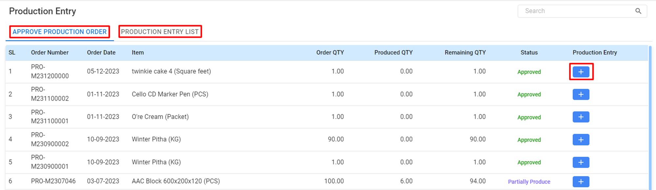

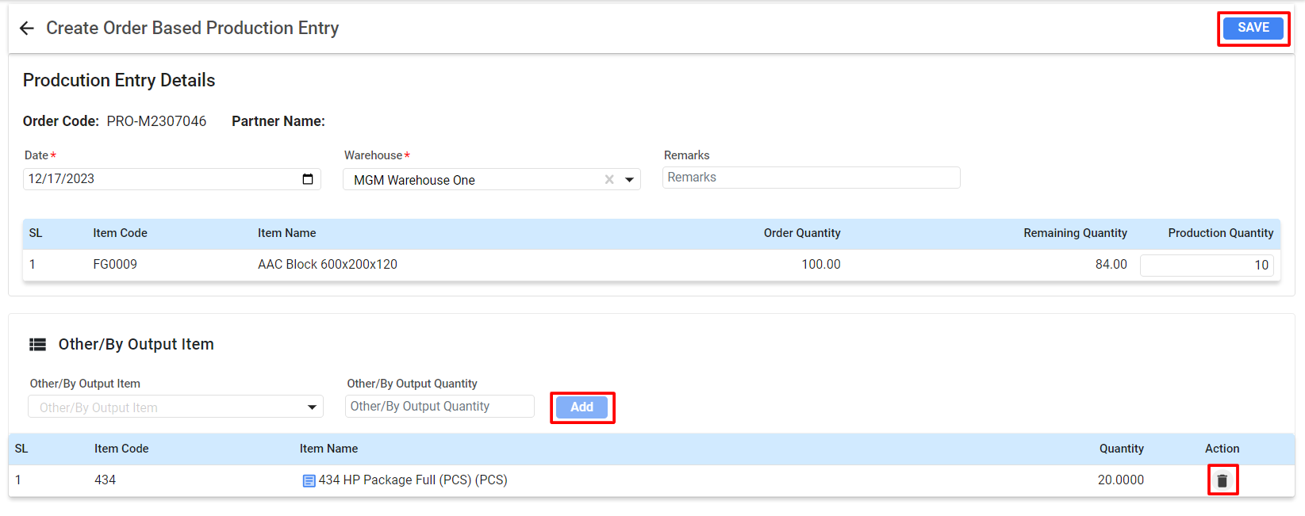

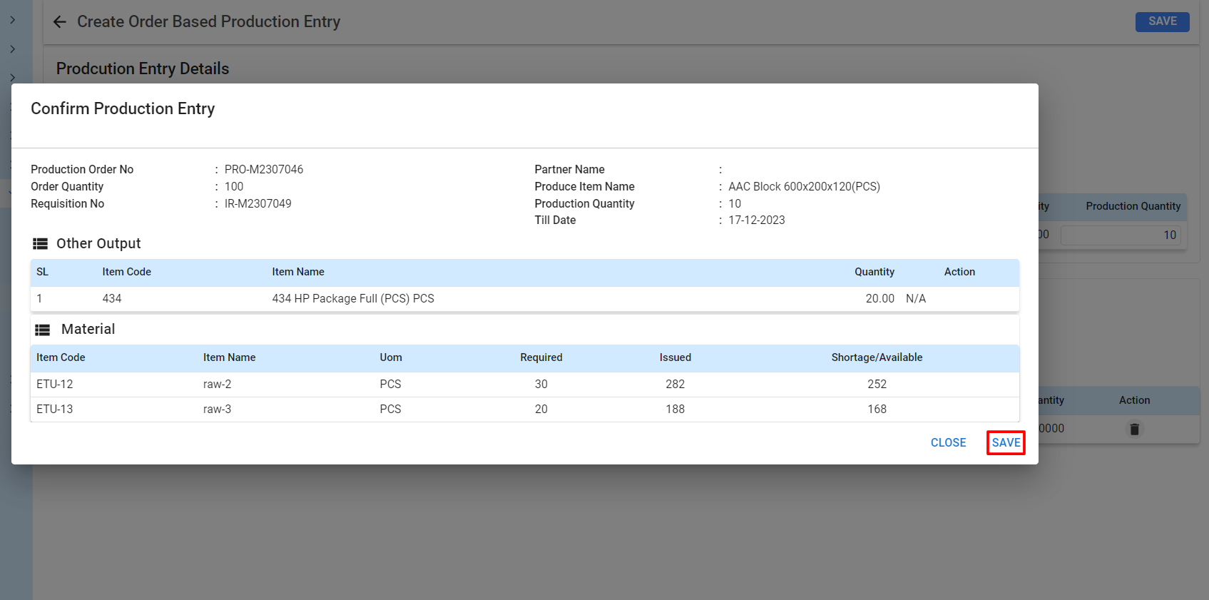

# **8. CRM**

## 8.1 Employee

## 8.2 Employee

# **9. Configuration**

## 9.1 Employee

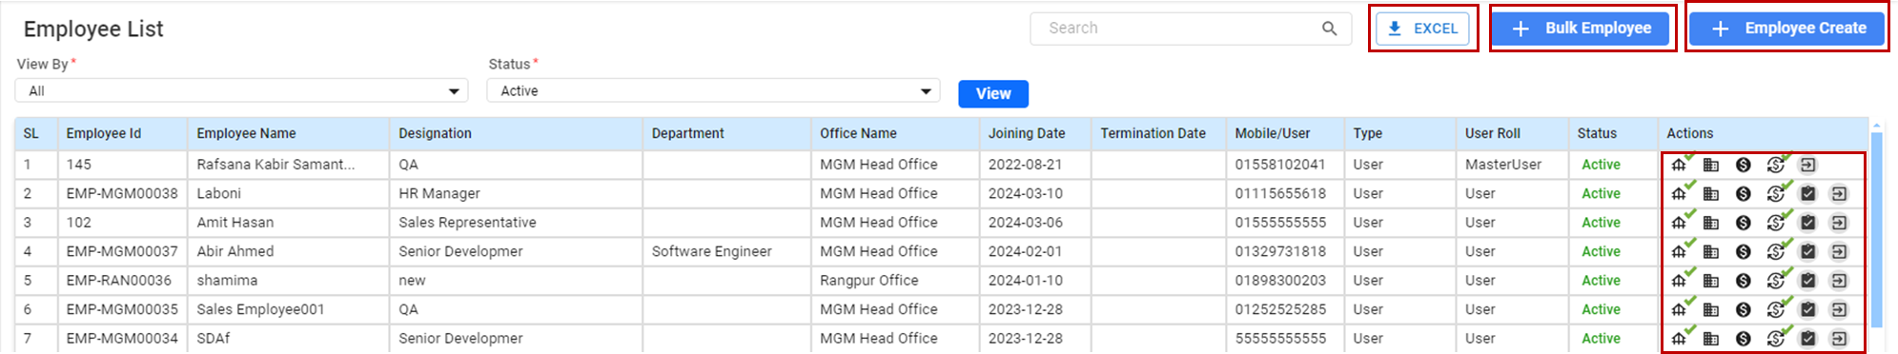

## 9.2 Item Profile

## 9.3 Account

## 9.4 Branch

## 9.5 Customer Profile

## 9.6 Office

## 9.7 Supplier Profile

## 9.8 Other Partner Profile

## 9.9 Warehouse

## 9.10 Company Profile

## 9.11 Offer Setup

## 9.12 Customer Price Setup

## 9.13 Standard Price Setup

## 9.14 Wallet Setup

## 9.15 Barcode

## 9.16 Sales Setup

## 9.17 MGT

## 9.18 Favorite Menu Setup

## 9.19 Approval Setup

## 9.20 Expose API Config

## 9.21 Expose API Config

## 9.22 User Group

## 9.23 Package

## 9.24 Banner Upload

## 9.25 Outlet Setup

## 9.26 Tour Plan Setup

## 9.27 Responsibility Transfer

## 

## 

## 

__________________________



## 